

City of Thornton, CO
2024-2029 HOUSING NEEDS ASSESSMENT

December 2024

Prepared by:
Civitas Consultants, LLC
&
City of Thornton Staff

Table of Contents
Section 1: Purpose and Overview 5
Affordability Matters 6
Impacts of Housing Affordability Challenges 6
Methodology 7
Research Data Sources 8
Common Definitions 8
Section 2: Socio-Economic Profile 10
Introduction: Thornton’s History 10
Demographics 11
Population Growth 11
Population Projection 12
Population Dynamics 13
Population Shift 14
Population by Age 16
Disability Status 17
Demographic Trends: Race, Ethnicity, and Language 18
Veteran Population 22
Persons Experiencing Homelessness 23
Household Trends 26
Household Growth 26
Household Size 26
Household Composition 28
Household Makeup (Homeowner vs. Renter) 30
Economic Profile 32
Labor Force and Employment 32
Jobs by Industry 35
Occupations by Sector 36
Commute Times 37
Household Income 38
Household Income Distribution 40
Household Income by Race and Ethnicity 42
Poverty 43
Households with Incomes Less than $25,000 44
Section 3: Housing Profile 45
Housing Stock 45
Property Type 45
Middle Housing Obstacles 46
Unit Sizes 47
Age of Housing 49
Additional Housing Types 51
Senior Living Options 51
Accessory Dwelling Units (ADUs) 53
Tiny/Micro Homes and Communities 53
Manufactured Homes 54
Mobile Homes 54
Housing Occupancy Development 57
Occupancy Characteristics 57
Housing Production Challenges 58
Naturally Occurring Affordable Housing 60
Benefits to Increasing High-end Rental Supply 60
Public Housing in Thornton 62
Types of Affordable Housing Units in Thornton 62
Section 4: Owner Market Analysis 64
Median Home Value vs Median Homeowner Income 64
Median Sale Price 65
Market Demand 66
Median Home Values 68
Colorado's Golden Handcuffs 71
Owner Affordability Trends 72
Homeowner Affordability Gap 73
Cost Burdened Homeowners 74
Section 5: Rental Market Analysis 76
Median Contract Rent vs. Median Renter Income 76
Median Rents Distribution 77
Renter Affordability Trends 80
Affordable, But Not Available 80
Area Median Income 81
Fair Market Rents 82
Current Rental Market 83
Cost Burdened Renters 85
Section 6: Public Policy Analysis 87
City Policy and Programs 87
Development Code Review 89
New Statewide Land Use and Housing Laws 91
Impact on Thornton 92
Development Fees and Taxes Impact on Housing Development 92
Stakeholder Input 94
Housing Needs and Gaps 94
Barriers to Development 95
Positive Aspects and Collaborative Efforts 95
Policy and Program Recommendations 95
Section 7: Key Findings 98
Finding 1: Current Housing Supply-Demand Mismatch Fuels Affordability Crisis 98
Home Ownership – Home Affordability Supply Gap Analysis 98
Renter – Unit Affordability Supply Gap Analysis 100
Finding 2: Housing Production Needs Greatly Outpace Current Supply Rate 102
Population and Household Growth Projections 102
Finding 3: Rising Housing Cost Sharply Outpaces Income Growth 104
Finding 4: There is a Shortage of Missing Middle Housing Development 105
Finding 5: Infrastructure Costs Significantly Impede Housing Development 106
Section 8: Strategic Recommendations 107
Action 1: Catalog Under-Utilized Properties For Housing Conversion Suitability. 107
Action 2: Revise Development Code to Facilitate Affordable Housing. 108
Action 3: Attract Housing Developers and Offer Incentives for Affordable Housing. 109
Action 4: Streamline the Zoning and Housing Development Approval Process. 112
Action 5: Explore Alternative Financing 113
Action 6: Leverage Additional Affordable Housing Opportunities. 115
Action 7: Support Residents Ability to Age in Place. 116
Action 8: Integrate Transportation Access into Affordable Housing Strategy 116
Action 9: Educate Residents to Reduce Effects of the Negative Sentiments of Affordable Housing. 117
Action 10: Advance Housing Choice. 118
Section 11: Fair Housing Assessment 119
Affirmatively Further Fair Housing 119
Racial and Ethnic Demographic Shifts and Fair Housing in Thornton 120
Income Disparities and Poverty Rates 121
Poverty Rates in Context 121
Racially/Ethnically Concentrated Areas of Poverty (R/ECAP) 123
Racial and Ethnic Disparities in Access to Housing 124
Access to Resources 125
Predominant Race/Ethnicity and Access to Citywide Resources 125
Access to Resources for Hispanic or Latino People in Poverty 125
Access to Resources for Black or African American People in Poverty 125
Access to Resources for Seniors (age 65 and older) Living in Poverty 129
Lending Analysis 130
Fair Housing Act 1968 130
Home Mortgage Disclosure Act 130
HMDA Analysis 130
High-Cost Lending 131
Loans for Manufactured Housing 132
Fair Housing Complaints 134
Local Survey – Fair Housing Insights 135
City of Thornton’s Fair Housing Efforts 136
Fair Housing Findings 137
Fair Housing Equity Plan 139
Appendix A: Local Stakeholder and Public Outreach 141
Stakeholder Survey Highlights 141
Public Survey Highlights 143
HNA Additional Sources 145

Section 1: Purpose and Overview
The City of Thornton Housing Needs Assessment (HNA) aims to comprehensively evaluate and understand the current and future housing needs of our community. This assessment is a critical tool that guides the city's efforts in planning, policymaking, partnerships, and acquiring funding for housing. These efforts will be designed to assist all residents, particularly marginalized and low-to-moderate-income (LMI) communities, have access to safe, affordable, and suitable housing. The HNA identifies key housing challenges, demographic trends, market conditions and community input to provide a foundation for developing targeted strategies to address these issues.
The City of Thornton is experiencing a demanding challenge in its housing sector due to continuous population growth. While the city has generally kept pace with housing demand in recent years (comparing city-issued housing permits with estimated household growth from Census data), projections indicate that if current population growth trends continue over the next 5 to 10 years, the city and its housing developers may face challenges in constructing enough housing units to meet the increasing demand. This situation presents a critical decision point for Thornton: to either embrace and accommodate further growth by accelerating housing development or to limit growth, which could result in rising housing demand and an increase in housing prices. This strategic choice will shape the future of Thornton's housing market and its affordability for residents.
The Denver Regional Council of Governments (DRCOG) released its 2024 Regional Housing Needs Assessment states that in the 10-county planning area: Housing needs for the Denver region are heavily skewed toward lower income households. An estimated 303,000 housing units for households earning 0–60% of the Area Median Income are needed to meet current and future demand. This is 59% of the estimated 511,000 housing units needed by 2050. Six out of 10 future housing units need to be affordable.
The goal of the HNA is to inform and support the City of Thornton’s initiatives in meeting the diverse housing needs of its current and future population. Adding a focus on marginalized, at risk, and LMI communities, the HNA seeks to highlight specific barriers these groups face in accessing and maintaining adequate housing. Through this targeted approach, the city can allocate resources more effectively and implement policies that foster inclusive growth and equitable access to housing, especially for the low-income households, to include senior households on fixed income.
Ultimately, the HNA serves as a roadmap for creating a more resilient and supportive housing landscape for all residents of Thornton. Recommendations are intended to be a foundation on which to build annual housing action plans that articulates specific local goals and activities to preserve and promote affordable housing and sustainable growth. The recommendations generally coincide with the strategic goals the city previously laid out in its Comprehensive Plan, to create quality and diverse neighborhoods, to support the enhancement of established neighborhoods, and to guide the design and development of new affordable and accessible neighborhoods.

Affordability Matters
Affordable housing is not just a social goal—it has far-reaching economic impacts on growth, opportunity, social mobility, and equity. For most American families, housing costs represent the largest component of household expenses. The income remaining after housing costs is what households have for necessities like food, healthcare, and transportation, as well as discretionary spending that drives local economies.
Housing affordability significantly affects educational outcomes. Families spending less on housing have more resources for education expenses. Research shows children from families spending around 30% of income on housing had higher test scores than those from families spending over 50%. High housing costs can hamper talent retention, threatening a city's economic development prospects.
Affordable, quality housing also leads to better health outcomes. Families with lower housing cost burdens have more income available for healthcare. Those on the margin of affordability often must choose between healthcare and housing payments.
For local governments, addressing housing affordability is crucial to avoid growing public costs associated with income insecurity, such as homelessness. With federal housing funding declining since the 1980s, the responsibility increasingly falls to local governments to develop sustainable affordable housing strategies.
Economic development follows housing. Economic growth is vital to a community's housing availability and affordability. Ultimately, affordable housing enables greater economic stability and mobility for families while supporting community growth and resilience. It is a key foundation for building thriving, equitable communities.

Impacts of Housing Affordability Challenges
The housing affordability crisis in Thornton has far-reaching impacts on residents, the local economy, and the city's overall well-being. This is borne out by the resident surveys received. Here's a concise overview of the key consequences. The rising costs in housing contribute to:
- Unattainable homeownership for many first-time buyers and middle-income families
- Escalating rents, putting financial strain on a growing number of households
- Increased housing cost burden, with more residents spending over 30% of income on housing
- Disproportionate impacts on low-income families and vulnerable populations
- Higher risk of eviction and homelessness for cost-burdened households (especially renters)
- Limited economic mobility and reduced ability to build wealth through homeownership
- Potential for slowed economic growth as businesses struggle to attract and retain workers
- Increased commute times and transportation costs as workers seek affordable housing elsewhere
- Reduced diversity in neighborhoods as certain income groups are priced out
- Strain on public services and infrastructure as the city struggles to meet housing needs

Methodology
The City of Thornton’s Housing Needs Assessment (HNA) was conducted via data research and analysis, community feedback, and stakeholder interviews to apprise key findings. The HNA was compiled using a data-focused model in partnership with Civitas. This methodology section explains the approach to data analysis and explains the path to our findings.
A comprehensive analysis of local data trends on population demographics, household cohorts, local employment and labor force, and current housing stock informed the Socioeconomic and Housing Profiles. This phase included interviews and community surveys with key city staff, local employers, churches, and organizations assisting the Thornton community. (See appendix in the full HNA for a complete listing.)
An assessment of existing housing market conditions, including data and trends on occupancy, housing type, condition, age of units, home price, and rents led to a Housing Supply Gap analysis which determined the difference in supply and demand for housing at different income levels. We also examined an inventory of current multifamily and single-family housing developments and the rate of recent development. Housing needs were established, then incorporated forecasts of future household and housing unit growth in the city based on projections of population growth and regional job growth.
In the final phase of the Housing Needs Assessment, we synthesized the data and analyses from the community and housing profiles alongside evaluations of existing public policies and programs. By integrating insights from population demographics, housing supply gaps, and stakeholder feedback, we identified critical issues impacting Thornton’s housing landscape. This comprehensive production enabled us to develop key findings that accurately reflect the community’s most pressing needs and challenges. Building on these findings, we formulated targeted strategies aimed at mitigating identified issues, enhancing housing affordability, and promoting sustainable growth. These strategies are designed to leverage existing resources, optimize public policies, and foster collaboration among city officials, community organizations, and residents. This holistic approach ensures that the recommended actions are both evidence-based and tailored to support Thornton’s vision for a thriving, inclusive, and resilient community.

Research Data Sources
Data for this report came from various sources, including:
- United States Census Date via the American Community Survey 2008 – 2012; 2018-2022
- U.S. Bureau of Labor Statistics (BLS) data
- Policy Map, Inc.
- U.S. Department of Housing and Urban Development (HUD) data
- Building Permits Survey
- Local plans and reports

Data note: The ACS 5-year estimates are comprehensive data sets from the U.S. Census Bureau, derived from data collected over five years, providing detailed insights into social, economic, housing, and demographic characteristics across the U.S. These estimates offer reliable information for small geographic areas and subpopulations due to their large sample size. They are period estimates, reflecting average characteristics over the five-year span, which helps smooth out short-term fluctuations and provides stable trend data. The ACS 5-year data are extensively used by policymakers, researchers, and organizations for resource allocation, service planning, and understanding demographic changes at the community level.
The ACS 5-year estimates, while not as current as some other data sources, provide the most comprehensive data analysis available for conducting trend analysis, estimating current issues, and forecasting future trends, assuming consistent patterns. The Thornton HNA primarily relied on these 5-year estimates (most recent dataset during research was 2018-2022) due to their robust sample size and detailed insights into socio-economic and demographic characteristics. Also incorporated are current estimates from HUD and local sales and rent data, including AMI rates, fair market rents, sales prices, and rent prices, to ensure a well-rounded analysis. The data sources are not intermixed. Instead, they are used in distinct sections to provide a nuanced understanding of the housing market. The reader should be aware of these constraints. For example, while the ACS provides an estimated median home value, recent sales data can sometimes present a different picture, highlighting the importance of using multiple data sources.

Common Definitions
Above Median Income: Households earning more than 100% of the AMI.
Affordable Housing: Housing units where rent and utilities (such as electricity, gas, water, and sewer services) do not exceed 30% of a specified income level.
Affordable and Available: Rental units that are both financially accessible (affordable) to households at a specific income level and practically accessible (available)—meaning they are either unoccupied or occupied by households within that income level.
Area Median Income (AMI): The median income level of families within a specific metropolitan or nonmetropolitan area. The United States Department of Housing and Urban Development (HUD) publishes annual AMI levels for regions, adjusted for family size.
Cost Burden: Under a standard set by the U.S. Department of Housing and Urban Development, a household is considered cost-burdened when it spends 30% or more of its gross income on gross housing costs (including utilities, insurance, etc.), whether for renter or ownership housing.
Extremely Low-Income (ELI): Households whose income is at or below either the federal poverty line or 30% of the AMI, depending on which is greater. (The 2024 Federal poverty line for a family of four is $31,200. The Denver-Aurora-Lakewood MSA AMI for a family of four is $39,100. In this case, the local MSA would be used to determine ELI level.)
Low-Income (LI): Households with incomes ranging from 51% to 80% of the AMI.
Middle Housing: Middle housing is defined as housing types that fall between single-family detached homes and large multifamily apartment complexes. These housing types typically include buildings such as condominiums, duplexes, triplexes, fourplexes, townhouses, or bungalow courts.
Median Income: Income level that divides a population into two equal groups, with half of them earning above that amount and half are earning below it. This measure is often considered more accurate than average income because it is not skewed by extremely high or low incomes. Household median income can provide insights into the standard of living and economic conditions within a specific region or demographic group.
Middle-Income (MI): Households with incomes between 81% and 100% of the AMI.
Naturally Occurring Affordable Housing (NOAH): Naturally occurring affordable housing is housing that is priced by market forces at levels affordable to low-income residents. Housing is traditionally considered affordable if total housing costs (rent or mortgage, plus utilities) represent no more than 30% of the occupying household’s gross income. NOAH housing often makes up a significant portion of a jurisdiction’s affordable housing stock, in addition to publicly subsidized housing. NOAH includes older, privately owned rental properties that are affordable due to their age, condition, or location—not because of government subsidies.
NIMBY - An acronym for "Not In My Back Yard," describes the phenomenon where local residents oppose developments or projects in their area that they perceive as undesirable. NIMBYism refers to this collective resistance to such local developments.
Severe Cost Burden: The condition of spending over 50% of household income on owned or rented rent housing expenses including utility costs.
Very Low-Income (VLI): Households with incomes that fall between the ELI threshold and 50% of the AMI.

Section 2: Socio-Economic Profile

Introduction: Thornton’s History
The history of the City of Thornton begins on the Eppinger family farm just north of Denver. This is where developer Sam Hoffman bought 400 vacant acres in 1952 to build an affordable but self-sustaining community. When Hoffman launched an open house to showcase the first three completed homes in 1953, actress Jane Russell decorated the interiors of the homes and attended the open house to sign autographs and promote the new community. Starting from scratch only 68 years ago Thornton is relatively a young community. Prior to 1952, very few homes or structures existed in current day Thornton.
Incorporated in 1956, the city began to expand, and municipal services also needed to expand. By 1960, the population had grown to just over 11,000 people, and that number would continue to increase. As this growth brought in new families, the need for space and especially water became a real challenge. Many projects arose in the 1960's and 1970's to address these concerns, including a larger civic center, a new water treatment plant, the purchase of Northwest Utilities, and plenty of annexations.
Margaret Wilson Carpenter served as a City Council member in the mid-1970's and was elected as Mayor in 1979. She would launch Thornton into the greatest era of expansion and development it had yet seen, with more annexations, business openings, and greater community management and service. The I-25 Interchange at Thornton Parkway was completed in the summer of 1986, and actress Jane Russell once again visited Thornton to attend the opening ceremony and congratulate Margaret Carpenter on Thornton's success.
Today, Thornton is the 6th largest city in Colorado and about to become 5th largest. Thornton estimates the current population to be approximately 155,174 people and will likely grow to 242,000 by 2065. Thornton became a destination for primary employers and regional retail discovered Thornton as a successful base of operations. Builders and developers found Thornton to be a desired location for a variety of new housing opportunities. Thornton has a very diverse population with a wide range of socio-economic conditions for residents throughout the city. Thornton benefits from its proximity to downtown Denver (6 miles), Denver International Airport (16 miles), and the foothills of the beautiful Rocky Mountains (15 miles). The city offers both established neighborhoods and newer homes, creating a safe, sought-after, and active environment with a wide variety of municipal services and facilities.

Demographics

Population Growth
Between 2012 and 2022, the City of Thornton experienced substantial population growth, increasing from 118,747 residents to 141,799 residents. This represents 23,052 new residents and a 19.4% increase over the decade. This growth rate is notably higher than the statewide increase for Colorado, which saw a 14.4% rise in population in the same period. Nationally there was a population increase of 6.1% during the same period.
Adams County, where Thornton is located, also experienced substantial growth, with its population increasing by 17.4% from 442,996 in 2012 to 520,149 in 2022. This growth rate, while significant, is slightly lower than Thornton's, indicating that Thornton is one of the more rapidly growing areas within the county.
Overall, the data indicates the City of Thornton is experiencing robust population growth, exceeding the statewide average and reflecting broader demographic trends in the greater Denver metropolitan region. Based on the historical growth rate, the population of the City of Thornton is projected to increase to approximately 169,482 by 2032, assuming the growth rate remains constant. The steady increase in population underscores the importance of strategic planning and resource allocation to accommodate the expanding community and ensure sustainable, affordable housing development in Thornton.

Table: Population Growth – 2012 to 2022
Jurisdiction | 2012 | 2022 | % Change  2012-2022
Population
City of Thornton | 118,747 | 141,799 | 19.4%
Adams County | 442,996 | 520,149 | 17.4%
Colorado | 520,149 | 5,770,790 | 14.4%

Source: 2008-2012; 2018-2022 ACS 5-Yr Estimates (S0101)

Population Projection
According to census estimates, in 5 years, Thornton's population is expected to reach over 156,000, based on the latest city figures. In 10 years, the population is projected to grow to approximately 169,482. By city estimates, the city has already reached over 155,000 in population. These projections indicate a large and steady increase in population, which will have significant implications on the demand for housing, infrastructure development, and public services in Thornton. The city will need to plan accordingly to accommodate this growth and ensure sustainable development.

Graph: Population Project – 2022 to 2032

Source: 2008-2012; 2018-2022 ACS 5-Yr Estimates (S0101)

Population Dynamics
The population density is highest in the southern and central corridors of the city, where most of the area is zoned for residential. The northern census tracts are primarily set aside for economic corridors and the eastern portions of the city are primarily open green space and agricultural.

Map: Population Density by Block Group
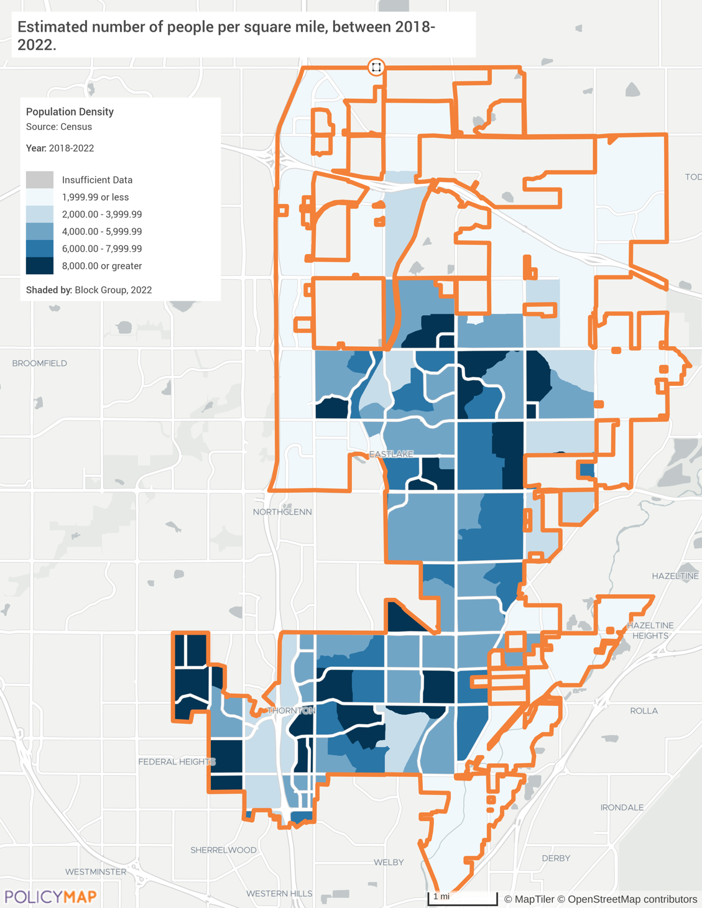

Source: United States Census Bureau ACS 2018-2022 via PolicyMap

Population Shift
While the population of the City of Thornton has grown overall, this growth has not been uniform across all areas. Specifically, the southeastern corner and several other block groups throughout the city have seen increases of over 20% in the last five years. Conversely, some block groups in the central and southern parts of the city have experienced population decreases during this same timeframe. Note the dark shaded southern tip is showing a skewed population change, as most portions along the South Platte River and west of I-76 are reserved for parks, trails, and open space. The northern areas of the city have limited data for analyzing the population shifts over the last five years, as this area was recently annexed by the city. Those block groups have seen a notable increase in overall population compared to the southern areas of the city in recent years.
These shifts can significantly impact housing demand and availability, simply applying the law of supply and demand. Areas with substantial population growth may face increased pressure on housing markets, leading to higher prices and a greater need for affordable housing options. Conversely, areas with declining populations might experience reduced demand for housing, which could impact property values and lead to potential challenges in maintaining community services and infrastructure. Addressing these varied housing needs will be crucial for balanced and sustainable urban development in Thornton.

Map: Population Change
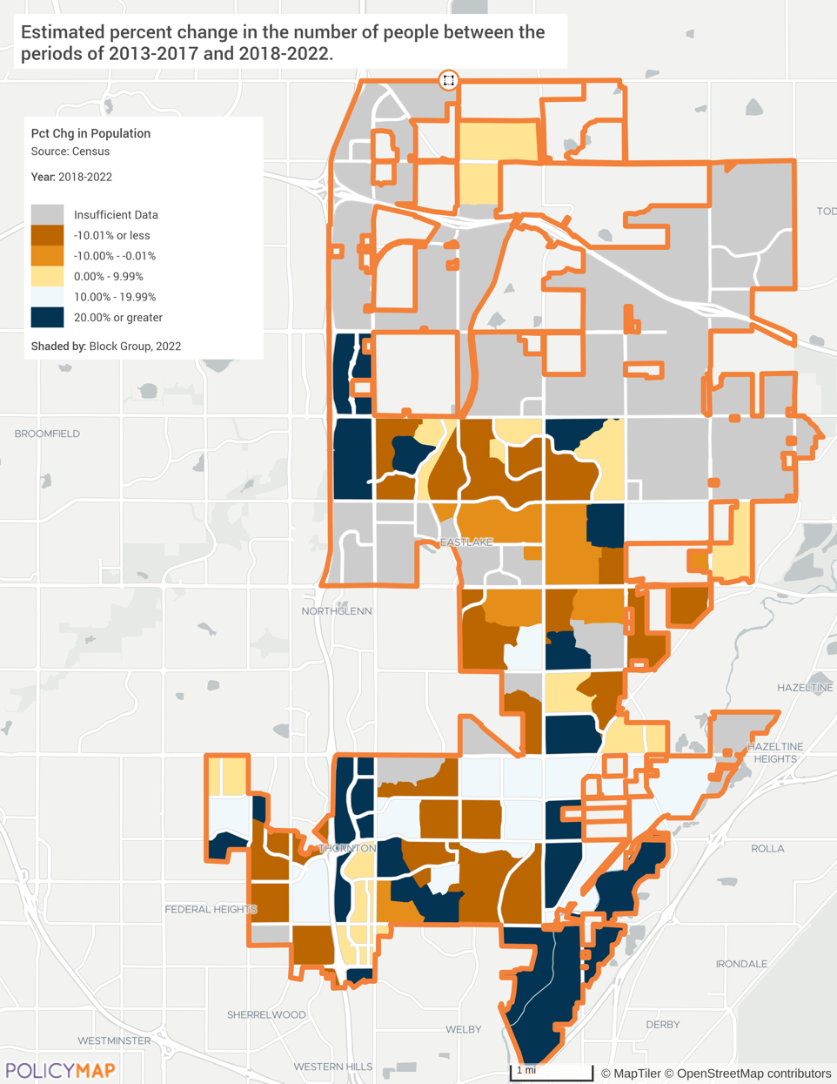

Source: United States Census Bureau ACS 2018-2022 via PolicyMap

Population by Age
Tracking the age distribution of a city's population is a tool for effective urban planning and resource allocation, ensuring that housing, services, and infrastructure meet the diverse needs of all age groups. From 2012 to 2022, the 65 years and older cohort saw a significant increase from 8,101 residents (6.8%) to 14,270 (10.1%), reflecting a growing need for senior housing and services. The 20 to 24 years age group grew from 7,734 (6.5%) to 10,337 (7.3%), indicating a rising demand for housing suited to younger adults. The 40 to 64 years cohort increased from 26,569 to 31,472, maintaining a stable percentage of the population at around 22.2%.
The substantial growth in the elderly population underscores the necessity for more senior housing options and related services. The residential housing survey identified senior living and the second highest housing need in the city. Accessible housing for residents with a disability was cited by 40% of the respondents and a preferred feature. Lack of disability accessibility was identified by 11% of the residents participating in the city’s Community Meeting’s housing voting game. Adding safe, affordable, and accessible homes for seniors in the city is essential. Various city officials and non-profit stakeholders cited that assisted living for seniors was not anticipated or planned for by previous generations.
Additionally, the rise in younger adults suggests an increased need for affordable starter homes and rental units. Addressing these varied housing demands is crucial for accommodating all age groups and ensuring a balanced and inclusive housing market.

Table: Age Distribution 2012-2022
Age Cohort | 2012 Total | 2012 % | 2022 Total | 2022 % | 2012 – 2022 Rate of Change
Under 5 years | 9,524 | 8.0% | 9,670 | 6.8% | 1.5%
5 to 19 years | 28,087 | 23.7% | 31,525 | 22.2% | 12.2%
20 to 24 years | 7,734 | 6.5% | 10,337 | 7.3% | 33.7%
25 to 39 years | 38,732 | 32.6% | 44,525 | 31.4% | 15.0%
40 to 64 years | 26,569 | 22.4% | 31,472 | 22.2% | 18.5%
65 years and older | 8,101 | 6.8% | 14,270 | 10.1% | 76.2%
Total | 118,747 | 100% | 141,799 | 100% | 19.4%
Median Age | 31.9 years | -- | 33.7 years | --

Source: 2008-2012; 2018-2022 ACS 5-Yr Estimates (S0101)

Disability Status
The City of Thornton has a total of 13,428 residents with a disability, comprising 9.5% of the overall population. Disability surveys include those with a hearing difficulty, a vision difficulty, a cognitive difficulty, an ambulatory difficulty, and/or a self-care difficulty. Among the elderly population, 4,523 individuals have a disability, representing a significant 32.4% of the elderly cohort. Approximately 2,655 elderly persons have an ambulatory disability, which likely will require housing modifications. Thirty-nine percent (1,665) of the disabled population with independent living difficulty are 65 or older.
The rates of disability are similar to those of the countywide rates. This data underscores the critical need for accessible and safe housing and supportive services in Thornton, particularly for the elderly, who have a high prevalence of disabilities. Addressing these needs is essential for ensuring that all residents, especially the most vulnerable, have safe and suitable living conditions.

Table: Citywide Population with a Disability
Jurisdiction | With a disability | Percent with a disability | Elderly with a Disability | Percent of Elderly with a Disability
Thornton | 13,428 | 9.5% | 4,523 | 32.4%
Adams County | 57,376 | 11.1% | 19,088 | 34.7%

Source: 2018-2022 ACS 5-Yr Estimates (S1810)

Graph: Citywide Disabled Population with Independent Living Difficulty

Source: 2018-2022 ACS 5-Yr Estimates (S1810)

Demographic Trends: Race, Ethnicity, and Language
Between 2012 and 2022, the racial and ethnic composition of Thornton’s population saw remarkable shifts. The White population decreased from 83.0% to 67.7%, while the Hispanic population grew from 30.1% to 37.3%. The percentage of residents identifying as Two or More Races increased from 3.0% to 15.6%. (This may represent a shift in how the question was interpreted during the 2022 Census survey.) Additionally, the Asian population grew from 4.4% to 5.6%, and the Black or African American population increased from 1.7% to 2.3%.
These demographic changes show a growing diversity in Thornton, which has implications for housing needs and preferences. Increased diversity may drive demand for various types of housing to accommodate different cultural and socioeconomic needs. For example, cultures embracing multigenerational living need larger and fully accessible housing. This diversification highlights the importance of comprehensive housing policies that promote affordable and accessible housing options for all demographic groups. It also points out the need to provide accommodations and specific housing outreach efforts to different language and cultural groups.

Table: Population by Race and Ethnicity
 | 2012 Population | 2012  Percent of Population | 2022 Population |  | 2022 Percent of Population
Total Population | 118,747 | 100% | 141,799 |  | 100%
Race
White | 98,574 | 83.0% | 96,021 | 67.7%
Black or African American | 1,997 | 1.7% | 3,191 | 2.3%
American Indian and Alaska Native | 803 | 0.7% | 1,341 | 0.9%
Asian | 5,255 | 4.4% | 8,007 | 5.7%
Native Hawaiian & Other Pacific Islander | 105 | 0.1% | 12 | 0.01%
Some other race | 8,388 | 7.1% | 11,105 | 7.8%
Two or More Races | 3,625 | 3.0% | 22,122 | 15.6%
Ethnicity
Hispanic | 35,788 | 30.1% | 52,923 |  | 37.3%
Not Hispanic | 82,959 | 69.9% | 88,876 |  | 62.7%

Source: 2008-2012; 2018-2022 ACS 5-Yr Estimates (DP05)

Individuals who speak a language other than English at home and have limited skills in reading, writing, speaking, or understanding English are considered Limited English Proficient (LEP). LEP individuals may qualify for language assistance when accessing Community Development Block Grant (CDBG) programs and activities. The table below highlights the top ten LEP populations in Thornton. While 13% of the population speaks Spanish at home, 6.78% of these individuals do not speak English “very well.”

Table: Top 10 Languages Spoken at Home
# | Language | Estimate | Percent (%)
1 | English (Speaks only English) | 97,686 | 73.93%
2 | Spanish | 8,961 | 6.78%
3 | Other Indo-European languages | 813 | 0.62%
4 | Chinese | 532 | 0.40%
5 | Vietnamese | 517 | 0.39%
6 | Other Asian and Pacific Island languages | 460 | 0.35%
7 | Russian, Polish, or other Slavic languages | 336 | 0.25%
8 | Other and unspecified languages | 233 | 0.18%
9 | Arabic | 100 | 0.08%
10 | Tagalog (incl. Filipino) | 84 | 0.06%

Source: City of Thornton 2024 Language Assistance Plan
Thornton has a diverse array of races and ethnicity. In 2022, 52,923 people or 37.3% of the city’s population identified as Hispanic as their ethnicity. The Predominant Race map below shows, shown by Census block groups, the racial group that constitutes the largest proportion of that area's resident population. Households identifying as white remain the predominant race in the city. They are most prevalent throughout most block groups in the city. The southern portion of the city has a few block groups with “two or more races” or “other” making up the bulk of the block group, according to 2022 ACS estimates. When compared to Median Household Income map on page 33 and the Median Home Value map on page 63, the northern sections of the city have higher levels of household income as well as new homes and higher median home values. Higher rates of poverty are seen in the southern areas, including bock groups with higher concentration of “Two or more races” and “Other”.

Map: Predominant Race
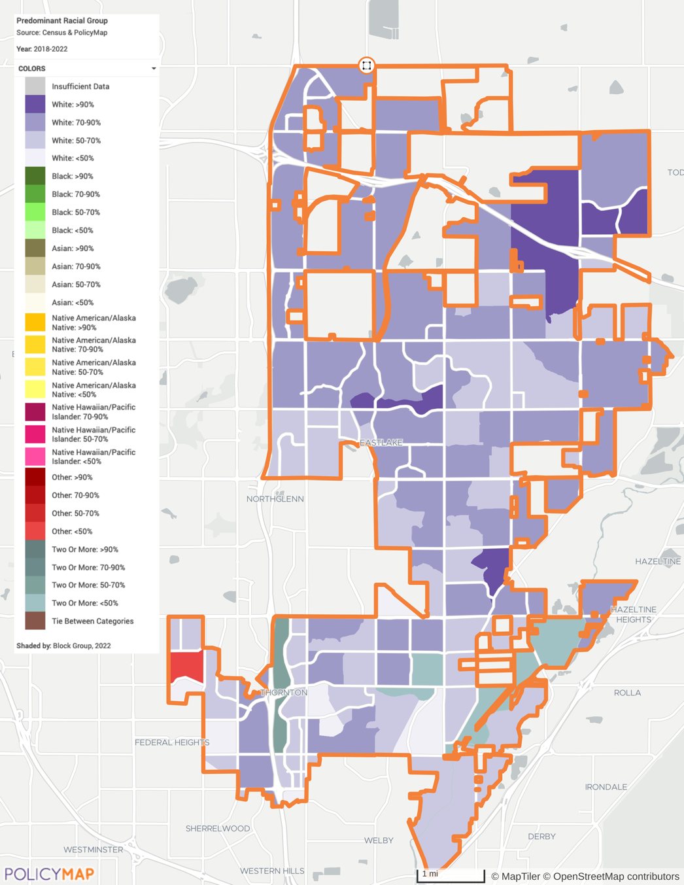

Source: United States Census Bureau ACS 2015-2019 via PolicyMap

Veteran Population
The city’s Veteran population is estimated to be 6,868 or 6.6% of the civilian population 18 years and over. Veterans are predominantly male and 37.8% are above the age of 65. Most are in the labor force, only 1.4% estimated as unemployed. Census reports 224 veterans are living below the poverty line and the 1,460 have a disability (details unknown). Countywide homeless report counted 49 veterans as homeless during the 2023 outreach. Five were in transitional housing, 25 were unsheltered.

Persons Experiencing Homelessness
Homelessness remains a pressing concern for the City of Thornton, reflecting broader regional challenges in housing affordability and access to essential services. While specific data for Thornton is not readily available, the 2023 Adams County Point in Time (PIT) count identified 970 people experiencing homelessness across the county. This represents an estimate 180% increase since 2021. The 2023 PIT count reported 363 individuals (37%) were unsheltered. Thirty-seven percent (363 persons) were unsheltered, and most were considered chronically homeless. Black or African American persons experiencing homelessness made up 14.4% of the homeless count and are disproportionately impacted compared to the racial population rate at the city level. This underscores the need for continued efforts to address this complex issue.
Thornton recognizes that homelessness is not just about lack of housing, but often involves interconnected challenges such as mental health issues, substance abuse, unemployment, and lack of access to healthcare. In response, the city has implemented a multifaceted approach that combines direct outreach, resource provision, regional collaboration, and support for affordable housing initiatives. These efforts aim to not only provide immediate assistance to those experiencing homelessness but also to work towards long-term, sustainable solutions for our community.
While Thornton does not have adult homeless shelters within its boundaries, it actively works to connect residents with resources in surrounding communities and collaborates on regional solutions to address homelessness. The city's multifaceted approach demonstrates its commitment to supporting those experiencing homelessness and working towards long-term solutions. Almost Home, Inc. in Brighton and Brighton Housing Authority provide the closest transitional housing facilities. The city helps to fund these organizations with 2020 CDBG, CDBG-CV, and the city’s Thornton Assistance Grant funds.
Despite limited resources, Thornton demonstrates a commitment to addressing homelessness through several key efforts:
- Homeless Outreach Team (HOT): The city has established a dedicated team that builds relationships with unhoused populations, provides resources, and investigates encampments. This team operates Monday through Friday from 8 a.m. to 5 p.m., with occasional weekend and evening hours.
- HOT runs Thornton’s side of the county’s Severe Weather Activation Program (SWAP) to provide hotel/motel vouchers during cold and hot weather.
- Resource Referrals and Regional Collaboration: Thornton actively participates in the Adams County Coalition for the Homeless and other county-wide homelessness initiatives. City staff serve in leadership roles for collaborative efforts such as the Point in Time count.
- Community Connections organizes donation requests and drives each year, such as the Mayor’s Food and Sock Drive held every November.
- Resource materials: The city has developed homeless resource supplies, housing brochures, and maintains a website section dedicated to basic needs resources.
- Affordable housing initiatives: Thornton supports the development and preservation of affordable housing, including partnering on projects like the Crossing Pointe South housing development.
- Emergency Solutions Grant (ESG): The city was awarded $100,000 in ESG funding which was applied to the Homeless Outreach Team for street outreach and administration.
People experiencing homelessness face a complex array of challenges that extend far beyond the lack of stable housing. Their needs encompass a wide spectrum, including access to safe emergency and transitional shelters, personal documentation, communication, nutritious food, comprehensive healthcare (including mental health and substance abuse treatment), personal hygiene facilities, appropriate clothing, reliable transportation, employment opportunities, education, and legal assistance. Additionally, many require support in obtaining identification documents, case management services, and life skills training.
However, gaps in services often hinder efforts to address these needs effectively. These gaps include insufficient affordable housing options, limited emergency shelter capacity, inadequate mental health and substance abuse treatment programs, and a lack of long-term supportive housing for individuals with chronic conditions. Other critical shortfalls involve limited healthcare access for the uninsured, insufficient specialized services for vulnerable subgroups (such as LGBTQ+ individuals, youth aging out of foster care, seniors, and veterans), and inadequate coordination among service providers. Addressing these multifaceted needs and closing service gaps requires a comprehensive, collaborative approach involving neighboring government agencies, non-profit organizations, and community partners to provide holistic support and work towards sustainable solutions for those experiencing homelessness.
The city’s HOT coordinate with county counterparts to develop recommendations to address homelessness. Recommendations include:
- Prioritizing sub-populations such as veterans, unaccompanied youth, seniors, people with disabilities, and people fleeing domestic violence
- Increase rental assistance to prevent homelessness.
- Provide bridge housing to close the <= 90-day-gap between homelessness and stable housing placement for those that hold a housing voucher but cannot immediately enter housing (often due to finding a unit that will accept the voucher)
- Provide more Rapid Rehousing funds and support to quickly exit people from homelessness into housing through paying application fees, deposits, furniture, and several months’ rent to stabilize the individual or family.
- Increase domestic violence shelter beds
- Provide more Permanent Supportive Housing beds, whereby participants with disabilities receive long term financial support to obtain and remain in housing at no cost to the participant.
- Increase the number of assisted living beds serving seniors and people with disabilities that need assistance with activities of daily living such as eating, dressing, bathing, and toileting.
For the purposes of this report, increased shelter and transitional housing options in Thornton should continue address and increase homeless services by:
- Providing immediate safety and basic needs
- Offering a pathway to stability
- Facilitating access to essential services
- Reducing unsheltered homelessness
- Benefiting the broader community
To plan for these services, Thornton should:
- Explore diverse funding strategies and packages
- Help fund suitable temporary and/or transitional housing developments
- Partner with local organizations and governments
- Implement a Housing First approach
- Engage the community in planning
- Develop a data-driven, long-term strategy
These steps would enable Thornton to enhance its capacity to support homeless individuals and families, addressing both immediate needs and long-term solutions.

Household Trends

Household Growth
The citywide 19.4% population growth between 2012 and 2022 was previously noted. During that same period, Thornton also experienced a substantial increase in the number of households, growing from 40,253 to 48,466, which marks a 20.4% rise. This growth rate is higher than the overall household growth in Adams County, which increased by 20% from 151,034 to 181,211 households during the same period. Statewide, Colorado saw a 16.1% increase in households.
Thornton's higher growth rate compared to the state average suggests the city's consistent housing appeal during this period, potentially necessitating careful consideration of housing needs and urban planning strategies to meet the incoming housing demands.

Table: Household Growth – 2012 to 2022
Jurisdiction | 2012 | 2022 | % Change  2012-2022
Households
City of Thornton | 40,253 | 48,466 | 20.4%
Adams County | 151,034 | 181,211 | 20.0%
Colorado | 1,962,753 | 2,278,044 | 16.1%

Source: 2008-2012; 2018-2022 ACS 5-Yr Estimates (S0101)

Household Size
The household size for all households has been fairly steady with a slight decrease since 2020. The size of renter households started its decline in 2016, peaking at 2.99 persons per household, likely due to the COVID-19 Pandemic. The average family household size is 3.5, while the average non-family household size is 1.43. Single-parent households are also higher than the citywide average, confirming the skew that non-family household size has on the citywide average and the need to meet a variety of housing needs. Smaller household sizes may necessitate the development of more studio, one-bedroom, or smaller two-bedroom units, while larger household sizes may require more multi-bedroom units to accommodate larger families. This factor signifies the need for higher-density housing developments and more affordable per-unit costs.

Chart: Change in Average Household Size by Tenure

Source: United States Census Bureau ACS 2008-2012 through ACS 2018-2022 (B25010)

Household Composition
The majority of households in Thornton are family households, comprising 71% of all households in the city. Married couples make up the largest portion of family households at 54%, with a similar number of families with or without children. The remaining 8,262 family households consist of single parents or unmarried partners. More than a third (37%) of households in Thornton have children under the age of 18. While family households still dominate the household composition citywide, their proportion has decreased slightly from 74% in 2012 to 71% in 2022. The percentage of married couples with children has also seen a decline during this period, dropping from 30% to 27%. No major changes were noted in the other categories of family households, such as single parents or unmarried partners with children.

Table: Family Household Types
Composition | Total | Percent
Citywide Total | 48,466 | 100%
Family households | 34,603 | 71%
Married couple | 26,341 | 54%
Married couple with children | 13,190 | 27%
Married couple without children | 13,151 | 27%
Single head of household | 8,262 | 17%
Female householder | 5,267 | 11%
Female householder with children | 2,987 | 6%
Female householder without children | 2,280 | 5%
Male householder | 2,995 | 6%
Male householder with children | 1,775 | 4%
Male householder without children | 1,220 | 3%
Non-family households | 13,863 | 29%

Source: United States Census Bureau ACS 2018-2022 (S1101)

Data note; Householder is defined he person, or one of the people, in whose name the housing unit is owned, being bought, or rented. If no such person is present, any adult household member 15 years and over can be designated

Most family households are 2-person (32.3% of family households) and 3-person (26.7%) households. Nonfamily households predominantly consist of 1-person households (71.8%). This data can help identify and prioritize the development of housing that accommodates small to medium-sized family units and single-person households.

Table: Household Type by Household Size
Cohort | Estimate | Percent of Cohort
Citywide Total | 48,466 | 100%
Family households | 34,603 | 71.4%
2-person household | 11,169 | 32.3%
3-person household | 9,252 | 26.7%
4-person household | 7,461 | 21.6%
5-person household | 3,707 | 10.7%
6-person household | 2,083 | 6.0%
7-or-more person household | 931 | 2.7%
Nonfamily households | 13,863 | 28.6%
1-person household | 9,957 | 71.8%
2-person household | 3,029 | 21.8%
3-person household | 446 | 3.2%
4-person household | 293 | 2.1%
5-person household | 116 | 0.8%
6-person household | 22 | 0.2%
7-or-more person household | 0 | 0.0%

Source: United States Census Bureau ACS 2018-2022 (B11016)

Household Makeup (Homeowner vs. Renter)
Thornton has a significantly higher proportion of its housing units for homeowner households compared to renter households. According to the ACS estimates, 72.7% of the housing units in Thornton are owner-occupied, while only 27.3% are renter occupied. These rates are similar to the countywide rate; however, Thornton has a slightly higher proportion of owner-occupied households.
This data indicates homeownership is the predominant housing occupancy in Thornton, with nearly three-quarters of households owning their homes. The high rate of homeownership suggests Thornton is a community with a relatively stable and established population, as homeownership is often associated with long-term residency and investment in the community.

Table: Tenure by Household Type (2022)
Occupancy | Estimate | Percent
City of Thornton
Owner occupied households | 35,254 | 72.7%
Renter occupied households | 13,212 | 27.3%
Adams County
Owner occupied households | 123,826 | 68.3%
Renter occupied households | 57,385 | 31.7%

Source: United States Census Bureau ACS 2018-2022 (B25003)

While a smaller proportion of households are renters (27.3%) compared to homeowners, this segment of the population represents an essential portion of the housing market and important housing needs in the city. The lower percentage of renter-occupied households could be attributed to various factors, such as the availability and affordability of rental housing options, the demographics of the population (e.g., age, income levels), family status, and the overall housing market conditions in Thornton and the surrounding area. Renters comprise a larger proportion of nonfamily households and single-parent, female households than that of married couple or single-parent, male households.

Graph: Tenure by Household Type

Source: United States Census Bureau ACS 2018-2022 (B25003)

Economic Profile
The local economy analysis for the Housing Needs Assessment examines the economic and employment data available for Thornton to understand its influence on housing needs and challenges. Economic conditions, employment trends, and income levels directly impact the demand for housing, affordability, and the types of housing required. By analyzing these factors, we can identify areas of economic growth or decline, assess the housing market's capacity to meet current and future needs, and develop strategies to address housing affordability and accessibility, particularly for low-to-moderate-income residents.

Labor Force and Employment
The labor force estimates include both employed individuals and those actively seeking work, while employment refers only to those who currently have jobs. Between 2012 and 2023, the labor force in the City of Thornton grew from 67,143 to 84,759, reflecting a robust expansion of economic activity. Employment also increased vitally, from 61,196 in 2012 to 82,140 in 2023.
The unemployment rate saw a dramatic decline from 8.9% in 2012 to a low of 2.6% in 2017, before rising to 6.7% in 2020 due to COVID19 related economic disruptions, and then stabilizing around 3.0% in 2022 and 2023. This growth in labor force and employment, coupled with fluctuating unemployment rates, emphasizes the evolving economic landscape of Thornton and its impact on housing demand and affordability. As the labor force expands and employment rises, it typically leads to increased housing demand, potentially driving up home prices and rental rates, which can affect housing affordability for both new and existing residents.

Table: Labor Force and Employment Data
Year | Labor Force | Employment | Unemployment | Unemployment Rate
2012 | 67,143 | 61,196 | 5,947 | 8.9
2013 | 68,386 | 63,288 | 5,098 | 7.5
2014 | 69,388 | 65,673 | 3,715 | 5.4
2015 | 70,336 | 67,626 | 2,710 | 3.9
2016 | 72,792 | 70,489 | 2,303 | 3.2
2017 | 73,655 | 71,726 | 1,929 | 2.6
2018 | 76,115 | 73,808 | 2,307 | 3.0
2019 | 77,742 | 75,643 | 2,099 | 2.7
2020 | 79,988 | 74,600 | 5,388 | 6.7
2021 | 82,316 | 77,846 | 4,470 | 5.4
2022 | 83,750 | 81,207 | 2,543 | 3.0
2023 | 84,759 | 82,140 | 2,619 | 3.1

Source: Bureau of Labor Statistics (BLS – May 2024)

Graph: Labor Force and Employment Data

Source: Bureau of Labor Statistics (BLS – 2012 - 2023)

The largest contributors to the workforce are individuals aged 35 to 44 and 45 to 54, with participation rates of 89.9% and 82.2% respectively. Other age groups also show significant representation in the labor force.
Notably, younger age groups (20-34) demonstrate high participation rates, ranging from 82.2% to 91.2%. The 55-64 age range maintains strong involvement, with participation rates between 63.8% and 76.5%. It’s particularly interesting that 24.5% of individuals aged 65-74 are still active in the labor force, indicating a substantial portion of this age group continues to work beyond the traditional retirement age.
The overall labor force participation rate for the population 16 years and over stands at 72.6%, with an employment-to-population ratio of 69.9% and a relatively low unemployment rate of 3.2%.

Table: Employment by Age (Estimates for 2023)
Age Group | Citywide Total | Labor Force Participation Rate | Employment / Population Ratio | Unemployment Rate
Population 16 years and over | 115,186 | 72.6% | 69.9% | 3.2%
16 to 19 years | 6,024 | 50.5% | 43.5% | 13.8%
20 to 24 years | 10,431 | 89.8% | 86.5% | 2.2%
25 to 29 years | 13,498 | 91.2% | 82.3% | 8.8%
30 to 34 years | 9,965 | 82.2% | 81.5% | 0.0%
35 to 44 years | 21,037 | 89.9% | 88.0% | 1.7%
45 to 54 years | 20,047 | 82.2% | 80.8% | 1.7%
55 to 59 years | 7,746 | 76.5% | 73.9% | 3.4%
60 to 64 years | 9,318 | 63.8% | 63.8% | 0.0%
65 to 74 years | 11,594 | 24.5% | 23.4% | 4.8%
75 years and over | 5,526 | 10.7% | 10.7% | 0.0%

Source: United States Census Bureau ACS 1-Year Estimates 2023 (S2301)

Jobs by Industry
The employment landscape in Thornton also saw significant changes between 2012 and 2022. The Educational Services, Health Care, and Social Assistance sector remained the largest employer, growing from 17.5% to 18.1% of the workforce. Retail Trade maintained a strong presence, slightly decreasing in share from 12.5% to 12.4%, but still reflecting substantial growth in total jobs. Major shifts include the Construction sector, which increased from 8.3% to 10.4%.
In terms of total job growth within the sector, Construction saw over a 59% increase, indicating robust development activity. The Professional, Scientific, and Management Services sector slightly decreased from 11.8% to 11.2%. The Manufacturing sector saw a notable decline from 9.2% to 8.4%, and the Information sector decreased significantly from 4.0% to 2.7%. Information and Wholesale trade both saw total job decreases between 2012 and 2022. These changes highlight a trend towards service-oriented industries and construction, reflecting broader economic shifts and development patterns in the city.

Chart: Jobs by Industry

Source: Bureau of Labor Statistics (BLS 2012 - 2022)

Occupations by Sector
Thornton experienced significant job market growth and transformation between 2012 and 2022. The overall civilian employed population increased by 26.6%, adding 16,110 jobs to reach a total of 76,700 employed residents. This growth was not uniform across all sectors, indicating shifts in the local economy.
The Management, Business, Science, & Arts sector led the expansion with a 38.6% increase, adding 7,923 jobs and growing its share of total employment from 33.9% to 37.1%. This trend suggests a move towards more knowledge-based and skilled labor. Other sectors also showed healthy growth, with Natural Resources, Construction, & Maintenance increasing by 37.8%; Production, Transportation, and Material Moving by 34.7%; and Service Occupations by 29.7%.
Notably, the Sales and Office sector lagged, growing by only 2.7% and seeing its share of total employment drop from 28.0% to 22.8%, possibly due to automation and changing consumer behaviors. Overall, Thornton's job market demonstrated substantial growth and diversification. The data shows a clear shift towards higher-skilled occupations while maintaining growth across all sectors, indicating a balanced economic expansion.

Table: Occupations by Sector
Occupational Sector | 2012 |  | 2022 |  | 10-year Change
Occupational Sector | Total | Percent | Total | Percent | 10-year Change
Civilian employed population 16 years & over | 60,590 | -- | 76,700 | -- | 26.6% Increase
Management, Business, Science, & Arts | 20,552 | 33.9% | 28,475 | 37.1% | 38.6% Increase
Natural Resources, Construction, & Maintenance | 6,150 | 10.2% | 8,477 | 11.1% | 37.8% Increase
Production, Transportation, and Material Moving | 7,650 | 12.6% | 10,307 | 13.4% | 34.7% Increase
Service Occupations | 9,251 | 15.3% | 11,994 | 15.6% | 29.7% Increase
Sales and Office | 16,987 | 28.0% | 17,447 | 22.8% | 2.7% Increase

Data Source: 2018-2022 5-Yr ACS (DP03)

Commute Times
The commute times for Thornton residents reveal important insights about the city's housing and employment dynamics. The majority of workers (38,760 or 58.4%) have commute times ranging from 15 to 39 minutes, suggesting that many residents work outside the immediate vicinity of their homes but within a reasonable distance. Notably, 1,836 residents (2.8%) face commutes of 90 minutes or more, indicating that a small but significant portion of the population is willing to travel long distances for work, potentially due to housing affordability or job market factors.
There is often an understood trade-off between housing costs and location: Properties located further from city centers or urban areas tend to have lower prices. This implies residents may be choosing more affordable housing options in Thornton farther from Denver-centric employment centers, resulting in longer commutes.
These commute patterns highlight the complex interplay between housing location, job opportunities, and transportation infrastructure in Thornton, underscoring the importance of balanced urban planning to address both housing, infrastructure, and employment needs.

Chart: Travel Time to Work

Data Source: 2018-2022 5-Yr ACS (B08303)

Household Income
Citywide median household income in Thornton increased from $66,176 in 2012 to $95,064 in 2022, according to ACS estimates. This change initially represents an increase of 43.7 growth%. However, when adjusted for inflation, the real increase is 11.1%. The data indicates all groups experienced significant nominal increases in median household income over the decade, but the real increases (adjusted for inflation) were more modest. Renters saw a higher real increase of 18.8% compared to owner occupied households (8.0%). This suggests that renters' incomes have grown more robustly in real terms compared to homeowners, although they started from a lower base.
This analysis highlights the importance of considering inflation when evaluating income growth, as nominal increases can be misleading without accounting for changes in purchasing power. Household income data is also a crucial factor in analyzing housing needs, since it directly influences affordability of housing units.

Table: Median Household Income by Occupancy
Household | 2012 | 2022 | Nominal Change | Change in Real Dollars
Median Household Income | $66,176 | $95,064 | 43.7% | 11.1%
Owner Occupied Households | $79,719 | $111,244 | 39.5% | 8.0%
Renter Occupied Households | $41,699 | $64,034 | 53.6% | 18.8%

Source: United States Census Bureau ACS 2008-2012, 2018-2022 (B25119)

The median household income in Thornton varies across different age groups. Households led by individuals aged 45 to 64 years have the highest median income at $114,715, which is notably above the citywide median of $95,064. The 25 to 44 age group follows closely with a median income of $99,927, also exceeding the citywide figure. In contrast, younger households (15 to 24 years) and those 65 years and over have considerably lower median incomes at $70,028 and $65,723 respectively, both falling well below the citywide median. This income distribution reflects typical earning patterns across life stages, with peak earnings occurring in middle age. Once city residents reach 65 years and older they see a dramatic decline in their income. This more than 50% reduction primarily due to retirement, reduced work hours, and switching types of employment.

Table: Median Household Income by Age Range
Household Income By Age | Number | Percent Distribution | Median income (dollars)
15 to 24 years | 2,001 | 4.1% | $70,028
25 to 44 years | 20,527 | 42.4% | $99,927
45 to 64 years | 17,601 | 36.3% | $114,715
65 years and over | 8,337 | 17.2% | $65,723

Source: United States Census Bureau ACS 2018-2022 (S1903)

The map below shows estimated household income by block group. The visual data shows the highest distribution of wealth is in the city’s northern and northeastern sections of the city. These sections are also predominantly white households and represent an overall shift of higher income households to newer homes in the northern parts of the city as discussed on page 19. South of 104th Avenue median household incomes are only below $100,000.

Map: Median Household Income
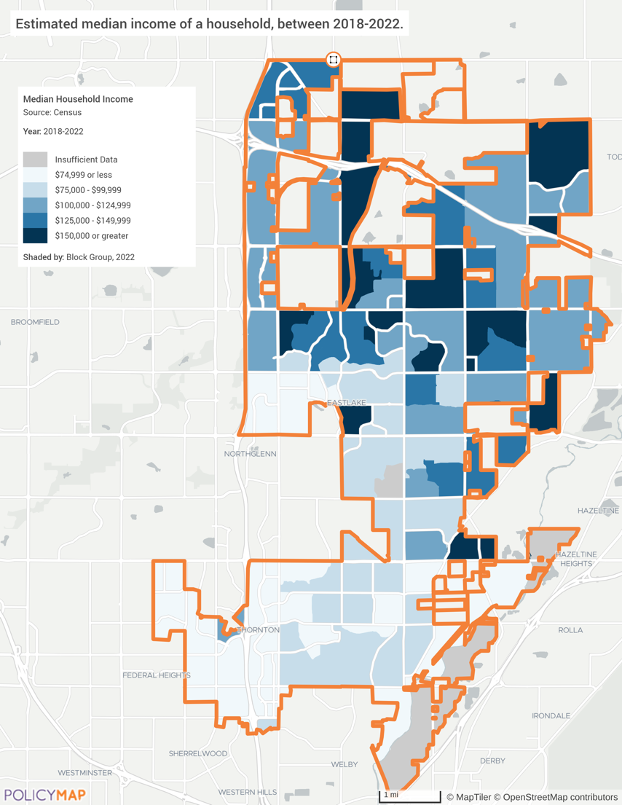

Source: United States Census Bureau ACS 2018-2022 via PolicyMap

Household Income Distribution
The household income distribution reveals important patterns across different household types. Family households, which make up 71% of Thornton's total households, generally have higher incomes compared to non-family households. Married-couple families in particular show the highest concentration of high incomes, with over 62% earning over $100,000 annually. In contrast, non-family households, which account for 29% of total households, demonstrate greater economic vulnerability, given the lower income distribution within this group.
Approximately 21.1% of all households in Thornton earn less than $50,000 annually. This percentage is much higher for non-family households, with 37.2% falling into this lower income category. This disparity highlights a potential need for targeted affordable housing initiatives for non-family households.
At the other end of the spectrum, Thornton has a substantial proportion of high-income households with 47.1% of all households earning more than $100,000 annually. This percentage rises to 54.5% for families and 62.5% for married-couple families. Over 17% of married-couple families in Thornton have incomes exceeding $200,000, which is lower than the state average of 19.6%.
When compared to the county and statewide estimates, the City of Thornton’s share of households earning more than $100,000 (47.1%) is greater than Adams County (41.8%) and the state (43.9%). Its share of family households earning over $100,000 (54.5%) is similar to the county (49.0%) and state (54.4%). The share of non-family households earning less than $50,000 for the city (37.2%) is lower than both Adams County 44.4% and the state of Colorado (45.4%).
These income distribution patterns have important implications for Thornton's housing needs. The elevated proportion of high-income households suggests a demand for higher-end housing options. However, the city must also address the needs of its lower-income residents, particularly non-family households, who may require more affordable housing alternatives. The diverse income landscape indicates a need for a varied housing stock that can accommodate the full spectrum of Thornton's population housing needs.

Table: City of Thornton Income Distribution for Families (2022)
Distribution | Households | Families | Married-couple Families | Non-Family Households
Less than $10,000 | 2.3% | 2.2% | 1.1% | 4.1%
$10,000 to $14,999 | 1.4% | 0.8% | 0.3% | 2.6%
$15,000 to $24,999 | 4.1% | 2.1% | 1.5% | 10.2%
$25,000 to $34,999 | 4.9% | 3.8% | 2.5% | 9.1%
$35,000 to $49,999 | 8.4% | 7.6% | 5.5% | 11.2%
$50,000 to $74,999 | 16.1% | 14.6% | 13.0% | 22.4%
$75,000 to $99,999 | 15.7% | 14.4% | 13.6% | 16.8%
$100,000 to $149,999 | 23.3% | 25.5% | 26.4% | 16.0%
$150,000 to $199,999 | 12.2% | 15.1% | 18.9% | 3.7%
$200,000 or more | 11.6% | 13.9% | 17.2% | 3.8%
Total Households | 48,466 | 34,603 | 26,341 | 13,863

Source: United States Census Bureau ACS 2018-2022 (S1901)

Table: Adams County Income Distribution for Families (2022)
Distribution | Households | Families | Married-couple Families | Non-Family Households
 | Estimates
Less than $10,000 | 3.4% | 2.6% | 1.3% | 6.4%
$10,000 to $14,999 | 2.3% | 1.2% | 0.5% | 5.0%
$15,000 to $24,999 | 4.7% | 3.2% | 2.0% | 9.2%
$25,000 to $34,999 | 5.9% | 4.6% | 2.7% | 9.9%
$35,000 to $49,999 | 9.7% | 8.5% | 6.0% | 13.9%
$50,000 to $74,999 | 16.9% | 15.5% | 14.3% | 20.7%
$75,000 to $99,999 | 15.3% | 15.5% | 15.6% | 14.2%
$100,000 to $149,999 | 21.1% | 23.7% | 26.1% | 12.9%
$150,000 to $199,999 | 10.8% | 13.2% | 16.4% | 4.4%
$200,000 or more | 9.9% | 12.1% | 15.0% | 3.4%
Total Households | 181,211 | 125,653 | 91,308 | 55,558

Source: United States Census Bureau ACS 2018-2022 (S1901)

Table: Colorado Income Distribution for Families (2022)
Distribution | Households | Families | Married-couple Families | Non-Family Households
 | Estimates
Less than $10,000 | 3.9% | 2.2% | 1.0% | 7.4%
$10,000 to $14,999 | 2.7% | 1.2% | 0.7% | 5.4%
$15,000 to $24,999 | 5.4% | 3.0% | 1.8% | 9.9%
$25,000 to $34,999 | 5.9% | 4.2% | 2.8% | 9.5%
$35,000 to $49,999 | 9.4% | 7.5% | 5.7% | 13.2%
$50,000 to $74,999 | 15.6% | 13.9% | 12.2% | 18.8%
$75,000 to $99,999 | 13.2% | 13.6% | 13.4% | 12.3%
$100,000 to $149,999 | 19.2% | 22.3% | 24.3% | 13.0%
$150,000 to $199,999 | 10.8% | 13.7% | 15.9% | 5.3%
$200,000 or more | 13.9% | 18.4% | 22.2% | 5.2%
Total Households | 2,278,044 | 1,427,813 | 1,117,627 | 850,231

Source: United States Census Bureau ACS 2018-2022 (S1901)

Data note: A household is all people occupying a single housing unit. A family household consists of a householder and at least one other person related by birth, marriage, or adoption. Married-couple families are family households where the householder is married and living with their spouse. Non-family households comprise a householder living alone or only with unrelated individuals.

Household Income by Race and Ethnicity
The below chart illustrates the median household income in the city, segmented by race and ethnicity. It reveals significant disparities among different groups. Black or African American households have the lowest median income, just over $60,000. Households identified as "Some other race" and those of Hispanic or Latino origin (of any race) have median incomes slightly higher, but still below the city median of $95,064. Asian households fall just below the city median household income, indicating a relatively higher economic standing. White households and those identified as "Two or more races" also exceed the city median.
This data highlights the economic inequalities present within the city, with Black or African American households earning significantly less than their White and Asian counterparts. The chart underscores the need for targeted economic policies to address these disparities and promote income equality across all racial and ethnic groups. It is noted that the Black household population (2.3%) and Asian population (5.7%) make up a relatively small portion of the overall population.

Chart: Median Income by Race/Ethnicity

Source: United States Census Bureau ACS 2018-2002 (S1903)

Data Note: Other Pacific Islander not available due to low citywide representation.

Poverty
Between 2012 and 2022, Thornton saw changes in poverty levels across various racial and ethnic groups. These changes reflect a mixed trend, with some groups experiencing significant improvements while others saw increased poverty levels. The overall citywide poverty rate decreased from 9.2% to 8.0%. The largest group (White alone) saw its poverty rate decrease by 1.3%. Black and African American alone saw their poverty rate decrease from 10.9% to 7.6%. The largest change was with the Native Hawaiian & Other Pacific Islander alone, they saw their poverty level decrease by 35%.
However, the poverty rate for American Indian and Alaska Native alone residents increased significantly from 3.5% to 13.6% and Asian alone households also saw their overall poverty rate increase from 9.9% to 13.4%.

Table: Poverty by Race/Ethnicity
Poverty and Race/Ethnicity | Population Below Poverty Level | Percent Below Poverty Level | Population Below Poverty Level | Percent Below Poverty Level | Poverty Level Change
Poverty and Race/Ethnicity | 2012 |  | 2022
Citywide Total | 10,796 | 9.2% | 11,208 | 8.0% | -1.2%
White alone | 8,622 | 8.8% | 7,086 | 7.5% | -1.3%
Black or African American alone | 216 | 10.9% | 235 | 7.6% | -3.3%
American Indian and Alaska Native alone | 28 | 3.5% | 183 | 13.6% | +10.1%
Asian alone | 518 | 9.9% | 1,074 | 13.4% | +3.5%
Native Hawaiian & Other Pacific Islander alone | 94 | 89.5% | 6 | 54.5% | -35.0%
Some other race alone | 1,163 | 14.0% | 769 | 6.9% | -7.1%
Two or more races | 155 | 4.3% | 1,855 | 8.4% | +4.1
Hispanic or Latino origin (of any race) | 5,723 | 16.2% | 4,127 | 7.8% | -8.4

Data Source: 2018 -2022 5-Yr ACS (Most Recent Year)

Households with Incomes Less than $25,000
The map illustrates the percentage of the population in Thornton with household gross incomes below $25,000 a year, which is almost 75% less than the median income of $95,064. The darkest blue areas, indicating the highest percentages (15% or greater) by Census block group, are predominantly located in the southern and southwestern regions of Thornton. These areas have more concentrated pockets of economic hardship compared to other areas of the city. This strongly suggests residents in these neighborhoods face greater financial challenges, especially in their housing cost burdens, which is normally the largest household expense.
The housing age in those areas is much older and likely to require ongoing maintenance and/or significant rehabilitation. Code Compliance staff confirmed the need for maintenance and sometimes extensive rehabilitation for many of these older homes. The city’s new Code Compliance Assistance Program (CodeCAP) program is working primarily in the older homes area to replace fences, remove hazardous trees, and remove junk and debris. The city’s Help for Home rehabilitation program also confirms the need for household repairs and rehabilitation in the southern and southwestern parts of the city.

Map: MHI Less than $25,000
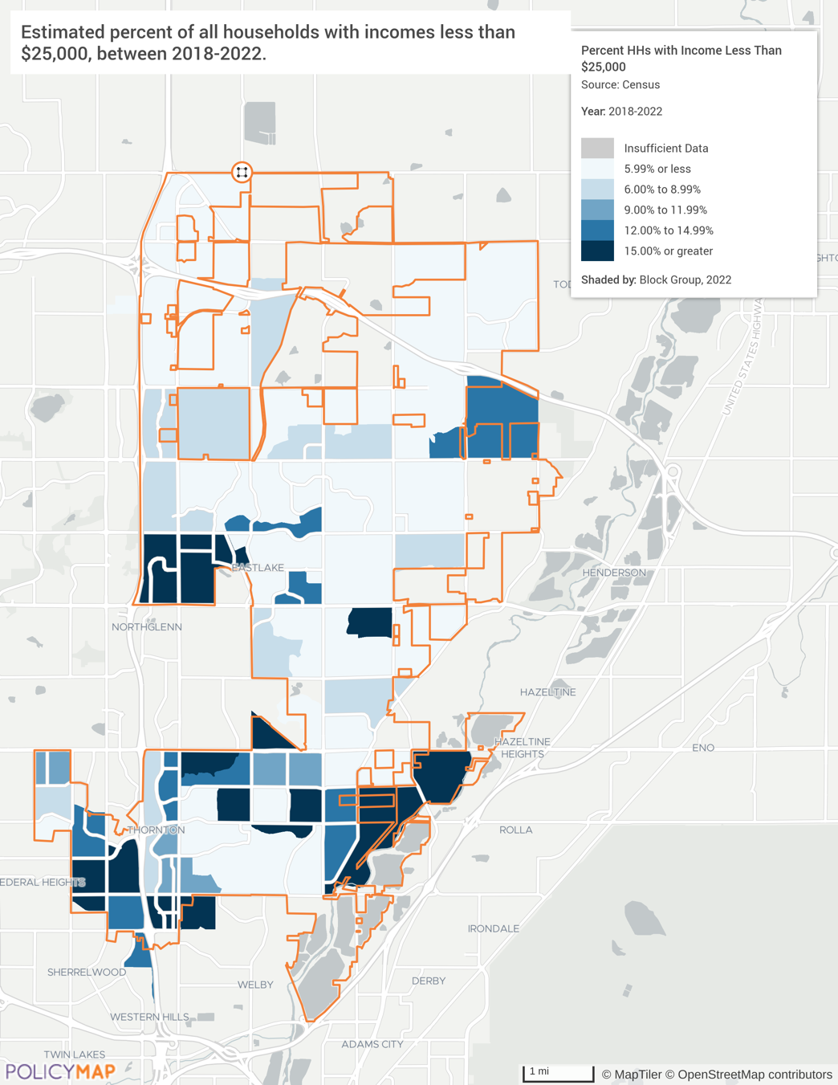

Source: United States Census Bureau ACS 2018-2022 via PolicyMap

Section 3: Housing Profile

Housing Stock

Property Type
The City of Thornton's housing stock has seen notable changes from 2012 to 2022, reflecting shifts in housing choice, availability, and affordability. The number of 1-unit detached structures increased from 27,074 to 31,036, maintaining a dominant share but slightly decreasing in percentage of total property types from 63.0% to 62.4%. This indicates a continued preference for single-family homes, though their relative share of the total housing stock has slightly diminished. The largest increase in 1-unit homes is with attached structures, rising from 3,656 units (8.5%) to 5,234 units (10.5%). This indicates a growing demand for townhomes, which often serve as a more affordable alternative to detached homes.
The number of 2-unit structures increased modestly from 92 to 138 units, while 3-4 unit buildings grew from 1,229 to 1,358 units, though their percentage of the total housing stock slightly decreased. The most notable growth within this category was in 5-9 unit buildings, which increased from 1,585 units (3.7%) to 2,660 units (5.3%), indicating a significant rise in medium-density housing options. Conversely, the number of 20 or more-unit buildings decreased from 3,266 units (7.6%) to 2,944 units (5.9%), reflecting a reduction in high-density housing, which could impact the availability of affordable rental options.
Mobile homes saw a slight increase in number from 2,545 to 2,811 units, but their percentage of the total housing stock decreased marginally. These changes in housing type suggest a diversification in Thornton's housing market, with a notable increase in medium-density housing types that could help address affordability issues. However, the decrease in high-density units may pose challenges for providing sufficient affordable rental housing. The city's efforts to promote affordable housing development by leveraging CDBG and HOME funds, Private Activity Bonds, Proposition 123 funding, and other grant or loan funding are crucial in addressing these gaps and ensuring a balanced housing market.

Table: Property Type in 2012 and 2022
Type | 2012 |  | 2022
Type | Number | Percentage | Number | Percentage
1-unit, detached structure | 27,074 | 63.0% | 31,036 | 62.4%
1-unit, attached structure | 3,656 | 8.5% | 5,234 | 10.5%
2 units | 92 | 0.2% | 138 | 0.3%
3 or 4 units | 1,229 | 2.9% | 1,358 | 2.7%
5-9 units | 1,585 | 3.7% | 2,660 | 5.3%
10-19 units | 3,507 | 8.2% | 3,598 | 7.2%
20 or more units | 3,266 | 7.6% | 2,944 | 5.9%
Mobile Home | 2,545 | 5.9% | 2,811 | 5.7%
Total | 42,954 | 100% | 49,779 | 100%

Source: 2008-2012, 2018-2022 ACS 5-Yr Estimates (DP04)

Middle Housing Obstacles
Middle housing is defined as housing types that fall between single-family detached homes and large multifamily apartment complexes. The statewide and Denver-metro area decline of middle housing availability, particularly the reduction in condominium construction, has significant implications for the City of Thornton's housing market.
Condominiums, often considered entry-level properties for homeownership, have seen a drastic reduction in new construction statewide since 2008. As of June 2023, the median sales price of a single-family home in Colorado was $625,000 and that of a townhouse/condo was $425,000—a difference of 32%. Townhouses and condominium price points and sizes are suited to younger adults and young families. Additionally, condos are an excellent way for empty nesters to downsize when they are over-housed. When older homeowners sell their home to downsize, they can free up equity, are not burdened with yard or building maintenance, and place their larger homes on the market for growing families to purchase. Unfortunately, condo housing construction came to almost a complete stop in 2008.
The decline is largely attributed to stringent construction defect laws, such as the 2001 Colorado Construction Defect Action Reform Act (CDARA) and subsequent legislation, which have increased the risk of litigation for developers, making condo construction less appealing. Prior to 2007, about one in five homes built in Colorado were condos (20%). When compared to apartment construction, between 2002 and 2008, one condo was built for every 1.25 apartments built. In 2023, condos are close to one in twenty homes built (3% - 5%) and one to fourteen apartments built. From 2007 to 2022, the number of condo developers in Colorado dropped from 146 to 23. This drastic reduction is shown in the chart below.
In Thornton, the impact of this statewide trend is evident in the rising home prices and limited availability of affordable housing options, including middle housing unit types and sizes. The median sales price of single-family homes in Thornton has increased to $538,616, reflecting a broader trend of housing becoming less affordable for many residents. This is particularly challenging for first-time homebuyers and those looking to downsize, such as empty nesters.
The results of the resident housing survey shows that smaller homes, townhouses, and condos are an identified need for the type of housing needed in Thornton. Limited housing diversity was also a resident identified problem in need of a solution.
The decline in condo construction has led to a housing construction market favoring rental units over entry-level homeownership. This shift is evident in the comparison of condo and apartment construction rates, with a drastic increase in apartment builds relative to condos as previously mentioned. The high demand for condos in the housing market, despite the downturn in construction, underscores the need for increased affordable homeownership options.

Graph: Condominiums Share of Housing Development in Metro-Denver Area
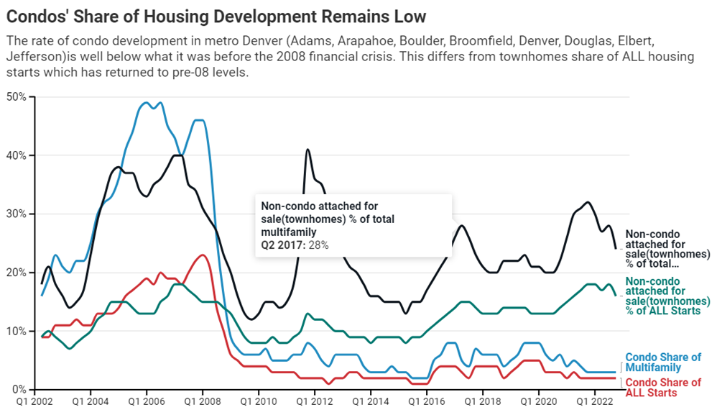

Source: Denver Post

Another primary obstacle to the development of missing middle housing in Thornton and the broader Denver area has been restrictive zoning laws. Many areas are zoned exclusively for single-family homes, which limits the ability to build higher-density housing. Statewide and citywide efforts are ongoing to remedy this drawback. Efforts to ease these restrictions statewide have sometimes faced resistance from local governments and residents concerned about changes to neighborhood character and property values.
Public attitudes and local policies often present significant housing development challenges. Homeowners frequently oppose changes that would allow for higher-density housing due to concerns about increased traffic, potential crime, and perceived decreases in property values.

Unit Sizes
While Thornton has diversified its overall housing stock to allow different household types, a reevaluation is needed to the balance of unit sizes, particularly the supply of 3-bedroom and 4-bedroom units for families, and the potential oversupply of larger units with 5 or more bedrooms.
The increase in smaller units (no bedroom and 1 bedroom) from 4,106 units (9.5%) in 2012 to 4,755 units (9.5%) in 2022 aligns with the decrease in family households, higher housing costs and steep rise in property taxes during this period. These smaller units likely cater to the growing number of single-person or smaller households in the city.
However, the significant increase in larger units with 5 or more bedrooms, from 2,033 (4.7%) to 4,311 (8.7%), seems to be a mismatch with the household composition trends. While the majority (71%) of households in Thornton are still family households, the percentage of married couples with children decreased from 30% to 27%. This suggests the demand for larger units may not be as high as the increase in supply. However, the higher demand may stem from the increase in post-COVID work at home needs.
The data also shows a stable but slight decrease in the percentage of 3-bedroom and 4-bedroom units, which have traditionally been popular choices for families with children. In 2012, these units accounted for 63.7% of the housing stock, while in 2022, they made up 62.6%. If this trend is continued it could create a shortage of these unit sizes if the demand from families remains strong.

Table: Unit Sizes
 | 2012 |  | 2022
 | Number | Percentage | Number | Number
No bedroom | 278 | 0.6% | 608 | 1.2%
1 bedroom | 3,828 | 8.9% | 4,147 | 8.3%
2 bedrooms | 9,450 | 22.0% | 9,546 | 19.2%
3 bedrooms | 18,485 | 43.0% | 21,331 | 42.8%
4 bedrooms | 8,880 | 20.7% | 9,836 | 19.8%
5 or more bedrooms | 2,033 | 4.7% | 4,311 | 8.7%
Total | 42,954 | 100% | 49,779 | 100%
Source: 2008-2012, 2018-2022 ACS 5-Yr Estimates (DP04)

Age of Housing
Thornton's housing stock is relatively new compared to statewide and county averages, reflecting recent growth and development. Approximately 41% of the statewide homes were built in 2000 or later, while in Adams County, about 32% fall into this category. In contrast, 41% of Thornton’s housing was built in 2000 or later, indicating a more recent development boom. Further illustrating the young age of Thornton’s housing stock, homes built prior to 1950 make up less than 1% (0.6%) of Thornton’s housing stock compared to 9.6% statewide and 8.7% countywide.
The significant proportion of new housing in Thornton reflects ongoing development and expansion. Newer homes typically offer modern amenities and energy efficiency, which can attract new residents and support population growth. However, newer homes often come with higher purchase prices, which may impact affordability for some residents.
Although a smaller percentage, the older housing stock (18% built between 1960 and 1979, and 5% built between 1940 and 1959) plays a crucial role in providing long-term affordability. Older homes often have lower purchase prices, making them more accessible to lower-income households. However, these homes require ongoing rehabilitation and maintenance to ensure they remain safe, accessible, and habitable. Assisting with the maintenance and rehabilitation of older properties is central to help families age in place, maintaining the home’s value, and for preserving affordable housing options in the city. As the city’s Historic Preservation Plan notes, the loss of an older home is the loss of an affordable home. The city's proactive measures, such as their Help for Homes program, address these needs and protect a balanced housing market.

Chart: Age of Housing

Source: 2008-2012, 2018-2022 ACS 5-Yr Estimates (DP04)

Older housing stock is more prevalent in the southern block groups of the city, while newer housing is more concentrated in the northeast corner. The block groups with higher concentration of older homes overlap with areas that have a higher rate of LMI households. These block groups provide a basis for areas of focus in the city in need of rehabilitation and housing assistance programs. Assistance could include the Community Development Block Grant (CDBG) program, the HOME Investment Partnerships Program (HOME) program, Proposition 123 programs, Private Activity Bonds, partnerships with non-profit housing organizations, land trusts and banks for housing development and rehabilitation.

Map: Median Year Built
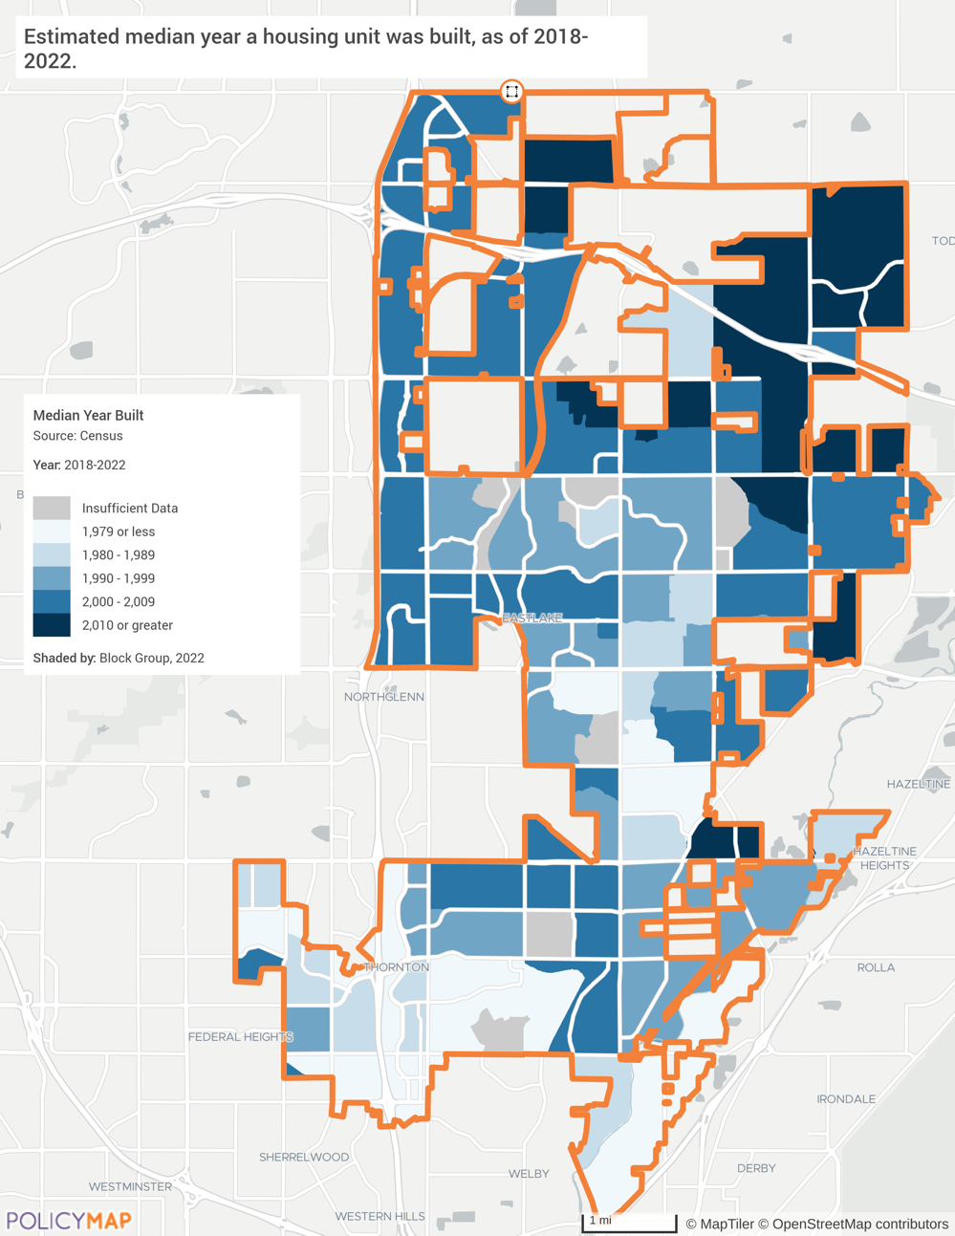

Source: United States Census Bureau ACS 2018-2022 via PolicyMap

Additional Housing Types

Senior Living Options
One of the primary needs for seniors in Thornton is the availability of affordable housing. Many seniors live on fixed incomes, making it challenging to afford rising costs, especially in housing. Census estimates senior households have a median annual income of $65,723, nearly $30,000 less than the citywide median income of $95,064. This financial strain of housing limits seniors' ability to afford other essential services and goods, such as healthcare and groceries.
The 2018-2022 ACS data indicates nearly 87% of senior households over 65 in Thornton own their homes, or 7,174. This however does not mean they no longer have a mortgage payment. There are several factors to consider when evaluating senior housing needs in the area. The senior population increased to 14,270 between 2012 and 2022, with projections estimating it will reach 25,115 by 2032. This growth highlights the need for serious investments in accessible and affordable housing plus aging-in-place services. A 2022 national poll found 88% of Americans aged 50 to 80 want to stay in their homes, but only 15% had considered the necessary modifications.
Proximity to essential services is crucial for seniors, impacting their quality of life. Senior housing developments in Thornton, like the transit-accessible Crossing Pointe North Senior Apartments, are strategically located for easy access to healthcare, grocery stores, retail, banking, and public transportation.
The cost of independent living in Thornton is thankfully below the national average, making it more affordable for seniors. The mean yearly cost for independent living in Thornton is approximately $21,862, compared to the national average of $23,100. With 170 senior housing rentals listed on Apartments.com, seniors have various living options. The city supports affordable housing through programs like the CDBG program, HOME program, and Private Activity Bonds, which helped finance the construction of affordable senior housing units, including 64 units at Crossing Pointe North.
Thornton has several enterprises to help seniors age in place. The city provides a comprehensive owner-occupied Home Rehabilitation Program which includes Help for Homes, Paint-a-Thon and CodeCAP. These HUD grant funded programs improve the health, safety, accessibility and efficiency of the home. They also help maintain property values, neighborhoods, and the city’s tax base. Seniors comprise approximately 75% of the recipients of these programs. The city also partners with other organizations to help seniors stay in their homes:
- CAPABLE - A program run by the Colorado Visiting Nurses Association, offers occupational therapy, nursing visits, and handyman services to make homes safer and more accessible, allowing seniors to stay in their homes longer.
- Sunshine Home Share - Program helping senior homeowners find compatible renters to share their homes.
- GRID Alternatives - Program funded by CDBG that installs free solar systems to power homes with electricity for free.
- The City of Thornton’s Active Adult Center - provides food, education, socialization, and services for the senior community.

Map: City of Thornton Percent Of Seniors by Block Group
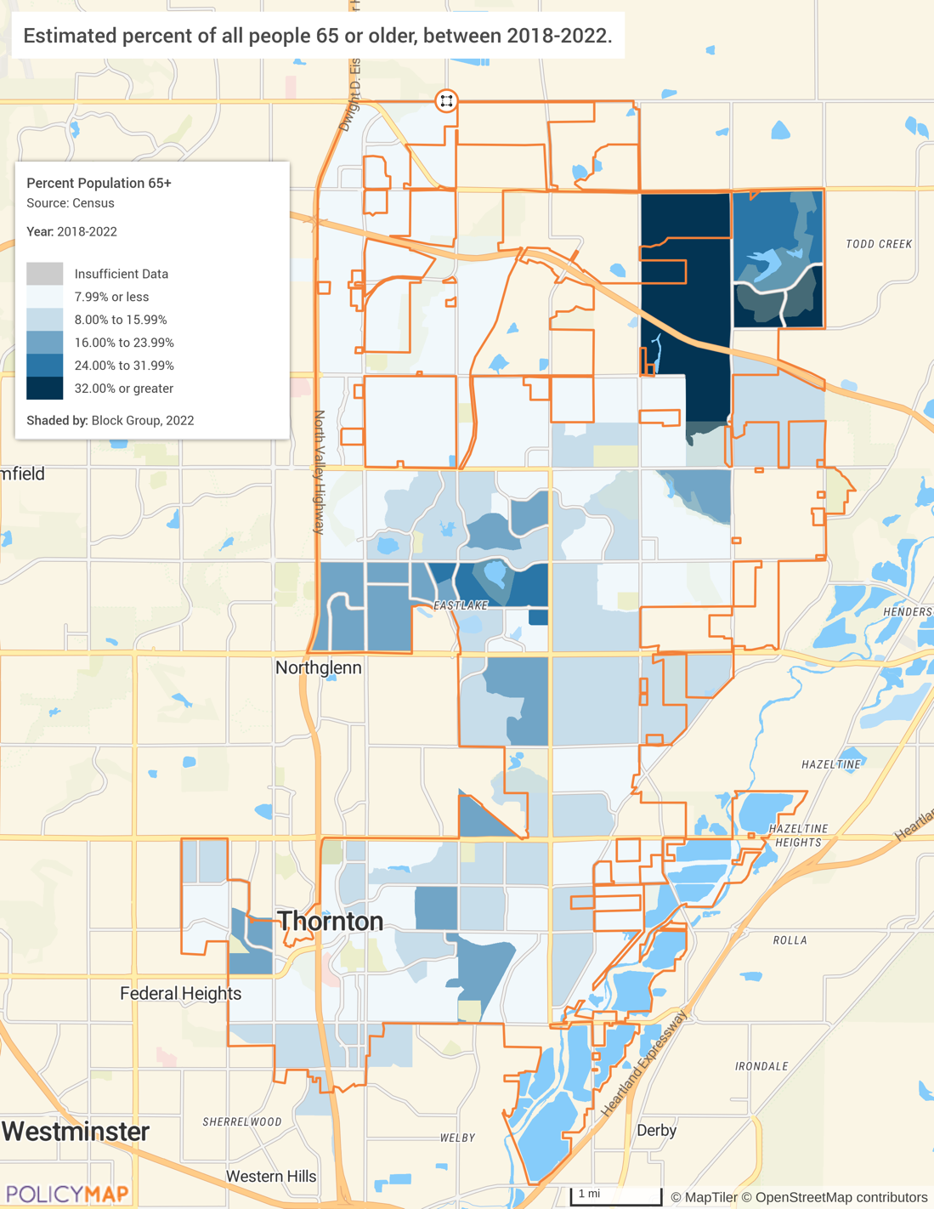

Source: United States Census Bureau ACS 2018-2022 via PolicyMap

Accessory Dwelling Units (ADUs)
Accessory Dwelling Units are separate housing units located within homes or on the same lot as single-family homes. They are often referred to as Mother-in-law Suites or Granny Flats. These units can be built as part of a home remodel, as additions to the existing house, or as separate structures entirely. National housing policy experts suggest ADUs offer a practical solution to housing shortages by increasing housing density without the need for new infrastructure such as water, sewer, and roads. They also assist seniors by providing a place for them to live with their families, live with their caregiver, or to increase their income. This makes them a cost-effective and efficient option for expanding housing availability.
ADUs are versatile and can serve multiple purposes. They are frequently used as rental units, providing homeowners with an additional source of income while contributing to the rental housing stock. Alternatively, they offer an adjacent housing option for relatives allowing for multigenerational living arrangements fostering closer family interactions and support.
However, there are some drawbacks to consider with ADUs. One potential drawback is the impact on neighborhood character; the increased density might lead to concerns about parking availability or changes in the community aesthetic. Additionally, while ADUs do not require new infrastructure, they add to existing public facility and utility uses, which increases the city’s emergency responses, maintenance requirements and potential costs for upgrades to infrastructure.
Thornton currently has five known ADUs. In 2024, Colorado implemented significant legislation regarding ADUs with the passage of House Bill 24-1152. This law marks a strong state commitment to facilitating the development of ADUs, aligning with similar efforts in states like California, Oregon, and Washington. These legislative efforts at the state level aim to make ADU construction easier.
The main opportunities for the city to promote ADUs include land use restrictions, building requirements, and the need for streamlined approval processes. City stakeholders recognized the potential challenges to infrastructure, traffic, and parking. Thornton could actively pursue the benefits of ADU developments by adopting state-level reforms that simplify ADU construction and provide financial incentives for homeowners. Careful considerations for city codes regarding ADU approval, size and design flexibility should be analyzed and updated to meet the needs of the residents. Financial incentives might include allocating grants to support ADU construction and free architectural plans and technical assistance for homeowners. Streamlining the city’s approval process would remove a barrier to ADU construction.

Tiny/Micro Homes and Communities
Tiny or Micro homes can be considered a type of ADU or a free-standing home. They offer a modest and affordable housing option for different sectors of the population. The city and surrounding communities have seen interest in tiny homes, with builders like Anchored Tiny Homes and Great Lakes Tiny Home providing local services. However, building and land use regulations can be a significant barrier. Tiny homes often face challenges related to zoning laws that do not accommodate their smaller size and unique structure. To facilitate this flexible solution to provide affordable housing, Thornton will need to amend zoning regulations to allow for tiny home and micro home communities integration into existing residential zones.
A local stakeholder offered an alternative view on housing solutions, suggesting that building smaller, such as through tiny homes, may not be the most cost-effective approach. Tiny homes often come with a higher cost per square foot, making them more reliant on subsidies and grants to make them affordable. Instead, the stakeholder proposed other strategies, such as increasing inclusionary zoning funding and encouraging the use of available city land for affordable housing with long-term affordability restrictions. The stakeholder also highlighted the importance of leveraging existing partnerships and suggests that mixed-income and mixed-product developments can provide a valuable model. These developments allow for a more integrated community where lower and higher-income residents live together, enriching the social fabric.

Manufactured Homes
Manufactured homes are prefabricated, stick-built housing units that are transported to and assembled on the home site. Mobile homes, a type of manufactured home, are built in factories and then moved to their permanent locations. They offer an affordable alternative to traditional homes. Thornton's zoning ordinances allow for manufactured homes in designated parks or subdivisions. Trends in manufactured housing indicate a steady supply and demand, with innovations in financing making it easier for people to purchase manufactured homes, including mobile homes. However, these homes often face stigma and zoning challenges that limit their placement, due in part to NIMBYism. The use of digital marketing and virtual tours has simplified the buying process and increased the appeal of manufactured homes. Additionally, there is a growing focus on eco-friendly building materials and energy-efficient designs in manufactured housing. To support manufactured housing, Thornton should revise zoning laws to allow for more flexible placement and work to reduce the stigma associated with these homes through community education and outreach.

Mobile Homes
This type of housing unit makes up 5.7% of the city’s total housing stock. Census data from 2022 estimates a total of 2,811 mobile homes in Thornton, a 10.5% increase from the previous decade. Local city officials cited a current total of 3,089 mobile homes in their six mobile home parks. Mobile homes are a sizable component of affordable housing for low-income households in Thornton.
A 2019 survey of mobile homeowners in Thornton highlighted several key issues faced by residents. Rent and fees were a significant concern, with rent having risen 83% over eight years, along with additional charges for water and sewer services. Residents also experienced unnotified rent hikes and additional fees for non-compliance with park rules and maintenance of common areas. There were discrepancies in water meter readings causing significant increases in water bills.
The Colorado Mobile Home Park Act, updated by House Bill 19-1309, has provided some protections for mobile home residents, such as extended time to cure late rent payments and sell or move homes after eviction. Other recent Colorado state bills (HB20-1201, HB20-1196, HB21-173, HB21-1121, HB22-1287, HB24-1294) have an overarching goal to enhance the accessibility, affordability, and regulatory framework of mobile and manufactured housing, thereby supporting homeowners and addressing broader housing challenges. Despite these protections, mobile home parks face challenges like rising land values and redevelopment pressures.
Each of the city’s mobile home parks are privately owned which means the owners must maintain all the parks’ infrastructure. It is important to recognize Thornton does not have infrastructure jurisdiction inside the mobile home parks. This infrastructure includes sewer, water, storm drainage, roads, trees, lighting, common areas/facilities and more. The city does provide metered hook-ups for the main water supply and sewage drainage lines at the parks’ property boundaries.
Over the past several years infrastructure problems were a repeated safety issue, with frequent water line breaks causing multiple days without clean water. Sewage has been backing up and making its way to local creeks forcing the city to flush the creeks with thousands of gallons of water, post warning signs, and repeatedly take water quality tests along the waterways. Roadways and other common areas are not being maintained. Residents have expressed their frustrations and concerns to city staff and City Council.
Despite the dramatic increase in pad rents and park fees, there has been a lack of maintenance on infrastructure. Housing affordability remains a critical issue for these residents because moving their home costs an average of $9,000. https://www.forbes.com/home-improvement/moving-services/cost-to-move-mobile-home/. They are essentially bound to their mobile home park because they cannot afford to move.
Housing prices and pad rents have continued to rise. The median sales price for mobile homes is difficult to assess, with some estimates at $84,950. The range of pricing varies based on age, quality, and size of the home. Currently a 3 bed, 2 bath mobile home in asking price ranges from $64,900 to $385,000 according to various listings on Realtor.com. The size and age of the mobile home account for the variance in asking price. Rent pad prices have also increased ranging from $1,000 a month to over $1,100, a substantial 25%+ increase from a few years ago. Realtor.com currently shows a range for HOA fees (pad rental+) from $920 to $1,179 per month for mobile homes. For home maintenance, residents of mobile homes faced costly repairs, with requirements to use expensive materials many cannot afford.
State regulatory changes have been implemented to provide more support for residents. The Colorado Division of Housing's Mobile Home Park Oversight Program now handles complaints and dispute resolutions. House Bill 19-1309 updated the Colorado Mobile Home Park Act, extending the time for homeowners to sell or move their homes after an eviction and the time to cure late rent payments.
Thornton should continue to provide the mobile home parks and support their residents through the HUD grant funded Help for Homes, Paint-a-Thon, and CodeCAP home rehabilitation programs, educational seminars, and referrals to legal and financial assistance programs. Additional efforts to preserve the existing parks and address their issues could include regular and transparent communication between the city and the park managers and out of state owners, tracking rent and fee increases and internal rule changes. The city could lobby for the state to continue strengthening regulations to protect park residents from arbitrary rule changes and retaliatory actions by park management is necessary. If the mobile homeowners are interested, the city could help them explore the new financial options allowing the homeowners to purchase their park.

Table: Thornton Mobile Home Community Information
Community | Address | # of Lots | Avg. Pad Rent | Est. Sales* $
Friendly Village of the Rockies | 2100 W. 100th Avenue | 524 | $859 | $39,300,000
Redwood Estates | 9595 Pecos St. | 754 | $876 | $56,550,000
Valley View (Alta Ridge) | 1201 W. Thornton Parkway | 382 | $813 | $28,650,000
Woodland Hills | 1500 W. Thornton Parkway | 434 | $838 | $32,550,000
Pine Lakes Ranch | 4210/4211 E. 100th Avenue | 762 | $821 | $57,150,000
Thornton Estates | 3600 E. 88th Avenue | 208 | $773 | $15,600,000
Average |  | 511 | $830 | $38,300,000

Source: City of Thornton

* Data notes:

- Estimated Sales assumes a purchase price of $75,000 per lot

- Assume $25,000 per lot for purchase costs, upgrades, and cooperative community formation - $100,000 resident lot purchase would result in a monthly payment of approximately: $830

Map: Manufactured Home Parks
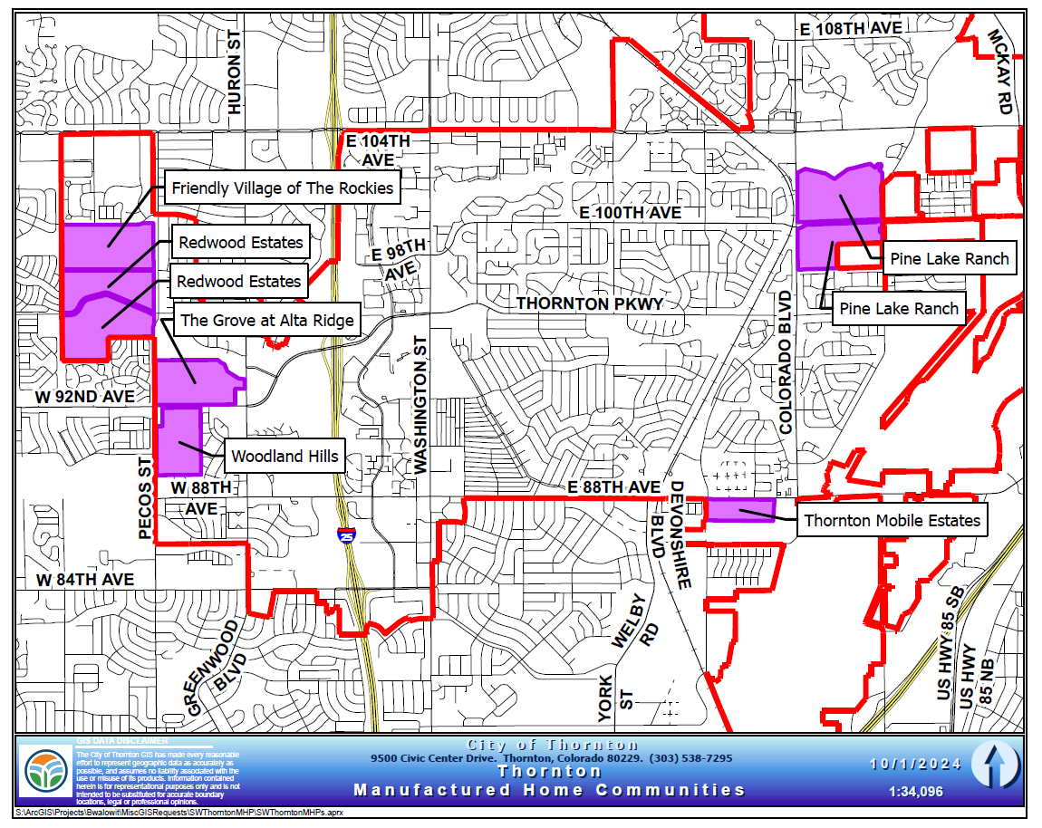

Housing Occupancy Development

Occupancy Characteristics
From 2012 to 2022, Thornton saw remarkable changes in its housing occupancy characteristics. The total number of housing units increased from 42,954 to 49,779, reflecting the city's growth (15.8% in total housing units). In 2012, 93.7% of housing units were occupied, with a vacancy rate of 6.3%. By 2022, the occupancy rate rose to 97.4% (48,466 units), and the vacancy rate dropped to 2.6% (1,313 units). This indicates a much tighter housing market with fewer unoccupied units.
The homeowner vacancy rate decreased from 2.7% in 2012 to 0.7% in 2022, showing high demand for owner-occupied homes. Similarly, the rental vacancy rate fell from 6.9% to 3.1%, reflecting increased demand for rental properties.
These trends highlight a robust demand for housing in Thornton, contributing to rising home values and rental prices (The median home value more than doubled to $445,200 from 2012-2022 and the median contract rent in increased by over 49%). As the city grows, a lag in housing supply and available units will challenge overall affordability and accessibility.

Table: Housing Occupancy in 2012 and 2022
 | 2012 |  | 2022
 | Number | Percentage | Number | Percentage
Total housing units | 42,954 | 100% | 49,779 | 100%
Occupied housing units | 40,253 | 93.7% | 48,466 | 97.4%
Vacant housing units | 2,701 | 6.3% | 1,313 | 2.6%
Homeowner vacancy rate | 2.7% |  | 0.7%
Rental vacancy rate | 6.9% |  | 3.1%

Source: 2008-2012, 2018-2022 ACS 5-Yr Estimates (DP04)

Housing Production Challenges
In analyzing Thornton's housing development history, it's evident the city's zoning has traditionally favored, like most suburban communities, single-family units. The zoning map predominantly features Single-Family Detached (SFD) and Single-Family Attached (SFA) districts, reflecting a historical preference for low-density residential development. However, Thornton has shown signs of adapting to changing housing needs. The city allows ADUs in single-family zones and has established some multi-family and higher-density zoning districts, particularly in Transit Oriented Development (TOD) areas near rail stations. While these changes indicate a gradual shift towards more diverse housing options, single-family zoning still appears to dominate the residential landscape. As Thornton addresses housing affordability concerns, the current land use code updates and changes should allow for more varied housing types, to signal an evolution in the city's approach to residential development.
Like other cites, Thornton's affordable housing development landscape is also influenced by its impact fees, including water tap fees, which have risen in recent years, affecting overall development costs. The city's approval process for new developments involves multiple stages of review and public hearings, which can impact the timeline and feasibility of housing projects.
The Census estimated a citywide households increased by 8,213 between 2012 and 2022, during which 8,218 housing permits were issued. Considering actual housing production can take at least 6-12 months for single-family homes and 12-24 months for multi-family units after permitting, the city should anticipate future demand and expedite the permitting process to keep pace with the city's growth. However, the types of permits issued may not align with household needs. A significant number of low-density, single-family detached homes were permitted, which does not address the rising demand for smaller household sizes.
Most households in Thornton are family households, comprising 71.4% of the total, with the majority of these being two-person and three-person households. Non-family households account for 28.6% of the total, predominantly consisting of one-person households. This data can help the city prioritize the development of housing that accommodates small to medium-sized families and single-person households.
Stakeholders cited several key points regarding Thornton's housing development landscape. The city's development momentum experienced a significant slowdown in 2019, causing developers to pause their activities and shift their focus away from Thornton. This interruption in the development quantity had lasting effects, as many developers committed to projects elsewhere. Consequently, Thornton is not expected to see substantial new housing development activity until around 2026. This notable gap in the city's growth and housing development timeline. If the average growth from 2016 – 2018 had continued, there would have been another 1,348 detached residential permits issued.
Stakeholders acknowledged the need for affordable housing and housing diversity in Thornton, but highlighted challenges in implementation. They mentioned the city's inclusionary housing policy, which requires 5% affordability, but noted that developers are reluctant to comply without incentives. Concerns were raised about maintaining affordability when units are resold. Stakeholders agreed on the need for more attached housing options, such as townhomes and condos, to diversify the housing stock. While stakeholders recognized the presence of multi-family developments, they expressed a preference not to expand manufactured home parks (MHPs). Amongst the city staff interviewed there was a citywide understanding of the need for both affordable and diversified housing options but balancing these needs with market realities and developer incentives remains challenging.

Table: Residential Construction Permits Issued by Year
Permits Issued | 2012 | 2013 | 2014 | 2015 | 2016 | 2017 | 2018 | 2019 | 2020 | 2021 | 2022 | 2023 | 2024*
Single Family Detached | 294 | 296 | 293 | 441 | 726 | 867 | 784 | 500 | 621 | 556 | 552 | 383 | 81
Single Family Attached | 8 | 6 | 22 | 16 | 82 | 28 | 39 | 249 | 194 | 199 | 70 | 6 | 10
Multifamily Living Units | 0 | 0 | 0 | 0 | 100 | 4 | 157 | 338 | 53 | 354 | 369 | 432 | 0
Total | 302 | 302 | 315 | 457 | 908 | 899 | 980 | 1087 | 868 | 1109 | 991 | 821 | 91

Source: City of Thornton; * 2024 data is through July 8, 2024

Naturally Occurring Affordable Housing
Naturally Occurring Affordable Housing (NOAH) refers to residential rental properties that are affordable without public subsidies. These properties are typically older, with fewer amenities, and maintain lower rents due to market conditions rather than government intervention. NOAH plays a crucial role in providing affordable housing options for low and moderate-income households. While NOAH preservation is essential, research and analysis around increasing the supply of rental housing, particularly high-end or luxury apartments, indicates beneficial impacts on overall rental affordability.

Benefits to Increasing High-end Rental Supply
Supply and Rent Dynamics: Increasing the supply of new apartments, especially higher priced units, can help moderate rent increases and, in some cases, reduce rents in the surrounding areas. This is supported by multiple studies, including those from the Upjohn Institute and the Federal Reserve Bank of Philadelphia, which found that new market-rate apartment buildings can decrease nearby rents by 5% to 7% compared to areas without such developments. The principle here is that more housing options create competition, which can lead to more stable or lower rents.
Filtering Process: The concept of "filtering" plays a crucial role in understanding how new luxury apartments can benefit the broader market. As high-income renters move into new luxury units, they vacate older, less expensive apartments, which then become available to middle-income renters. This chain reaction continues down the housing ladder, eventually increasing the availability of more affordable units for low-income households. The National Multifamily Housing Council (NMHC) supports this view, noting that the construction of Class A and B apartments has led to lower rent increases among Class C units.
Empirical Evidence and Economic Theory: Empirical studies and economic theory both support the notion that increasing the supply of housing, including high-end units, contributes to overall affordability. For instance, a 2020 study by the National Multifamily Housing Council Research Foundation highlighted that new construction targeted at middle- and higher-income groups facilitates the filtering process, thereby creating affordable housing opportunities for low-income households. Additionally, a UCLA review found that new market-rate housing construction generally lowers rents and makes housing more affordable across income all levels.
Challenges and Considerations: While increasing supply is crucial, it is part for all affordability issues. Zoning changes and regulatory barriers often limit the potential for new construction, and these need to be addressed to fully realize the benefits of increased housing supply. Moreover, while new construction can mitigate rent increases, it may not be sufficient to make housing affordable for all renters, necessitating the need for subsidies and affordable housing programs. To address these needs effectively, the city can adopt several best practices:
- Continue to improve and Streamline Permitting Processes: Reducing the time and complexity of permitting can help accelerate housing production, which is crucial given the long lead times.
- Monitor and Adjust Plans: Establish metrics for success and regularly review progress to ensure housing goals are being met and adjust strategies as needed.
- Diversify Housing Types: Thornton should consider policies that encourage the development of a wide range of housing types, including luxury apartments, to leverage the benefits of increased supply and the filtering process and avoid a citywide mismatch between the types of permits issued and household sizes/preferences. Increasing the supply and variety of multifamily and smaller housing units can better meet the needs of smaller households.
- Consider Density Bonuses: Explore the implementation of density bonuses as an incentive for integrating affordable housing units within new residential developments.

Public Housing in Thornton
Public housing authorities (PHAs) play a critical role in providing and managing affordable housing for low-income families, seniors, individuals with disabilities, and unit set asides like for foster graduates. In Thornton, the PHA is Adams County Housing Authority, known as Maiker Housing Partners.
Maiker Housing Partners serves the residents of Thornton by offering various programs aimed at providing safe and affordable housing. Maiker administers several key programs, including:
- Housing Choice Voucher (HCV) Program (Section 8): Maiker administers 1,533 housing choice vouchers to households in Adams County. This program helps low-income families, the elderly, and the disabled afford decent and safe housing in the private market. Participants receive a voucher that subsidizes their rent, allowing them to choose housing that meets program requirements and contribute only a reasonable portion of their income toward housing costs. Lengthy waiting lists for vouchers result in households waiting an average of 13 months to receive a voucher.
- Project-Based Vouchers (PBV): Maiker administers 159 project-based vouchers. These vouchers are tied to specific housing units within designated properties. Residents benefit from the rental subsidy if they live in the specific unit, providing stability and access to supportive services. PBVs also provide steady income for rental properties, making them financially sustainable. Many of these vouchers are tied to units at Crossing Pointe South, an affordable development located in Thornton.
- Public Housing: Maiker manages 22 affordable communities containing 2,200 rental units, providing affordable rental options for eligible low-income families. These units primarily include apartment complexes or multi-family housing developments, as well as several scattered sites. Typically, 15% to 20% of the residents utilize HCVs within Maiker’s properties.
- Family Self-Sufficiency (FSS) Program: Maiker helps families participating in the Housing Choice Voucher program to achieve economic independence. Participants receive support services such as job training, education, budgeting, and financial literacy to improve their earning potential and reduce reliance on assistance.

Types of Affordable Housing Units in Thornton
Thornton's affordable housing landscape includes a variety of options designed to meet the needs of its diverse population.
Multifamily rental properties are an important type of affordable housing, as they often make up the largest portion of affordable units in a region. There are two HUD-subsidized multifamily developments located in Thornton: Creekside Place and Rockview Terrace, which provide more than 250 subsidized units for Thornton residents. Creekside Place is managed by Maiker. Other multifamily units owned and operated by Maiker provide affordable multifamily rental units across Adams County. These apartment complexes offer reduced rents for income-eligible residents. They provide a range of unit sizes to accommodate different family structures. Under the Low-Income Housing Tax Credit (LIHTC) program, property owners must adhere to affordability restrictions by renting a specified percentage of units to low-income households at restricted rents for an extended compliance period.
Maiker also manages specialized housing developments which cater to the elderly, offering accessible units and age-appropriate amenities. Senior housing can be public housing complexes or privately managed properties with rent subsidies. Senior housing developments in Thornton that are managed by Maiker include Crossing Pointe North and Orchard Hills.
For residents facing immediate housing crises or those requiring additional support, transitional and supportive housing options provide a temporary but stable living environment combined with access to essential services. Transitional housing options in Thornton include Oxford House Skylake, a female-only transitional housing community focused on addiction recovery. Colorado Behavioral Health also provides transitional housing for mental health and substance use disorder recovery.
Lastly, HCVs allow any housing unit to become an affordable unit, as long as it meets program requirements. As previously mentioned, Maiker administers a total of 1,533 HCVs across the County, meaning that many units are affordable to low-income households.

Section 4: Owner Market Analysis

Median Home Value vs Median Homeowner Income
Over the past decade, the housing market in Thornton has experienced significant changes in home values. The median home value increased from $207,600 in 2012 to $445,200 in 2022, representing a nominal increase of 114.5%. When adjusted for inflation, this translates to a real increase of 65.9%. For owner-occupied households, the median household income increased from $79,719 in 2012 to $111,244 in 2022. This represents a nominal increase of 39.5%, but when adjusted for inflation, the real income increase is only 8.0%. Despite the increase in income, the real increase in home values (65.9%) far outpaces the real increase in homeowners' incomes (8.0%). Whether adjusting for inflation or not, this disparity shows that homeowners' income growth has not kept pace with the rising costs of homeownership, which leads to increased financial strain for those looking to purchase new homes or refinance existing mortgages.
The significant gap between the real increase in home values and the slower growth in homeowners' incomes indicates that many homeowners in Thornton are experiencing increased financial strain. This is especially evident in the western part of the city, where the highest burden of housing costs is concentrated, suggesting a need for targeted interventions to support homeowners in these areas. (See map in Cost burdened section below.)

Table: Median Home Value and Median Homeowner Income
 | 2012 | 2022 | % Change | Change in Real Dollars
Median Home Value | $207,600 | $445,200 | +114.5% | +65.9%
Median Homeowner Income | $79,719 | $111,244 | +39.5% | +8.0%

Source: 2008-2012, 2018-2022 ACS 5-Yr Estimates (DP04, B25058, B25119); CPI Inflation Calculator)

Median Sale Price
This section provides an overview of Thornton’s real estate market, highlighting a key metrics based on real-world sales data. In June 2024, the median sale price for homes in Thornton was $560,000, unchanged from the previous year. Interest rates have increased from 3.0% on January 6, 2021, to 7.0% on November 6, 2024, making home purchase affordability further out of reach. However, the inventory of homes for sale decreased by 10% over the past year. Additionally, homes are now staying on the market for an average of 18 days (June 2024), which is six days longer than the same period last year.
The graph and table below illustrate home sale price trends in Thornton and several other communities. The greater Denver area has seen a dramatic escalation in home prices over the past five years. Notably, the median sale price of a home in Thornton increased by nearly 50%, reaching $560,000 in June 2024. In contrast, Westminster, Commerce City, Brighton, and Broomfield experienced smaller relative price increases during the same period. The nationwide rate increased by 60% during the same timeframe, albeit at a lower level in sales price, from $276,000 to $442,000,

Graph: Median Home Sale Price, 2012 to 2024

Source: Redfin; Based on Redfin calculations of home data from MLS and/or public records.

Chart: Median Home Sale Price, 2019 to 2024
Location | 2019 Median Sale Price | 2024 Median Sale Price | % Change in Median Sale Price | Growth % YoY
Thornton, CO | $373,450 | $560,000 | 49.95% | 0.0%
Westminster, CO | $389,250 | $537,500 | 38.09% | -1.9%
Commerce City, CO | $375,000 | $533,700 | 42.32% | +2.1%
Broomfield, CO | $487,000 | $633,495 | 30.08% | -0.2%
Brighton, CO | $381,000 | $524,975 | 37.79% | -3.5%

Source: Redfin; Based on Redfin calculations of home data from MLS and/or public records.

Market Demand
The graphs below illustrate the evolving supply-demand dynamics in Thornton's housing market by tracking days on market and homes sold above asking price. Recent years have seen significant volatility, with the median time on market plummeting from 39 days in January 2014 to just 6 days in January 2021, during the pandemic-fueled housing boom. This period also saw a record 86% of homes in Thornton selling above list price. However, as higher mortgage interest rates cooled the market in 2022, this trend began to reverse. While homes still sold faster than pre-COVID-19 levels, the median list-to-sale time peaked to 40 days by early 2024 and stands at 18 days as of June 2024. These fluctuations underscore the importance of monitoring market indicators for both buyers and sellers to make informed decisions in a rapidly changing real estate landscape.

Graph: Median Days on the Market, 2013 to 2024

Source: Redfin; Based on Redfin calculations of home data from MLS and/or public records.

Graph: Homes Sold Above List Price, 2013 to 2024

Source: Redfin; Based on Redfin calculations of home data from MLS and/or public records.

Median Home Values
This section turns back to the ACS census data estimates for trend analysis of median home values. The table on home value distribution in Thornton from 2012 to 2022 reveals significant changes in the housing market over the decade. In 2012, the median home value was $207,600, with the largest portion of homes (39.7%) valued between $200,000 and $299,999. By 2022, the median home value had more than doubled to $445,200. The distribution of home values shifted dramatically, with nearly half of the homes (49.8%) valued between $300,000 and $499,999, and a substantial increase in homes valued between $500,000 and $999,999 (33.7%).
This tremendous increase in home values has several implications for homeownership in Thornton. Firstly, the significant rise in home prices likely reflects increased demand and limited housing supply, making it more challenging for first-time buyers to enter the market. The decrease in the percentage of homes valued under $200,000 from 46.3% in 2012 to just 5.3% in 2022 underscores the reduced availability of more affordable housing options.

Table: Home Value in 2012 and 2022
 | 2012 |  | 2022
 | Number | Percentage | Number | Percentage
Less than $50,000 | 2,235 | 7.8% | 1,425 | 4.0%
$50,000 to $99,999 | 779 | 2.7% | 1,040 | 3.0%
$100,000 to $149,999 | 3,297 | 11.5% | 465 | 1.3%
$150,000 to $199,999 | 6,951 | 24.3% | 338 | 1.0%
$200,000 to $299,999 | 11,365 | 39.7% | 2,061 | 5.8%
$300,000 to $499,999 | 3,758 | 13.1% | 17,574 | 49.8%
$500,000 to $999,999 | 127 | 0.4% | 11,882 | 33.7%
$1,000,000 or more | 112 | 0.4% | 469 | 1.3%
Total Units/Median Value | $207,600 | -- | $445,200 | --
Source: 2008-2012, 2018-2022 ACS 5-Yr Estimates (DP04)

The distribution of home values shown below further highlights the shift of Thornton's housing market towards higher property values over the past decade. Homes valued between $500,000 and $999,999 saw a major increase from 0.4% in 2012 to 33.7% in 2022. This shift indicates a substantial appreciation in home values, which has significant implications for homeownership. The rapid rising of home prices, coupled with a more modest increase in real household incomes (11.1% adjusted for inflation), upholds that affordability has become a growing concern.

Graph: Home Value by Price Range

Source: 2008-2012, 2018-2022 ACS 5-Yr Estimates (DP04)

Home values are much higher in the northern sections of the city, which also coincides with newer homes, higher incomes, and tracts with higher concentrations of White households.
Map: Median Home Value | Map: Predominant Race
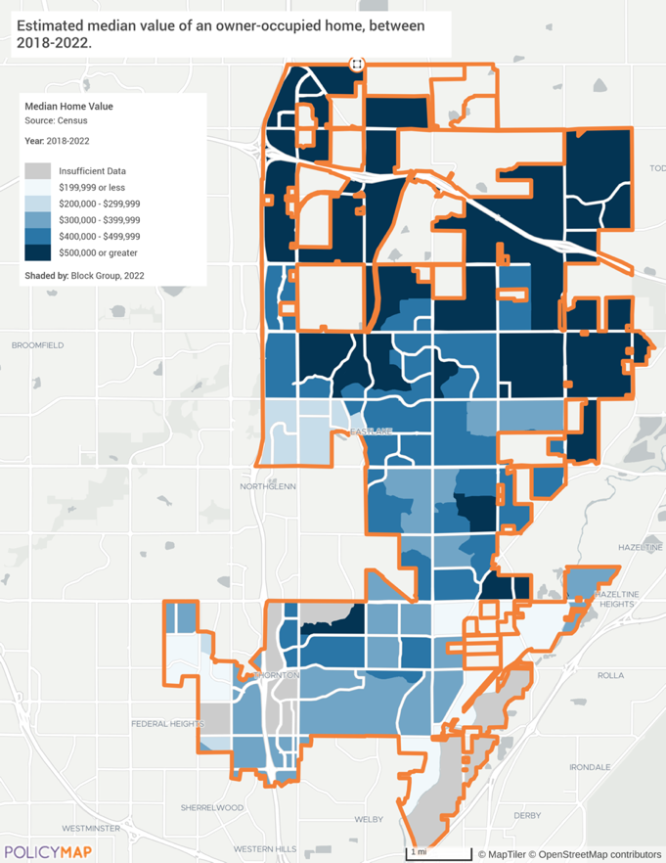 | 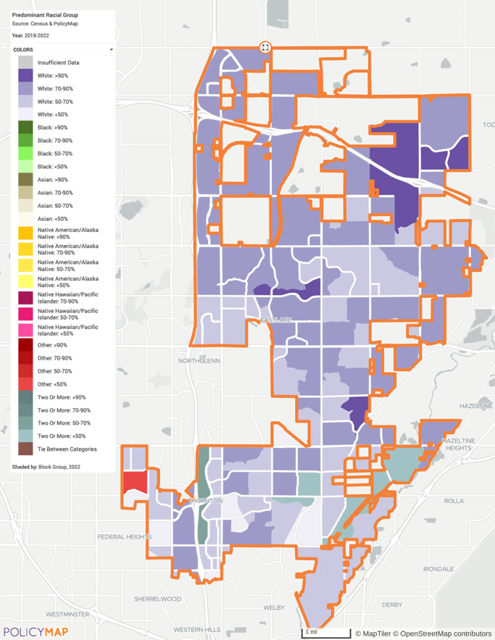
Source: United States Census Bureau ACS 2018-2022 via PolicyMap | Source: United States Census Bureau ACS 2015-2019 via PolicyMap

Colorado's Golden Handcuffs
Colorado homeowners find themselves in a unique predicament, facing the nation's largest "mortgage rate lock-in gap," a phenomenon often referred to as "golden handcuffs." This 3.45 percentage point difference between existing mortgage rates and current market rates significantly outpaces the national average of 3.15 points, according to a U.S. News & World Report study. The Federal Housing Finance Agency reports that the average rate for existing mortgages nationwide is 4.1%, highlighting the stark contrast in Colorado.
This substantial gap creates a powerful disincentive for homeowners to sell, potentially stagnating the housing market. Homeowners with favorable low-rate mortgages are reluctant to give up their advantageous terms, leading to reduced housing inventory and limited mobility. The situation is particularly pronounced in Colorado, where the gap exceeds that of other states like Texas, which has the smallest lock-in gap at 2.55 points.
The implications of this "lock-in effect" extend beyond individual homeowners, potentially impacting the broader real estate market and economy in Colorado. It could lead to decreased housing turnover, reduced economic mobility, and challenges for first-time homebuyers entering an already competitive market. As this situation persists, it may require innovative solutions from policymakers and the real estate industry to address the growing imbalance in the state's housing market.

Owner Affordability Trends
Analyzing recent sales trends and mortgage data in Thornton reveals significant housing affordability challenges for typical households in the area. The median sale price for homes in Thornton has reached $560,000 as of 2024, reflecting a rapid increase in housing costs that has outpaced income growth.
To afford the median-priced home in Thornton without being cost-burdened, a household would need an annual income of $133,903. This figure is based on a 30-year mortgage at a 6.5% interest rate, with an 80% loan-to-value ratio, resulting in a monthly mortgage payment of $3,348. The median family income in Thornton, according to 2022 ACS data, is only $95,064. This creates a substantial affordability gap of 40.9% between the income required to comfortably afford a median-priced home and the actual median income of Thornton residents.
When considering the more recent income estimates of the broader Denver Metro Area, the situation appears slightly better but still challenging. The median family income for the Denver Metro Area, as estimated by HUD, is $130,400. This higher figure brings the affordability gap down to just 2.7% for the entire metro area.
The current housing market in Thornton presents substantial barriers to home ownership for many local families, with median home prices requiring incomes well above the local median. As home ownership becomes increasingly out of reach, the rental market likely faces increased pressure, potentially driving up rental costs as well.

Affordability of the Median Sales Prices in 2024
Variable | Value
Mortgage Rate | 6.5%
Median Sale Price (2024) | $560,000
Loan-to-Value | 80%
Monthly Mortgage Payment (30-year term) | $3,348
Required Annual Income to Afford Thornton Median Home Sale Price | $133,903
Median Family Income - Denver Metro Area | $130,400
Affordability for Median Family Earning Denver Metro Area AMI | 102.7%
Median Family Income – Thornton | $95,064
Affordability for Median Family Earning Thornton AMI | 140.9%
Source: HUD Denver-Aurora-Lakewood, CO MSA; Five-Year American Community Survey (2022); Redfin
Data note: monthly payment assumes Loan Term: 30 years; Property Tax Rate: 0.78%; Annual Homeowners Insurance: $1,800

Homeowner Affordability Gap
Homeownership remains one of the most effective ways to secure intergenerational wealth and pull families out of poverty, providing stability, security, family cohesiveness, etc. Over time homes age, and many are eventually taken off the market, which can potentially reduce overall housing supply if not replaced at an equal or greater rate, thereby further effecting rising prices. In addition to the market price, regulations and available home types can further increase prices beyond the reach of many households. If home production does not keep pace with the demand, then prices rise beyond the affordability of many residents. A general measure of what a household can afford is currently estimated at five times their annual income. An affordability gap is created when there is a mismatch between what a household can afford, and the amount needed to purchase a median-priced home in an area.
The following chart visualizes the affordability gap for different income groups in Thornton, based on 2022 Census estimates. In the city the median home value is $445,200 which is affordable to those making 100% AMI. Income groups below 100% AMI have an affordability gap, which gets progressively worse for lower income groups.

Chart: Affordability Gap by Income Level
Source: 2008-2012, 2018-2022 ACS 5-Yr Estimates (DP04; S1901)

Median Home Value

Cost Burdened Homeowners
In Thornton, a weighty portion of households are experiencing housing cost burden, which is defined by the U.S. Department of Housing and Urban Development (HUD) as spending more than 30% of household income on housing costs, including mortgage, utilities, property taxes, and homeowner’s insurance. This measure is crucial for understanding housing affordability and its impact on residents' financial well-being. Additionally, Colorado has experienced significant increases in property valuations, which have led to higher property tax bills for many homeowners. The state's strong real estate market, especially in the greater Denver metropolitan area, has caused property values to rise substantially over recent years. While Thornton's property tax rate is slightly below the average for Adams County and below the average United States tax rate, increases in valuation will have further impacts to home ownership affordability.
Homeowners with a Mortgage
Homeowners with a mortgage face significant cost burden, with 30.5% of these households spending more than 30% of their income on housing. This group is affected by rising home values and mortgage interest rates, which increase monthly mortgage payments and overall housing costs. The financial strain on these homeowners can lead to difficulties in maintaining their homes and meeting other financial obligations, potentially increasing the risk of mortgage delinquency and foreclosure.
Homeowners without a Mortgage
Homeowners without a mortgage are the least affected by housing cost burdens, with only 13.0% of these households spending more than 30% of their income on housing. These homeowners benefit from not having monthly mortgage payments, which significantly reduces their housing costs. However, they still face expenses such as property taxes, insurance, utilities, and maintenance, which can be burdensome, especially for those on fixed incomes, such as retirees.

Table: Cost Burden
 | Population Cost Burdened | Percent of Population Cost Burdened
Homeowners with a Mortgage | 8,336 | 30.5%
Homeowners without a Mortgage | 1,019 | 13.0%

Source: United States Census Bureau ACS 2018-2022 (DP04)

The below map illustrates the estimated percentage of homeowners burdened by housing costs from 2018 to 2022, with data categorized by census block groups. A clear trend emerges. The central and eastern parts of Thornton exhibit a mix of moderate to low burden levels, with varying shades of blue indicating percentages ranging from less than 10% up to 70%. Notably, some areas in the central region show a significant burden, with percentages between 50% or more. The northern and southeastern parts of the city generally display lighter shades, indicating lower levels of cost-burdened homeowners (10% or less). It should be noted that the highest burden areas marked by dark blue shading are in less populated regions and may be skewed by the low population in those block groups.

Map: Cost Burdened Homeowners by Block Group
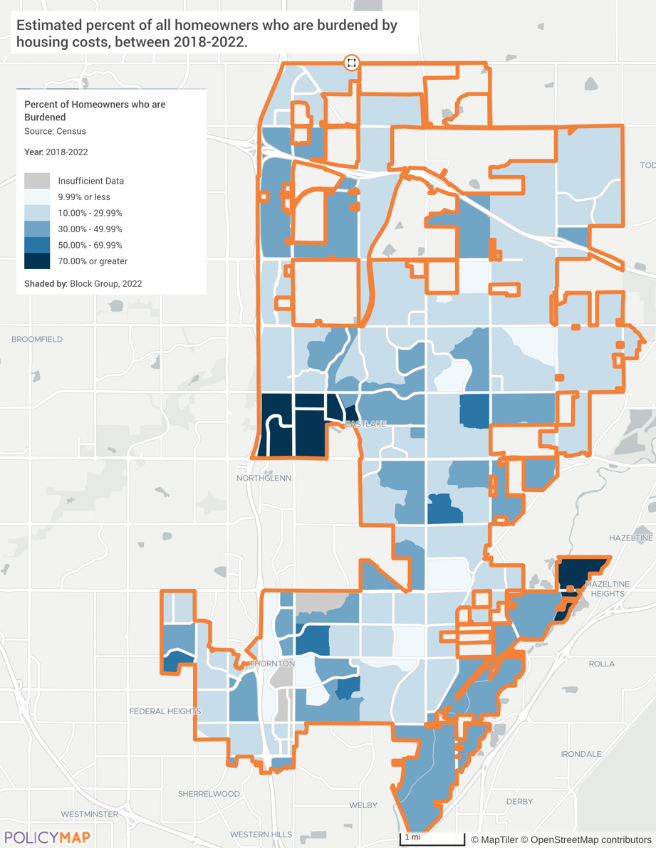

Source: United States Census Bureau ACS 2018-2022 via PolicyMap

Section 5: Rental Market Analysis

Median Contract Rent vs. Median Renter Income
The median contract rent in Thornton rose from $733 in 2012 to $1,095 in 2022, showing an increase of 49.4% and a real increase of 15.6%. Renter-occupied households saw an increase in their median income by 53.6% and a real increase of 18.8% (inflation-adjusted). This real income growth for renters (18.8%) outpaced the real increase in median contract rent (15.6%), indicating that renters' incomes have grown more robustly in real terms. This is a positive citywide trend, however the substantial increase in rental costs continues to impact the lower income households (earning less than 50% median income) which limits their financial abilities and limits their ability to save for future homeownership or other financial goals.
While it is encouraging that renters had a relatively stronger growth in purchasing power, the steep rise in home values and land costs continues to pose significant barriers for renters looking to transition to homeownership. This disparity underscores the challenges renters face in accumulating the necessary savings to purchase a home, even as their incomes have grown more substantially than those of homeowners. Additional data analysis in this section reveals other indicators of affordability challenges for renters citywide.

Table: Median Contract Rent and Median Renter Income
 | 2012 | 2022 | % Change | Change in Real Dollars
Median Contract Rent | $733 | $1,095 | +49.4% | +15.6%
Median Renter Income | $41,699 | $64,034 | +53.6% | +18.8%

Source: 2008-2012, 2018-2022 ACS 5-Yr Estimates (DP04, B25058, B25119); CPI Inflation Calculator

Median Rents Distribution
Between 2012 and 2022 there were several noteworthy shifts in the distribution of rental costs, reflecting broader trends in housing affordability and market dynamics. The data shows a marked increase in the number of rental units in higher rent categories, with a corresponding decrease in lower rent categories.
In 2012, a substantial portion of rental units (41.7%) fell within the $500 to $999 range. By 2022, this percentage had dramatically decreased to just 5.1%, indicating a significant reduction in the availability of lower-cost rental options. Conversely, the proportion of units renting for $1,000 to $1,499 increased from 13.3% in 2012 to 20.1% in 2022, and those renting for $1,500 or more surged from 55.1% to 70.7%.
Additionally, the number of units renting for less than $500 saw a slight increase from 363 units (3.2%) in 2012 to 532 units (4.2%) in 2022, representing an increase of 15 units per year. However, this category remains a small fraction of the overall rental market. Notably, Thornton has 915 units with monthly gross rents exceeding $2,500, highlighting the presence of high-end rental options (this response option did not exist for the 2008-2012 census survey).
The median gross rent, which includes estimated monthly utility costs, reflects these shifts, indicating that renters are facing higher overall housing costs. The increase in higher rent categories suggests rising rental prices and potentially greater financial burdens on renters, particularly those seeking affordable housing options. Affordability challenges for a renter may put down payment savings for a future home purchase out of reach, or it could prevent healthcare or emergency expenses from being met, potentially leading to a cycle of financial instability that increases the risk of eviction and homelessness. This trend underscores the need for policies aimed at increasing the availability of affordable rental housing to ensure that all residents can find suitable and affordable living arrangements.

Table: Median Rent
 | 2012 |  | 2022
 | Number | Percentage | Number | Percentage
Less than $500 | 363 | 3.2% | 532 | 4.2%
$500 to $999 | 4,778 | 41.7% | 655 | 5.1%
$1,000 to $1,499 | 1,521 | 13.3% | 2,568 | 20.1%
$1,500 or more | 6,316 | 55.1% | 9,047 | 70.7%
Total Units | 11,457 | --- | 12,802 | -
No rent paid | 172 |  | 410

Source: 2008-2012, 2018-2022 ACS 5-Yr Estimates (DP04)

Note: Median Rent is calculated based solely on those renters actually paying rent.

Chart: Units by Gross Rent Price Points

Source: 2018-2022 ACS 5-Yr Estimates (DP04)

As seen in the map below, higher rents are more prominent in the northern sections of the city, though there are pockets with high rents elsewhere. Few areas have a median gross rent that is under $1,500. More affordable rental options remain in the southern parts of the city, which is also where older units are built and may require ongoing maintenance or complete renovation in order to stay safe, decent, and feasible for long-term occupancy.

Map: Median Rent
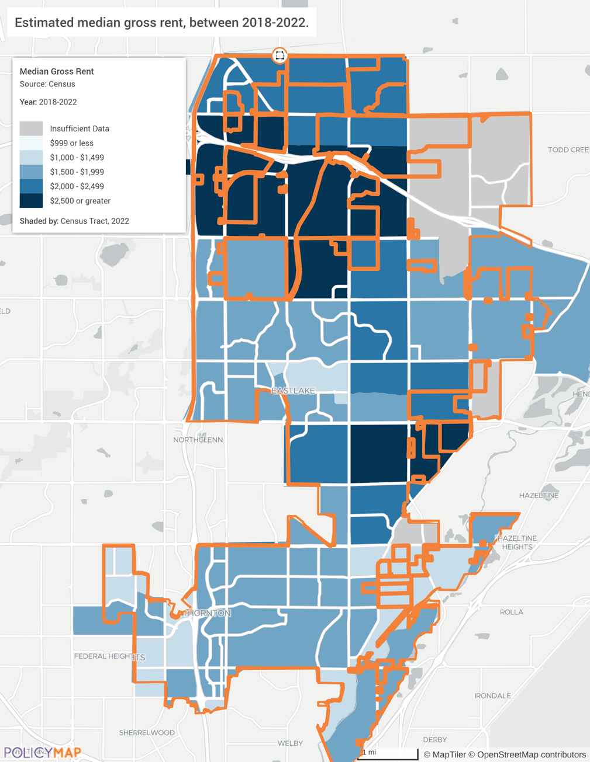

Source: United States Census Bureau ACS 2018-2022 via PolicyMap

Renter Affordability Trends
Previous analyses in this report have primarily used ACS census data to assess trends over the last decade of available information. This section will look at some current estimates based on the Department of Housing and Urban Development (HUD) annual calculations for area median income (AMI) and Fair Market Rents (FMR). These calculations will differ from the ACS 2018-2022 5-Year estimates.
Using AMI and FMRs to analyze Thornton's rental market provides a standardized framework for understanding housing affordability. By comparing local rents and household incomes to these benchmarks, we can identify affordability challenges and determine the need for housing assistance or policy interventions. For instance, if the FMR for a two-bedroom apartment in the Denver-Aurora-Lakewood MSA significantly exceeds what a household earning 50% of the AMI can afford, it highlights a gap that may necessitate increased financial housing support for more affordable housing units. This approach ensures the analysis is consistent with federal standards and can guide local housing policy effectively.

Affordable, But Not Available
The shortage of affordable housing for Thornton's lowest-income renters is exacerbated when considering the actual availability of these affordable homes. In the private market, high-income households often occupy homes that cost less than 30% of their incomes. This practice, while beneficial for those households, creates a significant challenge for lower-income residents.
When higher-income households in Thornton occupy rental units that would be affordable to lower-income households, they effectively remove these homes from the pool of available affordable housing. This phenomenon is particularly problematic for extremely low-income renters in Thornton, who must compete not only with their peers but also with all higher-income households for a limited number of affordable units.
For example, a family in Thornton earning 80% of the Area Median Income (AMI) might choose to rent a home that would be affordable to those earning 50% of AMI, reducing the available stock for lower-income families. Similarly, middle-income households might opt for housing typically affordable to low-income families, further constraining the options for those with the lowest incomes.
This situation creates a cascading effect where the scarcity of truly available affordable housing becomes more acute than raw numbers might suggest. As a result, extremely low-income renters in Thornton face not just a shortage of affordable housing on paper, but a severe shortage of affordable housing actually available in the marketplace.
Addressing this issue in Thornton requires increasing the overall supply of affordable housing and implementing policies that ensure affordable units reach those who need them most. This could include targeted rental assistance programs, income-restricted housing developments, and incentives for landlords to rent to lower-income tenants.

Area Median Income
Area Median Income (AMI) is a metric calculated annually by HUD that represents the midpoint of an area's income distribution. It's based on the median family income for a four-person household in a specific geographic area. AMI is used to determine eligibility for various housing assistance programs and to set income limits for affordable housing initiatives. The geographical areas used to determine AMI are derived from Metropolitan Statistical Areas (MSAs), which encompass large regions that typically include multiple cities and counties with significant economic and social integration. MSAs are used in calculating both AMI and FMRs to reflect the broader housing market conditions. The City of Thornton is part of the Denver-Aurora-Lakewood MSA.
AMI is used to describe “housing affordability” for renter households that fall within specified income limits. The table below shows the AMI and the corresponding affordable rent/mortgage payment (including utilities), which is equal to 30% of the income limit divided by 12 months.

Table: Income Limits And Affordable Rent/Mortgage & Utility Payments
Category | 1-Person | 2-Person | 3-Person | 4-Person | 5-Person | 6-Person
30% AMI | $27,400 | $31,300 | $35,200 | $39,100 | $42,250 | $45,400
(Affordable Rent/ Mortgage Payment) | $685/mo | $783/mo | $880/mo | $978/mo | $1,056/mo | $1,135/mo
50% AMI | $45,650 | $52,200 | $58,700 | $65,200 | $70,450 | $75,650
(Affordable Rent/ Mortgage Payment) | $1,141/mo | $1,305/mo | $1,468/mo | $1,630/mo | $1,761/mo | $1,891/mo
80% AMI | $71,900 | $82,150 | $92,400 | $102,650 | $110,900 | $119,100
(Affordable Rent/ Mortgage Payment) | $1,798/mo | $2,054/mo | $2,310/mo | $2,566/mo | $2,773/mo | $2,978/mo
100% AMI | $91,280 | $104,320 | $117,360 | $130,400 | $140,832 | $151,264
(Affordable Rent/ Mortgage Payment) | $2,282/mo | $2,608/mo | $2,934/mo | $3,260/mo | $3,521/mo | $3,782/mo
120% AMI | $109,560 | $125,160 | $140,880 | $156,480 | $168,960 | $181,560
(Affordable Rent/ Mortgage Payment) | $2,739/mo | $3,129/mo | $3,522/mo | $3,912/mo | $4,224/mo | $4,539/mo
150% AMI | $136,950 | $156,600 | $176,100 | $195,600 | $211,350 | $226,950
(Affordable Rent/ Mortgage Payment) | $3,424/mo | $3,915/mo | $4,403/mo | $4,890/mo | $5,284/mo | $5,674/mo

Source: Based on HUD FY 2024 Income Limits for the Denver-Aurora-Lakewood, CO. mo = month

Fair Market Rents
Fair Market Rents (FMRs) are estimates of the cost to rent a moderately-priced dwelling in a specific housing market. FMRs are determined annually by HUD and include the cost of rent plus essential utilities. These figures are used to set payment standards for housing assistance programs, ensuring the assistance adequately covers the cost of modest rental housing in the area. FMRs are crucial for programs like the Housing Choice Voucher Program, which helps low-income families, the elderly, and the disabled afford decent, safe, and sanitary housing in the private market.
By using the affordability standard that housing costs must account for less than 30% of household income to be considered affordable, the following table assigns the required annual income for the 2024 FMR rates. While the 2018-2022 ACS estimates the median renter household income is $64,034, the 2024 HUD estimated median renter household income from the area median income is $68,345 (Denver-Aurora-Lakewood, CO MSA). An immediate takeaway from either calculation is the average Thornton renter cannot afford FMR rates for one-bedroom or more.

Table: Income Needed to Afford Fair Market Rents (FMR)
 | Efficiency | One-bedroom | Two-bedroom | Three-bedroom | Four-bedroom
FMR | $1,658 | $1,835 | $2,201 | $2,874 | $3,225
Income Needed | $66,320 | $73,400 | $88,040 | $114,960 | $129,000

FY 2024 Denver-Aurora-Lakewood, CO MSA Fair Market Rents *FMRs

Current Rental Market
According to Zillow, the current median market rent for all bedrooms and all property types in Thornton is $2,708. The month-over-month change is - $107 (July 2024 to August 2024) and the year-over-year change is about +$8 (August 2023 to August 2024). This metric refers to the increase or decrease in average rent prices from one time period to the immediately preceding time period. It provides a short-term view of rental market trends and helps track the most recent shifts in pricing. The one-bedroom median rent is $1,649 and the two-bedroom median rent is $2,189. The price range for all bedrooms and all property types is $800 to $7,015. In the last year, rent has increased by $8 compared to the previous year.

Graph: Available Rental Properties at Various Price Range (August 2024)
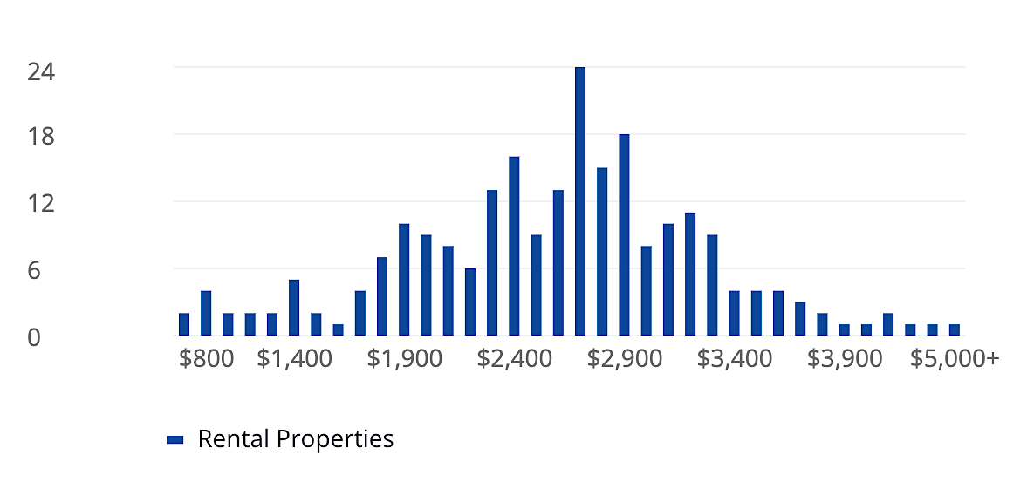
Units

Source: Zillow; Price range for all bedrooms and all property type

Graph: Median Rental Price over Time (August 2024)
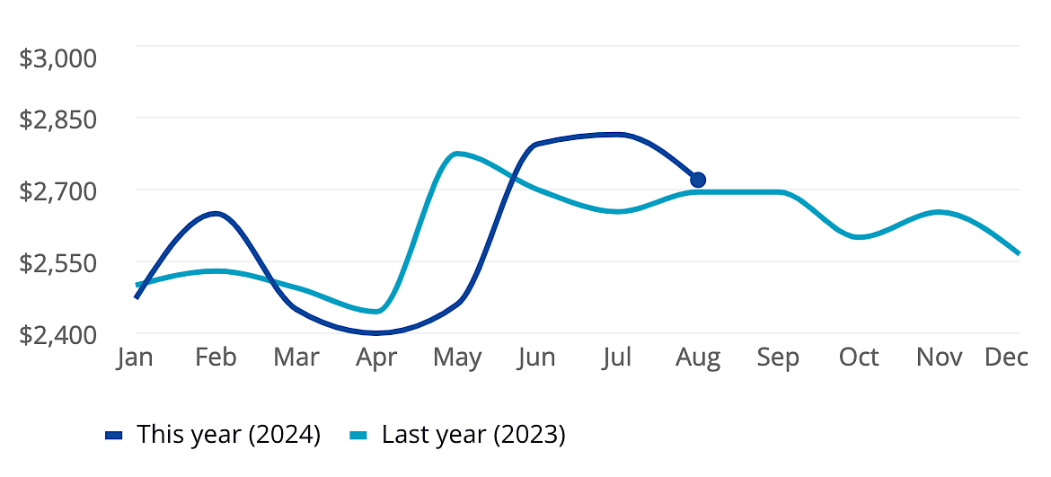

Source: Zillow

Rental Affordability Challenges
This section pulls the previous data points together to form an analysis of housing affordability in Thornton for renters at various income levels. Using the Annual Area Median Income (AMI) of $130,400, the prescribed extremely low-income group (30%) earns an annual income of $39,120 and the low-income group (50%) earns $65,200. The 2024 estimated median renter household income is $60,090. The estimated mean renter wage is $21.32, and Colorado’s minimum wage is $14.42.
Based on these comparisons, Thornton residents face harsh rental housing affordability challenges. The Fair Market Rents are high relative to the income levels of many residents, particularly those earning minimum wage. To afford a two-bedroom apartment at FMR ($2,201), a household would need to earn $88,040 annually, which is nearly $20,000 higher than the estimated MSA median renter household income of $68,345. This disparity indicates an enormous affordability gap for many renters in the area.
The data shows workers earning minimum wage would need to work 117 hours per week or have 2.9 full-time minimum wage jobs to afford a two-bedroom apartment. Even at the mean renter wage, 79 hours of work per week would be required to afford the same apartment.
These findings highlight the need for policies and initiatives to address housing affordability in Thornton, including increasing the supply of affordable housing and providing rental assistance to renters.

Chart: Affordable Rent for Low Income Households

Source: HUD 2024 AMI, 2024 FMR

Cost Burdened Renters
Over 55% of citywide renters are considered cost burdened. This somber percentage indicates most renters, 7,021 rental households, are struggling to afford their housing. This leads to financial instability and limits their ability to spend on other essential needs such as food, healthcare, and education.
Although recent rent costs have seemingly stabilized, providing a temporary reprieve for some renters, the decade-long trend of rising rental prices, as indicated by the increase in median contract rent, suggests that this issue may worsen in the future, making it difficult for renters to find affordable housing options.

Table: Cost Burden
Total Renters Paying Rent | Population Cost Burdened | Percent of Population Cost Burdened
12,622 | 7,021 | 55.6%
Source: United States Census Bureau ACS 2018-2022 (DP04)

Note: Excludes units where gross rent as a percentage of household income (GRAPI) cannot be computed.

House Poor
While we don't have specific survey data for Thornton, many stakeholders have raised concerns about residents experiencing extreme housing cost burdens, sometimes referred to as being "house broke" or "house poor." This situation goes beyond the already concerning severe cost burden level of 50% and can see households allocating an alarming 60-80% of their income to housing expenses, which may include homeowner households and rental households.
Such extreme cases encompass not just rent or mortgage payments, but also property taxes, insurance, maintenance, and utilities. The consequences of this financial strain are severe and far-reaching. Affected households often struggle to pay for other essential needs, face significant difficulty in building savings, and may accumulate debt just to cover daily expenses. This precarious financial situation can have ripple effects throughout the community, impacting local businesses, social services, and overall economic stability. The prevalence of such extreme housing cost burdens in Thornton underscores the critical need for comprehensive affordable housing strategies and support systems for residents facing housing insecurity.

Citywide block groups with higher rates of cost burdened renter households are scattered throughout the city. Cost burdening is a more prominent issue for renters than it is for homeowners.

Map: Cost Burdened Renters by Block Group
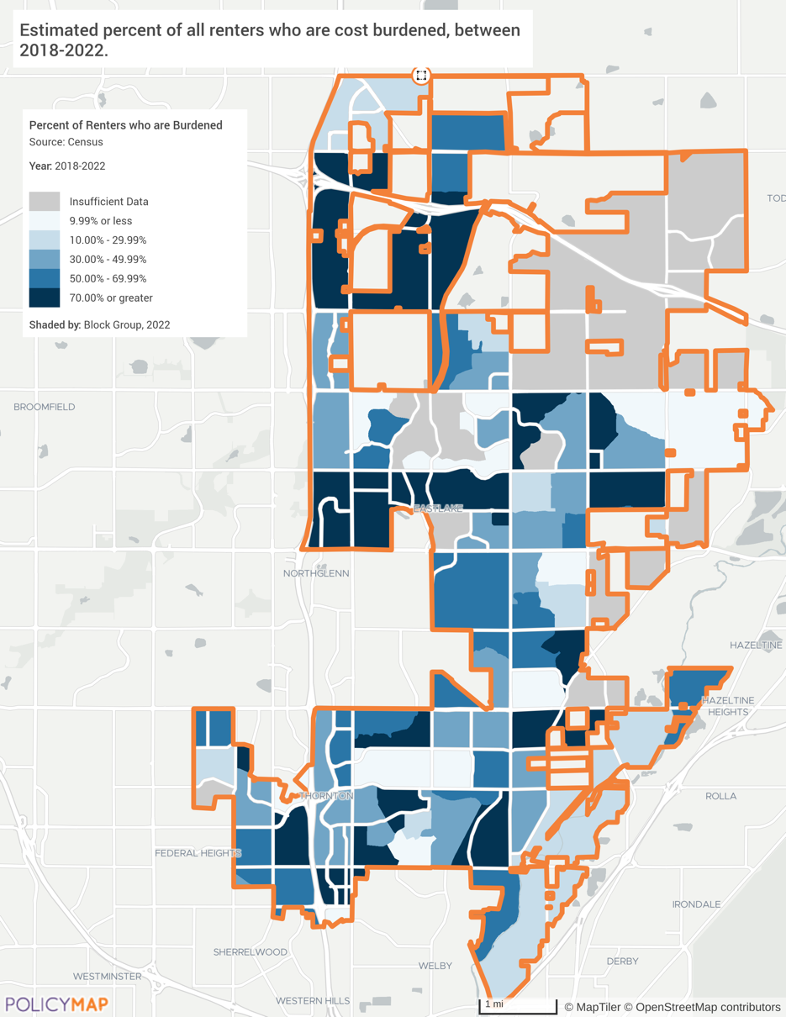

Source: United States Census Bureau ACS 2018-2022 via PolicyMap

Section 6: Public Policy Analysis

City Policy and Programs
The City of Thornton has taken a proactive role to promote affordable housing for its residents and enacted several public policies and programs designed to encourage affordable housing opportunities. These policies reflect, in part, the advice provided by the City’s Balanced Housing Task Force, created in 2017 to increase housing options for low- and moderate-income residents. They are also reflected in the city’s 2020 Comprehensive Plan and as amended in 2023.
Key policies most relevant and beneficial to support the expansion of affordable and fair housing in Thornton include:
Policy 1: Commitment to Sustainability of Housing.
The city is committed to ensuring sustainable developments are available to developers and for residents to have options to a variety of affordable, accessible, and quality housing types. This includes allowing different types of housing to be built throughout the city.
Policy 2: Support for Home Repairs, Home Retention, and Aging in Place.
The city offers HUD-funded repair programs for income-qualified, owner-occupied homes for health, safety, accessibility and energy and water efficiency. This provides needed rehabilitation on the existing housing stock, increasing their value, which promotes reinvestment and improvements in established neighborhoods. These homes are largely not governed by management associations, such as HOAs. The city collaborates with residents, mobile homeowners, neighborhood organizations, and non-profit organizations with the goals of bringing substandard housing into compliance with city codes, and improving the health, safety, accessibility, and efficiency of the home.
Policy 3: Encourage Housing around Major Public Transit Stations (TOD).
The city identified areas around existing and future train stations that can support a greater variety in choice of housing near employment, retail, and/or walkable neighborhoods. This policy seeks to encourage high-density housing and mixed-use development in areas served by or planned for high frequency transit, as appropriate, based on the immediate neighborhood context. The goal is to expand the housing densities and types near commercial uses to increase lifestyle options and economic opportunities within the community.
Policy 4: Support the Diversity of Housing Options.
The city favors a mix of housing options to meet the needs of residents of varied ages, abilities, and income levels throughout the city, including a diversity of rental and ownership housing options that promote varying lot sizes, types, and densities. The city also seeks to discourage the creation of new neighborhoods dominated by a single type of home or dwelling unit and, to the extent feasible, align the mix of housing options provided in new neighborhoods to address the middle housing gaps that exist in the surrounding area.
Policy 5: Widely Distribute Affordable Housing Across the City.
The Comprehensive Plan seeks an equitable and assorted distribution of housing options (e.g., affordable/workforce housing, senior housing, executive housing) throughout Thornton and provides ongoing strategies to achieve these goals with multiple city departments charges with identifying or creating opportunities to attract and facilitate affordable and attainable housing.
Policy 6: Support Age-In-Place Housing.
The City seeks to foster residents to remain in Thornton as their housing needs change over time. Possibilities include providing a diverse mix of housing, from entry-level to senior care facilities, as well as housing preservation and accessibility accommodations to help seniors age-in-place.
Policy 7: Expand Affordable Housing and Support First-Time Homebuyers
In the past the city allocated its Private Activity Bond (PAB) capacity to the Colorado Housing and Finance Authority (CHFA) to support first-time homebuyer initiatives and the issuance of mortgage credit certificates. These allocations have facilitated home purchases for over 400 households through the city's PAB financial assistance.
Policy 8: Improve the Housing Planning Process to Improve Affordability.
The City is updating all the City’s land use, development, and building codes. This started in 2023 and should be completed by 2025. During the revisions, the city is removing unnecessary barriers to diverse, affordable, and innovative housing options throughout the city. This includes increasing residential density, expanding allowable housing types including micro homes and ADUs.

Development Code Review
The City of Thornton and their consultant’s review of the land use and development codes published recommended updates. A review of the draft updates identified the following areas where the existing code should be amended:
- Expediting reviews with definitive review deadlines and procedural elements to provide more certainty in the time frame for new development.
- Reducing lot sizes to increase density and lower the cost of each housing unit developed;
- Allowing residential uses within non-residential areas to accommodate the opportunity for affordable rental units;
- Reducing parking space requirements to accommodate more efficient land use; and
- Expanding city staff approvals, especially where no rezoning is required, to streamline development processes. The city sought and received a Local Government Capacity Building grant from the Colorado Department of Local Affairs. This grant assists the city in developing a streamlined process to work with developers bringing the affordable housing development review time down to 90 days or less, once the property is properly zoned.
More specifically, these recommendations are tied to the following code sections.
- Section 18-37 Comprehensive Plan Amendments and Section 18 – 41 Zoning Amendments.
Recommend a definitive time frame for consideration and action by the Planning Commission and City Council. Suggest no later than 45 days within submittal of a completed application.

- Section 18-42 a.4. Planned Development (PD). Dwelling Unit (DU)

Regulation On: | Existing Limits for PD Districts | Recommended
Residential Lot Sizes | Minimum 950 sq. ft./DU | Reduce minimum sq. ft.
Density | Maximum 1.0 FAR; 25 DUs/acre | Increase DUs/acre where affordable housing in proposed (see comment below)
Coverage | Maximum 75% | Increase % where affordable housing in proposed

- Section 18-42 b.4. Planned Development.
The director shall provide written comments in no more than five (5) business days of the preapplication meeting.

- Section 18-42 c.4. Planned Development: Standards for Approval.
Add a time frame: The commission shall consider and make recommendations in no more than 45 days upon submittal of a completed application.

- Section 18-42 c.4. Planned Development: City Council Review.
Add a time frame: The City Council shall consider and make recommendations in no more than 45 days upon consideration and action by the planning commission.

- Section 18.43.a.4.
Expand administrative review for affordable housing projects if the zoning is consistent with the Comprehensive Plan.

- Sections 18-90, 18-91, 18-92 and 18-93
Amend to state that residential uses are permitted in all non-residential zoning districts where the residential use is intended to accommodate employees within or immediately adjacent to the zoning district;

- Section 18-596. Off Street Parking Requirements.
Reduce off-street parking standards to enable denser use of land and consistent with encouraging alternative transportation including:
- Office: reduce from 1 parking space for 333 square feet to 1 space for 350 square feet.
- Multiple dwellings: reduce from 1 parking space for each 500 square feet of floor area based on the number of bedrooms and the type of multi-family project as follows:

Multi-Family Use: | 1 bedroom | 2 bedrooms | 3 or more bedrooms
Duplex, Triplex | 1.8 parking spaces | 2.0 parking spaces | 2.1 parking spaces
Townhomes | 1.8 parking spaces | 2.3 parking spaces | 2.4 parking spaces
Apartment building | 1 parking space | 1.3 parking spaces | 1.9 parking spaces
Source: New Jersey Admin. Code § 5:21-4.14

- General Merchandise and Home improvement: 1 reduced space for every 250 square feet to 1 space for every 300 square feet.

- Reduce minimum floor area for residential structure from 1,000 square feet on single family detached and 800 square feet for single family attached by 10% to 20% to better accommodate a variety of housing and increase affordability.

- Multifamily residential development standards should be amended to facilitate higher density and more intense use of land including:
- Reduce multifamily residential side yards requirements from 15 feet to 10 or 12 feet.
- Increase Mixed Residential Neighborhoods (MRN) and Mixed-Use Neighborhoods (MUN) 18 units per acre to 20 or 22 dwelling units per acre.
- Increase lot coverage from 60% of site for residential structures to 65% of site.

New Statewide Land Use and Housing Laws
The following section describes five new Colorado laws affecting land use and housing, along with their potential impacts on housing development, particularly for affordable housing.
HB 24-1007: Residential Occupancy Limits
This law, known as the HOME Act, prohibits local governments from limiting the number of unrelated people who can live together in a single dwelling based on familial relationships. Local governments can still enforce occupancy limits based on health or safety standards, such as building codes and fire regulations.
Impact: This law should increase housing affordability by allowing more people to share housing costs, thus making it easier for low-income individuals and families to find affordable housing options.
HB 24-1304: Minimum Parking Requirements
This law eliminates minimum parking requirements for multi-family residential developments and adaptive reuse projects within a quarter mile of certain transit stops in metropolitan planning areas. Local governments can still enforce maximum parking requirements and requirements for bicycle parking.
Impact: By reducing the cost and space needed for parking, this law encourages the development of more affordable housing units and promotes the use of public transit.
HB 24-1152: Accessory Dwelling Units (ADUs)
This law requires Colorado's largest cities to allow the construction of accessory dwelling units (ADUs) on single-family lots, with sizes ranging between 500 and 800 square feet. The law aims to simplify the approval process and reduce associated costs.
Impact: ADUs can increase housing density without significant infrastructure changes. They provide needed living spaces for elderly relatives, care givers, other family members, and encouraging multigenerational living. It will also provide more affordable rental housing options bringing needed additional income to the homeowners.
HB 24-1313: Transit-Oriented Communities
This law promotes higher residential density near transit lines by setting a goal of 40 units per acre and requiring cities to submit housing opportunity goals and strategies to mitigate displacement. The law also includes a continuously appropriated $35 million grant fund to improve infrastructure in transit areas.
Impact: By encouraging denser development near transit, this law aims to create more affordable housing options, reduce traffic congestion, and increase public transit use.
SB 24-174: Sustainable Affordable Housing Assistance
This law provides technical assistance and funding to local governments for creating and implementing housing needs assessments, housing action plans, and strategies to mitigate displacement. It also prioritizes grant funding for local governments that comply with these requirements.
Impact: This law supports local governments in planning and implementing sustainable affordable housing, to help meet the current housing needs, and displacement risks are minimized.

Impact on Thornton
While specific impacts on Thornton are yet to be determined, these laws collectively aim to increase housing affordability and availability across Colorado. Thornton, being the 6th largest city in the state and part of the Denver metropolitan area, will likely see increases in affordable housing because of these laws.

Development Fees and Taxes Impact on Housing Development
The Denver metro area has seen a noteworthy increase in water/sewer tap fees in recent years, with costs rising dramatically and impacting housing affordability. For example, in Arvada, tap fees for a newly built single-family home increased from $25,000 to $54,000 in 2022, while Castle Rock's utility system fees rose from $37,067 in 2022 to $42,097 in 2023. These fees can now represent about 10% of the overall price of a new home, exacerbating affordability issues in the region.
The rising costs are primarily due to water scarcity, aging infrastructure needs, rapid population growth, and water conservation efforts. While these fees provide necessary funding for water infrastructure, they also contribute to rising housing costs and may impact development patterns. Thornton’s water connection fees increases were phased in over three years; effective January 1, 2022, January 1, 2023, and January 1, 2024. During that time, the fee increases have ranged from about 30% to over 50%. For example, the fees for a mobile home increased from $11,885 in 2021 to $17,940 in 2024. Multiple city stakeholders interviewed cited high water/sewer tap fees as an additional barrier to affordable housing development.
Thornton's efforts to secure water resources for future growth have faced significant legal and logistical challenges, particularly concerning the construction of a crucial water pipeline from Larimer County. This ongoing dispute over water rights and pipeline construction delayed new housing developments which exacerbating the housing shortage in the city.
Thornton acquired 19,000-acre-feet of water rights from Larimer County in the 1980s to accommodate future growth. However, the city has faced strong resistance from local residents and environmental groups regarding the construction of a pipeline to transport this water. The primary concern is the potential adverse effects on wildlife and residents along the pipeline's route. After several public meetings and cooperative accommodations by the city, Larimer County commissioners recently approved a revised proposal for the pipeline, which includes several concessions to address community concerns.
The revised pipeline route, which is 16.6 miles shorter than the original proposal, has been designed to minimize impact on residential areas and includes numerous conditions to address environmental and community concerns. These conditions include retaining experts to protect soil health and allowing for adjustments to the pipeline alignment with property owner approval. Despite these efforts, environmental groups like Save the Poudre continue to oppose the project, arguing that using the Cache la Poudre River channel for water delivery would be a more environmentally friendly solution.
The inability to access these water resources reduces housing development in Thornton. Developers emphasized the lack of water stalled their plans for affordable housing and other important developments. For instance, Chad Murphy, managing director at Hines, highlighted that their plans for an 800-acre, 4,000-home neighborhood known as Parterre are on hold due to the water dispute. Similarly, Adam Zard from Maiker Housing Partners noted that an 80-unit affordable housing project near an N-Line rail station in Thornton is also delayed.
Construction on other sections outside of Larimer County has already begun. The entire waterline should be operational by 2027. Thornton is expected to add approximately 50,000 to 65,000 new residents by 2040. Accommodating this growth will require between 20,000 and 25,000 new homes, as well as a range of jobs and services. It will enable Thornton to utilize into the new water source, facilitating the construction of thousands of homes and helping to address the rising costs of housing in the city. However, the ongoing community opposition suggest the path forward may still have difficulties.

Stakeholder Input
To gain a comprehensive understanding of the city's housing needs, 47 interviews were conducted with city stakeholders and 20 with city staff. The insights reveal a consistent theme of inadequate affordable housing both for renters and homeowners. The rising costs of housing, coupled with stagnant incomes, made homeownership increasingly difficult if not impossible. The demographic shift, with more people moving to suburbs, has exacerbated the situation, leading to increased demand and limited supply.
The City of Thornton and the Denver metro area, face high eviction rates, especially in mobile home parks where rule enforcement is strict. The average eviction judgment amount may not be as much as you would think. According to 2023 data from the 17th Judicial District, the average judgment amount, or the amount that the judge rules a tenant owes to avoid an eviction, is approximately $3,886. For many, falling one paycheck behind is the difference between housing and homelessness. According to the local CBS News – Channel 7, Denver County Court has seen more eviction case filings in 2023 than any other year since the 2008 housing crisis.

Housing Needs and Gaps
- Affordability: There is a pressing need for affordable rents, particularly for low-income and vulnerable populations. The lack of affordable rents for those earning 30% of the Area Median Income (AMI) or lower is an acute concern.
- Accessibility: Stakeholders highlighted various accessibility issues, including the need for home accessibility modifications for seniors and disabled persons, lack of public transportation near affordable housing, and difficulties in accessing housing resources. The complexity of application processes and the need for human assistance in navigating housing services were also emphasized.
- Supply Shortages: The inventory of affordable housing is insufficient, with a particular need for starter homes and units for seniors. The "missing middle" housing gap is evident, as people cannot afford to move from starter homes to larger properties. This shortage is exacerbated by rising property values and competition from corporate, out-of-state buyers.
- High Eviction Rates: Evictions are prevalent, particularly in mobile home parks in Thornton and the Denver metro area. The primary cause is nonpayment of rent due to the dramatic increases pad rent, utility cost, and the exorbitant cost to move the mobile home ($5,000 - $14,000).
- Rule Enforcement: Strict enforcement of mobile home park and HOA rules, often involving legal representation, disproportionately affects monolingual Spanish-speakers and the elderly.
- Rising Costs: Homeownership is becoming increasingly difficult due to high home prices, interest rates, property taxes, development fees, HOA fees, and property taxes.
- Income Disparities: The gap between housing costs and stagnant incomes is widening, making affordable housing less accessible.

Barriers to Development
- Regulatory and Financial Barriers: Developers face numerous challenges, including annexations, zoning regulations, development fees, and financing difficulties.
- The "Not In My Back Yard" (NIMBY): Opposition to new housing developments also poses a significant barrier to developing affordable housing.
- Lack of Transitional and Supportive Housing: There is a gap in transitional housing options for individuals transitioning out of homelessness or requiring temporary assistance. Longer term supportive housing with integrated services is also lacking.

Positive Aspects and Collaborative Efforts
- Community Engagement: Various stakeholders, including nonprofit and faith-based organizations, city staff, seniors, and developers, are actively collaborating to address housing needs. Successful models from other cities, like Fort Collins' land banking program, should be studied and if compatible, applied to the city’s housing plan.
- Past Successes: Some past projects, such as the Avilla development and Crossing Pointe, have been highlighted as successful and affordable, offering diverse housing options and integrating transportation and energy efficiency features.

Policy and Program Recommendations
The final strategy recommendations for Thornton's housing needs incorporate many of the valuable suggestions provided by residents and stakeholders during the interview and survey process. These recommendations focus on several high-level, high-impact actions designed to address the most pressing housing challenges in the community. However, it's important to note not all suggestions are directly reflected in the primary recommendations, this does not diminish their potential value or relevance. The additional solutions mentioned by stakeholders, though not featured in our main recommendations, remain worthy of consideration and may be revisited as the housing landscape evolves.

- Policy and Zoning Innovations
- Land Use:
  - Utilize city-owned land with affordability restrictions to maintain long-term affordability. Partner with other jurisdictions such as the county and school districts to utilize their land for affordable and restricted housing.
- Land Trusts and Land Banks:
  - Partner with land trusts and land banks to encourage new housing development, reduce costs, and promote sustainable affordable housing development
  - Fort Collins' land banking program was mentioned as a successful model.
- Accessory Dwelling Units (ADUs):
  - Encourage the development of ADUs to increase housing density without major infrastructure changes. Encouragement could include financial assistance, free pre-approved building plans, the use of modular homes, and providing an expedited process.
  - Recent state law changes have made it easier to build ADUs and reduce parking requirements.
- Financial Strategies
- Funding and Incentives:
  - Leverage Community Development Block Grants (CDBG), HOME funds, Private Activity Bonds, Low-Income Housing Tax Credits (LIHTC) and Proposition 123 funds to support affordable housing developers.
  - Waive development fees and provide tax incentives to attract quality developers and lower the costs for affordable housing projects.
  - Consider using CDBG, HOME, and other funding sources to cover tap fees.
- Down Payment and Rental Assistance:
  - Provide funding for down payment assistance programs to help lower income home buyers.
  - Greatly expand funding to rental assistance program partners to prevent evictions and reduce homelessness.
- Innovative Housing Models
- Mixed-Income and Mixed-Use Developments:
  - Support mobile homeowners that want to purchase their parks.
  - Develop mixed-income housing to integrate diverse economic groups and promote community cohesion.
  - Encourage mixed-use developments that provide residents with access to essential services and employment opportunities.
- Alternative Housing:
  - Explore micro home villages and co-housing developments as alternative affordable housing solutions.
  - Pursue modular housing to increase development speed, reduce costs and increase energy efficiency.
  - Remain open to new housing ideas such as kit homes, vehicle-based housing, safe parking areas for those living in their vehicles, campers or RVs.
  - Provide transitional housing for the homeless and emergency shelters for specific populations like runaway teens, families with children and the elderly.
  - Promote communal living arrangements to reduce costs, combat loneliness, and enhance community support.
- Community and Stakeholder Engagement
- Partnerships and Collaboration:
  - Strengthen partnerships between city staff, developers, faith-based, nonprofits, and community organizations to address housing needs collaboratively.
  - Seek partnerships with key employers, banks, and other financial institutions to find financial packages for desired developments.
  - Engage resident advocacy efforts to support affordable housing initiatives and reduce stigma.
- Education and Awareness:
  - Implement educational programs to raise awareness about affordable housing benefits and reduce NIMBYism.
  - Provide housing education on a wide range of topics including, eviction prevention, budgeting to make home repairs, first-time homebuyer, resources available, rights and responsibilities – especially for mobile home parks, and fair housing regulations and assistance.
  - Encourage community involvement in planning and decision-making processes.
- Successful Models and Best Practices
- Adoption of Successful Programs:
  - Study and consider adopting successful models from other cities, such as Alamosa's density scoring system. Durango’s micro home community, the Portland Twenty small-scale multi-family housing, and Denver's hotel-to-housing conversions.
  - Implement transitional housing programs with integrated support services, like Boulder’s SPAN initiative.
- Form an Action Plan

- Develop a unified strategy to address housing challenges, including:
- Creating a funding application schedule for housing initiatives
- Establishing diverse partnerships with trusts, banks, developers, and community organizations
- Implementing educational materials, courses and event for residents, property managers, and potential developers on housing related topics.
- Conducting targeted outreach to raise awareness and gather community input
- Researching and visiting successful affordable housing developments for best practices
- Identifying and removing barriers to affordable housing development and access

Section 7: Key Findings

Finding 1: Current Housing Supply-Demand Mismatch Fuels Affordability Crisis
The analysis of Thornton's homeownership market reveals a substantial mismatch between housing supply and demand across various income cohorts, highlighting a critical affordability crisis in the city, particularly for lower-income households. The housing market does not restrict households from purchasing homes at price points well below their income levels, nor does it prevent them from purposely buying above what is typically considered affordable.

Home Ownership – Home Affordability Supply Gap Analysis
A review of the availability of homeowner housing by cost in Thornton shows a tremendous need for affordable units within the recommended price points for lower-income households. For this supply analysis, we assume an ideal scenario where no household is burdened by housing costs; this approach provides us with an estimate of the unit supply gap or surplus.
The following section highlights households divided by income ranges (based on median household income (MHI)) and the total units currently built within those affordability ranges, based on the 30% cost burden threshold. Assuming all households either desire to continue as homeowners or to become homeowners, our analysis reveals a NET shortage of 9,016 affordable homeownership units. There is a deficiency of available houses for income groups below 100% MHI. In total, nearly 22,000 affordable units would be required to meet the homeownership needs of the population below the median income level.
The most severe shortages are concentrated in the low to moderate income brackets (0-80% MHI), with a combined deficit of 14,927 affordable units. The extremely low-income group (0-30% MHI) faces a shortage of 3,603 units priced below $37,500, while the very low-income group (31-50% MHI) lacks 3,484 units in the $37,500-$92,500 range. The largest gap is observed in the low to moderate income bracket (51-80% MHI), with a deficit of 7,840 units for homes priced $92,500-$175,000.
The middle-income cohorts present a mixed picture. The lower middle-income group (81-100% MHI) experiences a significant shortage of 6,985 units priced $175,000-$230,000. However, a stark change occurs at the upper middle-income level (100-120% MHI), where a surplus of 4,195 units in the $230,000-$375,000 range is observed. This trend continues into the upper income brackets, with substantial surpluses in the 120-150% MHI (4,831 units) and 150%+ MHI (3,870 units) categories.

Table: Supply-Demand Gap by Affordability in Thornton’s Owner’s Market, 2022
Income Cohort | # of Households | Affordable Mortgage | # of Units | Unit Supply
0% - 30% MHI | 4,724 | $0 - $37,500 | 1,121 | -3,603
31% - 50% MHI | 4,699 | $37,500 - $92,500 | 1,215 | -3,484
51% - 80% MHI | 8,603 | $92,500-$175,000 | 763 | -7,840
81%-100% MHI | 7,591 | $175,000-$230,000 | 606 | -6,985
100%-120% MHI | 3,391 | $230,000-$375,000 | 7,586 | +4,195
120%-150% MHI | 6,782 | $375,000-$500,000 | 11,613 | +4,831
150%+ MHI | 16,068 | $500,000 or more | 12,198 | -3,870

Source: United States Census Bureau ACS 2018-2022; Civitas, LLC

As mentioned, the overall homeownership market in Thornton faces a NET shortage of 9,016 affordable units, with 51,858 households potentially competing for only 35,102 available houses they can afford to purchase. This affordability shortage is unevenly distributed, with a stark contrast between the deficit of 21,912 units for households earning up to 100% MHI and a surplus of 12,896 units in higher price ranges. The actual need for affordable housing is likely much greater than these numbers suggest. Homeowners often look for housing below their maximum financial limit. This means households in the 100%+ MHI groups likely compete with lower-income households for more affordable units, potentially reducing availability even further for those with limited means.

An important factor to consider is the concept of "locked-in affordability." Many current homeowners purchased their homes 20 or 50 years ago when prices were significantly lower. While this provides an advantage for these long-term homeowners, it creates a disadvantage for new buyers entering the market. As housing prices increased over time, the availability of affordable stock is restricted not only in terms of sales but also in terms of affordability for new purchasers.
The imbalance between the surplus in higher-priced units (12,896) and the deficit in affordable units (-21,912) further exacerbates the situation. Even households who can afford more expensive homes may opt for lower-priced options, intensifying competition for the limited supply of affordable units.

Chart: Owner Unit Affordability Supply Gap

Source: Source: United States Census Bureau ACS 2018-2022; Civitas, LLC

Data Notes:

- Affordability based on 28% of income going to housing costs (including utilities) allowing variance for taxes, utilities, etc.

- The affordable mortgage cost is determined after removing average utilities and assuming a 20% down payment.

- Only to meet the current need, does not factor in the estimated future units.

Renter – Unit Affordability Supply Gap Analysis
An examination of Thornton's rental market reveals a significant mismatch between affordable housing supply and demand, particularly for lower-income households. The median household income for renters is $64,304 (2022 ACS), but the distribution of affordable units across income cohorts is highly uneven.
The analysis shows a NET deficit of 409 affordable units across all income ranges, highlighted by a severe shortage of 3,000 affordable rental units for households earning below 80% of the MHI. This shortage is exacerbated by the concept of "affordable but not available," where units that are presumably affordable to lower-income households are occupied by higher-income renters. This phenomenon particularly impacts the lowest income brackets, further reducing their already limited options. The surplus of units in the 81% through 150% MHI income cohorts indicates this may be ongoing at multiple levels.
For the 0-30% MHI cohort, there's a deficit of 1,082 rental units priced at $0-500 per month. This gap is critical, as these households are at the highest risk of housing instability and homelessness. The shortage continues in the 31-50% MHI bracket with a deficit of 1,101 units in the $500-$800 range, and in the 51-80% MHI bracket with a shortfall of 1,035 units priced $800-$1,250. The reduction in high-density housing, with 20 or more-unit buildings decreasing over the last decade, likely exacerbates the affordability crisis. These larger buildings often provide more affordable options, and their decrease limits the supply of potentially affordable units. This situation puts significant pressure on the most vulnerable renters and calls for targeted interventions to increase the supply of truly affordable and available rental units, particularly for households earning below 80% MHI

Table: Supply-Demand Gap by Affordability in Thornton’s Rental Market, 2022
Income Cohort | # of Households | Affordable Rent | # of Units | Unit Supply
0% - 30% MHI | 1,614 | $0-500 | 532 | -1,082
31% - 50% MHI | 1,386 | $500-$800 | 285 | -1,101
51% - 80% MHI | 2,303 | $800-$1,250 | 1,268 | -1,035
81%-100% MHI | 1,426 | $1,250-$1,600 | 2,696 | 1,271
100%-120% MHI | 1,371 | $1,600-$1,900 | 3,078 | 1,708
120%-150% MHI | 1,843 | $1,900-$2,400 | 3,427 | 1,584
150%+ MHI | 3,269 | $2,400 or more | 1,515 | -1,754

Source: United States Census Bureau ACS 2018-2022; Civitas, LLC

The "affordable but not available" concept is obvious in the middle-income ranges. While there's a surplus of 1,271 units in the 81-100% MHI bracket and 1,708 units in the 100-120% MHI bracket, many of these units are likely occupied by higher-income households who choose to rent below their maximum affordability. This creates a cascading effect, where each income group occupies units affordable to the group below, ultimately leaving the lowest-income renters with the fewest options. This barrier is even more pronounced due to the requirements of paying three months' rent upfront (first month's rent, last month's rent, and security deposit) and the stipulation that one’s income must be at least three times the monthly rent, which creates a major obstacle to renting and gives higher-income individuals a significant advantage over lower-income renters.
Interestingly, there's also a deficit of 1,754 units for the highest income bracket (150%+ MHI), suggesting a lack of high-end rental options where demand might otherwise be present. This could further contribute to higher-income households occupying units that would otherwise be available to lower-income renters.

Chart: Rental Unit Affordability Supply Gap

Source: United States Census Bureau ACS 2018-2022; Civitas, LLC

Finding 2: Housing Production Needs Greatly Outpace Current Supply Rate
The following section illustrates a simplified supply/demand forecast model for Thornton's housing unit production needs over the next 10 years. This model incorporates recent trends, 10-year trends, and additional factors such as population movement, mortality rates, and the impact of mortgage rates on renter proportions. It does include the affordability thresholds of various income ranges.

Population and Household Growth Projections
The City of Thornton experienced a 19.4% population growth from 2012 to 2022, increasing from 118,747 to 141,799 residents. Using this growth rate, we can project:
- 2027 (5-year) population: ~153,408
- 2032 (10-year) population: ~169,482

Household growth outpaced population growth slightly, increasing by 20.4% from 40,253 to 48,466 households between 2012 and 2022. Projecting this trend forward:
- 2027 (5-year) households: ~53,452
- 2032 (10-year) households: ~58,353

Factors Affecting Housing Demand
1. Changing Household Composition: The proportion of family households decreased from 74% to 71% between 2012 and 2022, indicating a trend towards smaller household sizes and housing cost sharing among roommates.
2. Household Size: There's been a slight decrease in overall household size (2.94 to 2.91), with a more pronounced decline in renter household sizes since 2016 (2.99 to 2.74).
3. Housing Tenure: As of 2022, 72.7% of housing units were owner-occupied, while 27.3% were renter occupied.
4. Property Type Changes: There's been an increase in medium-density housing (5-9 units) and a decrease in high-density units (20+ units).
Housing Unit Production Forecast
Based on these factors, we can estimate the number of new housing units needed:
1. Base Demand: The difference between 2032 and 2022 household numbers suggests a need for approximately 9,887 new units over 10 years (58,353 - 48,466).
2. Adjustments:
- Smaller household sizes may increase demand by about 2-3%: ~200-300 additional units
- Shift towards rentals due to high mortgage rates: ~5% increase in rental units, or ~500 units
- Replacement of aging housing stock: ~1% of existing stock over 10 years, or ~500 units
- Buffer for healthy vacancy rate (5%): ~500 units

3. Total Estimated Need: Approximately 11,500-12,000 new housing units over the next 10 years irrespective of household income levels.

Recommended Housing Mix
Given the current trends in household composition and property types the below would serve as a status quo baseline as it relates to single-family homes compared to both medium and higher density units:
- 60% Single-family homes (detached and attached): ~7,000 units
- 25% Medium-density units (2-9 units): ~3,000 units
- 15% High-density units (10+ units): ~1,750 units

However, as previously mentioned, there are innovative housing solutions that can significantly enhance Thornton's housing diversity and affordability. By integrating missing middle housing—such as duplexes, townhomes, co-housing, and smaller multifamily buildings—the city can provide a broader range of options for different household sizes, resident ages, and income levels. An alternative approach might see 30% as medium density and only 55% for single-family. Additionally, promoting the inclusion of Accessory Dwelling Units (ADUs) can increase the availability of affordable rental units and support multi-generational living arrangements.
Expanding the housing portfolio to include manufactured homes and mobile homes offers cost-effective alternatives to traditional housing, catering to residents seeking more affordable living solutions.
Annual Production Targets
To meet this demand, Thornton should aim to produce approximately 1,150-1,200 new housing units per year, distributed across various housing types to match the recommended mix. This forecast model considers Thornton's current growth trend, changing household dynamics, and external factors affecting housing demand. It's important to note this is a projection based on analysis of the trends between 2012 to 2022 using available Census data and should be regularly reviewed and adjusted as new data becomes available or as economic conditions change.
By embracing more innovative housing types and incentivizing affordable housing, Thornton can better meet the evolving needs of its population, alleviate housing affordability pressures, and create a more inclusive and resilient community. Diversifying the housing stock not only addresses current shortages but also positions Thornton to accommodate future growth and demographic changes effectively.

Finding 3: Rising Housing Cost Sharply Outpaces Income Growth
The data reveals a critical issue: the rising costs of housing in Thornton have significantly outpaced the growth in median incomes for both current homeowners and potential homeowners. In the homeownership market, the dramatic increase in median home values, which more than doubled in a decade, far exceeds the growth in median incomes. This widening gap creates substantial barriers for potential homebuyers and increases financial pressure on existing homeowners. Fixed-income households, such as retirees without mortgages, are also burdened by increasing property taxes and maintenance costs.
Property taxes are a primary driver of Colorado homeowners’ cost of living increase this year. Property taxes alone account for 17% of the increase in household expenses this year. For decades, the calculation of residential property taxes in Colorado was dictated by a voter-approved formula known as the Gallagher Amendment. Repealing the Gallagher Amendment in 2020, without a replacement, risks uncontrolled increases in property taxes.
Estimates from the Colorado Legislative Council staff indicate the residential property assessed value increased over 27% in 2023. Property taxes combined with other housing expenses accounted for 66% of the increase in average homeowner expenses. Between 2024 and 2026, homeowners face an estimated 32% to 54% cumulative increase in their property tax bill for a $500,000 home.
https://www.commonsenseinstituteus.org/colorado/research/taxes-and-fees/colorado-property-tax-primer
Adams County has one of the highest property tax rates in Colorado, with an average effective rate of 0.78%. This translates to a median tax bill of around $2,621 for homeowners in the county.
In the rental market, while rent increases have been less severe than home value appreciation, they still outpace the income growth of renters. The disconnect between Fair Market Rents and median renter incomes highlights a major affordability gap, particularly for low and extremely low-income households, whose earnings fall far short of what's needed to afford market-rate housing. Even households earning median incomes struggle to afford average rents or home prices. Renters face difficulties saving for down payments, while homeowners encounter rising costs that could exacerbate wealth inequality and limit economic mobility.
The ripple effects of this crisis extend to various aspects of community well-being and may have complex effects on social, economic, and environmental factors. When residents are forced to spend larger portions of their income on housing costs, they often have less to spend on other essentials and services in the community, such as food, medication, education, and transportation. This can lead to higher rates of housing instability and homelessness.
Research indicates that housing instability is associated with poorer health outcomes, decreased educational attainment for children, and reduced economic mobility. Additionally, the shortage of affordable housing options can lead to overcrowding and substandard living conditions, particularly for low-income households. This gap can also lead to economic inequality and greater strain on the labor market, as workers are forced to live farther away from their employment.

Finding 4: There is a Shortage of Missing Middle Housing Development
Thornton's housing market faces significant challenges in developing missing middle housing, crucial for addressing affordability and diversity in housing options. Middle housing, defined as housing types that fall between single-family detached homes and large multifamily apartment complexes, has seen a decline in availability across Colorado, particularly in condominium construction. This shortage is not merely a market preference for single-family detached units but stems from a complex relationship of factors.
Restrictive zoning laws, high construction liability insurance costs, and public opposition to higher-density housing (Not in my backyard - NIMBY-ism) have stifled the development of condominiums and other middle-density housing types. Additionally, state laws that disincentivize condominium construction have further limited this crucial and popular housing option. This trend, largely attributed to stringent construction defect laws like the 2001 Colorado Construction Defect Action Reform Act (CDARA), increased litigation risks and insurance costs for developers, making condo construction less appealing. This contributed greatly to the shortage of affordable homeownership options.
The missing middle housing shortage in Thornton reflects broader trends seen in many growing cities where the housing market struggles to provide a full range of options between single-family homes, apartments, and innovative forms of affordable housing. This gap not only affects housing affordability but also impacts community diversity, walkability, and overall urban design. The lack of these housing types of limits options for various demographic groups, including young professionals, growing families, and seniors looking to downsize, potentially forcing them to seek housing outside the city. This loss of local residents working, living, shopping, and contributing to the city is costly.

Finding 5: Infrastructure Costs Significantly Impede Housing Development
Infrastructure challenges and escalating utility costs in Thornton present substantial barriers to affordable housing and community development, especially amid disputes over crucial water resources. Stakeholders have identified various infrastructure demands that complicate housing affordability and new development. Thornton's efforts to secure water resources for future growth have encountered significant legal and logistical obstacles, creating a complex impediment to housing development for several years.
The dispute over water pipeline construction in Larimer County delayed new housing projects and dramatically increased costs, exacerbating the housing shortage and affordability crisis. These challenges have stalled both market-rate and affordable housing developments.
Compounding the issue is the broader trend of rising water/sewer tap fees across the Denver metro area, now accounting for approximately 10% of a new home's price. Water connection charges—also known as tap fees, impact fees, system development charges, or plant investment fees—are one-time fees assessed to new developments to cover the costs of connecting to a utility’s water system and supporting the necessary infrastructure and water resources capacity. These charges provide utilities with essential revenue for water system infrastructure and can be structured to influence water demand in new developments.
The impact is particularly severe for Thornton, with several projects on hold due to water uncertainty. This situation is compounded by the broader trend of rising water tap fees across the Denver metro area, which can now represent about 10% of a new home's price. Water connection charges — also called tap fees, impact fees, system development charges, or plant investment fees — are one-time charges assessed to new developments to help pay for the direct costs of connecting to a utility’s water system, and for the infrastructure and water resources capacity needed to support these new developments. These one-time charges provide utilities with much-needed revenue to pay for water system infrastructure; importantly, they can also be designed to influence water demand in new developments.
In Thornton, these increased costs, driven by water scarcity, aging infrastructure needs, and rapid population growth, are creating additional barriers to affordable housing development. These issues are compounded by high water/sewer tap fees and can disproportionately affect smaller, denser developments, making them financially less viable for developers.
This predicament underscores the complex interplay between resource management, environmental concerns, and urban development. It highlights the urgent need for innovative solutions, continued negotiation, and collaboration with local communities and stakeholders. Thornton must find a balanced approach that addresses water availability and environmental sustainability while also supporting crucial urban growth and housing affordability. Low-cost financing and pay scales based on household incomes are possible tools to help find the balance. The resolution of these western water challenges is critical to meet Thornton's housing needs and to ensure its long-term economic and social sustainability.

Section 8: Strategic Recommendations

The City of Thornton recognizes there are important steps to mitigate barriers to affordable and suitable housing, including a combination of strategic planning, legal and financial actions. These recommended actions will build on existing public policies and programs, offer new or expanded actions to stimulate residential investments, and increase and retain the supply of affordable housing in the city. Furthermore, under the housing goals established as part of securing state funding from Proposition 123, the City committed to expanding Thornton’s baseline of 2,974 affordable housing units in 2023 by 268 units, a goal of 3%. This would require at least 89 new affordable housing units per year. The following recommended actions will contribute to achieving housing goals.

Action 1: Catalog Under Utilized Properties For Housing Conversion Suitability.
There are several opportunities in Thornton to convert vacant office space or schools to missing middle housing or mixed-use spaces. This trend has accelerated throughout the Denver metropolitan area and nationally as a result in the shift to working from home since the pandemic. In Thornton, there are reported more than 34,000 square feet of vacant office space in the Pinnacle Town Center; 8,000 in Brookside Professional Building; and nearly 100,000 square feet in 25 Exchange Building. If these properties are not needed for commercial space, they may be suitable for converting to housing.
Area developers who have completed these conversions stated they saw savings of approximately 10% on the overall construction costs and were also able to see time savings in construction. Not every vacant office building is appropriate for this plan of action. Conversions can sometimes be more expensive and may require significant public funding to be economically viable. Full exploration and project feasibility should be conducted prior to significant development. While not a silver bullet for housing shortages, office-to-residential conversions can complement broader strategies to address Thornton's housing needs and urban development goals.
Case Studies - Office Conversions to Housing
There are several case studies and examples of converting vacant office space to housing, though not all specifically focus on "missing middle" housing. The city could consider the following types of conversion projects:
Park + Ford, Alexandria, VA: Completed in 2022, this project converted the former three-building Park Center office complex into a 435-unit apartment community.
The Slayte, Ottawa, ON: This project transformed a 1970s office building into modern apartments, providing 158 suites and over 17,000 square feet of amenity space.

Action 2: Revise Development Code to Facilitate Affordable Housing.
There are a range of reforms that can be enacted to reduce the cost of housing. Some of these reforms include:
- Reduce parking requirements for multi-family housing projects to accommodate more intense land use. This includes eliminating those requirements for residential developments near transit stops and within certain distances of stations and stops along major transit routes. This strategy has been authorized in State of Colorado Housing Reforms bill approved in 2024 (HB1304).
- Reduce lot sizes including in the Transit Oriented Development district, to increase density and affordability.
- Allow for increased lot area coverage for affordable housing projects.
- Allow innovative residential construction technologies such as manufactured, modular, tiny, kit, 3-D printed homes, vehicle based, and panelized housing that lowers the cost of housing.

Action 3: Attract Housing Developers and Offer Incentives for Affordable Housing.
Development Fees
Waive or seriously reduce development fees and taxes that drive up the cost of new housing for projects with affordable housing units. These housing developments would have a percent or number of units dedicated specifically for LMI households or specific vulnerable populations via income and/or rent restrictions. The following current fees could be reduced or waived.
- 3.75% construction permit use tax (suggested tax: 1% to 2%)
- 1.5% construction permit fee (consider 0.8% to 1.0% tax rate)
- $695 conceptual site plan review (suggested fee: $395)
- $100 per lot for architectural review (consider waiving fee)
These fees are especially important regarding the sales price impact on starter homes and monthly rental rates. The city should analyze the price point that reduces costs for the end user without adding a financial burden to the city. This analysis should include all fees and taxes imposed on housing developments.
Grant and Bond Utilization
The city should continue to utilize its CDBG, HOME, Private Activity Bonds, and Prop 123 funding to incentivize and support affordable housing initiatives. These funding sources have attracted developers such as Maiker Housing Partners, which contribute to housing rehabilitation efforts aimed at preserving affordable units. Additionally, as outlined in various sections of this report, these funds support a range of city programs, including homebuyer counseling and assistance, initiatives to expand homeownership, strategies to increase and retain affordable housing (including senior housing), and efforts to address the risk of homelessness.
A Case Study - Successful Affordable Housing Development
As a case study, consider the following affordable housing developer incentives from Longmont, CO which provided a variety of cost cutting measures that reduce fees and costs for developers, and ultimately the unit price for the end user. Longmont is only two-thirds the size of Thornton. Longmont’s affordable housing incentives comes from its multimodal and comprehensive strategy called Envision Longmont. The plan includes the goal of providing a range of incentives for development that includes affordable housing units.
Longmont's affordable housing program, stemming from inclusionary zoning, establishes clear requirements for both for-sale and rental projects to ensure a diverse housing stock accessible to various income levels. For new for-sale developments, 12% of all residential units must be affordable to low- and moderate-income residents, specifically households at or below 80% of the Area Median Income (AMI). The selling price for these units is determined by the City and updated annually to maintain affordability. Similarly, rental projects must designate 12% of their units as permanently affordable, but with a focus on even lower-income households—those at or below 50% of the AMI. The rent for these affordable units is regulated according to either CHFA or HOME rental standards, depending on the specific agreement between the developer and the City.
Other ways a development project can meet the affordability requirement include:
- On-site: Provide required affordable housing within the market-rate development.
- Fee-in-Lieu: Pay square-footage fees to the City’s affordable housing fund.
- Off-site: Build the required affordable housing in another location.
- Land Donation: Donate land to the City or a non-profit housing developer (only if approved by Council). Land must have all necessary infrastructure and support the affordable housing that would be required on-site.
- Combination of Options: A developer and/or builder can use a combination of the available options to fulfill the IH requirements.
- Voluntary Alternative Agreement: A developer and/or builder can propose to City Council an alternative way of meeting the requirements that are not in the Ordinance.
- Redemption of Credit: A developer and/or builder may acquire Surplus Unit credits from another developer/builder that built more than the minimum required affordable units and was issued credits by the City. Credits may be redeemed to offset an equal number of required affordable units in a new development.
Longmont offers several zoning and code-related incentives. These incentives work together to reduce development costs and increase housing supply, potentially resulting in more affordable options for end-users. By allowing greater density, diverse housing types, and reduced requirements, developers can create more units within the same land area, spreading costs over a larger number of homes and potentially lowering prices for residents. These incentives include:
- Five Mixed-Use Zones: Residential buildings are permitted as primary or secondary uses in the designated mixed-use zones (MU-N, MU-C, MU-D, MU-E and MU-R).
- No Density Limit: There is no density limit for residential builds in the five mixed-use zones.
- Affordable Housing Bonus: Increase in lot area coverage over what is allowed within a specific zoning district for projects providing affordable housing on site.
- Diverse Housing Types: There are expanded options for housing types in the residential mixed neighborhood (R-MN) and residential multi-family zoning districts (R-MF).
- Accessory Dwelling Units: Building Accessory Dwelling Units (ADU) is permitted in all residential zones.
- Building Height: Increased building height is available for buildings with a vertical mix of uses, developments providing affordable housing, or developments in close proximity to transit.
- Reduced Development Standards: Reductions may apply to such standards as setback and landscaping, as allowed by the land development code.
- Reduced and Flexible Parking Requirements: Only one space per affordable housing unit is required. The City of Longmont will also consider alternative parking plans to accommodate innovative proposals.
- Lot size and lot width reduction: A reduction to lot size and lot width for projects providing affordable housing on site.
- Home Size: Allow the smallest sized homes allowed by the current building code.
Longmont’s approved projects that provide more than the minimum requirement are eligible for additional financial incentives, subject to available funding, including:
- Fee Waivers: Development fees (permit fees, inspection fees) may be waived for qualifying projects, with reductions ranging from 50-100% for for-sale units and 20-50% for rental units. To qualify, projects must meet Longmont’s affordability criteria, including income thresholds and affordability periods. Since the program's implementation, several projects have successfully utilized these waivers, reduced development costs and increasing affordability for LMI households.
- Fee Deferral: As part of the Impact Fee Deferral Program, developers can defer payment of City-related fees for a specified period, typically until a certificate of occupancy is issued. Eligibility criteria include meeting affordability thresholds and demonstrating financial need.
The short-term construction loans available at the start of the development process carry relatively high interest rates compared with longer-term permanent financing. Collecting impact fees early in development increases developers' financing costs, limiting housing production and redevelopment opportunities. A fee deferral program aligns costs with city benefits by delaying payment until later stages, improving cash flow for developers and reducing financial strain, modestly boosting housing production, and improving affordability without additional public expense.
- Subsidy for Water/Sewer System Developments Fees: Projects that provide more than the minimum required affordability (12%) may qualify for a percentage of the fees to be subsidized. These subsidies are funded by the General Fund to ensure enterprise fund integrity. Eligible projects must demonstrate compliance with affordability criteria and affordability periods. The program has supported several developments by reducing upfront utility costs.
- Offsets for Cash-in-Lieu of Raw Water Deficits: A project that provides a minimum of 25% of total units as affordable may be eligible to receive an offset for a percentage of the raw water deficit cash-in-lieu owed to the City. This incentive is only available to projects that are being platted; redevelopment projects are ineligible. By lowering water-related costs, this incentive reduces overall project expenses and encourages affordable housing production.
Outcome and Impact
The specific impacts to the City of Longmont’s program are not completely available. The city reported a citywide increase of 562 affordable units from 2020-2024, an increase of 24% since 2019. The average annual generation anticipated 2023-2025 is 127 units. The latest available report (2022) on the City of Longmont’s Inclusionary Housing program highlighted the construction of 244 new affordable units, the highest annual mount since it started reporting. However, it should be noted that in 56% of the 2022 projects, developers selected a fee-in-lieu of providing the 12% affordable housing requirement.
This is the downside of the inclusionary housing requirement, as it often results in fewer on-site affordable units being constructed. Instead, funds collected through the fee-in-lieu may not keep pace with rising construction costs, delaying or reducing the production of affordable housing. Additionally, this approach can inadvertently raise the cost of market-rate housing by shifting the financial burden to buyers and renters, thereby undermining the program's broader affordability goals.
While Longmont's inclusionary zoning approach offers a comprehensive framework for affordable housing, Thornton need not adopt identical strategies. The city should carefully consider the potential drawbacks of strict inclusionary requirements, such as increased development costs that may be passed on to end-users. Instead, Thornton could explore a mix of incentives and flexible options that encourage affordable housing production without significantly raising overall housing costs. By focusing on developer-friendly approaches like density bonuses, streamlined permitting, or targeted financial incentives, Thornton may achieve its affordable housing goals while maintaining a balanced and economically viable housing market.

Action 4: Streamline the Zoning and Housing Development Approval Process.

Streamline the Review and Approval Process
The City’s review and approval process should be streamlined to facilitate affordable housing projects. Such actions could include:
- Compliance with the Proposition 123 requirement to reduce processing affordable housing developments proposals to under 90 days is due by November of 2026.
- Expediting all affordable housing reviews to provide more certainty in the time frame for new residential development.
- Allowing/Promoting residential uses within non-residential areas to accommodate the opportunity for affordable rental unit(s).
- Empower additional city staff to assist with the approval process.
- Evaluating the potential for form-based code within residential zoning districts.
- Modifying design standards to reduce setback requirements on larger parcels.
- Providing a selection of pre-approved design standards for detached ADU installation. Consider utilizing standard modular units and providing funding incentives.

Action 5: Explore Alternative Financing
Land Banks and Trusts
The City of Thornton should consider exploring the use of community land trusts (CLTs, land banks, and land conservancies as effective tools to address affordable housing needs. These mechanisms have demonstrated significant benefits in various communities across the country, including nearby Commerce City and Fort Collins, Colorado.
Community land trusts such as Elevation CLT, Urban Land Conservancy CLT and Thistle CLT, operate in Colorado and provide opportunities for families to remain in their communities for generations. They use a model that separates land ownership from home ownership. This approach removes the cost of land from the home purchase price, offering a substantial subsidy to households and making homeownership more accessible. In Fort Collins, Elevation Community Land Trust has several affordable single-family homes on the market and is constructing 54 townhomes. Vail Valley has developed a workforce housing strategy that builds upon partnerships and resource allocation for affordable housing development, showcasing the potential for similar developments in Thornton.
Land banks, often working in concert with CLTs, have proven effective in reversing disinvestment trends and creating a pipeline of vacant and abandoned properties for redevelopment. No land banks are listed for Colorado in the National Land Bank Map. Generally, land banks cannot directly operate across state lines. They are regulated by state law and have no federal oversight. Proposition 123 provides grants to local governments and loans to nonprofit organizations with a history of providing affordable housing. The funds help buy land for affordable housing development.
The benefits of implementing these tools extend beyond just creating affordable housing. Land banks and CLTs have been shown to:
- Expand the production of affordable housing by partnering with organizations like Habitat for Humanity and local contractors.
- Build stronger, safer neighborhoods by converting vacant lots into recreational amenities and public spaces.
- Advance racial equity by reforming policies to achieve more just outcomes in communities where vacant properties disproportionately impact neighborhoods of color.
- Support workforce development goals through partnerships with local vocational and trade schools.

While CLTs help provide affordable housing, it's important to note they do limit equity growth for property owners, which is a trade-off for long-term affordability. However, this model ensures that homes remain affordable for future generations, creating a lasting impact on the community and it can help Thornton make significant strides in addressing its housing challenges while fostering stability and economic growth. Especially mobile home parks according to HB22-1287.
While this model sacrifices rapid wealth creation, it provides long-term housing stability and prevents displacement, especially in high-cost markets. To balance affordability with wealth-building opportunities, further analysis should assess the impact on residents' ability to build wealth and the city’s economic stability. Exploring equity-sharing mechanisms or supplemental financial tools could help mitigate these limitations while maximizing the benefits of the CLT model.

Investment Funds and Groups
Investment funds and groups have proven useful in financing affordable housing development and preservation. These groups provide affordable housing lenders with capital resources so they can provide flexible, low-interest, and below-market rate funding that will support increases in new housing developments, the preservation and rehabilitation of existing home stock, property conversions, and nontraditional housing capacity in diverse communities.
Their funds can be used in several ways:
- Short term, low interest loans to bridge the long-term permanent financing sources -a portion of loan may remain in the project as permanent debt
- Short term loan guarantees for new construction and rehabilitation
- A source of gap financing
Their allowable uses include:
- Infrastructure
- Pre-development
- Acquisition (land and/or structure)
- Fees and permits
- Preservation & rehabilitation
- New construction
- Energy improvements
- Individual homeownership
The city should explore the use of investment funding groups like:
- Colorado Housing Investment Funds
- Home Investment Partnership Program
- Housing Development Grant Funds
- Housing Development Loan Funds
- National Housing Trust Funds
- Transformational Housing Loan Fund

Action 6: Leverage Additional Affordable Housing Opportunities.
The City of Thornton needs to ensure it and its residents have the maximum advantage of existing local and state housing programs. These do not necessarily connect directly to housing development or preservation, but they help residents afford their housing costs. Adams County and the State of Colorado have enacted a diverse group of measures to produce more affordable housing in cities across the county and state. Some of these opportunities most useful for the City of Thornton include:
- Support opportunities to utilize the CLTs to acquire and maintain existing affordable housing units.
- Promote the Thornton Water Assistance Program to better assist residents: This program helps low-income individuals and families pay their water bills by providing a $360 credit to Thornton Water account holders and an $80 credit to residents in master meter communities. Eligible residents—including those in apartments, manufactured home parks, condominiums, and townhomes served by the City—can apply once per calendar year. By increasing awareness, more residents can benefit from this financial assistance.
- Promote the Colorado Low-income Energy Assistance Program (LEAP), a federally funded program that helps eligible families, seniors and individuals pay a portion of their winter home heating costs (November through April). The energy assistance benefit is paid directly to the household energy supplier if a household’s income is up to 60% of the state median income level. Additional funding is also available through LEAP to assist low-income households with their water services.
- Colorado House Bill 1152 includes grant funding to help middle- and lower-income households build accessory dwelling units (ADUs) or to help subsidize ADUs that will be rented to tenants at lower income levels and offer funding for loan or down-payment assistance.
- Strengthen the partnership with Maiker Housing Partners, Almost Home, and similar organizations to include and promote their educational programs to residents.
- Solicit housing developers that have demonstrated their commitment to affordable housing projects.
- Seek philanthropic contributions from foundations, private sector organizations, and major local employers that can be utilized for housing renovation for low- and fixed-income residents.

Action 7: Support Residents Ability to Age in Place.
The City and its nonprofit partners need to advance maintenance, rehabilitation, accessibility, and the safety programs for homes occupied by seniors. The City's proactive measures, such as funding several home rehabilitation programs, are key to addressing this need, maintaining residents in affordable housing and ensuring a balanced housing market.
Recent research on home-based health programs suggests that aging in place can yield potential cost savings at the individual, state, and federal levels. While specific data for Thornton or neighboring communities is not available, studies have shown that home modifications can be cost-effective in reducing healthcare costs and delaying the need for assisted living. For example, a cost-benefit analysis conducted in Tompkins County, NY found that home modifications for older adults can be economically beneficial, though the exact savings vary depending on individual circumstances.
According to the Johns Hopkins School of Nursing program - Community Aging in Place Advancing Better Living for Elders program (CAPABLE) decreases hospitalization and nursing home stays by improving medication management, problem-solving ability, strength, balance, mobility, nutrition, and home safety. CAPABLE also significantly reduces healthcare costs, health disparities, and depression.
The City should also look to expand the Home Rehabilitation Programs which includes Help for Homes, Code Compliance Assistance Program, and Paint-A-Thon programs to support Thornton homeowners age in place. Projects can include exterior painting, hazardous tree removal, roofing, plumbing and electrical repairs, and fence replacements. This is not an exhaustive list, and all these services are free to income qualified homeowners.
The city should continue to support and should expand the services provided by the Active Adult Center and Community Connections. As the senior population continues to grow, growth needs to occur in programs and staffing.

Action 8: Integrate Transportation Access into Affordable Housing Strategy
Thornton should prioritize transportation accessibility when planning and developing affordable housing solutions for LMI households. Many LMI residents have limited transportation options, which can significantly impact their ability to access jobs, healthcare, and essential resources. To address this, the city should:
Prioritize Transit-Oriented Development (TOD)
Focus on developing affordable housing near existing public transit routes or planned expansions. This approach, known as Equitable Transit-Oriented Development (ETOD), can reduce transportation costs for LMI households while improving access to opportunities.
Collaborate with Regional Transit Authorities
Work closely with local transit agencies to expand and improve public transportation services in areas with high concentrations of affordable housing. This may include increasing bus frequencies, extending service hours, or developing new transit routes.
Implement Alternative Transportation Programs
For areas underserved by public transit or for residents with special needs, consider implementing alternative transportation solutions:
- Voucher Programs: Provide transportation vouchers for ride-sharing services like Uber or Lyft, especially for elderly or disabled residents. For example, the LyftUp program offers discounted rides to individuals and communities in need.
- Community Shuttles: Establish free or low-cost shuttle services connecting affordable housing developments to key destinations like grocery stores, medical facilities, and community centers6.
- Volunteer Driver Programs: Partner with local nonprofits to organize volunteer driver programs for seniors and individuals with disabilities.
Explore Partnerships
Collaborate with organizations like Goodwill's Wheels to Work program or local Community Action Agencies to provide affordable transportation solutions, including vehicle repair services for LMI households who own cars.
Consider Paratransit Services
For residents with disabilities, ensure that paratransit services are available and easily accessible. Many cities offer these services in compliance with the Americans with Disabilities Act.
Implement Reduced Fare Programs
Work with local transit authorities to establish or expand reduced fare programs for LMI residents, similar to the Chicago Transit Authority's program for individuals with disabilities.
By implementing these strategies, Thornton can create a more holistic approach to affordable housing that considers the crucial role of transportation in the lives of LMI households. This integrated approach will not only improve housing affordability but also enhance overall quality of life and access to opportunities for LMI residents.

Action 9: Educate Residents to Reduce Effects of the Negative Sentiments of Affordable Housing.
To effectively reduce NIMBY (Not In My Backyard) opposition to affordable and lower-cost housing options, a strategic approach focusing on community engagement, education, and policy reform is essential. Here is a concise strategy:
- Engage and Educate Early: Initiate open dialogues with community members early in the planning process to address any misconceptions about affordable housing, the development plan, future residents, and the final product. Educating the community about the benefits of such projects, including economic growth and diverse needs, can shift perceptions.
- Highlight Economic and Social Benefits: Demonstrate how affordable housing can enhance local economies by increasing consumer spending and job creation. Use data and case studies from other communities to show positive outcomes, such as increased property values and reduced crime rates following affordable housing developments.
- Build Strategic Partnerships: Collaborate with local organizations, nonprofits, and community groups to build a broad base of support. This can include forming alliances with YIMBY (Yes In My Backyard) movements, which advocate for inclusive housing development.
- Innovative Design Solutions: Employ architectural designs that blend with existing community aesthetics to mitigate concerns about neighborhood character changes. Highlight sustainable building practices to address environmental concerns.
- Policy Advocacy: Advocate for zoning changes that allow denser development and streamline approval processes. Encourage policies that tie state and federal funding to the removal of exclusionary zoning practices.
- Build for Specific Resident Groups: Residents have fewer concerns when they understand the homes are being built for targeted groups. These can be workforce, age, ability, or need related. These groups include teachers, emergency workers, seniors, veterans, assisted care, and domestic violence survivors.

Action 10: Advance Housing Choice.
Advancing Housing Choice is a crucial strategy to address the diverse housing needs of urban residents. This approach recognizes that affordable housing is not a one-size-fits-all solution and aims to provide a variety of housing options to meet the unique requirements of different population segments.
To truly advance housing choice, cities should focus on developing a range of affordable housing types that cater to various needs. The following are examples of currently needed affordable housing to help city residents:
- Fully Accessible to Persons with Disabilities
- Senior housing
- Foster graduates
- Intergenerational living
- Pet-friendly
- Transportation access based
- Assisted Care – locally owned are typically less expensive than corporate owned
- Emergency shelters
- Safe parking areas for the homeless living in their cars
- Transitional housing from homelessness like the Inn Between in Longmont, CO
Advancing Housing Choice also requires exploring innovative and effective solutions to address the affordable housing challenge. The following are examples of inventive and successful affordable housing options that the City of Thornton should consider and incorporate when possible:
- Co-housing
- Cottage housing
- Micro housing/villages
- Vehicle homes – RVs, conversions and van-lifers
- Kit homes
- 3-D printed homes
- Employers help employees purchase homes - Longmont, CO’s Start 2 Home program
- Single Room Occupancy buildings
- Duplex, Triplex and Quadplex homes
- Monthly mortgage programs
- ADUs

Section 11: Fair Housing Assessment

Affirmatively Further Fair Housing
The City of Thornton, Colorado, has conducted an Analysis of Impediments to Fair Housing Choice (AI) to comply with the requirements of the Housing and Community Development Act of 1974, as amended. This legislation mandates that any community receiving Community Development Block Grant (CDBG) funds must actively promote and further fair housing. In alignment with its Affirmatively Further Fair Housing (AFFH) obligations. Thornton’s Community Connections Division oversees this initiative, ensuring that the city's CDBG program adheres to the federal Fair Housing Act. Additionally, this compliance responsibility extends to nonprofit organizations and other entities that receive federal funds through the City of Thornton.
Entitlement communities receiving CDBG funds are required to:
- Examine and Address Housing Discrimination: Identify and work to eliminate discriminatory practices within their jurisdiction.
- Promote Fair Housing Choice: Ensure that all individuals have equal opportunities to choose their housing without facing discrimination.
- Provide Inclusive Housing Opportunities: Facilitate the residence of all persons in any housing development, regardless of race, color, religion, sex, disability, familial status, or national origin.
- Enhance Accessibility: Promote housing that is accessible to and usable by persons with disabilities.
- Ensure Non-Discrimination Compliance: Adhere strictly to the non-discrimination mandates of the Fair Housing Act.
These objectives are achieved through the preparation of an Analysis of Impediments to Fair Housing Choice. This chapter of the HNA report offers an examination of fair housing issues within the City of Thornton. It includes an analysis of various demographic, economic, and housing indicators; a review of public and private sector policies that impact fair housing; and an evaluation of the city’s efforts to promote fair housing choice.
The Analysis of Impediments to Fair Housing Choice serves as a vital resource document for the City of Thornton, providing valuable insights into community needs and outlining strategies to address these needs effectively. By identifying barriers and recommending actionable solutions, this report supports Thornton’s commitment to fostering an inclusive, equitable, and thriving community for all its residents, ensuring compliance with AFFH requirements and advancing social equity.

Racial and Ethnic Demographic Shifts and Fair Housing in Thornton
Between 2012 and 2022, Thornton experienced significant changes in its racial and ethnic composition, reflecting a trend toward greater diversity that is essential to fair housing considerations. The White population decreased from 83.0% to 67.7%, while the Hispanic population increased from 30.1% to 37.3%. Additionally, the percentage of residents identifying as Two or More Races surged dramatically from 3.0% to 15.6%, possibly indicating a shift in how respondents interpreted the census survey questions in 2022. The Asian population also grew from 4.4% to 5.6%, and the Black or African American population increased from 1.7% to 2.3%.
As previously mentioned, these demographic changes highlight Thornton's evolving diversity, which has profound implications for fair housing policies and practices. As the community becomes more diverse, there is an increasing demand for a variety of housing types that accommodate different cultural and socioeconomic needs. For instance, cultures that embrace multigenerational living may require larger, fully accessible homes to support extended family structures. This diversification underscores the importance of implementing comprehensive fair housing policies that ensure affordable and accessible housing options are available to all demographic groups.
Furthermore, the growing diversity in Thornton emphasizes the need for targeted housing outreach and accommodations tailored to various language and cultural communities. Effective fair housing strategies must include multilingual resources, culturally sensitive communication, and partnerships with community organizations to ensure equitable access to housing opportunities. By addressing these diverse needs, Thornton can promote an inclusive community where all residents have the opportunity to secure safe, affordable, and suitable housing, thereby advancing social equity and enhancing the overall quality of life for its increasingly diverse population.

Income Disparities and Poverty Rates
The city's median household income is $95,064, serving as a baseline for comparison. Several groups have median incomes below the city average:
- Black or African American households: Just over $60,000
- "Some other race" households
- Hispanic or Latino origin households
- Asian households: Slightly below the city median

Poverty Rates in Context
When considering both poverty rates and median incomes:
- Black or African American households have the lowest median income but a poverty rate (7.6%) close to the citywide rate (8.0%).
- Asian households, despite having a median income slightly below the city median, show a higher poverty rate (13.4%) than the citywide average.
- Hispanic or Latino origin households have a below-median income but have reduced their poverty rate significantly from 16.2% in 2012 to 7.8% in 2022.

While the poverty rates alone might not show severe disparities for some groups, the median income data reveals significant economic inequalities. Black or African American households, in particular, face considerable economic challenges with the lowest median income, despite having a poverty rate close to the citywide average.
The data suggests a more complex economic landscape than initially apparent. Some groups, like Asian households, have median incomes close to the city average but higher poverty rates, indicating potential income inequality within the group.
The significant improvement in the poverty rate for Hispanic or Latino origin households (from 16.2% to 7.8%) is noteworthy, although their median income remains below the city average.

Chart: Median Income by Race/Ethnicity

Source: United States Census Bureau ACS 2018-2022 (S1903)

Data Note: Other Pacific Islander not available due to low citywide representation.

Racially/Ethnically Concentrated Areas of Poverty (R/ECAP)
Racially or Ethnically Concentrated Areas of Poverty (R/ECAPs) are a concept developed by the U.S. Department of Housing and Urban Development (HUD) to identify neighborhoods where there are significant concentrations of both poverty and racial or ethnic minorities. R/ECAPs are defined as census tracts with a non-white population of 50% or more and a poverty rate of 40% or higher (or at least three times the average tract poverty rate for the metropolitan/micropolitan area).
Despite some disparities in income levels among races and ethnicities, there are no R/ECAP tracts identified within the city. This is a positive finding, indicating that the city does not have areas of extreme concentrated poverty coinciding with high concentrations of racial or ethnic minorities.
It's important to note that the absence of R/ECAPs does not mean there are no economic challenges or areas for improvement. The data still shows income disparities among different racial and ethnic groups, with some groups having median incomes below the city average. However, these disparities have not reached the threshold of creating R/ECAPs as defined by HUD.

Map: R/ECAP Tracts
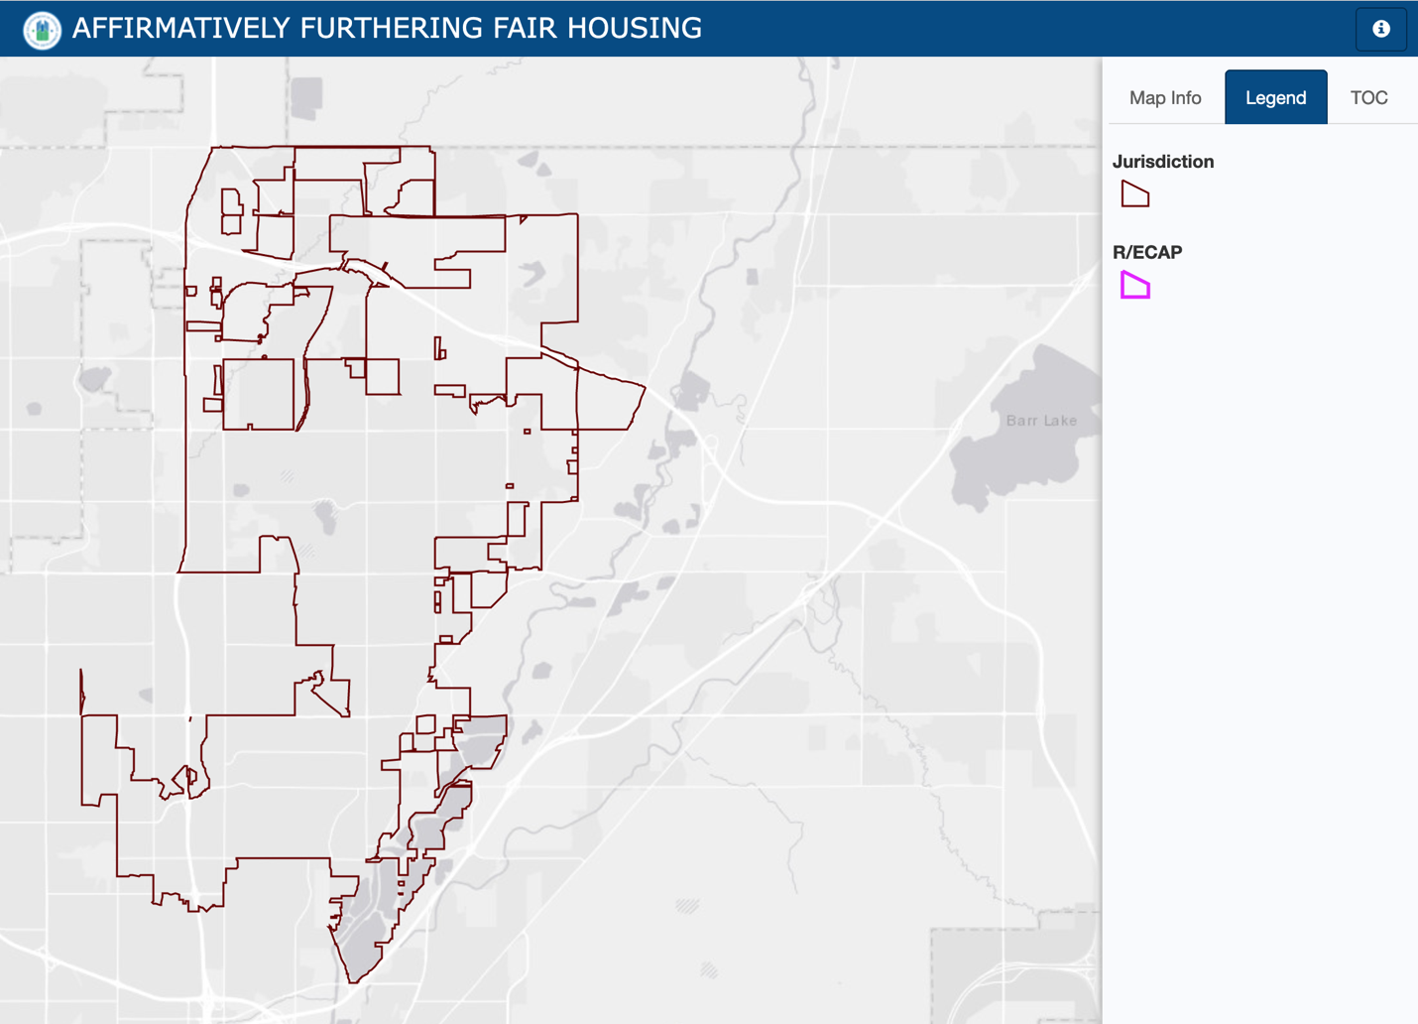

Source: Department of Housing and Urban Development AFFH Mapping Tool (AFFHT0006)

Racial and Ethnic Disparities in Access to Housing
The citywide rate of homeownership is over 72%. Most racial and ethnic households are within a similar range. However, Black and African American households have a much lower homeownership rate at 48%. This is likely tied to a lower income rate among this group and should be considered for targets programs such as housing counseling, down payment assistance, education and job training.

Chart: Percent of Population Living in Owner-Occupied Units by Race/Ethnicity

Source: United States Census Bureau ACS 2018-2022 (S2502)

Access to Resources
As outlined in HUD's equity plan, a comprehensive fair housing assessment must examine several key factors that impact housing opportunities and quality of life for all residents. Specifically, this assessment will focus on access to community assets and availability of affordable housing options across neighborhoods; and equitable pathways to homeownership for all racial and ethnic groups.

Predominant Race/Ethnicity and Access to Citywide Resources
The map below illustrates the predominant racial or ethnic groups in various block groups between 2018 and 2022. The central and northern areas are mainly White households, while the southern blocks are predominantly Latino. Icons on the map indicate the presence of nonprofits, medical sites, and other resource assistance programs, suggesting that resources are fairly distributed across the city. This distribution implies that access to essential services is not heavily restricted for any particular group, promoting inclusivity and support throughout the community.

Access to Resources for Hispanic or Latino People in Poverty
This map focuses on Hispanic or Latino individuals living in poverty. It shows varying levels of poverty by block group, with some areas experiencing higher concentrations compared to others. Despite these challenges, the distribution of resources throughout the city implies that access to essential services is not heavily restricted for any particular group, promoting inclusivity and support across communities.

Access to Resources for Black or African American People in Poverty
This map highlights the distribution of Black or African American individuals living in poverty within the city. It also reveals varying levels of poverty, with some areas, including a small concentration in the southeast corner, experiencing higher densities compared to other block groups. Despite these disparities, the equitable distribution of resources throughout Thornton ensures that access to essential services remains widely available. This promotes inclusivity and provides support across all communities, ensuring that no particular group faces significant barriers to accessing the services they need.
Please refer to the next three maps for more information.

Map: Predominant Racial and Ethnic Group by Census Block Group

Source: United States Census Bureau ACS 2018-2022 via PolicyMap

Map: Hispanic or Latino People in Poverty by Census Block Group

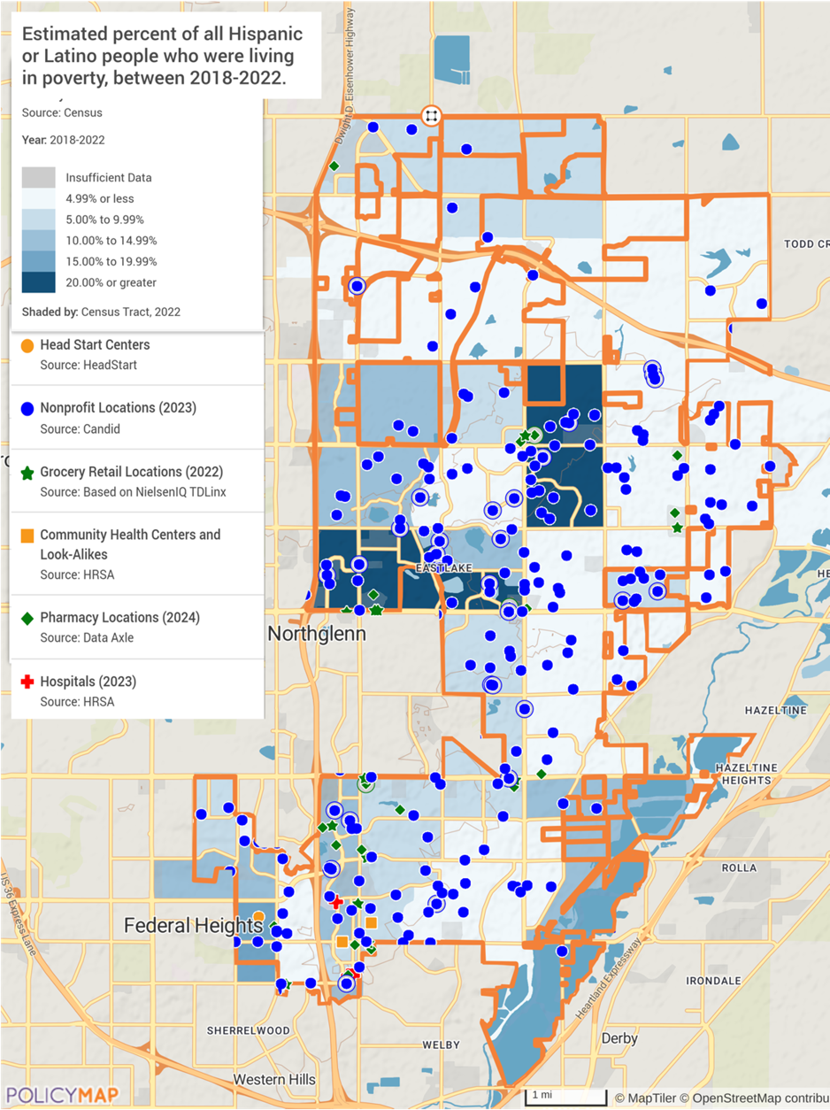

Source: United States Census Bureau ACS 2018-2022 via PolicyMap

Map: Black or African American People in Poverty by Census Block Group
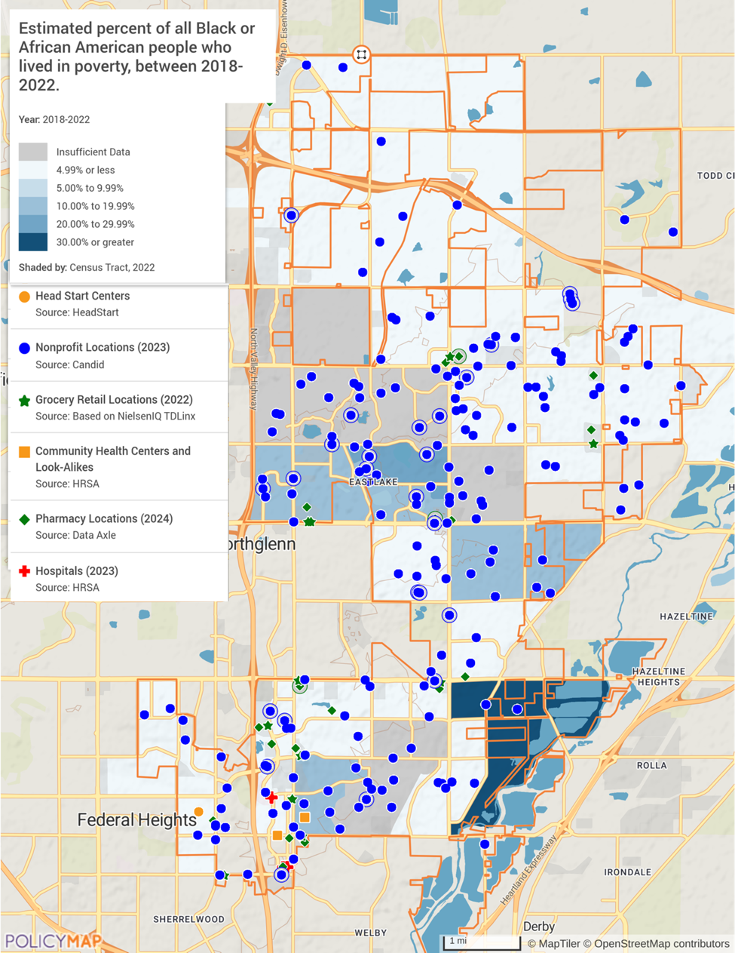

Source: United States Census Bureau ACS 2018-2022 via PolicyMap

Access to Resources for Seniors (age 65 and older) Living in Poverty
The map shows the estimated percentage of seniors (65 or older) living in poverty by block group between 2018 and 2022. Darker shades indicate higher concentrations of poverty among seniors. Once again, the map also highlights the distribution of resources, including nonprofits, grocery retail locations, community health centers, pharmacies, and hospitals. This spread of resources suggests that essential services are accessible across different areas, helping to support seniors in need throughout the city.

Map: Seniors (age 65 and older) Living in Poverty by Census Block Group
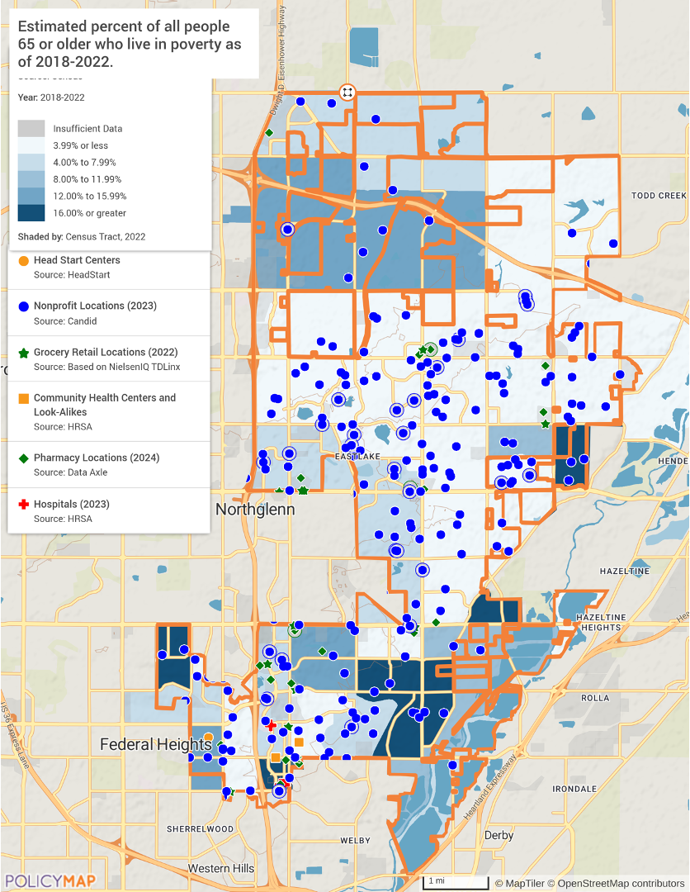
Source: United States Census Bureau ACS 2018-2022 via PolicyMap

Lending Analysis

Fair Housing Act 1968
“Discrimination in mortgage lending is prohibited by the federal Fair Housing Act and HUD's Office of Fair Housing and Equal Opportunity actively enforces those provisions of the law. The Fair Housing Act makes it unlawful to engage in the following practices based on race, color, national origin, religion, sex, familial status or handicap (disability):
- Refuse to make a mortgage loan or refinance a mortgage loan;
- Refuse to provide information regarding loans;
- Impose different terms or conditions on a loan, such as different interest rates, points, or fees;
- Discriminate in appraising property;
- Refuse to purchase a loan or set different terms or conditions for purchasing a loan; and
- Discriminate in providing other financial assistance for purchasing, constructing, improving, repairing, or maintaining a dwelling or other financial assistance secured by residential real estate.”

Home Mortgage Disclosure Act
The Home Mortgage Disclosure Act (HMDA), enacted by Congress in 1975, requires that mortgage lenders make loan data public. HMDA tracks information to ensure that fair and safe home financing is available in all geographic areas including urban neighborhoods. This information is made available to highlight whether or not lending institutions are servicing the neighborhoods and communities in which they are located. HMDA data is a useful tool in assessing lending practices and trends within a jurisdiction. The Consumer Financial Protection Bureau oversees HMDA compliance. Data collected and reported on includes applications, approvals and denials, loan amount, type of loan, applicant demographic information, property type, and census tract. This information is released annually each September. Since enactment of the HMDA in 1975, lending institutions have been required to collect and publicly disclose data regarding applicants including: location of the loan (by Census tract and MSA); income, race and gender of the borrower; the number and dollar amount of each loan; property type; loan type; loan purpose; whether the property is owner‐occupied; action taken for each application; and, if the application was denied, the reason(s) for denial. Property types examined include one‐to‐four family units, manufactured housing and multi‐family developments.

HMDA Analysis
In 2022, 3,645 home loans were originated in the city. Thornton saw 58% of its loans originated for the purpose of purchasing a home and 41.8% for refinancing in 2022. In 2022, 98.4% of loans in the city were for borrowers whose income was less than 50% of the Metropolitan Statistical Area's (MSA) Median Family Income in 2022 (<$58,900 for a family of four).

Table: 2022 Loan Originations
 | Originations | Loans | Refinance
City of Thornton
Number of Loans | 3,645 | 2,121 | 1,524
Median Loan Amount | $395,000 | $455,000 | $305,000
State of Colorado
Number of Loans | 149,345 | 91,284 | 58,061
Median Loan Amount | $395,000 | $445,000 | $305,000

High-Cost Lending
A loan is considered high cost when a rate spread is reported. In the fourth quarter of 2009, HMDA changed its rules for reporting rate spreads in an effort to more accurately capture high-cost lending activity. For 2009Q4 and 2010 - 2022, the rate spread on a loan is the difference between the Annual Percentage Rate (APR) on the loan and the estimated average prime offer rate (APOR). Rate spreads are only reported by financial institutions if the APR is more than 1.5 percentage points higher for a first lien loan, or more than 3.5 percentage points higher for a second lien loan.
Nearly 5% of loans originated in Thornton were high-cost loans in 2022, compared to 3.8% of loans in Colorado. Looking across high-cost loans originated in 2022, 74.9% were to Whites, 0.56% were to African Americans, 3.9% were to Asians, and 36.9% were to Hispanics. The disproportionately high rate of high-cost loans for Hispanic borrowers is concerning and may indicate discriminatory lending practices targeting this group. The very low rate for African American borrowers could suggest they face barriers in accessing mortgages overall, rather than just receiving high-cost loans.

Table: High-Cost Loans
 | 2017 | 2018 | 2019 | 2020 | 2021 | 2022
Citywide
Number of Loans | 424 | 472 | 667 | 271 | 205 | 179
Median Loan Amount | $280,000 | $285,000 | $295,000 | $305,000 | $345,000 | $355,000
High-Cost | 2017 | 2018 | 2019 | 2020 | 2021 | 2022
Loans to Whites
Number of Loans | 356 | 402 | 564 | 221 | 152 | 134
Median Loan Amount | $280,000 | $285,000 | $295,000 | $305,000 | $345,000 | $290,000
Percent of Loans to Whites | 9.15% | 10.68% | 11.02% | 2.98% | 2.31% | 5.05%
Percent of High- Cost Loans | 83.96% | 85.17% | 84.56% | 81.55% | 74.15% | 74.86%
Loans to Black/African Americans
Number of Loans | 12 | 12 | 7 | 6 | 3 | 1
Median Loan Amount | $244,500 | $305,000 | $285,000 | $335,000 | N/A | N/A
Percent of Loans to African Americans | 14.12% | 16.9% | 7.78% | 4.41% | 2.27% | 1.54%
Percent of High- Cost Loans | 2.83% | 2.54% | 1.05% | 2.21% | 1.46% | 0.56%
Loans to Asians
Number of Loans | 14 | 7 | 12 | 3 | 10 | 7
Median Loan Amount | $297,000 | $315,000 | $200,000 | N/A | $345,000 | $395,000
Percent of Loans to Asians | 6.22% | 3.4% | 4.24% | 0.6% | 2.1% | 2.65%
Percent of High- Cost Loans | 3.3% | 1.48% | 1.8% | 1.11% | 4.88% | 3.91%
Loans to Hispanics
Number of Loans | 148 | 153 | 242 | 93 | 78 | 66
Median Loan Amount | $280,000 | $295,000 | $315,000 | $325,000 | $365,000 | $395,000
Percent of Loans to Hispanics | 16.39% | 15.84% | 18.11% | 5.16% | 4.39% | 8.31%
Percent of High- Cost Loans | 34.91% | 32.42% | 36.28% | 34.32% | 38.05% | 36.87%
Loans to Non-Hispanics
Number of Loans | 246 | 278 | 368 | 148 | 100 | 90
Median Loan Amount | $280,000 | $275,000 | $285,000 | $285,000 | $330,000 | $285,000
Percent of Loans to Non-Hispanics | 7.27% | 8.77% | 8.49% | 2.27% | 1.74% | 3.83%
Percent of High- Cost Loans | 58.02% | 58.9% | 55.17% | 54.61% | 48.78% | 50.28%

Studies have found that even when controlling for credit scores and other risk factors, Black and Hispanic borrowers tend to receive higher interest rates and are more likely to be steered towards high-cost loan.
It's important to note that while these disparities exist, determining definitive discrimination requires more in-depth analysis controlling for factors like credit scores, income, and loan characteristics. However, the data does suggest potential fair lending concerns that warrant further investigation, particularly for Hispanic borrowers.

Loans for Manufactured Housing
Loans for the purchase or refinance of manufactured housing, (primarily mobile homes), are often structured differently than for conventional housing. In Thornton, there were 110 loans originated for manufactured housing in 2022, representing 2.93% of the total loan activity, this category represented 3.03% of the loans to Whites, 0% of loans to African Americans, 0.38% of loans to Asians, and 9.26% of loans to Hispanics. A high rate of Latino/Hispanics has also been observed in the city’s census blocks with mobile home parks.
The southern tracts of the city have a higher rate of loan application denials. Loan denials are not necessarily discrimination, they may indicate lack of credit history, poor credit, insufficient down payment or income.

Map: Loan Denials by Census Tract
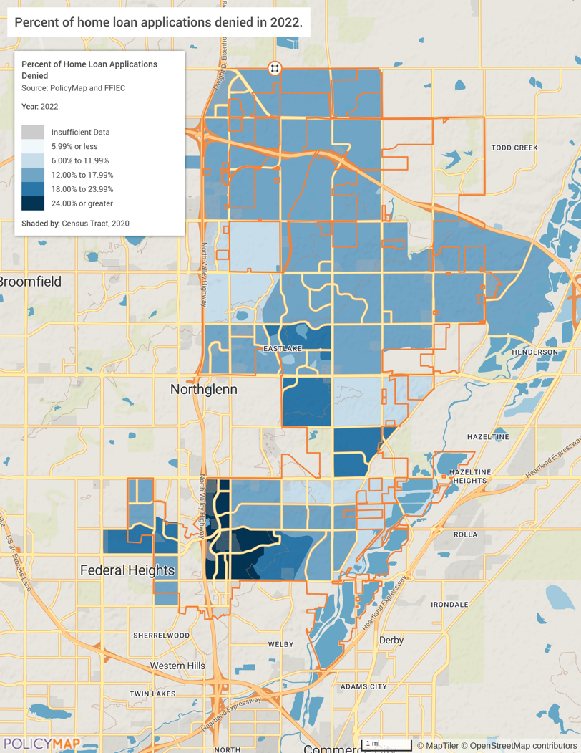

Fair Housing Complaints
HUD’s office of Fair Housing and Equal Opportunity (FHEO) is responsible for enforcing the federal Fair Housing Act and other civil rights laws that prohibit discrimination in the sale, rental, or financing of dwellings because of race, color, national origin, religion, sex, familial status, or handicap.
Housing discrimination complaints can be filed with the HUD Regional Office or the State/City. Fair housing complaints can be used as an indicator to identify heavily impacted areas and characteristics of households experiencing discrimination in housing. The Fair Housing Act lists seven prohibited bases for discrimination: race, color, national origin, religion, sex, disability, and familial status. The Fair Housing Act makes it unlawful to coerce, threaten, intimidate or interfere with anyone exercising or aiding others in enjoying their fair housing rights.
The following analysis considers fair housing complaint data filed against respondents in Thornton with HUD or Fair Housing Assistance Programs (FHAP) between 2019 and March 2024. While conducting the analysis, several data limitations were identified. Though not exhaustive, the list below summarizes the most important limitations of the datasets. The complaint process relies on people self-reporting, and the data represents only those complaints that were filed. Due to lack of knowledge of resources, instances of discrimination are often under-reported. The sample size is extremely low to have any meaningful takeaways. A total of 15 fair housing complaints were filed with HUD between 2019 and March 2024. Eighty percent of the complaints included disability as the sole factor or in combination with other reported issues. This continues to be a highly reported issue nationwide.

Table: Fair Housing Complaints in Thornton from 2018 to March 2024
Filing Date | Bases | Issues
12/11/19 | Disability | Discrimination in terms/conditions/privileges relating to rental; Discriminatory acts under Section 818 (coercion, Etc.); Failure to make reasonable accommodation
12/12/19 | Disability, Retaliation | Discriminatory terms, conditions, privileges, or services and facilities; Discrimination in terms/conditions/privileges relating to rental; Discrimination in services and facilities relating to rental; Otherwise deny or make housing unavailable; Discriminatory acts under Section 818 (coercion, Etc.); Failure to make reasonable accommodation
01/05/21 | Race, Color | Discriminatory terms, conditions, privileges, or services and facilities; Discrimination in terms/conditions/privileges relating to rental; Otherwise deny or make housing unavailable
09/17/21 | Disability, Retaliation | Discriminatory terms, conditions, privileges, or services and facilities; Otherwise deny or make housing unavailable
11/19/21 | Race, Color, National Origin, Disability, Retaliation | Discriminatory terms, conditions, privileges, or services and facilities; Otherwise deny or make housing unavailable; Failure to make reasonable accommodation
11/23/21 | Disability, Retaliation | Discriminatory terms, conditions, privileges, or services and facilities; Otherwise deny or make housing unavailable; Discriminatory acts under Section 818 (coercion, Etc.); Failure to make reasonable accommodation
05/15/22 | Disability | Discrimination in terms/conditions/privileges relating to rental
05/24/22 | Disability | Discriminatory refusal to rent
09/09/22 | Disability, Retaliation | Discriminatory terms, conditions, privileges, or services and facilities; Failure to make reasonable accommodation
09/16/22 | Race, Disability, Retaliation | Discrimination in terms/conditions/privileges relating to rental; Otherwise deny or make housing unavailable
07/12/23 | Disability | Discrimination in terms/conditions/privileges relating to rental; Failure to make reasonable accommodation
07/24/23 | Disability | Discrimination in terms/conditions/privileges relating to rental; Failure to make reasonable accommodation
07/26/23 | Race, Color | Discriminatory terms, conditions, privileges, or services and facilities; Discrimination in terms/conditions/privileges relating to rental
01/19/24 | Disability | Discriminatory terms, conditions, privileges, or services and facilities; Discrimination in terms/conditions/privileges relating to rental; Failure to make reasonable accommodation
02/22/24 | National Origin, Sex, Retaliation | Discriminatory terms, conditions, privileges, or services and facilities

Source: HUD March 2024

Local Survey – Fair Housing Insights
The city’s local resident survey provided some unique insights into fair housing discrimination. Source of income was reported as the top issue of those surveyed. Other issues reported were age discrimination and marital or familial status. A variety of organizations or positions were reported as having discriminated. It is noted that the sample size is rather small, and most reported that discrimination is rare in the city.

On what basis were you denied housing or treated differently related to housing?

What individual/entity/organization denied you housing or treated you differently related to housing?

City of Thornton’s Fair Housing Efforts
The City of Thornton demonstrates a strong commitment to promoting fair housing and preventing discrimination through several ongoing efforts:
The city actively educates residents about their rights under the Federal Fair Housing Act and Colorado Anti-Discrimination Act, which prohibit housing discrimination based on protected characteristics like race, color, religion, national origin, sex, disability, and familial status. Thornton provides detailed information on its website about these laws and prohibited discriminatory practices in housing sales, rentals, and lending.
To support residents who may have experienced housing discrimination, Thornton connects them with multiple resources for filing complaints and seeking assistance. This includes referrals to the Denver Metro Fair Housing Center, Colorado Civil Rights Division, and HUD's Office of Fair Housing and Equal Opportunity. The city ensures residents know how to access free investigation services and file complaints within the required one-year timeframe.
Additionally, Thornton has implemented a Mobile Home Park Dispute Resolution program to address potential violations in that housing sector. The city also promotes mediation services and legal clinics to help resolve housing disputes. Through these multifaceted efforts, Thornton demonstrates an ongoing commitment to advancing fair housing access and educating both housing providers and residents about their rights and responsibilities.

Stakeholder Ranking Estimations of Housing Discrimination

Fair Housing Findings
- Income data indicates the economic inequalities present within the city, with Black or African American households earning significantly less than their White and Asian counterparts. This underscores the need for targeted economic policies that address both poverty reduction and income inequality across all racial and ethnic groups in the city.
- The city has successfully avoided the formation of Racially or Ethnically Concentrated Areas of Poverty (R/ECAPs), indicating an absence of extreme concentrated poverty coinciding with high concentrations of racial or ethnic minorities. While income inequalities persist among different racial and ethnic groups, the lack of R/ECAPs suggests that the city has managed to prevent the most severe forms of economic segregation, highlighting the importance of ongoing efforts to promote inclusive economic opportunities and diverse housing options for all residents.
- People with disabilities have a higher rate of housing complaints than other protected categories. Access to housing modifications is often an issue, and sometimes unreported. Outreach campaigns are required to assist those in need and educate landlords and property managers of air housing rights.
- The City provides a variety of assistance programs, online resources, and policies that promote fair housing across all public programs. All major resources are available in Spanish for the high Latino population, and translations resources are available as needed for public services.
- Source of Income (SOI) refers to the practice of refusing to rent to or placing additional barriers for potential tenants based on their lawful source of income, particularly those using housing vouchers or other forms of public assistance to pay rent. This form of discrimination disproportionately affects renters of color, people with disabilities, elderly renters, and women.
Colorado's House Bill 20-1332, effective January 1, 2021, amended the state's Anti-Discrimination Act to prohibit housing discrimination based on source of income. The law protects individuals relying on various forms of lawful income, including government assistance programs, private assistance, and employment income, from being denied housing or facing unfair rental terms. (The bill includes some exemptions for small-scale landlords.) Despite the bill, challenges in implementation and enforcement remain.
Source of income was the highest reported type of discrimination by local stakeholders. SOI discrimination particularly affects those using Housing Choice Vouchers. In communities with SOI protections, voucher holders are more likely to find housing quickly and move to well-resourced neighborhoods. Intersection with SOI discrimination often intersects with other forms of discrimination against protected classes under the Fair Housing Act. It can serve as a proxy for illegal discrimination based on race, disability, or familial status.

Fair Housing Equity Plan
1. Enhance Fair Housing Education and Awareness
Goal: Increase fair housing knowledge and understanding across Thornton by implementing comprehensive education initiatives.
Actions:
- Collaborate with local libraries to host interactive fair housing displays and events.
- Conduct regular fair housing workshops for residents, landlords, and real estate professionals.
- Develop multilingual fair housing materials and distribute them throughout the community.
- Partner with schools to incorporate fair housing concepts into relevant curricula.
2. Target Housing Assistance to Underrepresented Minority Groups
Goal: Increase homeownership rates among underrepresented minority groups, especially Black households, through targeted housing counseling and financial assistance programs.
Actions:
- Establish partnerships with organizations like the Deerfield Fund for Black Wealth to provide down payment assistance specifically for Black first-time homebuyers.
- Create a dedicated outreach program to connect minority households with existing homebuyer assistance resources.
- Offer culturally sensitive housing counseling services tailored to the needs of different minority communities.
- Set specific targets for increasing minority participation in homeownership programs.
3. Expand Housing Options for Low-Income Residents
Goal: Increase the availability and diversity of affordable housing options for low-income individuals and families across Thornton.
Actions:
- Implement the recommendations of the 2024 Housing Needs Assessment, especially Actions 6-10.
- Explore the creation of a community land trust to preserve long-term housing affordability.
- Expand the city's Help for Homes program to assist more low-income homeowners with critical repairs.
- Partner with nonprofit developers to increase the supply of affordable rental units in high-opportunity areas.

4. Improve Housing Accessibility for People with Disabilities
Goal: Enhance access to housing services and modifications for residents with disabilities to promote independent living and equal housing opportunities.
Actions:
- Establish a dedicated fund for accessibility modifications in existing housing units.
- Provide training for local contractors on accessibility standards and universal design principles.
- Create a resource guide on housing rights and available services for people with disabilities.
- Partner with disability advocacy groups to conduct regular assessments of housing accessibility needs in the community.

5. Advance Housing Equity Through a Source of Income (SOI) Training Program
Goal: Ensure housing professionals and tenants are aware of the source of income protections through education and program promotion.
Actions:
- Educate landlords, property managers, and tenants about SOI discrimination and its implications. Host a yearly seminar to educate housing professionals on the HCV and other assistance programs.
- Collaborate with local fair housing organizations and the housing authority to provide resources and support for those experiencing SOI discrimination.
- Consider the implement of a robust enforcement mechanism, including testing programs and complaint processes.

By implementing these goals and associated actions, Thornton can work towards creating a more equitable housing landscape that addresses the needs of all residents, particularly those from underrepresented and vulnerable populations.

Appendix A: Local Stakeholder and Public Outreach

Stakeholder Survey Highlights

Ranking Community Needs

Housing Conditions – Community Needs

Barriers for Potential Renters

Barriers for Potential Buyers

Public Survey Highlights

What type of housing do you need or would like to see available?

What are your preferred features in housing development?

Does the current quality of housing available meet the needs of the community?

Which of the following do you consider the biggest challenge to achieving more equitable housing opportunities?

HNA Additional Sources:
- Cbsnews.com/Colorado complex showcases possibilities that can come from converting office space into affordable housing - CBS Colorado
- Housing Supply Accelerator Playbook: National League of Cities and the American Planning Association.
- https://dlg.colorado.gov/innovative-affordable-housing-strategies
- https://oedit.colorado.gov/proposition-123-colorado-affordable-housing-financing-fund,https://www.chfainfo.com/
- Home ownership partner example at https://www.longmontcolorado.gov/departments/departments-e-m/housing-and-community-investment/housing-program-assistance/assistance-for-home-buyers/affordable-housing
- Innovative AH communities Ft. Collins - https://www.fcgov.com/socialsustainability/affordable-housing and Vail at: https://www.vailvalleypartnership.com/advocacy/workforce-housing/
- www.strongtowns.org/6 Reasons Your City Needs a Form-Based Code (strongtowns.org)
- www.maikerhp.org
- www.brothersredevelopment.org
- https://nhc.org/policy-guide/land-based-solutions/land-banks-and-community-land-trusts/
- https://communityprogress.org/blog/a-pioneering-approach-to-bring-a-legacy-of-quality-affordable-housing-to-communities/
- https://communityprogress.org/blog/new-report-on-ten-years-of-land-banking-in-new-york-offers-compelling-metrics-of-success-useful-lessons-and-a-lot-of-inspiration/

Construction litigation blocking condo development in Colorado, but how does it get unblocked? The Denver Post PUBLISHED: December 3, 2023 at 6:00 a.m. | UPDATED: December 4, 2023 at 8:13 p.m. By ALDO SVALDI |asvaldi@denverpost.com
https://commonsenseinstituteco.org/condominium-construction/
https://www.rockethomes.com/real-estate-trends/co/thornton?focus-chart=true&locationIds=place_c2c095aee6571aa70e4f645f46bd4202&bedroom=all&propertyType=all&timeFrame=two_year&trendDataType=medianSoldPrice
https://www.senioradvice.com/independent-living/thornton-co
https://www.brookings.edu/articles/cities-need-more-housing-adus-can-help/
https://localhousingsolutions.org/housing-policy-library/accessory-dwelling-units/
https://jbartlett.org/2024/02/how-building-more-luxury-apartments-helps-the-poor/
https://rentalhousingjournal.com/do-new-luxury-apartments-bring-lower-rents-for-all/
https://www.nmhc.org/research-insight/research-notes/2024/why-building-luxury-apartments-brings-down-rent-for-all/
https://www.multifamilydive.com/news/new-housing-slows-regional-rent-growth-nyu-report/701471/
Refers to residential properties or rental assistance programs that receive funding from the U.S. Department of Housing and Urban Development to provide affordable housing options for low-income individuals and families.
Source: Bankrate.com, 30-year fixed mortgage rates, https://www.bankrate.com/mortgages/historical-mortgage-rates/#rates-over-time
https://money.usnews.com/loans/mortgages/articles/states-where-homeowners-are-locked-in-by-mortgage-rates
https://www.huduser.gov/portal/datasets/fmr/fmrs/FY2024_code/2024summary.odn
https://leg.colorado.gov/bills/hb24-1007
https://leg.colorado.gov/bills/hb24-1304
https://coloradonewsline.com/2024/01/31/colorado-more-accessory-dwelling-units/
https://leg.colorado.gov/bills/hb24-1313
https://leg.colorado.gov/bills/sb24-174
https://coloradosun.com/2024/04/24/thornton-water-pipeline-larimer-county-approvals/
https://www.denverpost.com/2024/05/02/thornton-water-pipeline-poudre-river-larimer-county-commissioners/
https://www.businesswire.com/news/home/20220629005344/en/Lowe-and-USAA-Real-Estate-Unveil-Park-Ford-Transformation-of-1980s-Era-Office-Complex-Into-Modern-Apartments-in-Alexandria-Virginia
https://www.tvo.org/article/turning-offices-into-homes-could-help-address-the-housing-crisis-but-can-it-be-done
Note: Increasing site area coverage for multi-family housing projects has the potential to impact stormwater runoff and associated infrastructure. To mitigate potential financial and operational impacts on the stormwater system, further investigation and analysis should be conducted. This could include exploring green infrastructure solutions, such as permeable pavement, rain gardens, and on-site stormwater detention, to ensure that increased development density does not adversely affect stormwater management.
https://longmontcolorado.gov/housing-and-community-investment/affordable-housing-resource-list/affordable-housing-incentives/
https://longmontcolorado.gov/planning-and-development-services/envision-longmont/
https://shelterforce.org/2021/07/19/community-land-trusts-combining-scale-and-community-control/
https://www.huduser.gov/portal/periodicals/em/fall13/highlight2.html
https://labs.aap.cornell.edu/sites/aap-labs/files/2024-01/home_modifications_report.pdf
https://www.courbanize.com/blog/overcoming-nimbyism-for-affordable-housing-projects
ttps://www.internationalhousingassociation.org/fileUpload_details.aspx?channelID=38488&contentID=263482&contentTypeID=3&subContentID=715714
https://www.theinnbetween.org/
https://longmont.start2home.com/
https://www.hud.gov/topics/fair_lending

