City of Thornton
2025-2029 Consolidated Plan and
the 2025 Annual Action Plan

Executive Summary

ES-05 Executive Summary – 24 CFR 91.200(c), 91.220(b)
1. Introduction
The City of Thornton, Colorado, receives an annual entitlement allocation of Community Development Block Grant (CDBG) program funds from the U.S. Department of Housing and Urban Development (HUD). The federal CDBG Program provides annual grants on a formula basis to entitlement cities and urban counties to help develop viable communities by providing safe, decent, and affordable housing; suitable living environments; and expanding economic opportunities, primarily for low- and moderate-income (LMI) residents.
To receive these funds, the City is required by HUD to complete a Consolidated Plan every five years with the first year Annual Action Plan (AAP) included. as required by HUD. This Consolidated Plan and AAP serves as a planning document meeting the federal government statutory requirements in 24 CFR 91.200-91.230, for preparing a Consolidated Plan and guiding the use of CDBG funding based on applications to HUD. The first year of the Consolidated Plan, Program Year (PY) 2025 AAP, and subsequent AAPs, are subsets of the Strategic Plan addressing the overall goals of the plan for each program year of the five-year Consolidated Plan. PY 2025 begins on October 1, 2025, and ends on September 30, 2026.
Housing affordability and availability remains the most significant issues for LMI households in Thornton. After the severe housing price increases over the previous few years, the housing market in Thornton is now experiencing reduced housing price increases. Data from the Colorado Association of REALTORS indicates that from January 2024 to January 2025, the median sales price of single-family homes increased only slightly from $520,000 to $522,500 in Adams County – an increase of 0.5%. Thornton reported a higher 3% increase from $530,000 to $546,000 in the same timeframe, according to Redfin. However, county-wide Townhouses and Condos experienced a pronounced increase from $365,000 to $390,000 or 6.8% in the same period. Thornton’s median sales for townhomes outpaced the county and jumped from $390,000 in January 2024 to $424,000 in February 2025, an 8.7% increase.
Average Rent costs (all sizes combined) have also been affected this past year, with current rents in Thornton According to Zillow, the current median market rent for all bedrooms and all property types in Thornton is $2,708. The month-over-month change is - $107 (July 2024 to August 2024) . In contrast, before the pandemic, rent costs averaged just under $1,600 (Source: Yardi Matrix). For perspective, a single person earning minimum wage brings home approximately $31,000, which is $2,583 a month (Source: 2025 PAY CALC Order). Fortunately, rent increases have stabilized in the past year but remain very high. Due to these circumstances, the City identified the development and preservation of affordable housing as high-priority needs, especially for LMI residents.

Adams County HOME Consortium
The City is a member of the Adams County HOME Consortium and receives HOME Investment Partnerships funds through the HOME Consortium (HOME). The HOME program is the largest federal block grant to state and local governments designed exclusively to create affordable housing for LMI households. The grant funds a wide range of activities including building, buying, and/or rehabilitating affordable housing for rent or homeownership, or providing direct rental assistance. Through an Intergovernmental Agreement (IGA), the City receives HOME Program funding on an annual basis. These funds are not programmed in the city’s AAPs, as the City is not a direct recipient of HOME funds from HUD. As the direct recipient, Adams County is in charge of programming the Consortium’s HOME funds. The City has completed an abbreviated ConPlan. As a member of the Adams County HOME Consortium, the County’s ConPlan completes the remaining information - Needs Assessment and Market Analysis which includes Thornton.
2. Summary of the objectives and outcomes identified in the Plan Needs Assessment Overview
The City has developed its strategic plan based on an analysis of the data presented in the Needs Assessment, the Market Analysis of the Consolidated Plan, and the community participation and stakeholder consultation process. Through these efforts, the City has identified four (4) priority needs and associated goals to address these needs. Over the 5-Year plan period, the City will work to accomplish the following outcomes, which are listed by Priority Needs.
Priority Need: Affordable Housing
Goal - 1A Affordable Housing Development and Rehabilitation
Provide single-family, owner-occupied housing rehabilitation activities to help preserve the housing stock of LMI households through home repairs, weatherization programs, accessibility and safety improvements, energy and water efficiency improvements, code compliance, and exterior painting of the homes. This goal also includes assisting with the public facility needs for new affordable housing construction or rehabilitation as permitted by CDBG and HOME regulations.
Priority Need: Public Services
Goal - 2A Provide Services for LMI & Homeless residents
Provide public services to support and improve the quality of life for LMI individuals and the homeless. Homeless needs will be addressed through Thornton's Homeless Outreach Team (HOT) and other supportive non-profit services which provide life-saving supplies, resource navigation, and limited case management to people experiencing homelessness in Thornton. Other identified priority LMI needs for public services include crime victim assistance, in-home assistance, homelessness prevention, nutrition and food access, health services, mental health services, employment, and educational support.
Priority Need: Public Facilities & Infrastructure
Goal - 3A Expand/Improve Public Facilities & Infrastructure
The City desires to expand and enhance public facilities and infrastructure in low- and moderate-income (LMI) areas. Improvements may include American Disabilities Act (ADA) accessibility upgrades, sidewalk and connectivity enhancements, safety measures, parks and recreation facilities, public safety buildings, stormwater and drainage systems, roads, and streetlights. Additionally, the City will support public facility improvements that enable the development of new affordable housing, in accordance with CDBG and HOME regulations
Priority Need: Effective Program Management
Goal - 4A Effective Program Management
Effective program management will include general administration of HUD grant programs, monitoring subrecipients, and keeping strict grant-based accounting. Comprehensive planning requirements will include the development of the next four years of AAPs, an evaluation of the performance of the programs through annual reports, program planning activities, needed studies and assessments, fair housing and equal opportunity promotion, and meeting citizen participation requirements.
3. Evaluation of past performance
The City is building upon previous experience and success in utilizing HUD funding for housing rehabilitation, public services, and public facility and infrastructure improvements. In addition to the five-year Consolidated Plan and the Annual Action Plans, the City must complete a Consolidated Annual Performance and Evaluation Report (CAPER) to maintain compliance with each grant received. To date, the City of Thornton has successfully completed all regulatory reporting requirements and has effectively reported on the accomplishments of previous Annual Action Plans for the planned expenditures.
During the previous 2020-2024 Consolidated Plan, the City enacted its goal to support affordable housing by funding the Help for Homes program, the Code Compliance Assistance Program (CodeCAP), and other critical home rehabilitation services for LMI households. Additionally, the City funded public facility and infrastructure improvements, including the McAllister Park design project, Fire Department equipment, ADA sidewalk designs and construction, water detention areas, and improvements to Loma Linda Park, which provided new playground equipment, ADA-compliant pathways, and other upgrades. These projects directly benefited residents in LMI neighborhoods by improving accessibility, neighborhood safety, and public spaces.
In PY 2020, LMI services were supported through partnerships with nonprofit organizations and other City departments to provide essential services to domestic violence survivors and homelessness prevention. In 2021, the HOT was established with CDBG funds. Each year since, the city’s public service funds were 100% allocated to HOT. HOT expanded its efforts in direct outreach, limited case management, and support services and essential supply delivery to individuals experiencing homelessness.
In 2020, the City incorporated the CDBG-CV funding through the CARES Act and quickly allocated the $977,876 to 15 different public service programs. These subrecipients assisted LMI residents with emergency rental, mortgage, and utility assistance programs, mental health programs, domestic violence victim support, food and meal deliveries, senior support, drug and alcohol treatment during the COVID-19 pandemic. Approximately 5,500 LMI residents were directly assisted by these extra funds.

CAPER REPORTING
The CAPER evaluates progress toward both the five-year and one-year goals established for HUD entitlement grants, including CDBG. The City’s performance is reviewed and summarized annually in the CAPER report. A summary of accomplishments organized by priority for PY 2023, is reported from the most recent CAPER is below.
Housing:
The City of Thornton addressed affordable housing needs during Program Year 2023. The Help for Homes (H4H) program provided free home repairs to 11 LMI households, ensuring critical safety and accessibility improvements. The Code Compliance Assistance Program (CodeCAP), launched in August 2023, served 26 households, addressing property code compliance issues to alleviate unsafe living conditions and serious fines and fees from the city. Additionally, the Paint-A-Thon (PAT) program assisted 10 households by providing exterior home painting services for seniors and residents with disabilities. Roof-top solar installation was also provided to 4 LMI homes through the GRID Alternatives program. These programs collectively contributed to the rehabilitation of 51 owner-occupied homes during PY 2023, achieving 75% of the annual goal. The city fell short of its program year target of 68 homes primarily due to over estimating the number of H4H projects that could be completed per month, the slow down and eventual withdrawal of GRID Alternatives as a subrecipient, and the time needed to reallocate GRID’s CDBG funding to H4H.
Public Facilities and Improvements:
The City invested CDBG funds to improve public facilities and infrastructure in LMI neighborhoods. The McAllister Park Design project progressed through engineering and community engagement phases, benefiting an estimated 5,525 residents. The Loma Linda Park Improvement project was completed, providing ADA-compliant sidewalks, new playground equipment, and accessibility enhancements for 715 residents. Additionally, the Sidewalk Improvement project at 100th Ave & Riverdale Rd completed its engineering and design stage and in 2025 has progressed to the contractor procurement stage. This project provides tremendously safer pedestrian access for 6,100 residents. In total, public facility and infrastructure projects benefited 12,444 residents, exceeding the annual goal by 1,011.71%. With 65,362 residents assisted to date, the City has already exceeded its five-year goal in this category.
Public Services:
The City allocated CDBG funds to support public service programs that assist vulnerable residents. Thornton’s Homeless Outreach Team provided case management, hygiene supplies, and referrals to individuals experiencing homelessness. Additionally, the City supported specialized programs such as subsistence payments and homelessness prevention, with a total of 1,302 individuals benefiting from public service initiatives. These programs exceeded the annual goal of 500 individuals served, reaching 260.4% of the target. Thornton is on track to exceed its five-year public service goals by continuing to collaborate with nonprofit partners and expand outreach efforts.
Homelessness:
The City of Thornton strengthened its efforts to address homelessness through targeted initiatives and expanded outreach. The HOT engaged with 762 unique (new) individuals, providing 6,922 direct referrals for housing, shelter, food, and other critical services. The Severe Weather Activation Program (SWAP) provided hotel vouchers to 550 individuals during extreme weather conditions. The city opened the Margaret Carpenter Recreation Center to provide a warm location for the unhoused to escape the elements overnight. These were open during the evening and overnight hours. The Community Reach Center opened a 10-bed youth shelter for 12 – 17-year-olds needing emergency shelter. Additional services include medical, therapy, case management and family reunification. HOT’s homelessness prevention services reached 565 individuals, surpassing the annual target by 226%. The City remains on track to meet its five-year homelessness assistance goals through continued investments in outreach, emergency services, and housing stabilization efforts.
CARES Act Accomplishments:
CDBG-CV funds were used to address the continued negative impacts of the COVID-19 pandemic. Almost Home, Inc. provided emergency rent, mortgage, and utility assistance to six households with CDBG-CV funding. In total, the City expended $938,217 in CDBG-CV funds, leaving a remaining balance of $39,659 (4%), which will be utilized in Program Year 2024 for urgent homelessness prevention and housing stability due to COVID-19.
The City of Thornton is committed to achieving its five-year housing and community development goals. Through strategic partnerships, efficient resource allocation, and ongoing investments in public services, staff, and infrastructure, the City continues to support its most vulnerable residents and foster long-term community resilience.
4. Summary of citizen participation process and consultation process
The City has adopted its HUD approved Citizen Participation Plan (CPP) as per 24 CFR 91.105, which sets forth the City’s policies and procedures for citizen participation in the Consolidated Plan and 2025 AAP. The CPP provides guidance for public notices for the various stages of Consolidated Plan development, public hearings, and the public review of the proposed plans and reports. The public input meetings for the 2024 Housing Needs Assessment (HNA) are also mentioned because they covered the housing and community development needs and goals discussed in the Consolidated Plan. Details of the City’s outreach efforts are provided below:
ALL WARDS COMMUNITY MEETING: On August 8, 2024, the city hosted a Community Meeting. As part of the event CDBG staff hosted a voting game whereby participants identified their perceived community needs, especially those related to housing, for the Housing Needs Assessment.
CITY RESIDENT SURVEY: A total of 89 residents responded to the Community Survey. Results of the survey are summarized in the PR-15 and the Citizen Participation Attachment.
CITY STAKEHOLDER SURVEY: A total of 29 City stakeholders responded to the Stakeholder Survey. Results of the survey are summarized in the PR-15 and the Citizen Participation Attachment.
HNA PUBLIC INPUT MEETINGS: Three Public Input Meetings were held on July 30, 2024, August 7, 2024, and November 18, 2024, respectively, to discuss community needs, especially those related to housing, for the 2024 HNA. They were held at the Parks, Recreation & Community Programs Department - Community Connections Division at 9471 Dorothy Blvd., Thornton, CO, 80229, noticed, signed and promoted in English and Spanish. Four residents attended the July PIM, two stakeholders attended the August PIM, and four residents attended the November PIM for a total of 10 attendees. None of the attendees needed the available Spanish interpreter.
GROUP STAKEHOLDER MEETINGS: During the month September 2024, CDBG staff conducted group stakeholder meetings on the topics of Homelessness Prevention, Seniors, Trama Victims, Health & Nutrition, and Residents with Disabilities. Twenty individuals attended in total representing 13 non-profit and faith-based organizations.
CITY OF THORNTON STAFF INTERVIEWS: Twenty staff members were interviewed during the months of July and August of 2024. The department and division leaders in Parks, Recreation, and Community Programing, Infrastructure, Community Development, Fire, Police, Homeless Outreach Team, Building, Active Adult Center, Planning, Victim Advocates, Long Range Planning, Code Compliance, and Economic Development were interviewed using the same set of questions.
PUBLIC INPUT MEETING: A Public Input Meeting was held on May 1, 2025, at the Parks, Recreation & Community Programs Department - Community Connections Division at 9471 Dorothy Blvd., Thornton, CO, 80229. This meeting was not attended by any residents.
PUBLIC HEARING: A public hearing was held on July 22, 2025, at 7:00 PM, during the City Council meeting in the Council Chambers, 9500 Civic Center Drive, Thornton, CO 80229. City Council meetings could also be viewed online at https://www.thorntonco.gov/government/city-council/Pages/council-meetings.aspx. Guidance on audience participation is provided at the link above.
Summary of Citizen Participation Process and consultation process continued
PUBLIC COMMENT PERIOD: The City held a public comment period from June 13, 2025 to July 14, 2025, at Community Connections and on the city website at www.gocot.net/cdbg. Written comments could be returned to the address above or emailed to cdbg@ThorntonCO.gov.

Details of citizen participation outreach for the Consolidated Plan and PY 2025 AAP are also located in the PR-15 and attachments.
5. Summary of public comments
All Wards Community Meeting. Fourteen participants ranked the community’s chief housing problems as (1) the shortage of accessible homes for seniors and people with disabilities, (2) escalating land and construction costs, and (3) limited housing diversity. They favored three corresponding solutions: expanding down-payment assistance programs, encouraging a broader mix of unit sizes and price points, and pursuing grant or foundation funding for new affordable developments.
HNA PUBLIC INPUT MEETINGS: Residents described “shady” landlords, HOA boards, and mobile-home operators that raise fees without infrastructure upgrades or accountability. They also noted how difficult it is to locate reliable information on affordable vacancies and asked the City to host a real-time database, especially for seniors. Aging in place, inadequate transit for non-drivers, a lack of housing types such as tiny homes, and high land prices were cited as critical obstacles; participants urged greater public engagement to address the current housing and homelessness crises.
CITY RESIDENT SURVEY: A total of 89 residents completed the community survey. Feedback included concerns about the high housing costs, including high property taxes, and the need for additional affordable housing options. Housing needs include increased supply of single-family homes and senior housing.
CITY STAKEHOLDER SURVEY: A total of 29 City stakeholders completed the Stakeholder Survey. Feedback included the importance of safe, decent, affordable housing, homeless support, and housing for special needs groups such as seniors. Housing affordability and availability were consistently cited as the most important concerns.
FOCUS GROUP STAKEHOLDER MEETINGS: Discussions on homelessness prevention highlighted that rising taxes, rents, and utilities are pushing many—particularly seniors—into housing instability, while some landlords continue to discriminate by income. Senior advocates pointed to isolation, transportation gaps, and minor-repair needs, recommending home-sharing, cottage-style villages, and dedicated service navigators. Service providers working with trauma victims called for trauma-informed property management, pet-friendly policies, and additional case managers. Disability advocates underscored the near-absence of accessible, affordable units and asked for a centralized vacancy registry and quicker safety-net responses. Family- and youth-oriented groups stressed the burden of high entry costs and documentation hurdles, proposing realtor-supported education teams, multigenerational housing models, and expanded job training.
CITY OF THORNTON STAFF INTERVIEWS: Internal interviews reinforced these themes, citing rapid cost inflation, cumbersome development processes, and a severe shortage of senior and assisted-living units as primary barriers. Staff suggested land banking, vertical or mixed-use construction, creation of shelters and transitional housing, accessory dwelling units, down-payment assistance, stronger incentives for affordable developments, and better inter-departmental coordination to address the City’s widening housing gaps.
PUBLIC INPUT MEETING: No attendees
PUBLIC COMMENT PERIOD: There were no comments made the comment period.
PUBLIC HEARING: There were no comments made at the public hearing.

All comments and views were accepted at the public hearing and public comment period review process. A summary of outreach efforts is in the PR-15 Participation.
6. Summary of comments or views not accepted and the reasons for not accepting them
All comments or views were accepted at the public hearing and public comment period.
7. Summary
The City is committed to providing a meaningful way for residents to communicate their needs. The Community Connections Division serves as the primary resource for residents seeking housing, human services, and community development assistance. Additionally, the Thornton Assistance Funds (TAF) Advisory Board annually provides recommendations on approximately $300,000 in City grant allocations for nonprofit organizations that assist residents in the areas of housing, food, health, and human services. The City engages with local stakeholders, service providers, and community members to help guide program priorities and funding decisions.
City staff regularly conduct public meetings, Ward meetings, outreach events, and consultations to provide residents and stakeholders with an avenue to communicate with City officials regarding community needs. The City will continue to update residents on the progress of HUD-funded programs and seek public input to ensure funding decisions align with community priorities.
The Consolidated Plan is comprised of several sections, including an assessment of the current housing and community development needs of the area, information on the citizen participation process, a Strategic Plan, and the 2025 AAP. The Strategic Plan is an essential component of the Consolidated Plan, outlining the objectives and outcomes necessary to meet the identified needs. The 2025 AAP is the first of five annual action plans the city will develop, which will detail how federal resources will be allocated each year to achieve the objectives identified in the Consolidated Plan. Additionally, each AAP will be evaluated to see the City's performance in meeting the Consolidated Plan's objectives. At the end of each program year, the City will complete a Consolidated Annual Performance and Evaluation Review (CAPER).
Not only are the priority needs in the City identified through the needs assessment and market analysis, but the City also determines these needs through a citizen participation process, which includes engagement with community nonprofit organizations and with members of the community. As a member of the Adams County HOME Consortium, additional analysis on Comprehensive Housing Affordability Strategy (CHAS) data, Public Housing Authority (PHA) needs, and homelessness trends can be found in the Adams County HOME Consortium Consolidated Plan.
Primary data sources for the Consolidated Plan include 2008-2012 & 2018-2022 American Community Survey (ACS) 5-Year Estimates, Longitudinal Employer-Household Dynamics (LEHD), the Bureau of Labor Statistics (BLS), HUD Low/Mod Income Summary Data and local data sources. Data for map analysis came from the 2018-2022 ACS.
Executive Order Compliance
Thornton agrees that its compliance in all respects with all applicable Federal anti-discrimination laws is material to the U.S. Government’s payment decisions for purposes of section 3729(b)(4) of title 31, United States Code.
Thornton will not operate any programs that violate any applicable Federal anti-discrimination laws, including Title VI of the Civil Rights Act of 1964.

The Process

PR-05 Lead & Responsible Agencies - 91.200(b)
1. Describe agency/entity responsible for preparing the Consolidated Plan and those responsible for administration of each grant program and funding source
The following are the agencies/entities responsible for preparing the Consolidated Plan and those responsible for administration of each grant program and funding source.
Agency Role | Name | Department/Agency

CDBG Administrator | THORNTON | Parks, Recreation, and Community Programs Dept
Table 1– Responsible Agencies

Narrative
The lead agency for preparing the 2025-2029 Consolidated Plan is the Parks, Recreation, & Community Programs Department – Community Connections Division. This division, with the assistance of the departments mentioned below, are responsible for the administration of the CDBG program. Division staff present a draft of the AAP to the City Council each year. Staff report on a quarterly and annual basis on the status of activities addressing homelessness, affordable housing, community development, and providing fair housing and equal opportunities to residents. Staff from the Finance, Contracts, and Legal Departments provide CDBG administration support as necessary. The City Council approves the AAP and its submittal of plans, plus any substantial amendments to HUD.
Thornton CDBG staff coordinate with Adams County (County) to assign Thornton’s portion of HOME funds. The City Council approves Intergovernmental Agreements and projects as needed; the County administers the funds and is responsible for conducting the citizen participation requirements of the HOME grant.
Consolidated Plan Public Contact Information
Grant & Housing Supervisor
Community Connections Division
9471 Dorothy Blvd
Thornton, CO 80229
CDBG@thorntonco.gov
Phone: 720-977-5800

PR-10 Consultation - 91.100, 91.110, 91.200(b), 91.300(b), 91.215(l) and 91.315(l)
1. Introduction
The City of Thornton is committed to gathering input from residents, municipal officials, nonprofit organizations, private and nonprofit housing developers, governmental agencies, and the Regional Continuum of Care as part of the Consolidated Plan and Annual Action Plan processes. Consultations include stakeholder meetings, community input hearings, public surveys, community meetings, newspaper advertisements, website announcements, social media posts, local Channel 8 TV, public notices, and public meetings with hearings to solicit feedback on the draft Consolidated Plan and Annual Action Plans.
Citizen participation is strongly encouraged throughout all phases of short- and long-range planning, plan implementation, and assessment. In addition to conducting targeted outreach, the City of Thornton maintains ongoing conversations with partner agencies throughout the year to assess the evolving needs of LMI residents, provide CDBG technical assistance, and solicit CDBG funding applications. City staff rely on these relationshipsto gather input on community needs, promote available resources, coordinate service partnerships, and develop action plans for the upcoming year and beyond.
Provide a concise summary of the jurisdiction’s activities to enhance coordination between public and assisted housing providers and private and governmental health, mental health and service agencies (91.215(I)).
The City of Thornton actively collaborates with public and private entities to enhance coordination between assisted housing providers, governmental and private health agencies, mental health service providers, and nonprofit organizations to address housing and supportive service needs. The Community Connections Division, which administers the City's CDBG program, plays a key role in fostering these collaborations to support LMI residents, individuals experiencing homelessness, and other vulnerable populations.
Thornton participates in regional coordination efforts with entities such as Adams County Human Services, Maiker Housing Partners (Adams County Housing Authority), the Metro Denver Homeless Initiative (MDHI), Denver Regional Council of Governments (DRCOG), and various nonprofit service providers. These partnerships ensure a comprehensive approach to affordable housing, homelessness prevention, and supportive services. The City also works with the real estate, finance, and construction industries to implement CDBG-supported housing rehabilitation and homebuyer assistance programs.
Efforts to enhance coordination between public and assisted housing providers, and private and governmental health, mental health, and service agencies, include ongoing consultations with Maiker Housing Partners (MHP) and private housing developers to coordinate on affordable housing projects. These include Crossing Pointe North and South (64 LMI senior units and 142 LMI units), the Overlook Apartments rehabilitation (164 units with PAB funding), and the current consultations’ future developments. The City continues to work with the HOT and MDHI to provide direct outreach, resource navigation, and severe weather sheltering for individuals experiencing homelessness. As the human services arm of the City, Community Connections staff continually collaborate with housing, health, education, employment, food, and homelessness outreach service providers to identify unmet needs and coordinate solutions. In 2024, division staff provided over 48,000 direct service referrals or other assistance for Thornton residents. Thornton’s co-organizes the CDBG User Group, Community Resource Network, and various Adams County task forces and committees further expands its engagement with regional efforts to support LMI residents.
The City is also addressing digital access and high-speed internet infrastructure for LMI residents through partnerships with Aftersight (formerly Audio Information Network) and MHP. MHP is incorporating broadband-ready infrastructure into its affordable housing developments, while Aftersight provides discounted mobile hotspots, broadband service, and digital literacy training to help bridge the digital divide. Thornton continues to consult with internet service providers and community organizations to ensure that residents have access to essential online services, including education, job opportunities, and telehealth.
Thornton is also engaged in emergency preparedness, climate resilience, and hazard mitigation planning in partnership with the Adams County Office of Emergency Management and Thornton’s Office of Emergency Management. The City collaborates with Adams County to update its Hazard Mitigation Plan, which includes strategies to reduce risks of flood, drought, fires, tornados, earthquakes, extreme weather impacts, and infrastructure vulnerabilities. The City’s Energy Action Plan is guiding energy efficiency efforts. Thornton is also working to mitigate urban heat impacts by expanding tree canopy coverage and promoting sustainable building practices in public and private developments.
Continued below in optional narrative
Describe coordination with the Continuum of Care and efforts to address the needs of homeless persons (particularly chronically homeless individuals and families, families with children, veterans, and unaccompanied youth) and persons at risk of homelessness
The City of Thornton is committed to addressing the needs of individuals and families experiencing homelessness, as well as those at risk of homelessness, through regional collaboration, direct outreach, and resource coordination. Thornton actively participates in the MDHI, which serves as the lead agency for the Metro Denver Continuum of Care (CoC), overseeing homelessness services across a seven-county region, including Adams County. The City also works closely with Adams County Human Services, nonprofit organizations, and regional coalitions to ensure that those in need have access to shelter, supportive services, and long-term housing solutions.
Thornton established the HOT in response to the COVID-19 pandemic, and due to its success, the program continues to receive CDBG funding while also pursuing additional resources to sustain and expand its efforts. HOT provides lifesaving supplies, resource navigation, case management, assistance obtaining vital documents, and support in securing housing vouchers for people experiencing homelessness in Thornton. The team maintains daily connections with local homeless service providers, the County, MDHI, and the regional CoC to ensure coordination and maximize available resources.
Thornton participates in key regional homelessness initiatives, including the Severe Weather Activation Program (SWAP), which provides hotel/motel vouchers for homeless individuals during extreme weather events. The HOT team also contributes to CoC-led efforts such as the Homeless Management Information System (HMIS) coordination, the Adams County Coalition for the Homeless, and Point-in-Time (PIT) count leadership. These partnerships strengthen the regional response to homelessness by improving data collection, streamlining service delivery, and enhancing collaboration among government agencies and service providers.
The Community Connections Division serves as a critical point of contact for individuals, nonprofit organizations, and private entities seeking to connect with homeless assistance resources. The City has developed homeless resource and housing brochures and maintains a dedicated section on its website to provide information on essential needs, such as food, health care, housing, and transportation. Community Connections staff also provide direct support via phone, email, and in-person consultations to assist individuals in crisis.
Thornton’s efforts to address homelessness receive strong political and community support, including engagement from the Metro Mayor Caucus, where the Thornton Mayor and other regional leaders have prioritized homelessness as a critical issue. The City also leads an internal homelessness task force, bringing together multiple city departments, including Police, Code Enforcement, Legal, Parks, Recreation & Community Programming, and Fire, to share data, provide program updates, and develop strategies for preventing and reducing homelessness.
Thornton remains committed to enhancing collaboration with public and nonprofit agencies, participating in regional planning efforts, and leveraging all available resources to provide housing stability and essential services to individuals experiencing homelessness. Through continued coordination with the CoC, local and regional partners, and internal city departments, the City aims to strengthen its homelessness response system and work toward long-term solutions for those in need.
Describe consultation with the Continuum(s) of Care that serves the jurisdiction's area in determining how to allocate ESG funds, develop performance standards and evaluate outcomes, and develop funding, policies and procedures for the administration of HMIS
The City of Thornton applied and was awarded $100,000 in ESG funding for the HOT. The grant agreement was executed in March 2024. The funds are to be used for street outreach and administration of the HMIS. Data collected through HMIS will be reported to the Division of Housing (DOH) quarterly. HMIS collects data about people accessing services related to homelessness throughout Colorado. This data will track client and program outcomes, measures system performance, and informs regional and local efforts to end homelessness. HOT staff will attend any CoC provided HMIS training on data collection requirements and stay current with any revised standards.
2. Describe Agencies, groups, organizations and others who participated in the process and describe the jurisdictions consultations with housing, social service agencies and other entities

Table 2– Agencies, groups, organizations who participated
1 | Agency/Group/Organization | Maiker Housing Partners (Adams County Housing Authority)
1 | Agency/Group/Organization Type | PHA  Services - Narrowing the Digital Divide
1 | What section of the Plan was addressed by Consultation? | Housing Need Assessment  Public Housing Needs  Anti-poverty Strategy
1 | How was the Agency/Group/Organization consulted and what are the anticipated outcomes of the consultation or areas for improved coordination? | MHP and City staff speak regularly on the Crossing Point South LMI apartment completion, allocating Private Activity Bonds (2022, 2023 & 2024) on future affordable housing projects. MHP was awarded 2025 TAF funds. In 2023, staff brought MHP and the City Waterwise staff together to improve water efficiency for Maiker properties. Since 2020, the City provided a $1.9 million dollar incentive to develop Crossing Pointe affordable apartments, $23,920,896 in PABs, and will continue to coordinate city programs across multiple apartment complexes at the PHA, such as the community garden water credit and the Water Assistance and Tax Rebates Program for LMI residents. Staff also met with Maiker apartment managers to explain and share printed resources on dozens of programs to support their LMI residents.
2 | Agency/Group/Organization | Brothers Redevelopment Inc.
2 | Agency/Group/Organization Type | Housing
2 | What section of the Plan was addressed by Consultation? | Housing Need Assessment  Lead-based Paint Strategy  Anti-poverty Strategy  Colorado Housing Connections Hotline Data First-time Homebuyers Housing Education
2 | How was the Agency/Group/Organization consulted and what are the anticipated outcomes of the consultation or areas for improved coordination? | The city has partnered and funded Brothers Redevelopment since 2010 to conduct the H4H and PAT minor home repair programs and fund the housing hotline at Colorado Housing Connects. TAF awarded this organization with 2025 funding for rent, mortgage, utilities, security deposits, and application fees. City staff hold monthly meetings and training courses regarding the operation of the HRP to ensure continued compliance. The city collaborated with the agency on programs to collaborate on the priority needs identified in the Consolidated Plan. Staff have been communicating about building relationships with mobile home park property management groups to share the minor home repair services available. Brothers Redevelopment also participates monthly in presenting courses for the city Housing University program.
3 | Agency/Group/Organization | Community Resources and Housing Development Corp
3 | Agency/Group/Organization Type | Housing  Homebuying Assistance, CHDO  Community Development Financial Institution
3 | What section of the Plan was addressed by Consultation? | Housing Need Assessment  Anti-poverty Strategy
3 | How was the Agency/Group/Organization consulted and what are the anticipated outcomes of the consultation or areas for improved coordination? | To address affordable home ownership, Thornton hosts a monthly CRHDC Homebuyer Workshop for residents exploring homeownership and down-payment assistance options. Since January 2023, 443 people have attended these six-hour seminars. Together we discuss ideas about increasing affordable housing and relevant trends in the local affordable housing market.
4 | Agency/Group/Organization | Intervention, Inc.
4 | Agency/Group/Organization Type | Services - Housing  Services-Victims of Domestic Violence
4 | What section of the Plan was addressed by Consultation? | Homelessness Strategy  Homeless Needs - Families with children  Anti-poverty Strategy  Homelessness Prevention
4 | How was the Agency/Group/Organization consulted and what are the anticipated outcomes of the consultation or areas for improved coordination? | Intervention used CDBG funds to provide emergency rent, mortgage and utility assistance to victims of domestic violence. Thornton also partners with Intervention to provide domestic violence reduction workshops. The City will continue partnership with the agency through outreach events, referrals, and outreach material sharing.
5 | Agency/Group/Organization | PROJECT ANGEL HEART
5 | Agency/Group/Organization Type | Services-Persons with Disabilities
5 | What section of the Plan was addressed by Consultation? | Anti-poverty Strategy  Homelessness Prevention
5 | How was the Agency/Group/Organization consulted and what are the anticipated outcomes of the consultation or areas for improved coordination? | Project Angel Heart has a meal delivery program for people that are critically-ill. The city considered the agency for funding for 2024 public services funds. TAF awarded Project Angel Heart with 2025 funding. The City will continue partnership with the agency through outreach events, referrals, and outreach material sharing.
6 | Agency/Group/Organization | City of Thornton
6 | Agency/Group/Organization Type | Agency - Managing Flood Prone Areas  Agency - Management of Public Land or Water Resources  Agency - Emergency Management  Other government - Local  Grantee Department
6 | What section of the Plan was addressed by Consultation? | Housing Need Assessment  Homelessness Strategy  Economic Development  Anti-poverty Strategy  Homelessness Prevention, Affordable Housing Development, Aging in Place Security and Safety
6 | How was the Agency/Group/Organization consulted and what are the anticipated outcomes of the consultation or areas for improved coordination? | CDBG staff are continually in contact with other City departments and divisions, including City Council, the City Manager Office, Infrastructure, IT, Code Enforcement, Parks & Recreation, Legal, Finance, Active Adult Center, the Office of Emergency Management, Economic Development, Fire, Police, Code Enforcement, and Community Development. The goal is to improve service awareness and coordination between departments, identify resident needs, optimize funding and resources, and investigate potential projects for CDBG funding.
7 | Agency/Group/Organization | ADAMS COUNTY
7 | Agency/Group/Organization Type | Other government - County  Grantee Department
7 | What section of the Plan was addressed by Consultation? | Housing Need Assessment  Public Housing Needs  Homelessness Strategy  Economic Development  Anti-poverty Strategy  Aging in Place
7 | How was the Agency/Group/Organization consulted and what are the anticipated outcomes of the consultation or areas for improved coordination? | As members of the Adams County HOME Consortium, the City and County have ongoing communication to discuss the status of projects and identify collaborative opportunities. Monthly County staff use city facilities to meet 1 on 1 with residents to assist them in obtaining resources. Partnering on projects helps both organizations have a greater impact on achieving shared goals and leveraging funds for more affordable and attainable housing. The City will continue partnership with the County through outreach events, referrals, and outreach material sharing.
8 | Agency/Group/Organization | GROWING HOME, INC.
8 | Agency/Group/Organization Type | Services - Housing  Services-homeless
8 | What section of the Plan was addressed by Consultation? | Housing Need Assessment  Homeless Needs - Chronically homeless  Homeless Needs - Families with children  Homelessness Needs - Veterans  Homelessness Needs - Unaccompanied youth
8 | How was the Agency/Group/Organization consulted and what are the anticipated outcomes of the consultation or areas for improved coordination? | Community Connections interviewed this agency as part of the TAF process. They were a past CDBG subrecipients and have reapplied for funding. The City will continue partnership with the agency through outreach events, referrals, and outreach material sharing.
9 | Agency/Group/Organization | Aftersight (previously named Audio Information Network)
9 | Agency/Group/Organization Type | Services-Persons with Disabilities  Services - Broadband Internet Service Providers  Services - Narrowing the Digital Divide
9 | What section of the Plan was addressed by Consultation? | Non-Homeless Special Needs
9 | How was the Agency/Group/Organization consulted and what are the anticipated outcomes of the consultation or areas for improved coordination? | The city has a relationship with Aftersight (previously named Audio Information Network) since 2016 and regularly keeps in contact about the needs in the community. The agency was funded with CDBG-CV to continue providing discounted mobile hot spots, cable TV, and cell broadband infrastructure to Thornton residents with disabilities. They also provide the audio version of the Thornton City Voice newspaper and other city resources. The City will continue partnership with the agency through outreach events, referrals, and outreach material sharing.
10 | Agency/Group/Organization | Thornton Police Department
10 | Agency/Group/Organization Type | Agency - Emergency Management  Community Safety, Housing Safety
10 | What section of the Plan was addressed by Consultation? | Public Housing Needs  Homeless Needs - Chronically homeless  Anti-poverty Strategy  Homelessness, Multi-family Community Safety
10 | How was the Agency/Group/Organization consulted and what are the anticipated outcomes of the consultation or areas for improved coordination? | Re-established the PD-Community Connection joint IMPACT meetings of the managers of Apartment Complexes, Mobile Home Parks, HOA, and other high-density housing areas. Education on available services, sharing security issues and possible solutions, and networking are a part of the meetings. Hoarding, landscaping, crime prevention are also discussed. Almost weekly PD utilizes HOT, and vice versa, to assist the homeless in the city.
11 | Agency/Group/Organization | Adams 12 School District
11 | Agency/Group/Organization Type | Services-Children  Services-homeless  Services-Education  Food Access and Other Necessities
11 | What section of the Plan was addressed by Consultation? | Homelessness Strategy  Homelessness Needs - Unaccompanied youth  Anti-poverty Strategy
11 | How was the Agency/Group/Organization consulted and what are the anticipated outcomes of the consultation or areas for improved coordination? | The City collaborates with the agency on priority needs identified in the Consolidated Plan. The City will continue partnership with the agency through outreach events, referrals, and outreach material sharing.
12 | Agency/Group/Organization | Community Reach Center, Inc.
12 | Agency/Group/Organization Type | Services-Health  Health Agency  Publicly Funded Institution/System of Care
12 | What section of the Plan was addressed by Consultation? | Homeless Needs - Chronically homeless  Non-Homeless Special Needs  Anti-poverty Strategy
12 | How was the Agency/Group/Organization consulted and what are the anticipated outcomes of the consultation or areas for improved coordination? | Community Reach Center has assumed the substance abuse services in Adams County after Arapahoe House closed in December 2017. CRC is a past CDBG & CDBG-CV sub-recipient. CRC opened a 12-bed youth emergency shelter in Thornton in 2024. TAF awarded this organization with 2025 funding. The City will continue partnership with the agency through outreach events, referrals, and outreach material sharing.
13 | Agency/Group/Organization | ALMOST HOME INC.
13 | Agency/Group/Organization Type | Services - Housing  Services-homeless
13 | What section of the Plan was addressed by Consultation? | Homelessness Strategy  Homeless Needs - Chronically homeless  Homeless Needs - Families with children  Anti-poverty Strategy
13 | How was the Agency/Group/Organization consulted and what are the anticipated outcomes of the consultation or areas for improved coordination? | Almost Home (AH) applies for CDBG funding. They are currently finishing their CDBG-CV award for emergency rent, mortgage, and utility assistance. The City heavily relies on AH services and their leadership of the Severe Weather Assistance Program for the homeless. AH was funded in 2025 by TAF. The City will continue partnership with the agency through outreach events, referrals, and outreach material sharing.
14 | Agency/Group/Organization | There With Care (TWC)
14 | Agency/Group/Organization Type | Services-Children  Services-Persons with Disabilities  Services-Health
14 | What section of the Plan was addressed by Consultation? | Non-Homeless Special Needs
14 | How was the Agency/Group/Organization consulted and what are the anticipated outcomes of the consultation or areas for improved coordination? | TWC was interviewed and awarded TAF funds in 2025. The City collaborates with the agency on priority needs identified in the Consolidated Plan. The City will continue partnership with the agency through outreach events, referrals, and outreach material sharing.

Identify any Agency Types not consulted and provide rationale for not consulting
No organizations were intentionally left out of the public participation process. All comments and views were accepted and welcomed.
NOTE: The City consulted with a total of 35 agencies/government departments in developing this plan. Due to IDIS restrictions on entering additional consulation entries, a full list has been uploaded as an attachment to the AD-25 Grantee Unique Appendices.

Other local/regional/state/federal planning efforts considered when preparing the Plan
Name of Plan | Lead Organization | How do the goals of your Strategic Plan overlap with the goals of each plan?
Continuum of Care | Metro Denver Homeless Initiative | Similar to the City of Thornton's strategic plan, MDHI aims to reduce homelessness in the seven-county Denver metropolitan area. The CoC brings together public and private stakeholder organizations to provide a comprehensive array of homelessness prevention activities, housing placement assistance, and related supportive services for people who are experiencing homelessness or at risk of becoming homeless.
Comprehensive Plan | City of Thornton | In 2024 Thornton amended its Comprehensive Plan. The plan overlaps with the Consolidated Plan by establishing major strategies and key policies for Thornton's neighborhoods, future jobs, and potential amenities for residents. It also serves as an advisory document for development in the city. This Plan gives a broad overview of how the city will grow, and where future development or redevelopment will occur.
Housing Needs Assessment | City of Thornton | The HNA identifies key housing challenges, demographic trends, market conditions, and community input to provide a foundation for developing targeted strategies to address these issues. Through the HNA, the City developed a set of recommendations and goals to address the housing needs in Thornton. These recommendations helped to inform us of the housing goals in the Strategic Plan.
Table 3– Other local / regional / federal planning efforts

Describe cooperation and coordination with other public entities, including the State and any adjacent units of general local government, in the implementation of the Consolidated Plan (91.215(l))
The City of Thornton works closely with regional and local partners, including MHP, Denver Metro Fair Housing District, Community Resources and Housing Development Corporation (CRHDC), Almost Home, the MDHI, DOH, and Office of Economic Development and International Trade (OEDIT), to implement programs to solicit partnerships and funding for the priorities outlined in the Consolidated Plan and AAPs. Through the CDBG and HOME programs city staff seek to coordinate and cooperate with the County, City of Westminster and the City of Commerce City. Through co-planning the CDBG User Group the city helps to plan for educational and information sharing quarterly meetings for the entire District 8 HUD region.
Other surrounding governments include Arapahoe County, City of Aurora, City of Brighton, and the City and County of Broomfield. The Housing University program for our residents coordinates with these governments to encourage enrollment and course diversity to help with Fair Housing and Equal Opportunity, housing stability, aging in place and other housing topics.
Thornton is an active participant in regional housing efforts and collaborates with MHP, which develops, rehabilitates and manages affordable housing within the city. Newer developments, such as the Crossing Pointe Apartments the just completed rehabilitation of The Outlook at Thornton, and the 2025 application for Land Banking funds through the state’s Proposition 123 program, are solid examples of the city collaborating to bring and retain affordable housing within its borders.
The Community Connections Division plays a central role in fostering collaboration with other government and public service providers by offering free access to meeting and event space to organizations that support Thornton residents. The Community Connections building consists of ten meeting rooms with a capacity ranging from 3 to 160 attendees and provides free internet access, virtual and hybrid meeting capabilities, off-street parking, tables, chairs, and audio/visual equipment. Public service organizations and area governments, such as the County, utilize these spaces for free, receive set-up and clean-up services, as well as promotional support to enhance their outreach efforts for their event, class, or workshop for city and area residents.
Community Connections partnered with a variety of nonprofits and service providers to host essential programs, including Metro State University’s English classes, CRHDC’s and BRI’s Homebuying Workshops, Mile High United Way’s Parent Advisory Council, Healthy Living Matters sessions, CPWD Youth Employment Programs, TOPS Weight Loss Program, Homeless Point-in-Time Count events, Girl Scouts, Thornton Women’s Club meetings, Community Resource Network collaboration meetings, Adams County Human Services, and Adams County Aging Network board meetings. These partnerships strengthen the City’s ability to connect residents with critical resources while ensuring that public service organizations have the support needed to effectively serve the community.
Through ongoing coordination with housing, broadband, social service, and nonprofit partners, Thornton remains committed to integrating community input, enhancing service accessibility, and leveraging strategic partnerships to achieve the goals outlined in the Consolidated Plan. These efforts help ensure that residents, especially those in low- and moderate-income households, have access to affordable housing, digital resources, and essential public services that promote self-sufficiency and long-term community resilience.
Narrative
Provide a concise summary of the jurisdiction's activities continued
To further enhance coordination with local service providers, the Community Connections Division continues to collaborate with all city departments, including the Victims’ Advocate Division, Thornton Police Department’s High-Density Housing Unit, Thornton Fire Department, Infrastructure, Long-Range Planning, and Code Enforcement. The Thornton IMPACT organization (formerly the Partnership for Multifamily Communities) strengthens communication between the city (Police Department and Community Connections) and housing managers, HOAs, and manufactured home park operators. Thornton’s Community Connections staff also proactively work with affordable housing developers, nonprofit organizations, conservancies, land trusts, affordable modular home builders, and service providers looking to expand their presence in Thornton.
As the CDBG funds administrator, the City strategically allocates funding to meet critical needs. Community Connections actively consults, coordinates, and provides technical assistance to local service organizations to identify potential projects, explaining funding mechanisms and regulatory requirements at the city, regional, state, and federal levels. Thornton also provides general funds through the TAF program, offering $307,000 in 2025 in competitive grants to nonprofit organizations that assist LMI residents with housing stability, food security, health and medical services, and other human services.
The City of Thornton remains committed to strengthening collaboration between public housing providers, health agencies, nonprofit and faith-based organizations, and emergency management entities. These coordinated efforts ensure that LMI residents have access to safe housing, critical services, high-speed internet, and protections against natural and man-made disasters, and emergency hazards.

PR-15 Citizen Participation - 91.105, 91.115, 91.200(c) and 91.300(c)
1. Summary of citizen participation process/Efforts made to broaden citizen participation
Summarize citizen participation process and how it impacted goal-setting

City of Thornton has adopted its HUD approved Citizen Participation Plan (CPP) as per 24 CFR 91.105, which sets forth the City’s policies and procedures for citizen participation of the Consolidated Plan and first year 2025 AAP. Recently updated and amended in 2024, the CPP provides details about the public notice requirements for all meetings and the various stages of Consolidated Plan development, public hearings, accommodations for people with disabilities, and the conduct of public review of draft documents. Adhering closely to the CPP, the City held a public comment period and public hearing. Details of these outreach efforts are provided in the table below. All meetings are ADA accessible and available with live Spanish translation. Other accommodation is available upon request.
In advance of the current Consolidated Plan, Thornton completed and accepted a state-mandated Housing Needs Assessment (HNA) in December of 2024, providing a broad public-engagement campaign. Many of these efforts met and exceeded the federal requirements for citizen participation. The feedback and information gathered from the HNA was designed to assist with the formation of the Consolidated Plan and 2025 AAP.
The City administered a resident survey from July 2024 through February 2025, while conducting 47 interviews with community stakeholders and 20 interviews with City staff supplied qualitative depth. Three public input meetings were also held as described previously. Preliminary findings were presented for public comment at a community meeting on November 18, 2024, where the draft HNA and the companion Analysis of Impediments to Fair Housing Choice were discussed. Additional details on the community outreach and engagement conducted for the HNA can be found in the attachments to this plan.

Citizen Participation Outreach
Sort Order | Mode of Outreach | Target of Outreach | Summary of  response/attendance | Summary of  comments received | Summary of comments not accepted and reasons | URL (If applicable)
1 | Public Meeting | Non-targeted/broad community | A Public Input Meeting was held on May 1, 2025, at the Parks, Recreation & Community Programs Department - Community Connections Division at 9471 Dorothy Blvd., Thornton, CO, 80229. | No attendees | All comments were accepted.
2 | Public Comment Period | Non-targeted/broad community | The proposed ConPlan and first year AAP was made available to review for at least thirty (30) days from June 13, 2025 to July 14, 2025, at Community Connections and on the city website at www.gocot.net/cdbg. Written comments could be returned to the address above or emailed to cdbg@ThorntonCO.gov. | There were no comments made during the comment period. | All comments were accepted.
3 | Public Hearing | Non-targeted/broad community | A public hearing was held on July 22, 2025, at 7:00 PM, during the City Council meeting in the Council Chambers, 9500 Civic Center Drive, Thornton, CO 80229. City Council meetings could also be viewed online at https://www.thorntonco.gov/ government/city-council/Pages/council-meetings.aspx. Guidance on audience participation is provided at the link above. | There were no comments made at the public hearing. | All comments were accepted.
4 | Public Comment Period | Non-targeted/broad community | The City held a resident survey to gather the housing and community development needs in Thornton. | A total of 89 residents completed the community survey. Feedback included concerns about the high housing costs, including high property taxes, and the need for additional affordable housing options. Housing needs include increased supply of single-family homes and senior housing. | All comments were accepted.
5 | Public Comment Period | Non-targeted/broad community  Nonprofits | The City held a stakeholder survey to gather the housing and community development needs in Thornton. | A total of 29 City stakeholders completed the Stakeholder Survey. Feedback included the importance of safe, decent, affordable housing, homeless support, and housing for special needs groups such as seniors. Housing affordability and availability were consistently cited as the most important concerns. | All comments were accepted.
Table 4– Citizen Participation Outreach

Needs Assessment

NA-05 Overview
Needs Assessment Overview
The 2025-2029 Consolidated Plan for the City of Thornton provides a framework for addressing the city's most pressing community development needs over the next five years. As an abbreviated plan, this assessment focuses on non-housing community development priorities, including public facilities, public improvements, and public services, while also considering broader demographic and economic trends that shape resource allocation.
To develop a comprehensive understanding of community needs, the city utilized quantitative data analysis, stakeholder consultations, public input, staff leadership input, and institutional knowledge from past initiatives. By incorporating data from the U.S. Census Bureau, ACS, HUD, BLS, and local planning efforts such as Thornton’s Housing Needs Assessment (HNA), the City can ensure that funding decisions are informed by current observations, conditions, and projected trends.
This needs assessment partly serves as a foundation for identifying gaps in services, infrastructure, and public resources. In analyzing demographic shifts, economic conditions, and service accessibility, the city can use this section to prioritize investments that enhance community resilience and long-term sustainability.
Through this comprehensive and data-driven approach, Thornton aims to align funding with the existing and evolving needs of its residents, ensuring that public facilities, infrastructure, housing, and essential services remain accessible and responsive to the community’s growth and diversity.

If the PJ will establish a preference for a HOME TBRA activity for persons with a specific category of disabilities (e.g., persons with HIV/AIDS or chronic mental illness), describe their unmet need for housing and services needed to narrow the gap in benefits and services received by such persons. (See 24 CFR 92.209(c)(2) (ii))

NA-50 Non-Housing Community Development Needs - 91.415, 91.215 (f)
Describe the jurisdiction’s need for Public Facilities:
The City of Thornton requires ongoing investment in public facilities to accommodate population growth, state legislative changes, aging infrastructure in LMI neighborhoods, and maintain a high quality of life for residents. The city prioritized infrastructure improvements in community centers, parks, neighborhoods, and public safety facilities to enhance social engagement, safety, and accessibility for all residents.
Key public facility needs include:
- Community and Recreational Facilities – Ensuring LMI residents have access to well-maintained and modernized community centers, libraries, and recreation facilities to support social interaction, education, and wellness programs.
- Public Safety Facilities – Enhancements and expansion of fire stations, police substations, and emergency response planning, infrastructure, and equipment to improve LMI neighborhoods and overall city safety.
- Accessibility Improvements – Upgrades to existing pedestrian areas, public buildings, streets, and neighborhood open spaces to comply with the city’s Comprehensive Plan, the city’s ADA accessibility and connectivity standards, and to foster safe and accessible routes and public destinations for all residents.
How were these needs determined?
The identification of public facility needs was based on multiple sources, including public engagement processes, stakeholder consultations, staff interviews, and city planning documents such as the 2024 Annual Action Plan (AAP), the city’s Comprehensive Plan - as amended in 2024, and the 2024 HNA. Community feedback gathered through public forums, surveys, meetings, and interviews highlighted the need for expanded accessibility, recreational, and safety facilities, particularly in the older city neighborhoodsâÂÂ¿ÂÂ¿.

Describe the jurisdiction’s need for Public Improvements:
Thornton faces a need for public infrastructure improvements to support urban renewal, enhance accessible mobility and connectivity, neighborhood safety, and ensure community sustainability. The city recognized the necessity of transportation safety, ADA sidewalk improvements, drainage systems, commuter rail access, micro transportation, and other infrastructure in various neighborhoods, especially in older, lower income areas of the city.
Key public improvement needs include:
- Sidewalk and Connectivity Enhancements – Improving ADA accessibility, micro transportation, walkability and connectivity in LMI areas to rail services, retail, services, and natural areas.
- Stormwater and Drainage Infrastructure – Addressing issues related to flooding, erosion, and outdated drainage systems to improve resiliency and environmental sustainability.
- Transportation Safety Improvements – Implementation of the 2022 and Transportation and Mobility Master Plan and the Vision Zero Plan (Thornton Vision Zero - Travel Without Tragedy | City of Thornton) to create a safe transportation system for all roadway users, including pedestrians, bicyclists, transit and vehicle users.
- Code Compliance for Homeowners - To address issues related to dangerous trees, junk and debris removal, and other code violation issues. Provide education and access to yard maintenance equipment and delivery, for free or low-cost, to city residents for individual yards and neighborhood cleanups.
How were these needs determined?
The city identified these needs based on CDBG-eligible past project assessments, staff interviews, resident feedback, and planning studies. The 2024 AAP outlines Thornton’s commitment to targeting resources toward infrastructure improvements in LMI neighborhoods, particularly south Thornton and Wards 1 and 2, where the largest concentration of older homes, older infrastructure, elderly residents, and lower income households resideâÂ¿Â¿.

Describe the jurisdiction’s need for Public Services:
Thornton has identified expanding public services as a critical need to support LMI households, the unhoused, prevent homelessness, and provide essential resources to vulnerable populations. The city has prioritized homeless outreach, homelessness prevention, housing services, nutrition and food access, victim assistance, mental health services, employment assistance, and youth programs, health, safety, and economic needs.
Key public service needs include:
- Homeless Outreach and Prevention Services – Maintain and expanding the Thornton HOT, which provides direct assistance to residents experiencing homelessnessâ¿¿.
- Crime Victim Assistance – To assist victims of domestic violence, assault, sexual assault, elder abuse, and child abuse with recovery, safety, housing, and other resources.
- In-home Assistance Programs – To foster seniors to age-in-place, bedbug infestation resolution, remove hoarding conditions, and provide needed education for residents to learn home maintenance, safety, and available area resources.
- Nutrition and Food Access – Strengthening the availability of healthy affordable food to the elderly, disabled, seriously ill, and/or LMI households.
- Mental Health and Crisis Intervention – Strengthening mental health resources, family crisis support, particularly for LMI individuals and families facing illness, injury, or economic instability.
- Workforce Development and Educational Support – Increasing access to employment training programs and career development initiatives to enhance economic mobility. For K-12 students, the city seeks to provide needed school supplies and family educational resources.
How were these needs determined?
The city identified these needs based on CDBG-eligible past project assessments, staff interviews, resident feedback, and planning studies. The city also used HUD data, local stakeholder input, and resident feedback to determine priority needs and locations for public services.

Based on the needs analysis above, describe the State's needs in Colonias

Housing Market Analysis

MA-05 Overview
Housing Market Analysis Overview:
The city is a member of the Adams County HOME Consortium. A consortium-wide housing market analysis is found in Adams County’s Consolidated Plan. HUD requires member cities to conduct an abbreviated market analysis which is found in the sections below. It should be noted, expanded, citywide housing analyses can be found in a separate report. As previously mentioned, the city recently developed an internal HNA that covered many of the requirements by HUD, as well as those beyond the LMI focus.
The HNA identifies housing gaps, market dynamics, fair housing issues, and barriers encountered by Thornton residents and provides recommended actions to lessen the housing gaps, and to improve housing affordability. The report can be found at: 2024 - 2029 Housing Needs Assessment.docx
This section provides an overview of the economic, workforce, and demographic conditions shaping Thornton’s business environment and employment landscape. As part of the Denver metropolitan area, the city’s economy is influenced by regional job trends, commuting patterns, and workforce development efforts.
Educational attainment plays a key role in economic mobility, with higher levels of education correlating with lower unemployment rates and greater workforce participation. Expanding job training programs and strengthening partnerships between employers and educational institutions will be essential in ensuring that residents can access sustainable, higher-paying careers.
Economic development efforts in Thornton focus on attracting businesses, supporting entrepreneurs, and enhancing infrastructure to promote long-term economic stability. The city collaborates with regional organizations to strengthen its business climate and improve employment opportunities while making strategic investments in workforce readiness and transportation access.
Thornton’s continued growth (19.4% over the past 10 years) and expansion presents both opportunities and challenges, requiring a strategic approach to workforce alignment, economic resilience, and business support. By fostering a strong economy, the city can enhance job opportunities, strengthen local industries, and ensure long-term prosperity for the city and its residents.

MA-45 Non-Housing Community Development Assets - 91.410, 91.210(f)
Introduction
This section provides an overview of Thornton's economic development, with a focus on key areas such as business sector employment, unemployment rates, commuting times, and education levels. The accompanying table outlines employment distribution across the city's business sectors. Additionally, the analysis delves into trends in unemployment, average commuting times for workers, and educational attainment, all of which play significant roles in shaping Thornton's economic landscape and future growth.
Economic Development Market Analysis
Business Activity
Business by Sector | Number of Workers | Number of Jobs | Share of Workers  % | Share of Jobs  % | Jobs less workers  %
Agriculture, Mining, Oil & Gas Extraction | 1,002 | 132 | 1 | 0 | -1
Arts, Entertainment, Accommodations | 5,946 | 4,496 | 8 | 15 | 7
Construction | 7,924 | 1,602 | 11 | 5 | -6
Education and Health Care Services | 13,584 | 3,814 | 18 | 12 | -6
Finance, Insurance, and Real Estate | 3,983 | 1,295 | 5 | 4 | -1
Information | 2,305 | 634 | 3 | 2 | -1
Manufacturing | 6,329 | 568 | 9 | 2 | -7
Other Services | 3,774 | 870 | 5 | 3 | -2
Professional, Scientific, Management Services | 8,485 | 3,262 | 11 | 11 | 0
Public Administration | 4,092 | 1,272 | 6 | 4 | -2
Retail Trade | 8,844 | 6,837 | 12 | 22 | 10
Transportation and Warehousing | 5,556 | 5,506 | 7 | 18 | 11
Wholesale Trade | 2,529 | 558 | 3 | 2 | -1
Total | 74,353 | 30,846 | -- | -- | --
Table 11 - Business Activity

Alternate Data Source Name:
2018-2022 ACS (Workers), 2022 LEHD (Jobs)

Data Source Comments: | The most recent year available for LEHD data was 2022. The 2018-2022 ACS was used for time period consistency.

Share of Workers

Labor Force
Total Population in the Civilian Labor Force | 80,360
Civilian Employed Population 16 years and over | 76,700
Unemployment Rate | 3.10
Unemployment Rate for Ages 16-24 | 11.70
Unemployment Rate for Ages 25-65 | 3.60
Table 12 - Labor Force

Alternate Data Source Name:
2019-2023 ACS

Data Source Comments: | All data except Unemployment Rate from 2018-2022 ACS

Unemployment Rate

Jan | Feb | Mar | Apr | May | June | July | Aug | Sep | Oct
4.1 | 3.7 | 3.3 | 2.8 | 2.7 | 2.9 | 3.0 | 2.8 | 2.6 | 2.8
Nov | Dec
2.9 | 2.7
Table 1 - 2022 Unemployment Rates
Jan | Feb | Mar | Apr | May | June | July | Aug | Sep | Oct
3.1 | 3.3 | 2.9 | 2.7 | 2.9 | 3.5 | 3.1 | 3.3 | 3.0 | 3.0
Nov | Dec
3.0 | 3.2
Table 1 - 2023 Unemployment Rates
Unemployment Rate Over Time

Unemployment Rate Map

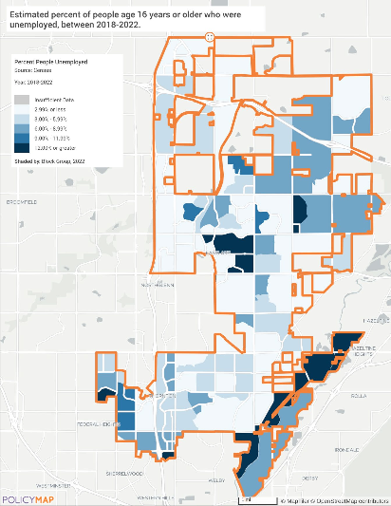
Unemployment Rate Map
Occupations by Sector | Number of People
Management, business and financial | 28,475
Farming, fisheries and forestry occupations | 231
Service | 11,994
Sales and office | 17,447
Construction, extraction, maintenance and repair | 8,246
Production, transportation and material moving | 10,307
Table 13 – Occupations by Sector

Alternate Data Source Name:
2019-2023 ACS

Data Source Comments:

Occupations by Sector

Travel Time
Travel Time | Number | Percentage
< 30 Minutes | 32,822 | 50%
30-59 Minutes | 27,253 | 41%
60 or More Minutes | 6,167 | 9%
Total | 66,242 | 100%
Table 14 - Travel Time

Alternate Data Source Name:
2019-2023 ACS

Data Source Comments:

Commute Travel Time

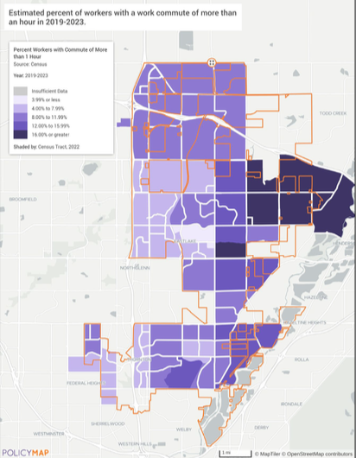
Commute Time More Than 1 Hour
Inflow-Outflow of Jobs in 2022

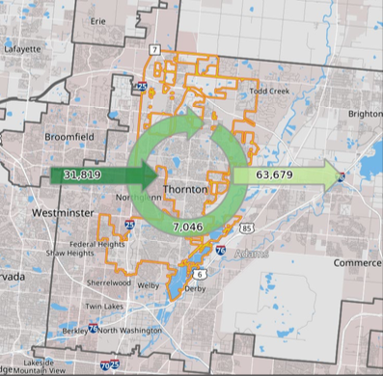
Inflow-Outflow of Jobs in 2022
Employed in the Selection Area | 38,865
Employed and Living in the Selection Area | 7,046
Employed in the Selection Area but Living Outside | 31,819
Living in the Selection Area but Employed Outside | 63,679
Data Source: 2022 LEHD Inflow/Outflow Job Counts
Table 1 - Inflow-Outflow of Jobs Counts 2022
Education:
Educational Attainment by Employment Status (Population 16 and Older)
Educational Attainment | In Labor Force
Educational Attainment | Civilian Employed | Unemployed | Not in Labor Force
Less than high school graduate | 6,225 | 486 | 2,595
High school graduate (includes equivalency) | 15,229 | 1,426 | 3,386
Some college or Associate's degree | 19,469 | 321 | 3,138
Bachelor's degree or higher | 21,708 | 603 | 1,833
Table 15 - Educational Attainment by Employment Status

Alternate Data Source Name:
2019-2023 ACS

Data Source Comments:

Educational Attainment by Employment Status

Educational Attainment by Age
 | Age
 | 18–24 yrs | 25–34 yrs | 35–44 yrs | 45–65 yrs | 65+ yrs
Less than 9th grade | 213 | 818 | 1,158 | 1,951 | 640
9th to 12th grade, no diploma | 1,881 | 1,315 | 1,626 | 2,300 | 1,356
High school graduate, GED, or alternative | 5,841 | 5,929 | 4,584 | 9,291 | 3,797
Some college, no degree | 3,818 | 4,855 | 4,712 | 6,509 | 3,420
Associate's degree | 479 | 2,032 | 2,095 | 2,702 | 1,465
Bachelor's degree | 1,538 | 5,699 | 5,438 | 5,844 | 2,074
Graduate or professional degree | 64 | 1,843 | 2,421 | 2,875 | 1,518
Table 16 - Educational Attainment by Age

Alternate Data Source Name:
2019-2023 ACS

Data Source Comments:

Educational Attainment by Age

Educational Attainment – Median Earnings in the Past 12 Months
Educational Attainment | Median Earnings in the Past 12 Months
Less than high school graduate | 40,985
High school graduate (includes equivalency) | 47,068
Some college or Associate's degree | 52,228
Bachelor's degree | 70,733
Graduate or professional degree | 78,647
Table 17 – Median Earnings in the Past 12 Months

Alternate Data Source Name:
2019-2023 ACS

Data Source Comments:

Median Earnings by Educational Attainment

Based on the Business Activity table above, what are the major employment sectors within your jurisdiction?

Describe the workforce and infrastructure needs of the business community:

Describe any major changes that may have an economic impact, such as planned local or regional public or private sector investments or initiatives that have affected or may affect job and business growth opportunities during the planning period. Describe any needs for workforce development, business support or infrastructure these changes may create.

How do the skills and education of the current workforce correspond to employment opportunities in the jurisdiction?

Describe any current workforce training initiatives, including those supported by Workforce Investment Boards, community colleges and other organizations. Describe how these efforts will support the jurisdiction's Consolidated Plan.

Does your jurisdiction participate in a Comprehensive Economic Development Strategy (CEDS)?
Yes
If so, what economic development initiatives are you undertaking that may be coordinated with the Consolidated Plan? If not, describe other local/regional plans or initiatives that impact economic growth.

Discussion

MA-50 Needs and Market Analysis Discussion
Are there areas where households with multiple housing problems are concentrated? (include a definition of "concentration")
HUD defines “housing problems” based on four specific data points: cost burden, overcrowding, lack of complete plumbing facilities, and lack of complete kitchen facilities. In Thornton, housing issues are infrequent overall, except for cost burden. According to the 2018-2022 ACS 5-Year Estimates, the citywide rates are as follows:
- Cost Burden Renters: 55.6%
- Cost Burden Homeowners: 26.6%
- Overcrowding: 3.8%
- Lack of Complete Plumbing Facilities: 0.3%
- Lack of Complete Kitchen Facilities: 0.2%
For an area to be considered "concentrated" with housing issues, it must exhibit two or more problems significantly above the citywide averages, using HUD's definition of “disproportionate.” This threshold in Thornton is set at 10 percentage points higher than the city average, equating to: a cost burdened renter above 65.6%, a cost burdened homeowner over 36.6%, overcrowding above 13.8%, lack of plumbing facilities above 10.3%, and lack of kitchen facilities above 10.2%.
In Thornton, there are no tracts that meet the criteria for having more than one concentrated housing problem. However, the Fire Department and Help for Home program regularly encounter residents without water, electricity and/or heating. These are typically found in the older sections of the city.
Are there any areas in the jurisdiction where racial or ethnic minorities or low-income families are concentrated? (include a definition of "concentration")
For the purposes of this analysis a “racial or ethnic concentration” will be any block group where a racial or ethnic minority group makes up 10 percent or higher than the citywide rate. According to the 2018-2022 ACS 5-Year estimates the racial and ethnic breakdown of Thornton’s population is:
- Black, non-Hispanic: 2.0%
- White, non-Hispanic: 51.1%
- American Indian and Alaska Native, non-Hispanic: 0.2%
- Asian, non-Hispanic: 5.5%
- Native Hawaiian and Other Pacific Islander, non-Hispanic: 0.0%
- Other Race, non-Hispanic: 0.3%
- Two or More Races, non-Hispanic: 3.6%
- Hispanic or Latino: 37.3%
In Thornton, White households are the largest demographic group, with significant concentrations in the northeastern, northern, and central parts of the city. Certain areas also show concentrations of Black/African American and Hispanic/Latino households, where these populations form a substantial share of the community. Other racial or ethnic groups do not display notable concentrations based on the established analysis criteria. The maps below illustrate these racial and ethnic distributions across Thornton, excluding populations without significant concentrations.
What are the characteristics of the market in these areas/neighborhoods?
LMI neighborhoods in Thornton are mostly comprised of small single-family homes, multifamily housing and mobile home parks. In the southern region of the city there are distinct market characteristics shaped by economic disparities and demographic composition. These areas have higher concentrations of Hispanic or Latino residents, with some census tracts in South Thornton having more than 50% of residents who are Hispanic or Latino.
Key characteristics of the market in these areas include:
- Older Housing Stock – Based on the 2024 HNA, much of the housing in South Thornton was built before 1980, making these units more likely to require significant repairs and maintenance. Many homes in these areas may still contain lead-based paint hazards and outdated energy systems, which pose health and safety risks to residents.
- Higher Cost Burdens – Many residents in LMI areas spend more than 30% of their income on housing costs, making them cost-burdened or significantly cost-burdened (> 50%). This financial strain eliminates disposable income for essential needs such as home maintenance, healthcare, transportation, and education, further exacerbating economic instability.
- Limited Housing Availability – According to the Thornton HNA, higher-income households occupying units typically considered affordable to low-income residents has further reduced the availability of affordable housing stock, making it even more difficult for low-income families to secure stable housing. The analysis identified an overall NET shortfall of 409 rental units city-wide, with the gap widening to more than 3,000 affordable units for households earning below 80 percent of the median household income. Units in buildings with 20 or more apartments or condos declined from 3,266 (7.6% of the stock) to 2,944 (5.9%), signaling a contraction in high-density housing that further tightens the supply of affordable rentals.
These market conditions underscore the need for targeted housing policies, reinvestment strategies, and community development efforts to expand affordable housing options, improve living conditions, and address economic disparities in Thornton’s low-income neighborhoods.
Are there any community assets in these areas/neighborhoods?
LMI neighborhoods in Thornton, particularly in South Thornton, benefit from several community assets that provide critical support services to residents. These resources help enhance economic mobility, promote well-being, and improve overall quality of life.
Key assets in or near the LMI areas of the city include:
- Community Connections – This division of Parks, Recreation and Community Programming (PRCP) directly assist residents, area non-profits, and the faith-based communities in or serving Thornton. Activities include direct assistance with referrals, water payment assistance, tax rebates, H4H, CodeCAP, PAT, HOT, LMI farmers markets and foods boxes, community gardens, Housing University courses, non-profit facility use, food drives, backpack giveaways, and much more. Assistance is given to all that contact our 13-member team. The services are free and over 48,000 direct referrals were given in 2024.
- Thornton Homeless Outreach Team (HOT) – The city’s Homeless Outreach Team (HOT) assists individuals facing housing instability, particularly in Ward 1, where a significant portion of Thornton’s unhoused population resides.
- Art and Culter Center – This division of PRCP is located next to Community Connections. Its mission is to engage in and celebrate the heritage, culture and creativity of the Thornton Community. It rotates area artists through its art gallery, provides archival storage, museums, historical preservation, art classes, camps and workshops.
- New Fire Station #1 – With the assistance of CDBG funds, the city constructed and equipped a new fire station to replace the original one. While providing the facilities needed for the fire fighters to protect the community, it also provides a community room, restrooms, and lobby for public use.
- Thornton Community Center – In 2025, the city opened the new Community Center on the site of the old Community Center – 2211 Eppinger Blvd, Thornton, CO 80229. It contains an Anythink Library, indoor track, teen center, gym, fitness center, skatepark, classrooms, multipurpose rooms, and boxing facilities. It is open seven days a week.
- Maiker Housing Partners – Located in neighboring Westminster, Thornton utilizes the County’s public housing authority – MHP. It operates affordable housing developments and rental assistance programs, including Housing Choice Vouchers (HCVs), to support low-income households.
- Almost Home, Inc. – Located in neighboring Brighton, this nonprofit offers homeless prevention services, emergency rent and utility assistance, and supportive housing programs to stabilize families at risk of displacement.
- Thornton Active Adult Center – Located 8 blocks north of the LMI areas, this new facility serves seniors and low-income residents. Their vision is to provide programming opportunities for the community to age well physically, mentally, emotionally, and socially. Part of their services include health and wellness programs, social gatherings, food assistance, educational services, and recreational activities, particularly for those living on fixed incomes.
- Thornton Civic Center - Contains the police headquarters, City Hall, City Court, Economic and Community Development Offices, and the Building Department.
Continued below Are there any community assets in these areas/neighborhoods
Are there other strategic opportunities in any of these areas?
In addition to existing community assets, Thornton's LMI neighborhoods present several strategic opportunities that could enhance economic development and improve residents' quality of life. Key areas for potential investment include:
- Redevelopment of Blighted Properties: According to the Thornton Office of Economic Development, the city aims to rejuvenate areas by addressing blighted properties through urban renewal strategies. A notable example is the Thornton Shopping Center, which, after decades of neglect and contamination, was seized by the Thornton Development Authority for redevelopment. Such initiatives can remove blight, invigorate stagnant areas, and catalyze long-term investment. The property has been razed, the contamination has been cleaned up, and Denver University and the University of Colorado submitted their development proposals to the city. Denver University’s proposal “Thornton Gateway” was the winner of the competition in May 2025.
- Expansion of Affordable Housing Near Transit Hubs: Based on information from the U.S. Department of Housing and Urban Development, developments like Crossing Pointe North, an affordable senior apartment building near the Thornton Crossroads/104th station, demonstrate the potential of transit-oriented development. Expanding similar projects can provide residents with affordable housing options that offer convenient access to transportation, employment centers, and essential services.
- Strengthening Partnerships with Nonprofit Organizations: Organizations such as Brothers Redevelopment and Maiker Housing Partners offer housing-related services to low-income residents. Collaborating with such nonprofits can enhance the delivery of services like housing counseling, home repairs, and senior support, thereby addressing housing insecurity and promoting community stability.
- Increasing Resident Knowledge - on resources, financial management, homeownership, prevention, fair housing, energy and water conservation and many other topics with Community Connections’ free Housing University courses.
- Leveraging State and Federal Financial Assistance Programs: Utilizing resources like the Colorado Housing Financial Assistance Programs can provide tenants with rent and utility assistance, foreclosure prevention, and other support services. Promoting awareness and accessibility of these programs can help stabilize housing for low-income residents.

By pursuing and/or expanding these strategic opportunities, Thornton can address existing challenges in its low-income neighborhoods, fostering economic growth and enhancing the well-being of its residents.
Are there any community assets in these areas/neighborhoods continued
- Food and Basic Needs Assistance – Eight area organizations like Adams County Food Bank, Thornton Community Food Bank, the Westminster Presbyterian Church, and other local pantries provide food security services to Thornton’s low-income families, addressing nutritional disparitiesâ¿¿.
- Community Reach Center – This non-profit provides mental health services provides therapy, medical services, peer support and care management on an in- and out-patient setting.
- Intervention, Inc. – This non-profit provides victim services to help support trauma victims.
Additional community assets include libraries, parks, county facilities, and other numerous community-based nonprofit organizations. These community assets play a vital role in supporting low-income residents, providing housing assistance, financial support, workforce training, and basic needs services. Supporting and expanding these resources will be essential to improving quality of life and fostering long-term stability for Thornton residents.
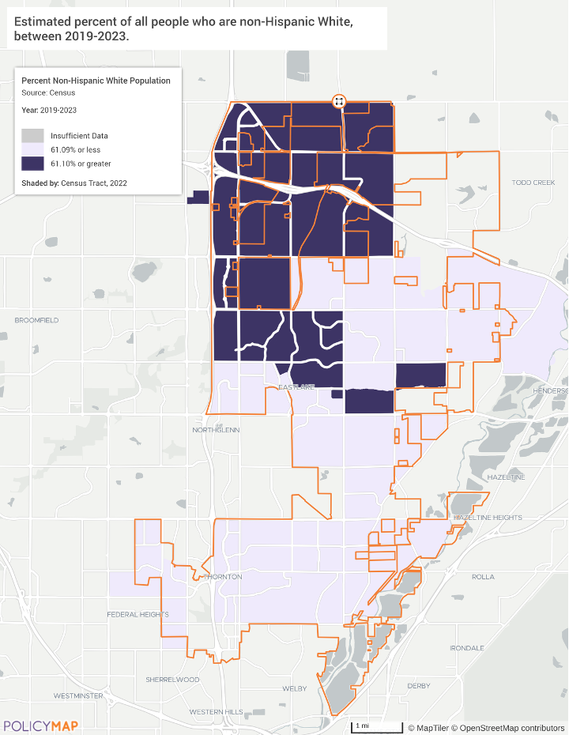
Concentration White (non-Hispanic) households over 61.1%
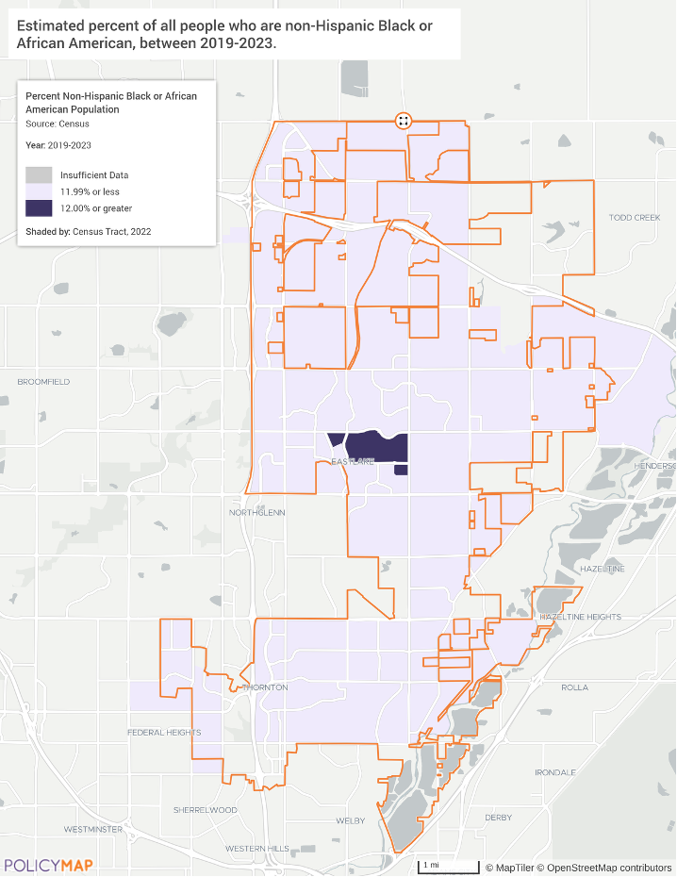
Concentration Black/African American (non-Hispanic) households over 12.0%
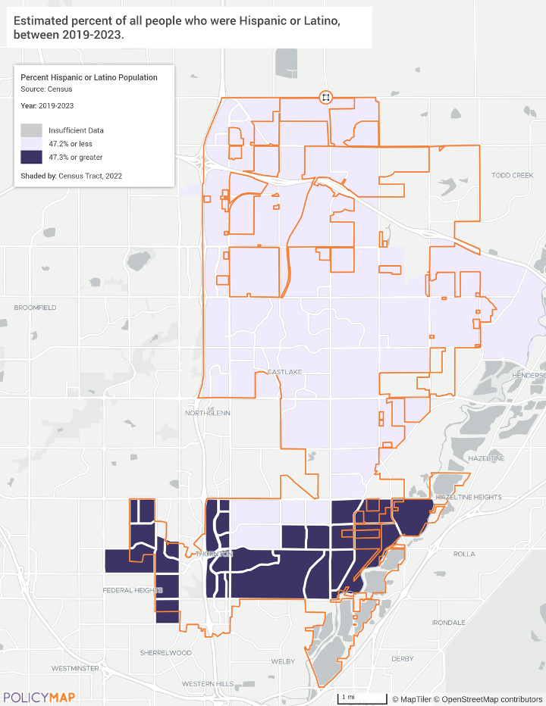
Concentration Hispanic/Latino households over 47.3%
Low Income Households

- Tract 08001009318 - $59,382
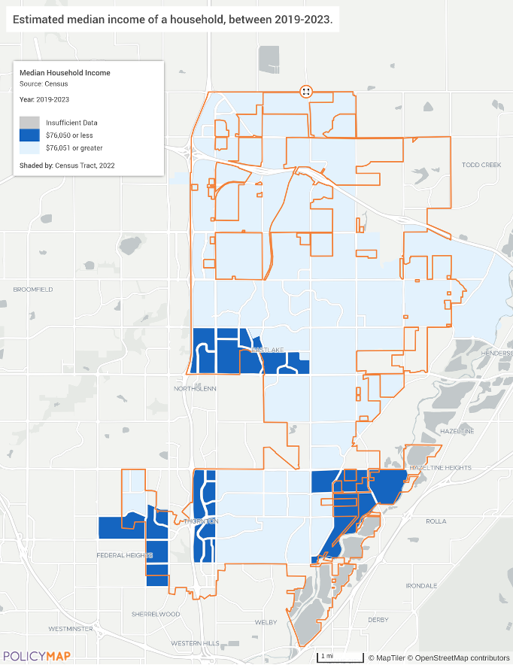
LMI Households (Income below 80% Area Median Income = $76,051)

MA-60 Broadband Needs of Housing occupied by Low- and Moderate-Income Households - 91.210(a)(4), 91.310(a)(2)
Describe the need for broadband wiring and connections for households, including low- and moderate-income households and neighborhoods.
Internet access is a critical component of modern communication and information-sharing, enabling users to benefit from the growing interconnectedness of business, education, commerce, and everyday activities. Reliable internet connectivity is essential for success in today’s domestic and economic landscape. Communities without broadband access face significant challenges in keeping pace with the rest of the country. The lack of broadband infrastructure limits residents' ability to access educational and entrepreneurial opportunities, which is especially concerning in LMI areas where economic opportunities are limited.
Research from the Pew Research Center underscores the vital role that high-speed internet plays in enhancing educational and employment opportunities, particularly in underserved communities. The center's studies have shown that individuals with reliable broadband access are more likely to engage in online learning, apply for jobs, and participate in economic activities that can improve their quality of life.
Similarly, reports from the Federal Communications Commission (FCC) highlight the direct correlation between broadband availability and economic development. The FCC's findings indicate that regions with robust internet infrastructure experience higher rates of job creation, educational attainment, and overall community growth.
Thornton enjoys comprehensive broadband coverage, with the vast majority of the city offering various internet service provider options, including in LMI areas. The average Thornton household has access to four (4) broadband-quality internet service options. According to ISPReports.org, Thornton benefits from a variety of infrastructure options, including cable, fiber, fixed wireless, and DSL. Ninety-five percent (95%) of households in Thornton have an internet connection. Of those households, 83% have fiber, cable, or DSL, 8% have satellite, 0% are still on dial-up, and 1% of households have internet but don’t pay for a subscription because it’s subsidized by the Affordable Connectivity Program. The map below illustrates broadband availability throughout Thornton, defined as advertised internet speeds of 768 kilobits per second or higher.
See map: Broadband Access
Describe the need for increased competition by having more than one broadband Internet service provider serve the jurisdiction.
To ensure high-quality broadband service, it is crucial to foster competition among service providers. A lack of competition, where a single provider dominates an area, can diminish the incentive to deliver reliable and consistent services. According to ISPReports.org, Thornton is served by fifteen (15) Internet providers offering residential service. Among these, Xfinity and Century Link (DSL) stand out as the leading providers in terms of coverage and speed. Internet providers throughout the city include:
- XFINITY (Cable)
- CenturyLink (Fiber and DSL)
- Quantum Fiber (Fiber)
- Earthlink (Fixed Wireless)
- T-Mobile Home Internet (Fixed Wireless)
- Verizon (Fixed Wireless)
- Rise Broadband (Fixed Wireless)
- Aerux Broadband (Fixed Wireless)
- AT&T (Fixed Wireless)
- Live Wire Networks (Fixed Wireless)
- Dish (Satellite)
- DirecTV (Satellite)
- HughesNet (Satellite)
- Viasat Internet (Satellite)
- Starlink (Satellite)
The map below shows the number of broadband service providers by census tract. Most of the city of Thornton has at least four (4) options of high-speed internet with competitive providers. This variety ensures that residents have multiple choices for reliable and affordable internet access throughout the city.
See map: Highspeed Internet Providers
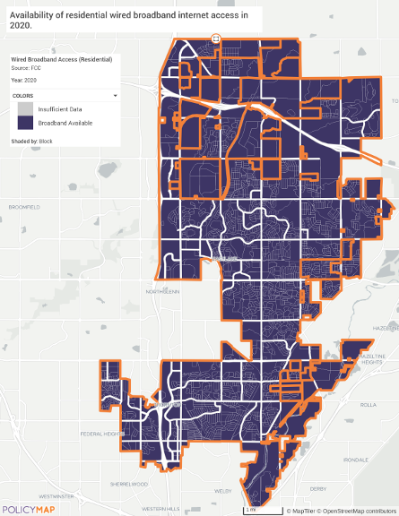
Broadband Access Map
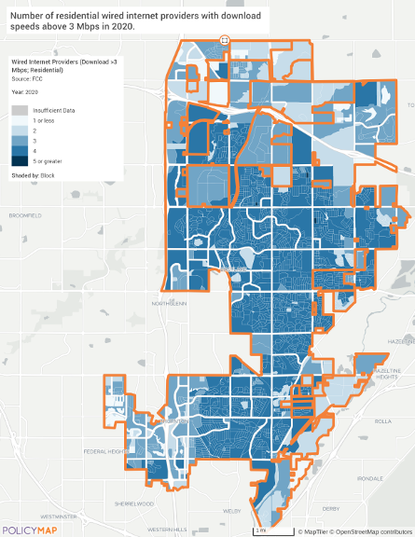
Highspeed Internet Providers Map

MA-65 Hazard Mitigation - 91.210(a)(5), 91.310(a)(3)
Describe the jurisdiction’s increased natural hazard risks associated with climate change.
Thornton, CO, has historically faced a variety of natural hazards, including drought, severe thunderstorms, floods, hail, winter storms, tornadoes, and earthquakes, as outlined in the 2023 Thornton, Federal Heights, and Northglenn Hazard Mitigation Plan (HMP). Research from this plan highlights that climate change is intensifying these risks, particularly extreme heat, drought, and flooding. The region has experienced one of the most rapid warming trends in the nation, with summer temperatures projected to rise significantly by 2100. Under a high-emission scenario, annual average temperatures could increase by up to 8.6°F, leading to more frequent and intense heat waves.
By 2036-2065, Thornton is expected to experience more days with temperatures exceeding 90°F, increasing drought severity due to higher evapotranspiration and reduced snowpack. Warmer temperatures will also prolong wildfire seasons and dry vegetation more quickly, making fires more frequent and severe. Additionally, rising temperatures will exacerbate stress on infrastructure, public health, and water resources.
At the same time, more intense precipitation events are expected to increase flood risks, particularly in urban areas with inadequate drainage and in wildfire-affected regions where vegetation loss leads to higher runoff and erosion. Thornton experiences an average annual precipitation of 14.15 inches, with the highest rainfall occurring in spring and summer. While winters may be warmer overall, the potential for stronger winter storms, including ice storms and sleet, remains a concern. Though earthquakes are not influenced by climate change, increased precipitation may heighten landslide and liquefaction risks in some areas.
According to the FEMA National Risk Index, Adams County, which includes Thornton, is particularly vulnerable to hazards such as cold waves, hail, lightning, and tornadoes as significant hazards for Thornton. As the city faces hotter, drier summers, more intense storms, and worsening flood risks, these vulnerabilities highlight the need for proactive mitigation strategies to protect infrastructure and communities.
Thornton’s population grew 21% from 2010 to 2020. The city’s population is projected to continue growing at a rapid pace, with an expected increase of 50,000 to 65,000 new residents by 2040. While it is uncertain if any of this growth is directly linked to climate change, increasing risks to coastal regions may influence migration patterns, housing demand, and infrastructure capacity.
Addressing climate-related challenges requires proactive planning and resilience-building strategies to mitigate risks and safeguard public health. The Centers for Disease Control and Prevention (CDC) emphasizes that climate change, combined with other environmental and human-induced stressors, exacerbates existing public health threats and introduces new risks, highlighting the need for comprehensive preparedness efforts.
Continued below in Describe the jurisdiction's increased natural hazard risks
Describe the vulnerability to these risks of housing occupied by low- and moderate-income households based on an analysis of data, findings, and methods.
LMI households, whether renting or owning, are particularly vulnerable to climate change and natural disasters due to limited financial resources. Rising electricity, water, and housing costs can push them into unstable living conditions, increasing the risk of homelessness or substandard housing. The 2024 America’s Rental Housing Study from Harvard’s Joint Center for Housing Studies highlights how escalating insurance premiums and coverage withdrawals in high-risk areas make securing protection against climate-related losses increasingly difficult, while stagnant operating income further limits property owners' ability to invest in climate resilience.
The 2021 EPA study on Climate Change and Social Vulnerability reinforces these concerns, revealing that low-income individuals are more likely to live in areas experiencing rising mortality rates from extreme temperatures and face the highest labor hour losses due to weather exposure. Rural communities are especially disadvantaged, often lacking emergency support and resources for climate-related home repairs. As climate threats intensify, strengthening resilience among low- and moderate-income households is essential to ensuring their safety, stability, and long-term well-being.
The HMP highlights the heightened vulnerability of LMI households to natural hazards, as economic and social challenges can limit their ability to prepare for and recover from disasters. As of 2020, 8.5% of Thornton’s population lived below the poverty level, compared to 10.3% statewide. Single-parent households are especially at risk, facing greater financial and logistical barriers to disaster preparedness. Housing affordability is another critical concern, with a median home value of $546,000 and rising rental costs, leaving many residents with fewer resources for emergency planning or relocation. Homeowners are facing extreme increases in the cost of hail damage coverage or the loss of this coverage completely. According to Liberty Mutual, Colorado is significantly more expensive than the national average, with the average annual premium reaching $3,820.
The plan also identifies racial minorities and residents with limited English proficiency as particularly vulnerable due to communication barriers and economic disparities. In Thornton, 35.2% of the population is Hispanic or Latino, and 24.7% speak a language other than English at home. The city's social vulnerability index varies by region, with the highest risks concentrated in the southern areas, where multi-unit housing, single-parent households, and economic hardships are more prevalent.
FEMA’s National Risk Index identifies Adams County as having a relatively high level of community resilience, indicating that its residents have a relatively high ability to prepare for, adapt to, and recover from natural hazards. This assessment encompasses six broad categories: social, economic, community capital, institutional, infrastructural, and environmental factors at the county level. The map below illustrates FEMA’s qualitative risk to natural hazards at the census tract level within the city, providing an intuitive way to gauge community risk based on Expected Annual Loss (EAL), Social Vulnerability, and Community Resilience scores.
Continued below in Describe the vulnerability to these risks of housing
Describe the jurisdiction's increased natural hazard risks continued
Thornton is actively enhancing its resilience to natural hazards through infrastructure improvements, emergency preparedness, and community education. Flood mitigation remains a priority, with projects such as the Niver Creek Tributary M improvements and the Niver Creek at 96th Ave. culvert replacement aimed at reducing flood risks and removing structures from the floodplain.
Fire stations are being replaced in the older areas of the city and in the growth areas they are being built. Fire station #8’s groundbreaking occurred in January 2025. The city is also improving emergency communication by working with Verizon to establish cell booster capabilities for disaster response. While Thornton monitors wildfire risks, its mitigation efforts primarily focus on risk assessments and preparedness initiatives rather than large-scale hazardous fuel reduction. Since the last hazard mitigation plan update, Thornton has implemented several new mitigation actions, prioritizing projects based on risk assessments and cost-effectiveness to strengthen community resilience.
Thornton’s Office Emergency Management (Emergency Management | City of Thornton) plans, coordinates and supports activities to reduce community vulnerability by preparing for, responding to, recovering from, and mitigating impacts to natural and man-made disasters and large-scale emergencies. The City of Thornton uses the CodeRED Emergency Notification System to warn residents of potential safety dangers and other emergencies like wildfires, floods, criminal activity, evacuations, and water utility outages.
Describe the vulnerability to these risks of housing continued
Risk levels across Thornton range from relatively high to very low, with most areas falling within a moderate risk index. This variation highlights the need for targeted mitigation efforts to address specific vulnerabilities. These two indexes measure risk from different perspectives—FEMA’s risk index evaluates a community's ability to respond to hazards (resilience), while the city’s qualitative assessment concentrates on the likelihood and severity of those hazards. This dual approach ensures that resources are allocated where they are most needed, promoting both preparedness and targeted intervention. The city must continue to address these geographic challenges by anticipating, planning, and adapting to the risks associated with climate change and the potential demographic shifts affecting vulnerable communities.
Thornton prioritizes community education and preparedness for multi-hazard mitigation. The city provides timely updates via its Emergency Management website, social media, and the CodeRED notification system, which alerts residents to emergencies via phone, text, and email. The Adams County Office of Emergency Management (OEM) coordinates disaster response and recovery, collaborating with local agencies and neighboring counties to share resources and best practices. It oversees emergency operations, training, public education, and preparedness initiatives. Additionally, Colorado Voluntary Organizations Active in Disaster (VOAD) strengthens community resilience through coordinated support. As climate risks grow, continued investment in education, emergency planning, and partnerships will be vital for long-term preparedness. Without emergency sirens throughout the community, the city relies on the CodeRed alert system on resident’s phones. Unfortunately, a low percentage (<20%) of residents have signed up for this free notification service. Seniors often find it difficult to add new technology to their phones and this is a problem for the city.
See map: Risk to All Natural Hazards
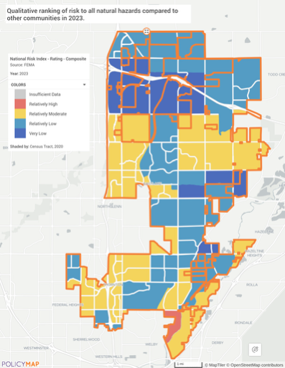
Risk to All Natural Hazards Map

Strategic Plan

SP-05 Overview
Strategic Plan Overview
The Strategic Plan outlines the City of Thornton’s housing and community development approach for the 2025-2029 Consolidated Plan. The plan describes how CDBG funds will be used to achieve HUD’s goals of providing affordable housing and a suitable living environment for LMI households and special need groups in the City. The City has prioritized addressing homelessness, housing, and public improvements with CDBG funds. The City identified these priority needs through data analysis, staff interviews, and citizen participation involving local nonprofit stakeholder organizations. Addressing these priority needs forms the basis of the five-year Strategic Plan.
The City does not allocate funding based solely on geographic requirements. It will consider investments in both LMI geographic areas and for eligible individuals and households citywide in its five-year plan. LMI areas (LMA) are primarily residential and have at least 51 percent of residents who are considered LMI as defined by HUD. The boundaries of these areas are defined at the census block groups at the tract level. Eligible activities with LMA benefits are public improvements like neighborhood facilities, community centers, parks, or infrastructure like roads and streets.
Within Thornton’s boundaries, the City also provides direct assistance to eligible LMI clientele (individuals) and households (LMC/LMH) earning 80% of the AMI or less.
The following are the four priority needs and associated goals identified in the Strategic Plan. More details of the priority needs are given in SP-25 and the goals are detailed in SP-45.

Priority Need: Affordable Housing
1A Affordable Housing

Priority Need: Public Services
2A Provide Services for LMI & Homeless

Priority Need: Public Facilities & Infrastructure
3A Expand/Improve Public Facilities & Infrastructure

Priority Need: Effective Program Management
4A Effective Program Management

SP-10 Geographic Priorities - 91.415, 91.215(a)(1)
Geographic Area
Table 18 - Geographic Priority Areas
1 | Area Name: | Citywide LMI Eligible
1 | Area Type: | Local Target area
1 | Other Target Area Description:
1 | HUD Approval Date:
1 | % of Low/ Mod:
1 | Revital Type: | Comprehensive
1 | Other Revital Description:
1 | Identify the neighborhood boundaries for this target area. | The Citywide LMAs in Thornton are census block group tracts where at least 51 percent of the residents are LMI. The majority of these tracts are in the southern areas of the City. This southern area is called Original Thornton and originated in 1956.  Within Thornton’s boundaries, the City also provides direct assistance to eligible LMI residents and households (LMC/LMH) earning 80% of the AMI or less.
1 | Include specific housing and commercial characteristics of this target area. | The population of Thornton has been growing rapidly in the past decade (19.4%), and to meet this need the number of housing units has increased. While a large portion of housing is new, there are still a number of older units in need of repair or improvement. An estimated 21% of all owner-occupied units and 26% of renter-occupied were built before 1980 (Source: 2019-2023 ACS). Naturally, older housing units may have higher maintenance needs, and a greater risk of lead-based paint hazards.
1 | How did your consultation and citizen participation process help you to identify this neighborhood as a target area? | The plan was informed by the City 2024 HNA, adopted in December of 2024. The HNA identified key housing challenges, demographic trends, past successes, market conditions, staff, stakeholders, and community input to provide a foundation for developing targeted strategies, to address these issues. The HNA helped guide efforts in planning, policymaking, partnerships, and acquiring funding for housing.  As part of the plan’s development process, Thornton held 4 public input meetings, stakeholder and resident surveys, a public hearing, staff interviews, and provided a 30-day public comment period to give citizens the chance to review and comment on the plan. The City consulted with 47 local community stakeholders, 20 city staff members, and individual residents to identify housing and community development needs. A resident and stakeholder survey was conducted online and in print. A total of 87 residents and 29 stakeholders responded to the survey.
1 | Identify the needs in this target area. | Housing and Homelessness  Affordable housing preservation is one of the priority needs in Thornton. Cost burdened households and homelessness are the most prevalent housing issues in the City. The most recent ACS data also shows 21% of homeowners and 26% of renters living in very old housing units built before 1980. Older homes typically need major repairs and code compliance assistance such as furnaces, accessibility improvements, roof replacements, dangerous tree removal, lead-based paint abatement, etc.  The HNA identified the current supply and demand mismatch is fueling a large gap in affordability LMI residents; housing production needs greatly outpace the current supply, rising housing costs surpass income, and development costs and fees impeded housing development. The ability for residents to safely and affordably age in place was identified as a significant need. Housing for survivors of trauma, specialized people with disabilities, and for people transitioning from homelessness into housing, including those with pets, were often identified by our citizens and stakeholders.  Homeownership is difficult to navigate and financially unattainable. Seniors have difficulty remaining safe in their homes. Young couples are not able to start their families because of extremely high housing costs. Education for future buyers is needed.  Owners want to remodel their homes to allow for roommates, caregivers, or ADUs - but regulations and costs are barriers.  Waiting lists exist for affordable senior and assisted-living housing (2-3 years) area wide. Rent assistance funding dries up fast. Electronic information and applications are barriers to those who do not have access or training.  Landlords have many upfront and monthly fees that increase steeply and without notification. Application fees, background check fees, multi-month deposits, and high security deposits limit the opportunity to seek and find decent and safe housing.  Public Facilities and Infrastructure  Public facilities and infrastructure improvement activities are a priority need in the City. Public improvements are needed to maintain and promote investment within low/mod areas. The needs identified included: park improvements, instilling a sense of neighborhood identity, beautification, utility and infrastructure modernization, lowering development fee costs, transportation access and safety, flood control, improved fire protection, and general safety issues. See the NA-50 for a list of focus areas.  Public Services  Public service needs address LMI households and the homeless in the City. Homeless services are available citywide, but a large portion of the services are targeted to south Thornton, where data has shown most people experiencing homelessness reside. Other public service needs include services for seniors and survivors of trauma, and programs for rent, mortgage and utility payments, deposit and move-in payments, lowering home maintenance barriers, ESL classes, navigation services, transportation for seniors, finding resources, bringing back community, and non-profit funding. As identified in the NA-50, there numerous needs for public services.
1 | What are the opportunities for improvement in this target area? | Several ideas were brought forth to help reduce the cost of housing in the city. Innovative housing models and strategies mentioned include mixed use, ADUs, micro-housing, co-housing, modular, transitional, communal, mobile home park resident ownership, multi-generational homes, group homes, exterior funding partnerships with land trusts, and land banks, grant leveraging and down payment and rental assistance.  Housing education for our residents to increase housing stability, lower housing costs, increase homeownership, and protect households members. Home rehab activities preserve and maintain affordable housing stock for LMI households in the City. Homebuyer assistance would improve homeownership access. Accessory dwelling unit (ADU) construction assistance would increase housing units, income potential, family unity, aging in place and property values. Creative housing choices would reduce costs and increase housing opportunities and lower homelessness. Reducing the number of violations and cost of code compliance has proven to be a huge opportunity for the city.  Housing developed/designated for specific at-risk users would reduce homelessness and increase their quality of life. Innovative methods and funding to address the needs identified previously are opportunities to help fix the housing problems and concerns.  Public facilities and infrastructure improvement activities enhance and revitalize neighborhoods, improve neighborhood safety, transportation safety, increase affordable housing, and encourage other public and private investments into these areas.  Public services help improve the quality of life for LMI residents and promote stable housing. Education, resource navigation and direct assistance also reduce homelessness.  Homeless services like transportation, food, critical document obtainment, clothing, and direct resource navigation services help reverse housing instability and help individuals and families regain economic self-sustainability.
1 | Are there barriers to improvement in this target area? | The city needs a housing plan and action plan to provide consistent direction and guidance for staff, developers, and investors, and their pursuit of projects. The general lack of funds to address all needs adequately is a barrier to improvement in the City of Thornton. The needed funds could originate from a combination of any of the following: grants, loans, financial partners, city funds, and local funds. There is also limited land for new development. Additionally, there is need for more Community Housing Development (CHDO) organizations in the area to assist with housing development.  A city housing rapid response team is needed to facilitate affordable housing opportunities in response to the market and Proposition 123 regulations.  Limited time, staff, expertise, and local resident efforts are also barriers to providing improvements for the city. The lack of community and grassroot efforts hinder local action. Housing has become complex and intimidating with city code restrictions, permits, HOAs, metro districts, fees, fines, and affordability – these are all barriers for our residents.  Mobility and transportation issues within the bedroom communities limit housing access. Resident resistance and fear of new affordable housing has placed barriers to some of MHP’s new affordable housing development plans. Significant increases in infrastructure costs limit the number of projects the city can afford/pursue.

General Allocation Priorities
Describe the basis for allocating investments geographically within the state
The City of Thornton’s CDBG funding must directly serve LMI individuals and families or be directed towards LMAs.
Direct services such as public services and affordable housing rehabilitation are based on individual household income eligibility or exempted status. For example, when planned activities are intended to serve individuals or households directly, beneficiaries must meet income and other qualifications, to receive assistance from the program. These benefits are defined for individuals as low/mod clientele (LMC), or for households as low/mod households (LMH).
Public facility and infrastructure improvement activities serve a community or neighborhood. These activities are said to have an “area-wide” benefit. Per HUD requirements, these areas must be within an eligible LMI census block group tract, as defined by HUD-CDBG regulations, whereby the majority of the residents are LMI (51% or greater). This objective is defined and identified by HUD as a LMA benefit.
To determine LMI tracts the City utilizes HUD’s CDBG Low Mod Income Summary Data (LMISD) from the HUD Exchange website, which has defined the eligible block group tracts within the jurisdiction. The tracts can be found at: https://www.hudexchange.info/programs/acs-low-mod-summary-data/.

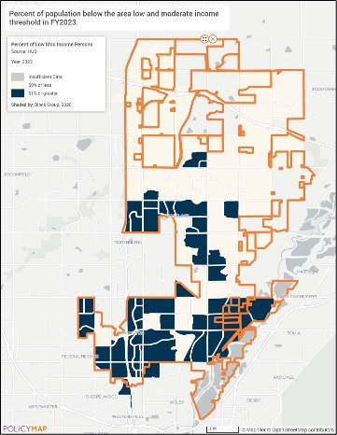
FY 2023 Low Mod BG Tracts (HUD LMISD)

SP-25 Priority Needs - 91.415, 91.215(a)(2)
Priority Needs
Table 19 – Priority Needs Summary
1 | Priority Need Name | Affordable Housing
1 | Priority Level | High
1 | Population | Extremely Low  Low  Moderate  Families with Children  Elderly
1 | Geographic Areas Affected | Citywide LMI Eligible
1 | Associated Goals | 1A Affordable Housing
1 | Description | Preserve and develop affordable housing through rehabilitation and public facilities. Rehabilitation activities include owner-occupied single-family rehabilitation. Developing affordable housing includes the payment or partial payment of tap fees and other development fees.
1 | Basis for Relative Priority | Community participation from residents, city staff, and stakeholders clearly demonstrated the need to produce and preserve affordable housing. The 2024 HN) further supports this, revealing a severe shortage of affordable housing in the City. As a result, creating and maintaining affordable housing for LMI residents in Thornton has been established as a top priority. Strong public input highlighting this urgent need—reinforced by data analysis and the City’s history with CDBG funding—has driven the designation of this issue as a high-priority need.  Historically the city administers several highly utilized home rehabilitation programs (HRP) using CDBG funds. One HRP program is called Help for Homes (H4H). Due to high demand, the City had to stop taking Help for Homes applications from late 2023 until April of 2024 to work through the long waitlist of applicants. Upon reopening H4H already has 23 projects underway. There are more older housing units that exist in the southern part of the City.  CodeCAP is another HRP funded by CDBG. It received the DRCOG 2024 Vision Award for innovatively combining home rehabilitation and small local business collaboration. This program within its first 18 months of operation has completed 45 projects, with 83% of them located in Wards 1 and 2.  PAT is a long-standing program for seniors with a consistent one-year waiting list.  The success with the Crossing Pointe developer partnership for new 206-unit senior and family apartments is another factor.
2 | Priority Need Name | Public Services
2 | Priority Level | High
2 | Population | Extremely Low  Low  Moderate  Large Families  Families with Children  Elderly  Chronic Substance Abuse  veterans  Persons with Mental Disabilities  Persons with Physical Disabilities  Persons with Developmental Disabilities  Persons with Alcohol or Other Addictions  Victims of Domestic Violence  Non-housing Community Development  Other
2 | Geographic Areas Affected | Citywide LMI Eligible
2 | Associated Goals | 2A Provide Services for LMI & the Homeless
2 | Description | Public services are needed to attend to the needs of LMI, people with special needs, and individuals experiencing homelessness in Thornton. As identified in the NA-50, there is a need for homeless outreach and prevention services; mental health and crisis intervention services; and workforce development, education support services and more. Homeless needs will be addressed through Thornton's HOT which provides life-saving supplies, resource navigation, transportation, and limited case management to people experiencing homelessness in Thornton.  Other public service needs for residents are greatly needed including food/nutrition, education, employment, rent, mortgage, and utility assistance, health/mental health, addiction recovery, family services, English as a Second Language (ESL) education, and many others.
2 | Basis for Relative Priority | Through community participation, surveys meetings and interviews with residents, city staff, and stakeholders plus a review of past CDBG activities, the City prioritized public services including areas such as homeless outreach and services, mental health services, addiction recovery, housing related education, employment assistance, and youth and family programs to address social and economic disparities. The basis for this high priority is to provide access to services to assist LMI residents reach better levels of stability and sustainability.
3 | Priority Need Name | Public Facilities & Infrastructure
3 | Priority Level | High
3 | Population | Extremely Low  Low  Moderate  Non-housing Community Development
3 | Geographic Areas Affected | Citywide LMI Eligible
3 | Associated Goals | 3A Expand/Improve Public Facilities/Infrastructure
3 | Description | Key areas of focus are community and recreational facilities; public safety facilities such as transportation routes, fire stations, police substations; and ADA accessibility improvements to upgrade existing public buildings and community spaces. Other public improvement activities include community walkability and connectivity enhancements; emergency protection infrastructure such as storm water management, flood protection, neighborhood safety and emergency preparedness. The City also identified in the MA-45, the need to improve broadband and digital infrastructure. Strengthening broadband infrastructure will help to support residents, schools, local businesses, remote professionals, and technology-based businessesâ¿¿.
3 | Basis for Relative Priority | As reported in the NA-50, the City of Thornton requires continual investment in public facilities to accommodate the 19.4% annual population growth and maintain a high quality of life for residents. Through community participation of residents, city staff, consultation of local stakeholders, and a review of past CDBG public facility projects the need for public facilities & infrastructure improvements was identified. Additionally, community feedback gathered through public forums and surveys highlighted the need for expanded recreational and safety facilities, particularly in underserved neighborhoodsâ¿¿. CDBG was founded upon infrastructure improvements for Entitlement Communities and the city will continue to pursue this historically successful directive.
4 | Priority Need Name | Effective Program Management
4 | Priority Level | High
4 | Population | Extremely Low  Low  Moderate
4 | Geographic Areas Affected | Citywide LMI Eligible
4 | Associated Goals | 4A Effective Program Management & Planning
4 | Description | Effective program management will include general administration and planning of the CDBG grant program, monitoring subrecipients, reporting and managing grant financials. Planning involves the development of AAPs, annual reports, and meeting citizen participation requirements.
4 | Basis for Relative Priority | There is a need to provide effective management of the CDBG grant program to ensure federal and city compliance with the regulations of the grant. Effective program administration ensures that the City meets the established objectives in the plan.

Narrative (Optional)
N/A

SP-35 Anticipated Resources - 91.420(b), 91.215(a)(4), 91.220(c)(1,2)
Introduction
The City of Thornton is designated as an “Entitlement Community” by the United States Department of Housing and Urban Development (HUD) and receives Community Development Block Grant (CDBG) funding based on an annual formula. For PY 2025, the City was awarded $811,771 in CDBG funds for its housing and community development projects to address the goals outlined in the Consolidated Plan. Activities to be funded will be housing rehab programs, public facility and infrastructure improvements, homeless outreach services, and the administration of the CDBG program.
Anticipated Resources
Program | Source of Funds | Uses of Funds | Expected Amount Available Year 1 |  |  |  | Expected Amount Available Remainder of ConPlan  $ | Narrative Description
Program | Source of Funds | Uses of Funds | Annual Allocation: $ | Program Income: $ | Prior Year Resources: $ | Total:  $ | Expected Amount Available Remainder of ConPlan  $ | Narrative Description
CDBG | public - federal | Acquisition  Admin and Planning  Economic Development  Housing  Public Improvements  Public Services | 811,771 | 0 | 0 | 811,771 | 3,247,084 | PY 2025 is the first program year of ConPlan. The expected amount available remainder of the ConPlan is 4x years of the annual allocation.
Table 20 - Anticipated Resources

Explain how federal funds will leverage those additional resources (private, state and local funds), including a description of how matching requirements will be satisfied
While matching funds are not a requirement for CDBG funding, Thornton encourages subrecipients to leverage awarded CDBG funds for additional local resources to further the impact of these funds. Examples include the HRP activities. Brothers Redevelopment (BRI) often provides leverage funding from DRCOG, and recently Adams County, to complete H4H projects, and PAT uses community volunteers to provide free labor on all their projects. CodeCAP regularly seeks and obtains volunteers, donations, and discounted costs for materials and labor to complete its activities.
The city pursued other leverage resources through the state. Approved by voters in 2022, Colorado’s Proposition 123 – State Affordable Housing Fund (Prop 123) was set in motion. As the Prop 123 programs were designed and rolled out by the state the city closely followed the training and release dates. So far, the city has received two Prop 123 grants, one for homelessness services and another to streamline the affordable housing development/redevelopment approval process down to 90 days. Additional funding for a MHP partnership for a land banking grant for 75 affordable senior housing units was applied for in 2025 but not awarded. The city will submit this NHP partnership grant application again at the next opportunity.
If appropriate, describe publically owned land or property located within the state that may be used to address the needs identified in the plan
At this time, Thornton has yet to identify any publicly owned land to address the housing needs identified in the Comprehensive Plan. A future city Housing Strategic Plan could include this research and mapping.
Discussion
The City is a member of the Adams County HOME Consortium and receives HOME Investment Partnerships funds through the HOME Consortium. HOME funds have a 25% matching requirement, and each HOME dollar spent is matched with 25% of general funds for projects within the program year. HOME funds are not entered in the table above as a resource as the HOME Consortium is the direct recipient of those funds and Adams County is ultimately responsible for the planning and reporting of HOME funds for the Consortium.

SP-40 Institutional Delivery Structure - 91.415, 91.215(k)
Explain the institutional structure through which the jurisdiction will carry out its consolidated plan including private industry, non-profit organizations, and public institutions.
Responsible Entity | Responsible Entity Type | Role | Geographic Area Served
City of Thornton | Government | Non-homeless special needs  Ownership  Planning  Rental  neighborhood improvements  public facilities | Jurisdiction
ADAMS COUNTY | Government | Homelessness  Planning  public facilities | Region
Maiker Housing Partners (Adams County Housing Authority) | PHA | Ownership  Public Housing  Rental | Region
Metro Denver Homeless Initiative | Continuum of care | Homelessness  Planning  public services | Region
Brothers Redevelopment Inc. | Developer | Non-homeless special needs
CODE COMPLIANCE ASSISTANCE PROGRAM | Non-profit organizations | Ownership  neighborhood improvements | Jurisdiction
CITY OF THORNTON HOMELESS OUTREACH TEAM | Non-profit organizations | Homelessness  public services | Jurisdiction
OTHER NON-PROFITS AND FAITH-BASED ORGANIZATIONS | Non-profit organizations | public services | Region
LAND BANKS, LAND TRUSTS, & DEVELOPERS | Non-profit organizations | Ownership  Rental | State
Table 21 - Institutional Delivery Structure
Assess of Strengths and Gaps in the Institutional Delivery System
The City of Thornton’s strength lies in its interdepartmental communication, strong partnerships with surrounding jurisdictions, local nonprofits, faith-based communities, and other organizations to provide attainable housing options, essential public services, and safe, supportive environments—especially for LMI households and during emergencies. A key asset in this effort is the Community Connections division, housed within the Parks, Recreation, and Community Programming Department. This team of 13 staff members brings expertise in housing, homelessness, grant administration, food and nutrition, physical and mental health, special needs, and resource assistance—with 93% of staff fluent in Spanish. In 2024, the division made 48,739 direct referrals, including 26,778 related specifically to housing and homelessness. Located in the heart of older, lower-income neighborhoods, the Community Connections building (formerly the City Hall) is another asset, offering free space to partners for events, classes, and clinics that serve tens of thousands of residents annually.
Thornton also demonstrates a long-standing commitment to helping residents access affordable housing, free or low-cost resources, and education. Over the past seven years, the city has launched numerous initiatives including the Community Connections division, Healthy Farmers Markets, a Homeless Outreach Team, the Code Compliance Assistance Program, Bi-annual Neighborhood Cleanups, and Housing University, which offers free housing-related courses and supplies. Thornton has doubled the TAF to $300,000 for nonprofit grants and significantly expanded funding in 2025 for the Water Assistance, Property Tax Rebate, and Food Sales Tax Rebate programs—all of which target LMI residents.
Despite these efforts, gaps remain—chiefly a lack of awareness among city staff, residents and nonprofit staff about each other’s services, events and available funding. Staff turnover in both nonprofit and city roles also leads to lost institutional knowledge, requiring significant time retraining and supporting new personnel through the learning curve. This hinders CDBG project and administrative.
Availability of services targeted to homeless persons and persons with HIV and mainstream services
Homelessness Prevention Services | Available in the Community | Targeted to Homeless | Targeted to People with HIV
Homelessness Prevention Services
Counseling/Advocacy | X | X
Legal Assistance | X | X
Mortgage Assistance | X
Rental Assistance | X | X
Utilities Assistance | X | X

Street Outreach Services
Law Enforcement | X | X
Mobile Clinics | X
Other Street Outreach Services | X | X

Supportive Services
Alcohol & Drug Abuse | X | X
Child Care | X
Education | X
Employment and Employment Training | X | X
Healthcare | X |  | X
HIV/AIDS | X |  | X
Life Skills | X
Mental Health Counseling | X | X
Transportation | X

Other
Table 22 - Homeless Prevention Services Summary
Describe how the service delivery system including, but not limited to, the services listed above meet the needs of homeless persons (particularly chronically homeless individuals and families, families with children, veterans and their families, and unaccompanied youth)
Community Connections’ Homeless Outreach Team (HOT) works directly with people experiencing homelessness. HOT also collaborates with Colorado Coalition for the Homeless, Almost Home, Adams County Human Services, Adams County Hard Reduction, Maiker Housing Partners, and many more who serve people who are homeless or close to being homeless in the area. In many cases, these agencies have been funded through Thornton's allocation of CDBG funds and Thornton Assistance Funds. HOT, Community Connections, and these agencies assist their clients with finding and accessing childcare services, health services, mental health services, housing assistance, transportation, GED classes and job skill training. The city provides contact information for these homeless service providers as well as other organizations that help people with their basic needs through the website marketing materials, and through face-to-face and phone interactions with those in need of service. The online list of resources includes agencies that provide food; housing; utility assistance; health care; help for home-bound, and assistance in a mental health crisis.
The city participates in the Metropolitan Denver Continuum of Care (CoC) led by the Metro Denver Homeless Initiative (MDHI), which is designated by the US Department of Housing and Urban Development. The Metro Denver Homeless Initiative is a regional system that coordinates in a regional system of nonprofit and government agencies, elected officials, nonprofit leaders, and people with lived expertise to bring about an end to homelessness in the seven-county Metro Denver region. MDHI provides services such as leading the OneHome Coordinated Entry with a client-centered approach to housing, grants and monitoring, leads the Colorado’s Homeless Management Information System (COHMIS), organizes the city’s Point in Time Count - a nationwide count of people experiencing homelessness, leads the regional coordination, and produces the reports and data.
The MDHI leads the Coordinated Entry System (CES) for the Metro Denver region. Coordinated Entry is a client-centered process that partners with service providers and community members to assess and identify the housing needs of people experiencing homelessness. OneHome Coordinated Entry matches individuals, youth, and families to the appropriate housing resource available while elevating client choice.
Describe the strengths and gaps of the service delivery system for special needs population and persons experiencing homelessness, including, but not limited to, the services listed above
A key strength of the homeless support system in Thornton is the presence of multiple established agencies dedicated to serving individuals experiencing homelessness and other special populations. These agencies are actively working to enhance the quality and effectiveness of their services. Housing service providers collaborate to prevent homelessness, offer immediate shelter to those in crisis, and support long-term efforts toward self-sufficiency. Organizations such as the Colorado Coalition for the Homeless, Almost Home, Adams County Human Services, Adams County Harm Reduction, and MHP serve individuals who are currently homeless or at risk of becoming homeless across the City and countywide. When service gaps are identified, these agencies regularly come together to discuss issues and develop coordinated solutions.
However, a major challenge facing the system is the lack of sufficient resources to meet the growing demand for services. Feedback from providers indicates that transportation is one of the most significant barriers for homeless and special needs populations, yet transportation assistance—such as vouchers—is limited. The demand for these critical services often exceeds availability and may require restructuring to more effectively meet the evolving needs of the community.
Provide a summary of the strategy for overcoming gaps in the institutional structure and service delivery system for carrying out a strategy to address priority needs
Overcoming the gaps in the institutional structure and service delivery system will be done in collaboration with other funders and through partnerships that meet the needs of Thornton’s most vulnerable groups. Overcoming these gaps was also a primary reason Thornton created the Community Connections Division to serve as the one-stop resource shop for residents to navigate service delivery. Community Connections staff work with several collaborative organizations to form partnerships to increase the level of service for our residents. Often, these efforts introduce service providers with other service providers that can partner or assist each other.
Three great new examples:
- In 2024, the Homeless Outreach Team collaborated with the faith-based communities, city Courts, Legal, and the Police Department to hold monthly resource fairs for people experiencing homelessness. The Thornton Empowerment Expo is located at Rock AG Church. The Homeless Outreach Team has also partnered with the Faith Based Community Alliance to recruit volunteers for the Expo events and provide donated meals.
- Additionally, the Homeless Outreach Team partnered with Courts, Legal, and the Thornton Police Department to create a diversion program called Thornton Fresh Start Court to target people experiencing homelessness. Even though this program is in the beginning phases, so far, we have seen two individuals in Thornton Fresh Start obtain housing!
- Through collaborative efforts, the City and its partners were able to identify a large gap in service delivery and worked to launch a severe weather activation plan to provide emergency shelter to residents experiencing homelessness. This brought together three separate service providers to work collaboratively to quickly stand up this new program and several municipalities provided navigation to residents experiencing homelessness.
Finally, Thornton will continue to provide technical assistance to agencies funded through CDBG with the goal of helping them to increase their capacity and operate their business more efficiently. Since these agencies serve all residents of the county, the city will support the county in their efforts to increase the capacity of local nonprofits who are struggling to provide the same or increased levels of service to their clients.

SP-45 Goals - 91.415, 91.215(a)(4)
Goals Summary Information
Sort Order | Goal Name | Start Year | End Year | Category | Geographic Area | Needs Addressed | Funding | Goal Outcome Indicator
1 | 1A Affordable Housing | 2025 | 2029 | Affordable Housing | Citywide LMI Eligible | Affordable Housing | CDBG: $2,238,255 | Homeowner Housing Rehabilitated:  125 Household Housing Unit
2 | 2A Provide Services for LMI & the Homeless | 2025 | 2029 | Non-Housing Community Development | Citywide LMI Eligible | Public Services | CDBG: $608,830 | Public service activities other than Low/Moderate Income Housing Benefit:  1750 Persons Assisted
3 | 3A Expand/Improve Public Facilities/Infrastructure | 2025 | 2029 | Non-Housing Community Development | Citywide LMI Eligible | Public Facilities & Infrastructure | CDBG: $400,000 | Public Facility or Infrastructure Activities other than Low/Moderate Income Housing Benefit:  15000 Persons Assisted
4 | 4A Effective Program Management & Planning | 2025 | 2029 | Non-Housing Community Development | Citywide LMI Eligible | Effective Program Management | CDBG: $811,770 | Other:  5 Other
Table 23 – Goals Summary

Goal Descriptions

1 | Goal Name | 1A Affordable Housing
1 | Goal Description | Provide single-family, owner-occupied housing rehabilitation activities to help preserve the housing stock of LMI households through home repairs, weatherization programs, accessibility improvements, energy and water efficiency improvements, code compliance, and exterior painting of the homes. Assist with the public facility needs of new affordable housing construction as permitted by CDBG and HOME regulations.
2 | Goal Name | 2A Provide Services for LMI & the Homeless
2 | Goal Description | Provide public services to support and improve the quality of life for LMI individuals and the homeless. Homeless needs will be addressed through Thornton's HOT and other supportive non-profit services which provide life-saving supplies, resource navigation, and limited case management to people experiencing homelessness in Thornton. Other identified priority LMI needs for public services include crime victim assistance, in-home assistance, nutrition and food access, mental health services, employment and educational support.
3 | Goal Name | 3A Expand/Improve Public Facilities/Infrastructure
3 | Goal Description | Provide improved access to public facilities in LMI areas, such as neighborhood facilities, homeless shelters and parks and recreation facilities. The City will expand and improve public infrastructure in LMAs, such as transportation safety, drainage systems, commuter rail access, micro transportation, ADA accessibility improvements, sidewalk and connectivity enhancements, community recreation facilities, public safety facilities, stormwater management, public infrastructure for affordable housing construction/rehabilitation, as permitted by CDBG and HOME regulations.
4 | Goal Name | 4A Effective Program Management & Planning
4 | Goal Description | Effective program management will include general administration and planning of the CDBG grant program, monitoring subrecipients, reporting and managing grant financials. Planning involves the development of AAPs, annual reports, and meeting citizen participation requirements.
Estimate the number of extremely low-income, low-income, and moderate-income families to whom the jurisdiction will provide affordable housing as defined by HOME 91.315(b)(2)
Through the CDBG program the City of Thornton estimates that over the next five years of the Consolidated Plan the city will assist 125 LMI households with affordable housing activities:
Public facilities/infrastructure assistance could reach 75 affordable units.

SP-65 Lead-based Paint Hazards - 91.415, 91.215(i)
Actions to address LBP hazards and increase access to housing without LBP hazards
Organizations/Subrecipients under agreement with the CDBG program coordinate the home rehabilitation work with Thornton’s HRP to comply with the Environmental Protection Agency (EPA) regulations for lead-based paint. They require their contractors and subcontractors to follow the testing and abatement procedures as necessary. Depending on the square footage or cost of the potential area of disturbance, different levels of mitigation are completed. The City also provides the “Protect Your Family From Lead in Your Home” informational booklet to residents and HRP clients, in English and Spanish. Refer to the website https://www.epa.gov/lead/protect-your-family-lead-your-home-english
CDBG and Community Connections staff will review the actions taken for HRP projects and ensure supporting documentation is in place to comply with the Lead-Safe Housing Rule requirements (LSHR), as identified in 24 Code of Federal Regulations Part 35. Invoices from subrecipients for the LSHRs are reviewed at each HRP drawdown request and during regular monitoring.
How are the actions listed above integrated into housing policies and procedures?
The City or its representative inspects for lead at each home built prior to 1978 seeking HRP assistance, to comply with the LSHR, as identified in 24 Code of Federal Regulations Part 35. Homeowners the HUD lead-safe housing rule brochure, which explains the dangers and hazards associated with lead-based paint. The City's HRP policies and procedures include specific actions to take, and for the subrecipient to take, in training, testing, and remediation. These policies ensure any lead hazards are properly addressed and/or removed, making the home safe for occupancy both during and after the rehabilitation process

SP-70 Anti-Poverty Strategy - 91.415, 91.215(j)
Jurisdiction Goals, Programs and Policies for reducing the number of Poverty-Level Families
According to the 2019-2023 ACS, the poverty rate in Thornton was 7.3%. This is lower than the countywide rate of 9.4%. The city will continue to strive to reduce the number of poverty-level households through the activities described in this plan.
The city continues to seek local, small and disadvantaged businesses to bid for CodeCAP and other CDBG projects. The city partners with Colorado APEX Accelerator to provide organized annual seminars to assist these and all businesses become federally qualified to bid on federally funded projects. Through this process, the city increased their CDBG eligible contractor choices from 1 to 8 federally qualified businesses. All of them are local, small and disadvantaged businesses.
Thornton will continue to explore different ways to reach out to small local contractors and educate them on Section 3 requirements and the benefits of being a Section 3 contractor. For new construction-related projects expected to reach or exceed $200,000, Thornton will provide sub-recipients and contractors with information on Section 3 and will track all Section 3 businesses funded through CDBG. These will be reported via the Section 3 report that is submitted to HUD. Lastly, the City will promote training and contracting opportunities using their Section 3 webpage: Community Development Block Grants (CDBG) | City of Thornton.
Community Connections’ activities help reduce poverty through direct assistance with referrals, water payment assistance, property and food tax rebates, H4H, CodeCAP, PAT, HOT, LMI farmers markets and foods boxes, community gardens, free Housing University courses, free non-profit facility use, food drives, backpack giveaways, tens of thousands of resource referrals, and much more.
Thornton will continue to award approximately $300,000 in grants through the Thornton Assistance Funds program to aid nonprofit organizations in their efforts to move residents from relying on private or public assistance to providing for their own needs. Thornton believes if basic needs can be met and other supportive services can be provided, it can help offset some of the immense financial strain on residents. Unanticipated costs derail family budgets and their ability to pay bills. These difficulties result in the loss of time worked, transportation issues, savings depletion, forgoing preventative medical and dental care, and increased risk of homelessness. By supporting basic needs and other supportive services Thornton helps support individuals and families remain housed and to continue their upward efforts toward self-sufficiency and financial independence.
The City’s CDBG funded programs target LMI individuals and households. Activities intended to benefit communities and neighborhoods target low/mod areas as defined by HUD’s Low/Mod Summary Income Data (see more details on HUD LMISD data in the SP-10).
How are the Jurisdiction poverty reducing goals, programs, and policies coordinated with this affordable housing plan
The City has created four (4) goals to address identified priority needs that work to reduce poverty in Thornton. These goals are affordable housing; public services for LMI residents - especially for homeless people; public facilities and infrastructure improvements; and the effective management of the CDBG program. For more details, see the SP-45 Goals.

SP-80 Monitoring - 91.230
Describe the standards and procedures that the jurisdiction will use to monitor activities carried out in furtherance of the plan and will use to ensure long-term compliance with requirements of the programs involved, including minority business outreach and the comprehensive planning requirements
The primary objective of monitoring is to ensure that Federal funds received are used only for approved activities and are administered according to all applicable statutory and regulatory requirements. This established monitoring approach provides an early indication of problems or potential problems in meeting applicable requirements.
Before subrecipients are selected, each application for funding is reviewed for eligibility and risks using our Eligibility & Risk Assessment form. After selection, the city provides subrecipient orientations for new recipients and occasional refresher orientations for renewed subrecipients. Staff discusses expectations, clarifies any questions, and provides templates to the subrecipient. The meeting also enables the CDBG staff to have a greater understanding of the program or project and how the CDBG funds can be incorporated most effectively and efficiently. This meeting is relatively informal and is meant to allow for a greater breadth of understanding by both parties and identify potential difficulties that will need to be remedied before implementing the project.
All applicants who are awarded CDBG funds understand their organization is subject to the monitoring policies set forth in their agreement. It is not intended to provide a negative outcome on any one organization, but to provide the city with a fair assessment of potential risks, at all levels, of any project. Monitoring by the city is not just a regulatory process or a fact-finding mission, but rather, it involves effective communication and cooperative, problem-solving relationships between the city and its subrecipients.
To achieve this monitoring objective, the city will use an interactive, ongoing process. This approach includes instructional training, ongoing technical assistance, site visits, quarterly reporting, drawdown reviews, and annual monitoring. Thornton promotes efficient and effective subrecipient performance.
CDBG staff utilize the Monitoring & Training Schedule to identify and determine the needed types of technical assistance and monitoring for each subrecipient. It also tracks the areas to review for compliance, contact dates, any findings and their resolutions. The following types of monitoring events are incorporated into the City's comprehensive approach:
Ongoing Individual Project Monitoring (Conducted As Needed): This is the primary technique used for monitoring and reviewing funded activities implemented by the City and its sub-recipients. It includes informal weekly or monthly contact with subrecipients (virtually, by email, or phone), and the completion of regular reimbursement request documentation reviews. If issues are identified during ongoing monitoring, the city will exercise necessary interventions to ensure subrecipients address problems in order to be compliant. Based on a review of the records and an examination of the program, technical assistance is provided, and a follow-up letter may be sent to the agency.
Desk-Top Monitoring (Conducted Quarterly): This monitoring technique is used on a quarterly basis and provides staff with an effective tool for regularly examining ongoing project activities. Through this process, subrecipients are required to submit quarterly reports to identify ongoing accomplishments, rate of expenditures, and concerns. For public facilities, CDBG staff require monthly updates. Desk-top monitoring also includes annual audit reviews.
See the AD-25 Grantee Unique Appendices for the full SP-80 Monitoring narrative.

Expected Resources

AP-15 Expected Resources - 91.420(b), 91.220(c)(1,2)
Introduction
The City of Thornton is designated as an “Entitlement Community” by the United States Department of Housing and Urban Development (HUD) and receives Community Development Block Grant (CDBG) funding based on an annual formula. For PY 2025, the City was awarded $811,771 in CDBG funds for its housing and community development projects to address the goals outlined in the Consolidated Plan. Activities to be funded will be housing rehab programs, public facility and infrastructure improvements, homeless outreach services, and the administration of the CDBG program.
Anticipated Resources
Program | Source of Funds | Uses of Funds | Expected Amount Available Year 1 |  |  |  | Expected Amount Available Remainder of ConPlan  $ | Narrative Description
Program | Source of Funds | Uses of Funds | Annual Allocation: $ | Program Income: $ | Prior Year Resources: $ | Total:  $ | Expected Amount Available Remainder of ConPlan  $ | Narrative Description
CDBG | public - federal | Acquisition  Admin and Planning  Economic Development  Housing  Public Improvements  Public Services | 811,771.00 | 0.00 | 0.00 | 811,771.00 | 3,247,084.00 | PY 2025 is the first program year of ConPlan. The expected amount available remainder of the ConPlan is 4x years of the annual allocation.
Table 24 - Expected Resources – Priority Table

Explain how federal funds will leverage those additional resources (private, state and local funds), including a description of how matching requirements will be satisfied
While matching funds are not a requirement for CDBG funding, Thornton encourages subrecipients to leverage awarded CDBG funds for additional local resources to further the impact of these funds. Examples include the HRP activities. Brothers Redevelopment (BRI) often provides leverage funding from DRCOG, and recently Adams County, to complete H4H projects, and PAT uses community volunteers to provide free labor on all their projects. CodeCAP regularly seeks and obtains volunteers, donations, and discounted costs for materials and labor to complete its activities.
The city pursued other leverage resources through the state. Approved by voters in 2022, Colorado’s Proposition 123 – State Affordable Housing Fund (Prop 123) was set in motion. As the Prop 123 programs were designed and rolled out by the state the city closely followed the training and release dates. So far, the city has received two Prop 123 grants, one for homelessness services and another to streamline the affordable housing development/redevelopment approval process down to 90 days. Additional funding for a MHP partnership for a land banking grant for 75 affordable senior housing units was applied for in 2025 but not awarded. The city will submit this NHP partnership grant application again at the next opportunity.

If appropriate, describe publically owned land or property located within the jurisdiction that may be used to address the needs identified in the plan
At this time, Thornton has yet to identify any publicly owned land to address the housing needs identified in the Comprehensive Plan. A future city Housing Strategic Plan could include this research and mapping.
Discussion
The City is a member of the Adams County HOME Consortium and receives HOME Investment Partnerships funds through the HOME Consortium. HOME funds have a 25% matching requirement, and each HOME dollar spent is matched with 25% of general funds for projects within the program year. HOME funds are not entered in the table above as a resource as the HOME Consortium is the direct recipient of those funds and Adams County is ultimately responsible for the planning and reporting of HOME funds for the Consortium.

Annual Goals and Objectives
AP-20 Annual Goals and Objectives - 91.420, 91.220(c)(3)&(e)
Goals Summary Information
Sort Order | Goal Name | Start Year | End Year | Category | Geographic Area | Needs Addressed | Funding | Goal Outcome Indicator
1 | 1A Affordable Housing | 2025 | 2029 | Affordable Housing | Citywide LMI Eligible | Affordable Housing | CDBG: $527,651.00 | Homeowner Housing Rehabilitated: 25 Household Housing Unit
2 | 2A Provide Services for LMI & the Homeless | 2025 | 2029 | Non-Housing Community Development | Citywide LMI Eligible | Public Services | CDBG: $121,766.00 | Public service activities other than Low/Moderate Income Housing Benefit: 350 Persons Assisted
3 | 4A Effective Program Management & Planning | 2025 | 2029 | Non-Housing Community Development | Citywide LMI Eligible | Effective Program Management | CDBG: $162,354.00 | Other: 1 Other
Table 25 – Goals Summary

Goal Descriptions

1 | Goal Name | 1A Affordable Housing
1 | Goal Description | Provide single-family, owner-occupied housing rehabilitation activities to help preserve the housing stock of LMI households through home repairs, weatherization programs, accessibility improvements, energy and water efficiency improvements, code compliance, and exterior painting of the homes. Assist with the public facility needs of new affordable housing construction as permitted by CDBG and HOME regulations.
2 | Goal Name | 2A Provide Services for LMI & the Homeless
2 | Goal Description | Provide public services to support and improve the quality of life for LMI individuals and the homeless. Homeless needs will be addressed through Thornton's Homeless Outreach Team (HOT) and other supportive non-profit services which provide life-saving supplies, resource navigation, and limited case management to people experiencing homelessness in Thornton. Other identified priority LMI needs for public services include crime victim assistance, in-home assistance, nutrition and food access, mental health services, employment and educational support.
3 | Goal Name | 4A Effective Program Management & Planning
3 | Goal Description | Effective program management will include general administration and planning of the CDBG grant program, monitoring subrecipients, reporting and managing grant financials. Planning involves the development of AAPs, annual reports, and meeting citizen participation requirements.

AP-35 Projects - 91.420, 91.220(d)
Introduction
In PY 2025, the City of Thornton will fund projects addressing affordable housing, homeless services, and CDBG administration. Up to 20% of the CDBG allocation will support the CDBG administration, and up to 15% will be used for public services (homeless services). The remainder of the grant will fund affordable housing projects that benefit the LMI community.
# | Project Name
1 | CDBG: Administration (20%)
2 | CDBG: Home Rehabilitation Program
3 | CDBG: Public Service Programs
Table 26 – Project Information

Describe the reasons for allocation priorities and any obstacles to addressing underserved needs
All three projects in the 2025 AAP will address an identified priority need in the 2025-2029 Consolidated Plan. Eligible individuals or households must be LMI, and activities will focus on providing services for individual households and residents that are unhoused.
The preservation of affordable housing was identified as a priority in Thornton. The City will address this need with our HRP through three separate activities – Help for Homes (HJ4H), Code Compliance Assistance Program (CODECAP), and Paint-a-Thon (PAT). Each HRP must improve at least one of the following categories health, safety, accessibility, and/or water and energy efficiency
HRP obstacles include increased costs per home because of the radon abatement, repair materials and services’ costs remain very high and are on the rise; capacity of the subrecipients and city staff to move rapidly through the waiting list HRP applications; finding SAM certified contractors; and delays in obtaining windows and doors.
The 2025 public services allocation will go to Thornton’s HOT program, which assists people experiencing homelessness with service referrals, necessities, transportation, a severe weather emergency program, opioid assistance, obtaining vital documents, and housing. Only 15% of the total CDBG grant allocation can be directed toward this public service.
The major obstacles for public services include the general lack of funds to help fund HOT’s overhead expenses, the rising levels of addiction, the lack of temporary and transitional housing, and the loss of area nonprofits that assisted the homeless. The city will continue to explore additional funding opportunities to leverage the resources it currently has. While the City recognizes this high priority needs, the city may choose to not use CDBG funds for HOT every year of the 5-year Consolidated Plan’s planning period.

AP-38 Project Summary
Project Summary Information

1 | Project Name | CDBG: Administration (20%)
1 | Target Area | Citywide LMI Eligible
1 | Goals Supported | 4A Effective Program Management & Planning
1 | Needs Addressed | Effective Program Management
1 | Funding | CDBG: $162,354.00
1 | Description | Funds are used for the general program administration and program planning activities for PY 2025.
1 | Target Date | 12/31/2026
1 | Estimate the number and type of families that will benefit from the proposed activities | N/A
1 | Location Description | Citywide, eligible.
1 | Planned Activities | Matrix Code 21A CDBG Program Delivery; and possibly others such as 20 Planning, 21C Public Information, 21D Fair Housing Activities, and 21E Submission of Applications for Federal Programs.
2 | Project Name | CDBG: Home Rehabilitation Program
2 | Target Area | Citywide LMI Eligible
2 | Goals Supported | 1A Affordable Housing
2 | Needs Addressed | Affordable Housing
2 | Funding | CDBG: $527,651.00
2 | Description | Activities include home rehabilitation activities to address health, safety, accessibility, and energy/water-efficiency activities. This can include CodeCAP, H4H, and PAT activities.
2 | Target Date | 9/30/2026
2 | Estimate the number and type of families that will benefit from the proposed activities | Homeowner Housing Rehabilitated: 25 Household Housing Unit  Please see the Planned Activities for a breakdown of households served by activity.
2 | Location Description | Citywide, LMI eligible.
2 | Planned Activities | Planned activities include:  Code Compliance Assistance Program  Help residents fix exterior code violations, estimate 10 LMI households assisted (14A & 14H)  Brother's Redevelopment, Inc., Help for Homes  Housing repair program, estimate 10 LMI households assisted (14A & 14H)  Brother's Redevelopment, Inc., Paint-a-Thon  Housing repair program, estimate 5 LMI households assisted (14A & 14H)
3 | Project Name | CDBG: Public Service Programs
3 | Target Area | Citywide LMI Eligible
3 | Goals Supported | 2A Provide Services for LMI & the Homeless
3 | Needs Addressed | Public Services
3 | Funding | CDBG: $121,766.00
3 | Description | Homeless Outreach Team outreach materials, supplies and staff wages and benefits will be funded. Should the city decides to cover some or all of HOTâ¿¿s expenses during the 2025 PY, the remaining funds will be reallocated to another program that applied for 2025 funding following the cityâ¿¿s CPP.
3 | Target Date | 9/30/2026
3 | Estimate the number and type of families that will benefit from the proposed activities | Public service activities other than Low/Moderate Income Housing Benefit: 350 Persons Assisted
3 | Location Description | Citywide, LMI eligible.
3 | Planned Activities | City of Thornton Homeless Outreach Team, (03T)

AP-50 Geographic Distribution - 91.420, 91.220(f)
Description of the geographic areas of the entitlement (including areas of low-income and minority concentration) where assistance will be directed
Thornton does not have a specified geographic target area identified in the Consolidated Plan for direct assistance. Thornton has identified the boundaries of the CDBG LMA eligible areas, primarily encompassing neighborhoods south of 104th. This section of the City comprises older neighborhoods with a higher concentration of older homes, older residents, and LMI households. Also, there is a higher concentration of Hispanic individuals in the southern section of Thornton than in other areas of the City. According to American Community Survey data, most of the southern census tracts consist of more than 47.3% Hispanic population. As such, the areas with the largest percentage of Hispanic individuals coincide with the areas that have the highest proportion of LMI families.
See the “Discussion” below on specific tracts with race/ethnicity and LMI income concentrations.
When the city identifies that public facility and infrastructure improvements are needed with CDBG funding, these activities are directed to LMAs. These areas will be specific to census block group tracts that have an LMI household population of at least 51%. The determination of these LMA is discussed further below.
Geographic Distribution
Target Area | Percentage of Funds
Citywide LMI Eligible | 100
Table 27 - Geographic Distribution

Rationale for the priorities for allocating investments geographically
Thornton has concentrated efforts to target resources to areas of south Thornton, which have a disproportionate share of LMI residents and where the largest share of the City's racial and ethnic minorities lives. The HRP and HOT homeless services are available citywide, but a large share of the services will be targeted to south Thornton.
Direct service activities such as public services, target individual clientele (LMC) and HRP activities for LMI households and eligibility are based on individual household income rather than area benefit. For these activities, city staff and/or one of its subrecipients review all submitted application materials and determine activity eligibility. If eligible and funding remains, the activity will be placed in the queue.
Discussion
Low-Income Households Concentration
A “low-income concentration” is any census tract where the median household income (MHI) is 80% or less than the MHI for the City of Thornton. According to the 2019-2023 ACS 5-Year Estimates, the MHI in Thornton is $100,985. A census tract is considered to have a low-income concentration if the MHI is $80,788 or less. There are six (6) tracts with a concentration of low-income households. One tract (0800100555) is located centrally on the western border of the City just north of East 120th Ave. and other five tracts are scattered in the southern areas of the City: 08001009103, 08001009203, 08001009316, 08001009318, and 08001009322. These tracts also have a high concentration of Hispanic persons. For a map displaying a concentration of low/mod households, see the MA-50.
Race/Ethnic Minority Concentration
A “racial or ethnic concentration” is any census tract where a racial or ethnic minority group makes up 10% or more of that group’s citywide percentage. Data was taken from the 2019-2023 ACS 5-Year estimates. Due to the small sample size, only racial or ethnic groups that make up at least 1% of the City’s population were analyzed.
Black or African American, non-Hispanic: This group makes up 1.9% of the citywide population, and a census tract is considered a concentration if 11.9% of the population is part of this racial group. There are no census tracts with this level of concentration. The tract with the largest concentration of Black or African American, non-Hispanic (0800100554) is located on the corner of East 124th Ave and Colorado Blvd.
Income data indicates the economic imbalances present within the city, with Black or African American households earning significantly less than their White and Asian counterparts. This underscores the need for targeted economic policies that address both poverty reduction and income imbalances across all racial and ethnic groups in the city.
The city successfully avoided the formation of Racially or Ethnically Concentrated Areas of Poverty (R/ECAPs), indicating an absence of extreme concentrated poverty coinciding with high concentrations of racial or ethnic minorities. While income imbalances persist among different racial and ethnic groups, the lack of R/ECAPs suggests that the city has managed to prevent the most severe forms of economic disparities, highlighting the importance of ongoing efforts to promote accessible economic opportunities and more housing options for all residents.
Asian, non-Hispanic: Approximately 5.7% of the City population identifies as Asian. A census tract is considered a concentration if 15.7% of the population is part of this racial group. There are no census tracts with a high concentration.
Between 2012 and 2022, the racial and ethnic composition of Thornton’s population saw remarkable shifts. The White population decreased from 83.0% to 67.7%, while the Hispanic population grew from 30.1% to 37.3%. The percentage of residents identifying as Two or More Races increased from 3.0% to 15.6%. (This may represent a shift in how the question was interpreted during the 2022 Census Survey.) Additionally, the Asian population grew from 4.4% to 5.6%, and the Black or African American population increased from 1.7% to 2.3%.
Hispanic: Hispanics make up 37.3% (2022) of the city's population, and a census tract is considered a concentration if 47.4% of the population is part of this racial group. There are nine (9) tracts with a concentration, all in the southern part of the city: 08001009101, 08001009103, 08001009104, 08001009202, 08001009203, 08001009207, 08001009316, 08001009318, and 08001009322. Several of these tracts also have a concentration of LMI households.

AP-85 Other Actions - 91.420, 91.220(k)
Introduction
There are a variety of housing obstacles to meeting underserved needs in Thornton. These include:
1) Keeping pace with the high level of Thornton's growth (19.4%).
2) The corresponding growing need for public services as the community expands
3) Cost-burdened homeowners (27%)
4) Cost burdened renters (56%)
5) Limited outreach on available resources within the community
6) Competition for federal, state, and city funds
7) Low availability of accessible and affordable housing
8) The doubling of the median home value from 2012 to 2022
9) Rent increasing by 49% (2012-2022)
10) Massive increase in the cost of housing ÂÂÂ¿ housing cost up 66% (2012 ÂÂÂ¿ 2022)
11) Property taxes went up (17% in 2024), pad rental costs up 25% (now ranging between $920 -$1,179 per month), plus soaring land prices (average list price for 8.8 acres is $2.9 million), HOA fees, home insurance costs, and annual utility increases.
12) Gaps in affordability of owner-occupied and rental housing for populations at specific income levels
13) Lack of affordable specialized housing for people with disabilities
14) Lack of affordable senior housing ranging from assisted living to full care
15) Decrease in public funding for nonprofit organizations specializing in housing
16) No formal city housing team to facilitate affordable housing ÂÂÂ¿ currently in development
17) Financial barriers to home purchasing (interest rates (6.98%), low vacancy rate (3.1%),
18) Increased staff time for CDBG compliance and training for the ever changing technical knowledge required for administering the funds (Section 3, BABA, CARES Act, Radon, Section 3, Davis-Bacon, Income updates, Lead Safe Housing updates, VAWA, Floodplain, etc.)
Actions planned to address obstacles to meeting underserved needs
The City of Thornton will take the following actions to meet the needs of underserved populations:
1) Actively pursue increasing the amount of new affordable housing. Historically, the city allocated CDBG funds to affordable housing projects which pay for public facility costs and leverage federal, state, county, and/or assigned Private Activity Bond funds for new or refurbished affordable housing projects.
2) Continue to apply for grant funding to increase affordable housing (applied four times for Prop 123 Land Banking funding, twice the city was successful)
3) Increase courses available from 2 to 6 classes through the city's Housing University. These classes are free to residents and include topics on home buying, prevention, home maintenance, budgeting, code compliance, available housing resources, financial fitness, fair housing, rights and responsibilities, home accessibility, home sharing, etc. (started to increase the program in 2024)
4) Organize a rapid response team to facilitate affordable housing
5) Actively pursue partnerships with affordable housing developers (ongoing)
6) Rewrite the land use codes to reduce affordable housing barriers (Will be complete by 2026).
7) Provide letters of support for quality affordable housing projects being considered for Low Income Housing Tax Credits (as requested)
8) Participate in regional meetings to learn about changes to existing services and new programs available to residents, specifically programs to prevent homelessness (ongoing)
9) Formation of a Housing Resource Booklet for city residents ÂÂÂ¿ completed in May and now in production
10) Routinely posts resources, in English and Spanish, on the cityÂÂÂ¿s official website (ongoing)
11) Continue to educate the public on available resources. In 2024, Community Connections Division staff provided 48,739 resource referrals to residents for housing, food banks, health providers, medical, mental, and substance abuse, transportation, water assistance, COVID, seniors, and employment. Fifty-five percent (55%) of these referrals were for housing and homelessness resources
12) Provide residents with free resources to reduce their monthly overall costs (Utility assistance, food access, reduced family recreation costs, HRP programs and ThorntonÂÂÂ¿s Assistance Program benefits)
13) Continue to offer resources for residents who speak Spanish as their primary language. Over 93% percent of the staff at Community Connections are fluent in Spanish
14) Continue to host/attend off-site events and meetings to provide resources to all residents, especially LMI and special needs populations (attending ThorntonFest, Movies on the Park, Active Adult Center Easter Extravaganza, FallFest, PrideDay, etc.)
15) Community Connections staff continue to co-host the Community Resource Network (CRN) organization meetings of public service organizations that meet six times a year. CRN is a networking and information-sharing organization
16) Continue to attend grant administration training and seek professional grant consultant assistance
Actions planned to foster and maintain affordable housing
Thornton will support the development and preservation of affordable housing by awarding CDBG funds to continue HRP activities. These activities help LMI homeowners make essential repairs related to health, safety, accessibility, water and/or energy efficiency improvements to their homes so they can remain housed and age in place.
Thornton will continue to expand the free Housing University courses to increase opportunities for LMI individuals to become first-time homeowners and increase their housing maintenance knowledge. Additionally, the city will increase housing organization and developer partnerships, encouraging and hopefully help fund Accessory Dwelling Units (ADUs,) and work to eliminate the list of barriers previously described.
The City is part of the Adams County HOME Consortium and will use its HOME funding to support the development or redevelopment of affordable housing. Thornton aims to prevent homelessness by directing eligible LMI households to various assistance programs, including rent, mortgage, and utility Assistance Programs, home repair initiatives, and aging-in-place services. These programs are designed to help individuals and families facing unemployment, illness, fixed incomes, disabilities, and the challenges of extreme inflation. To qualify, household income must not exceed 80% of the area median income.
Actions planned to reduce lead-based paint hazards
Organizations that have agreements with the CDBG program coordinate rehabilitation work with Thornton's HRP activities to ensure compliance with regulations regarding lead-based paint. They require their contractors and subcontractors to adhere to the necessary testing and abatement procedures. Depending on the square footage, occupants, or cost of the area being disturbed, varying levels of mitigation are implemented. Residents receive an EPA booklet in English or Spanish that outline the dangers of lead in their homes.
CDBG and Community Connections staff will review the actions taken for these projects and ensure supporting documentation is in place to comply with the Lead-Safe Housing Rule requirements (LSHR), as identified in 24 Code of Federal Regulations Part 35. Invoices from subrecipients for the LSHRs are reviewed on a home-by-home basis and during regular monitoring.
Thornton also provides the Protect Your Family From Lead in Your Home informational pamphlet in English and Spanish at Community Connections and staff refer to the website: https://www.epa.gov/lead/protect-your-family-lead-your-home-english
Actions planned to reduce the number of poverty-level families
All the activities described the 2025 AAP are intended to reduce the number of poverty-level families in Thornton. Each household receiving one or more HRP activities helps maintain and preserve affordable housing. Public services help assist those already experiencing homelessness with services to regain self-sufficiency, and other public services help stabilize LMI residents in need. Thornton will also support public service agencies and continue to expand Housing University courses aimed at reducing the number of poverty-level families by ensuring there are opportunities to increase financial knowledge when purchasing or managing a home, and by increasing supportive services for those in poverty.
As indicated in the 2019-2023 ACS (S1702), the rate of homeowners at or below the poverty level increased slightly from 3.2% in 2022 to 3.3% in 2023 in Thornton. This means that LMI homeowners still need assistance with increasing their net worth and avoiding debt. For this reason, Thornton will continue to support down payment assistance and first-time homebuyer loan programs by providing free courses and teaching facilities, resource outreach and affordable housing coordination. It will also assist with funding sources such as Private Activity Bond and state grant awards. The attendance at the Housing University courses has quadrupled since 2022. These courses and their corresponding housing education opportunities are key to the long-term success of the resident obtaining, retaining, and maintaining a home.
The City will continue to seek local, small and disadvantaged businesses to bid for HRP activities as described in the SP-70 of the ConPlan.
Thornton will continue to award grants through TAF to assist nonprofit organizations in helping individuals transition from relying on private or public aid to meeting their own needs.
Actions planned to develop institutional structure
Incorporated in 1956, Thornton is a "home-rule" city, meaning it has its own constitution. The city is governed by a nine-member Council, which, along with the City Manager, is responsible for establishing policy, creating laws, and setting goals for the community. The Council adopts ordinances and resolutions by majority vote to guide Thornton in its operations. The City Manager implements the policy directions set by the City Council and oversees the work of staff in departments under the Council’s authority. One such department is the Parks, Recreation, and Community Programs Department, which administers the CDBG program within the Community Connections division.

There were no visible gaps found in the institutional delivery system. Thornton will continue to build and maintain relationships within the city departments to enhance city services, especially for LMI residents. The city will also collaborate with other local jurisdictions and organizations to improve the community and engage in regional efforts that promote information sharing and dialogue on affordable housing, as well as support special needs populations, including those at risk of homelessness. We currently co-host the Community Resource Network (CRN is a networking and information-sharing organization with hundreds of members), Adams County Aging Network, and Faith-Based Leadership Council here at Community Connections to foster ideas, collaborations and actions. We also provide a monthly newsletter to over 400 organizational partners sharing resources and events.
Actions planned to enhance coordination between public and private housing and social service agencies
Thornton will work with public and private housing and social service agencies to enhance coordination in the implementation of the Consolidated Plan. Some of the actions the city will take include:
1) Producing a 90-day Affordable Housing (AH) development or redevelopment, city approval process to comply with Proposition 123 requirements.
2) Produce a city-based Developers Tool Kit to facilitate affordable housing development within the city
3) Coordinate/attend meetings within the city, neighboring cities and counties, and/or state agencies to coordinate projects in Thornton and the region. Topics cover housing, public services, economic development and public facility issues, ideas, goals and coordinated actions.
4) Communicating with organizations serving Thornton to determine if there are any new needs or services in the community.
5) Offering technical assistance to agencies to discuss the sources of funding available, associated timelines for applying for funds, and most impactful uses of funds.
6) Continue to set up meetings with housing professionals and managers to discuss fair housing, available resources, safety, and to identify how the city can assist its residents.
7) Offering pre-application meetings for potential developers and/or property owners that are considering new development or rehabilitation
8) Providing letters of support on behalf of affordable housing project proposals or other project proposals from agencies that are requesting funding from external sources.
9) Facilitating opportunities for agencies to collaborate in assisting the low-income population they serve.
10) Continue bringing free services, classes, activities, and resource events directly to the city, especially within LMI neighborhoods, to provide education, outreach and access to our residents (Adams County Human Services, legal services, school backpack giveaways, homelessness resources, Housing University, etc.).
11) Continuing to provide a high level of participation in regional efforts and meetings with public and private housing and social service agencies and other entitlement communities.
Discussion
As outlined in the 2025-2029 Consolidated Plan, Community Connections utilizes monitoring efforts to ensure programs funded by CDBG comply with federal, state, and local regulations. To accomplish this, the City has created a comprehensive monitoring plan for all CDBG-funded projects.

In PY 2025, staff will follow their policies as described in section SP-80 of the Consolidated Plan. The extent of monitoring will vary based on the subrecipient's prior experience with CDBG, their performance, and the complexity of the project. Additionally, the city ensures compliance during the setup, updates, and closeout of activity information in the Integrated Disbursement and Information System (IDIS). This system tracks grant fund drawdowns, providing an extra layer of monitoring to confirm program eligibility. Regular updates to IDIS also help verify that subrecipients are meeting their expenditure and outcome goals. This ongoing review enables Thornton to identify the needs of subrecipients and offer further support if necessary.

Program Specific Requirements
AP-90 Program Specific Requirements - 91.420, 91.220(l)(1,2,4)
Introduction
It is anticipated that 100% of CDBG funds will be used for activities benefiting LMI people. The City does not generate any program income through its CDBG programs.
Community Development Block Grant Program (CDBG)
Reference 24 CFR 91.220(l)(1)
Projects planned with all CDBG funds expected to be available during the year are identified in the Projects Table. The following identifies program income that is available for use that is included in projects to be carried out.

1. The total amount of program income that will have been received before the start of the next program year and that has not yet been reprogrammed | 0
2. The amount of proceeds from section 108 loan guarantees that will be used during the year to address the priority needs and specific objectives identified in the grantee's strategic plan. | 0
3. The amount of surplus funds from urban renewal settlements | 0
4. The amount of any grant funds returned to the line of credit for which the planned use has not been included in a prior statement or plan | 0
5. The amount of income from float-funded activities | 0
Total Program Income: | 0

Other CDBG Requirements
1. The amount of urgent need activities | 0

2. The estimated percentage of CDBG funds that will be used for activities that benefit persons of low and moderate income.Overall Benefit - A consecutive period of one, two or three years may be used to determine that a minimum overall benefit of 70% of CDBG funds is used to benefit persons of low and moderate income. Specify the years covered that include this Annual Action Plan. | 100.00%

Discussion
N/A

Attachments

Citizen Participation Comments
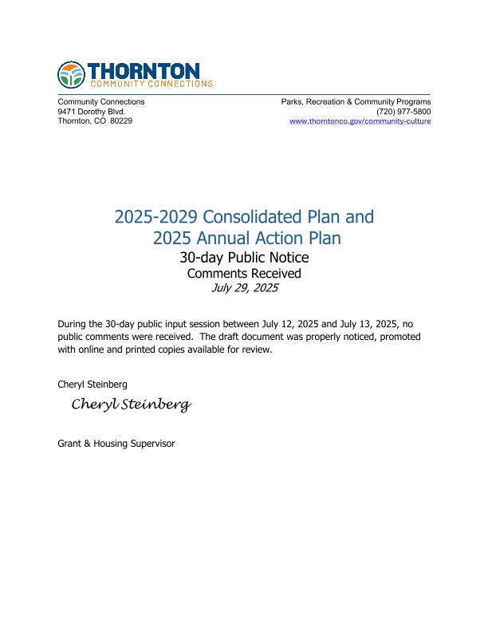
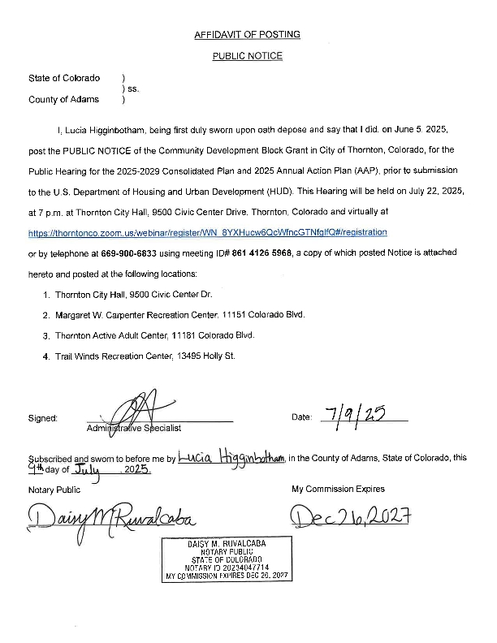
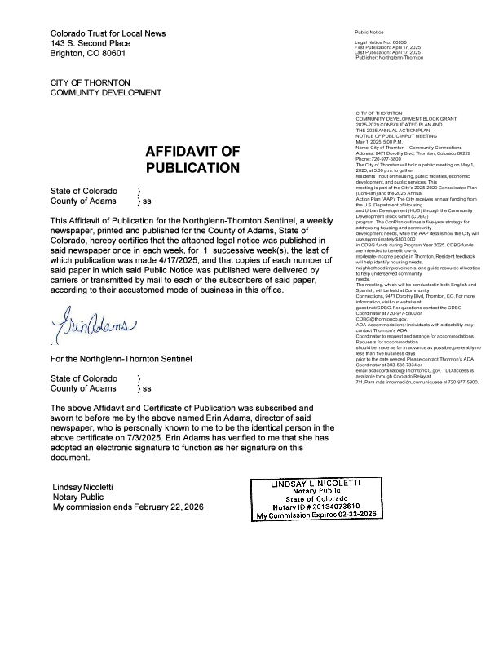
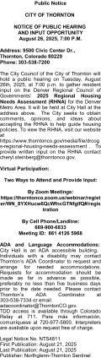
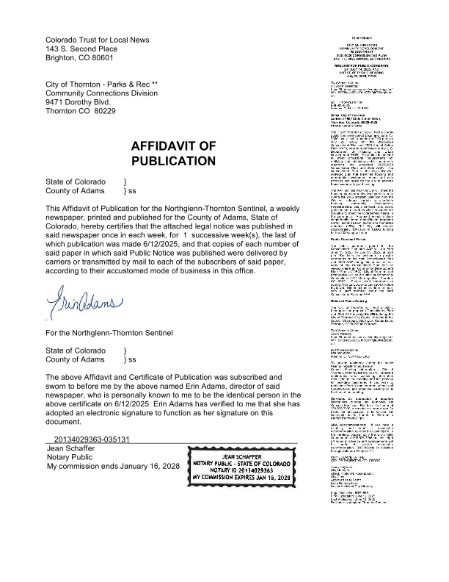
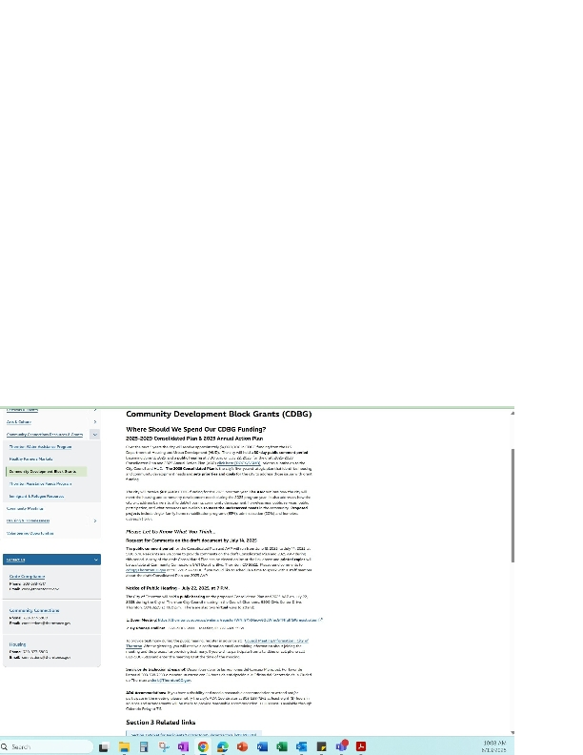
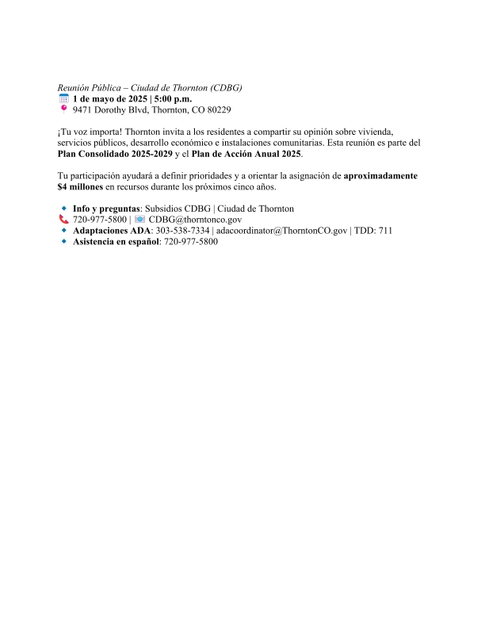
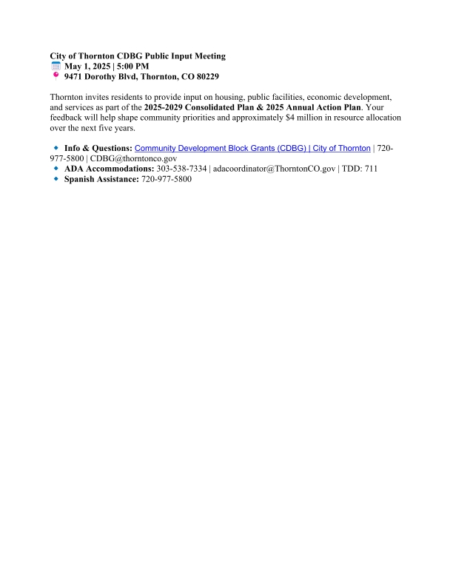
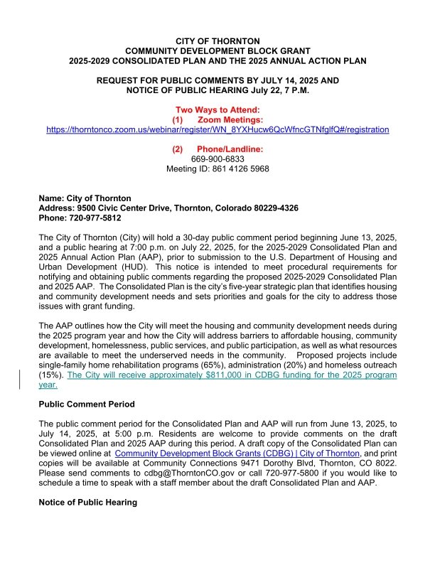
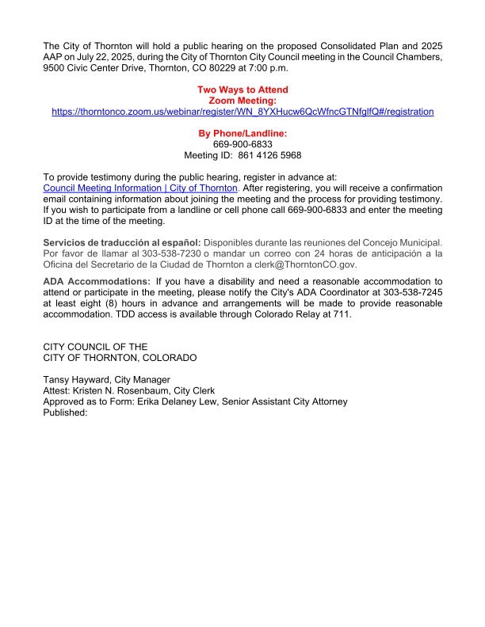
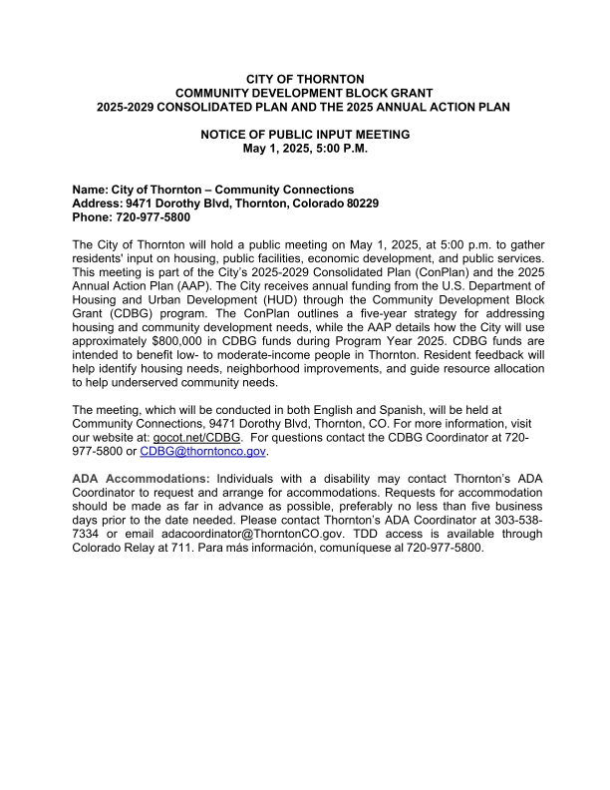
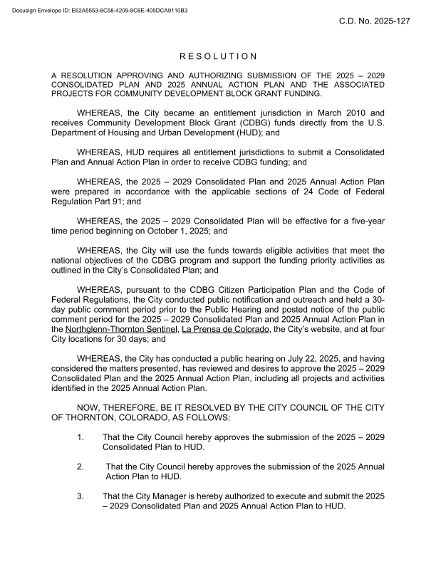
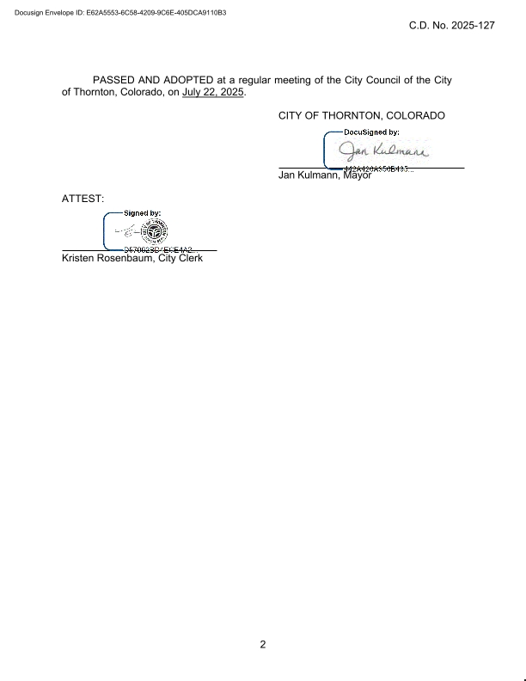
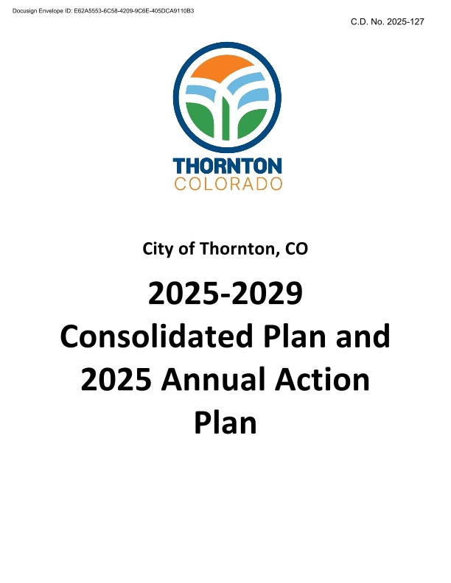
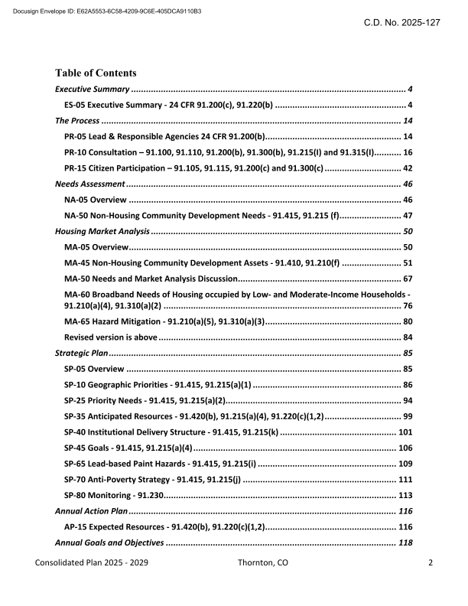
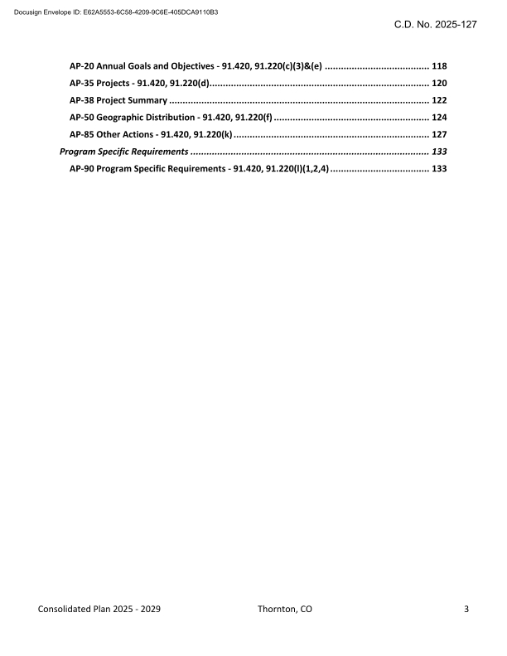
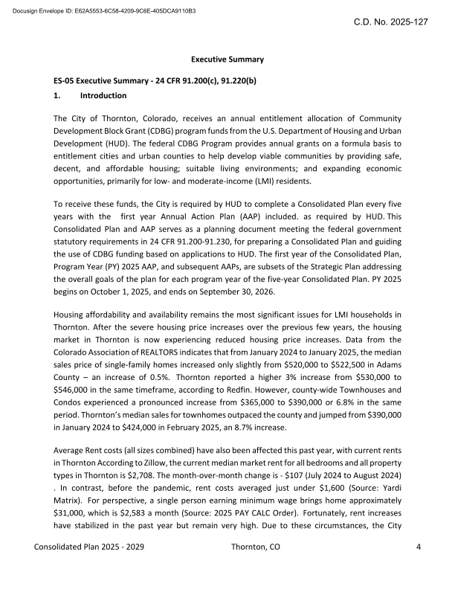
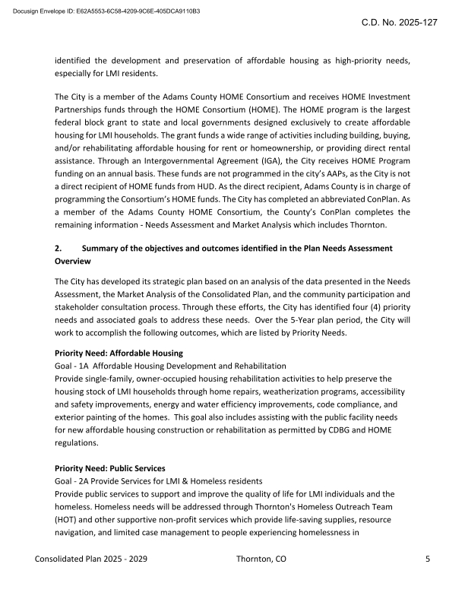
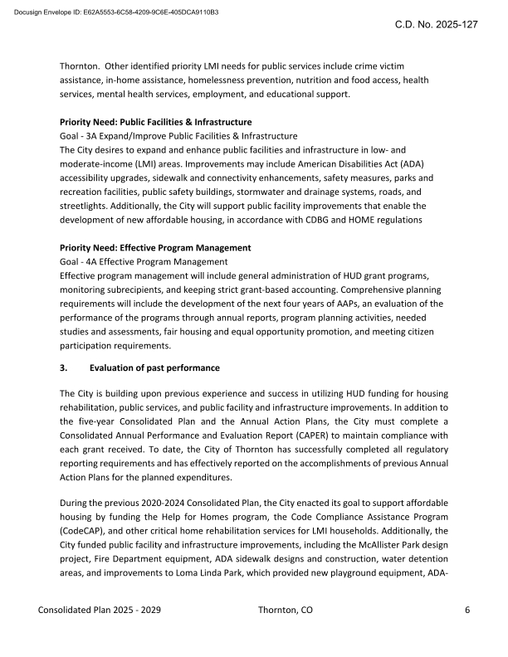
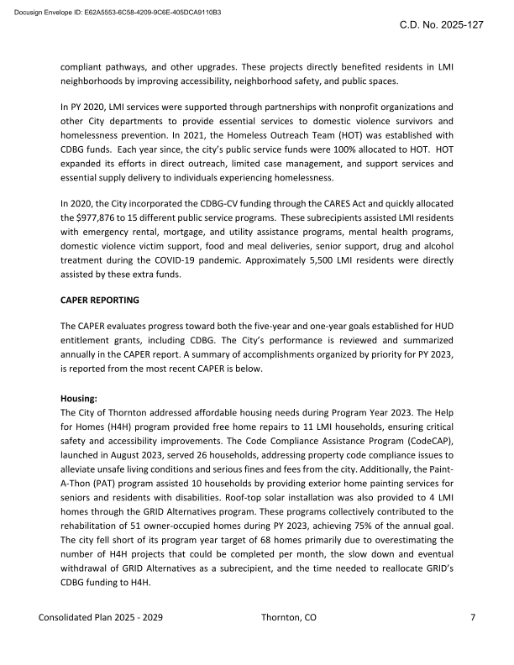
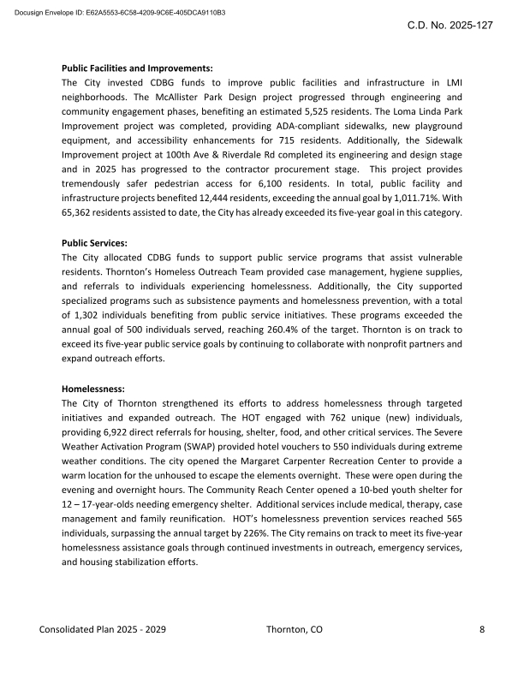
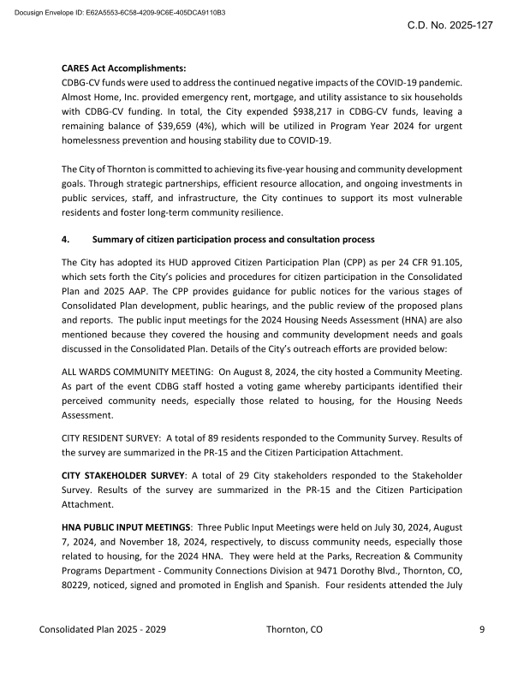
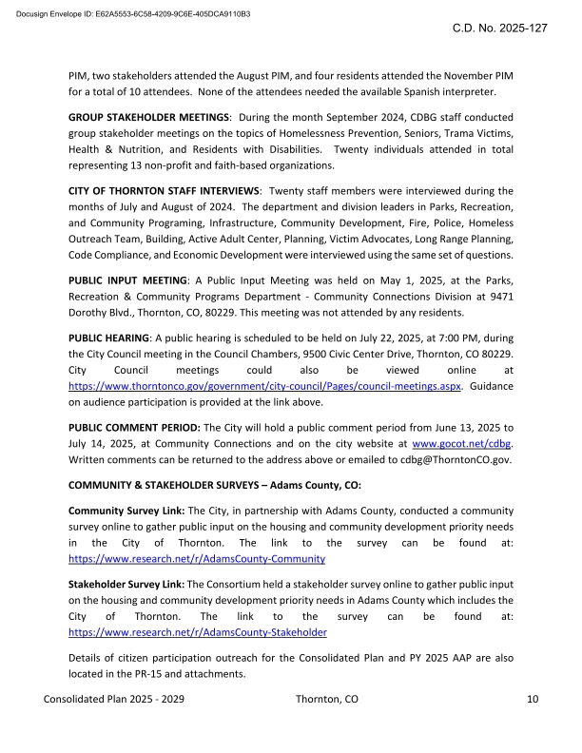
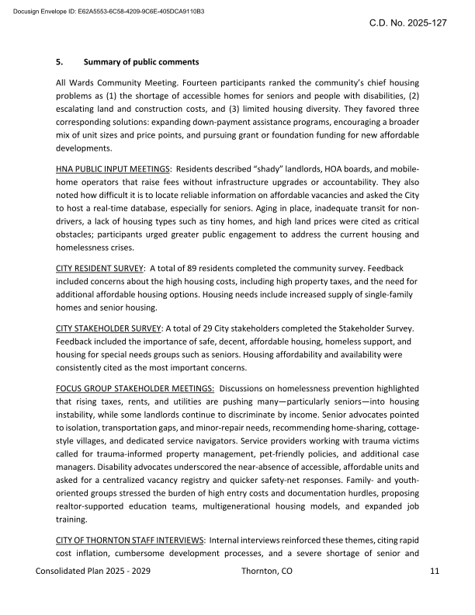
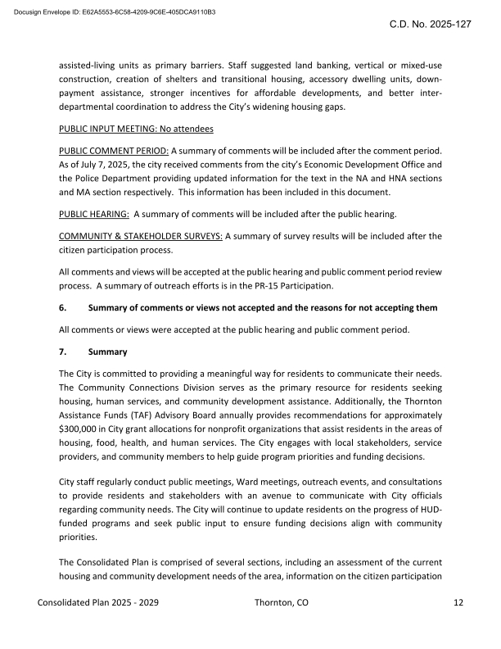
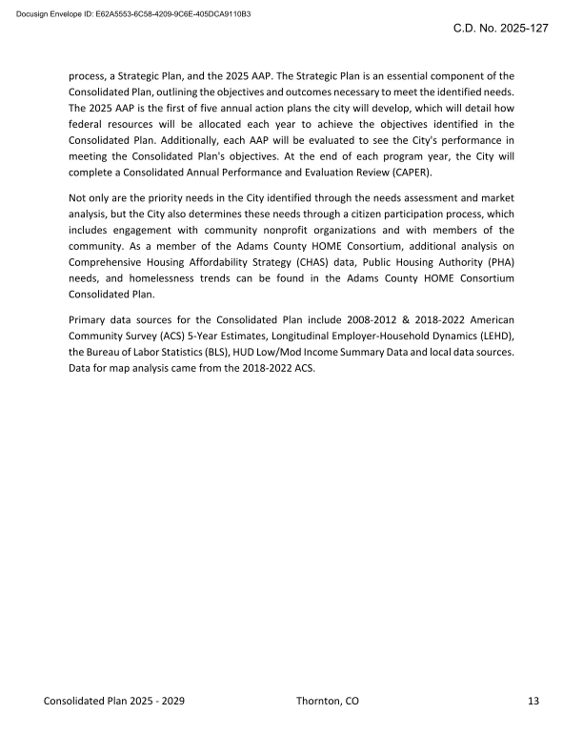
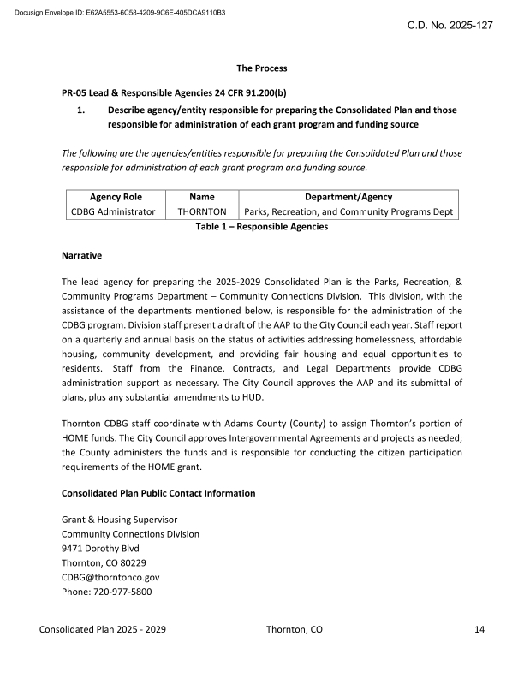

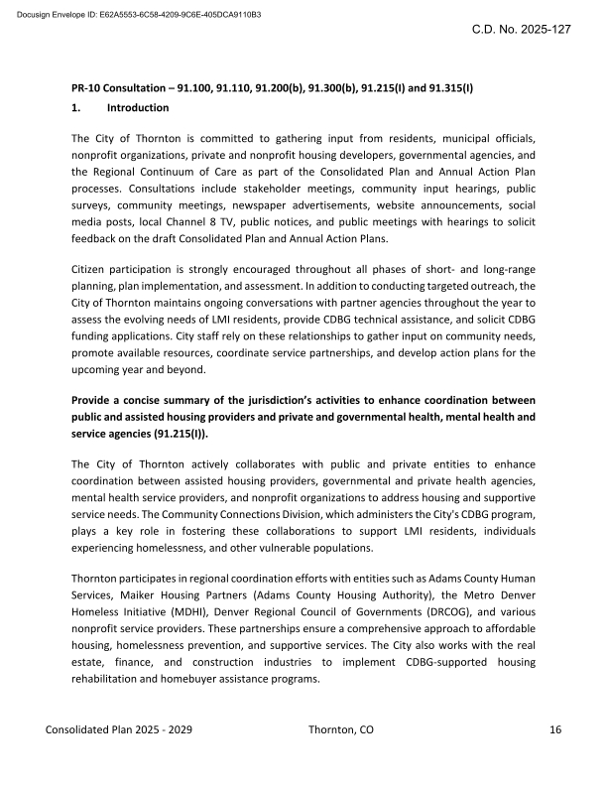
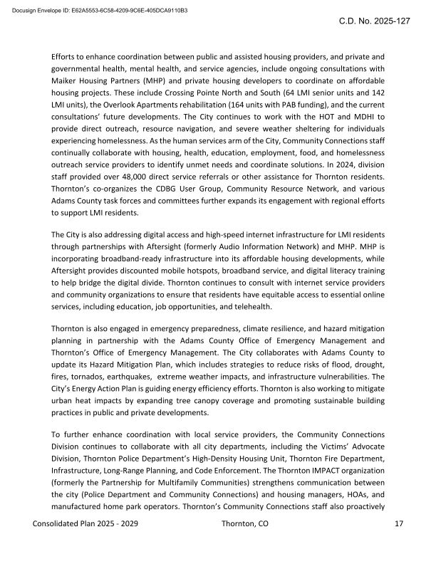
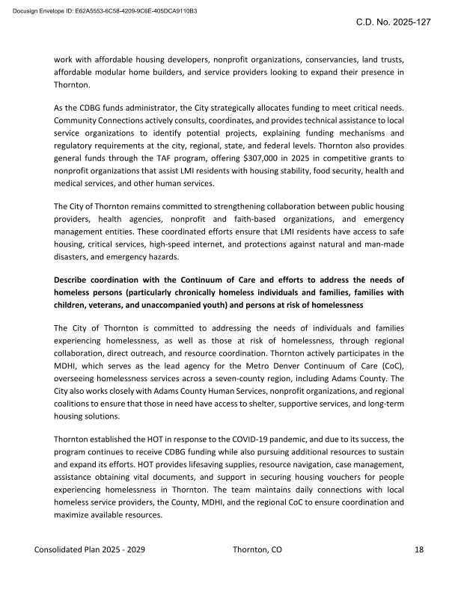
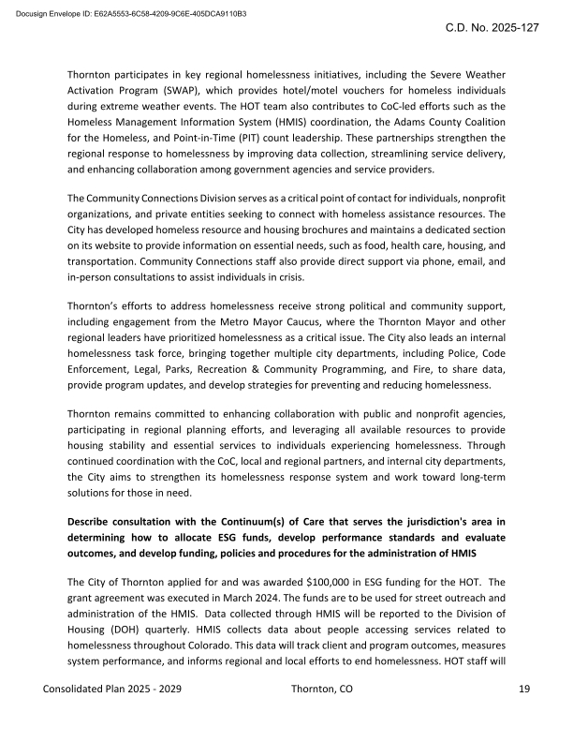
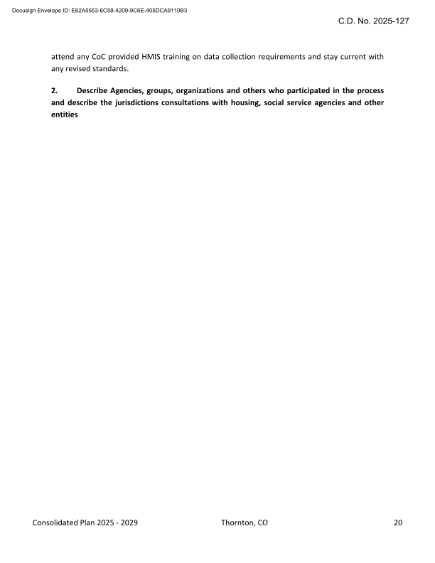
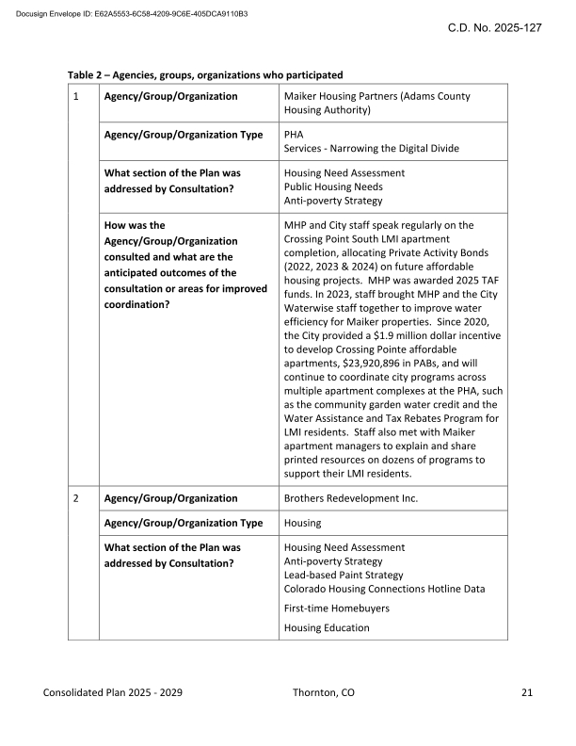
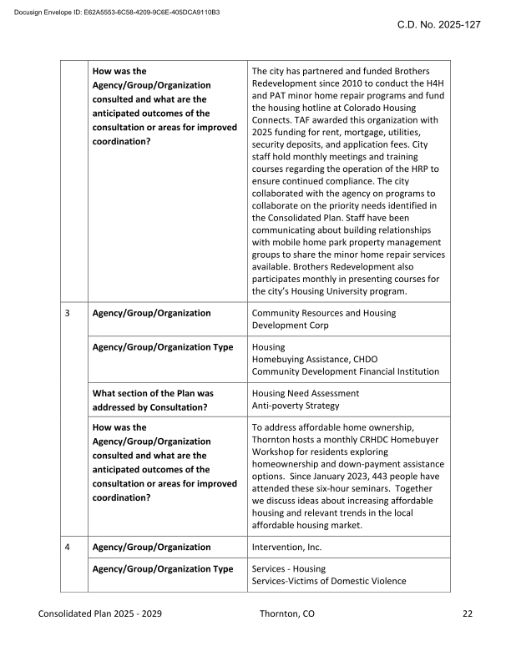
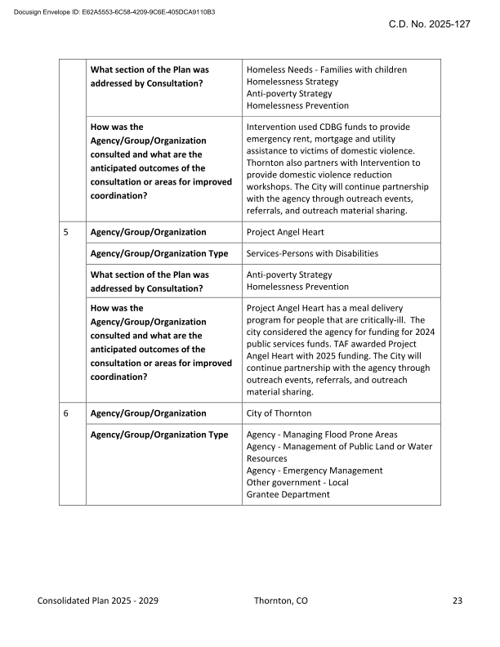
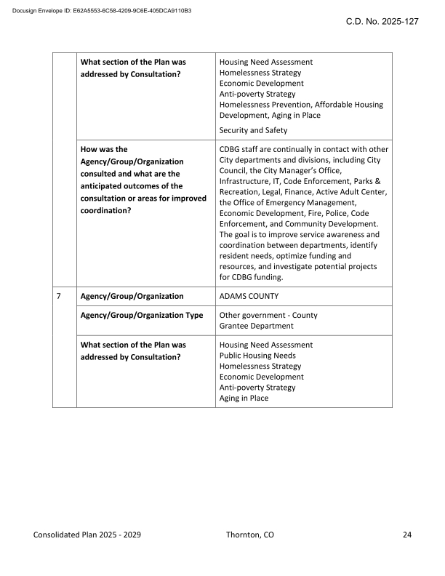
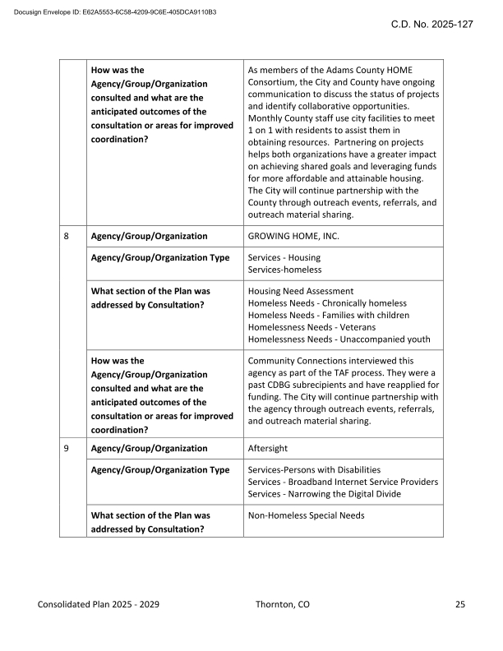
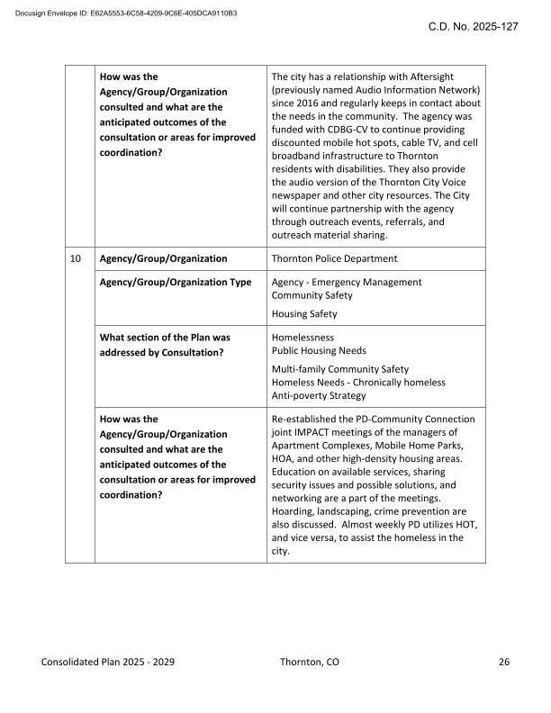
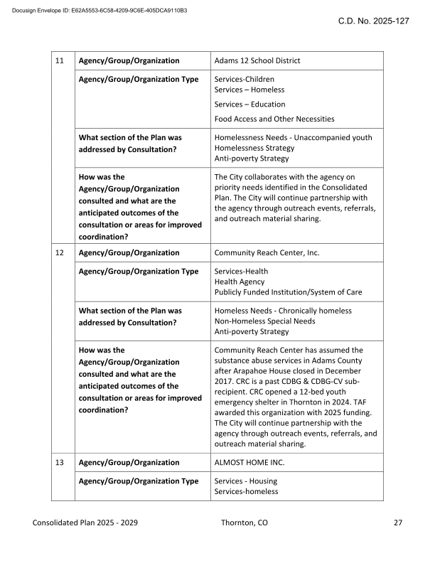
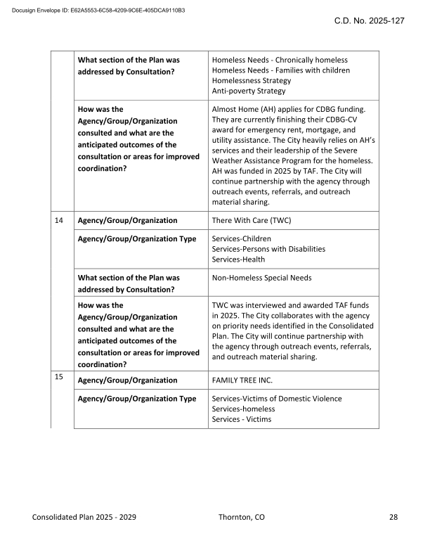
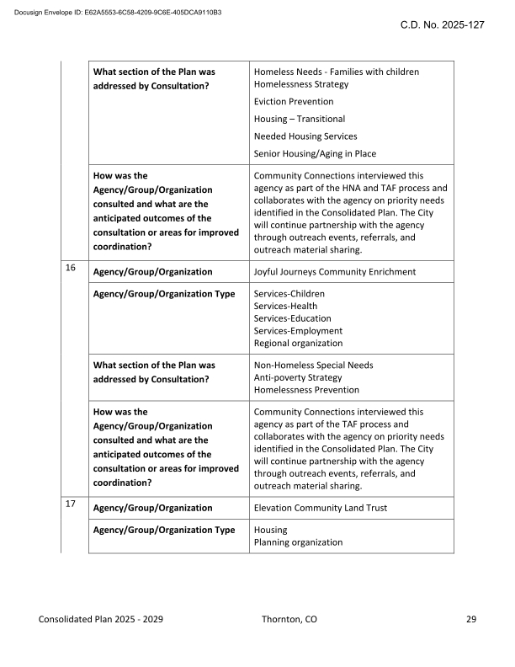
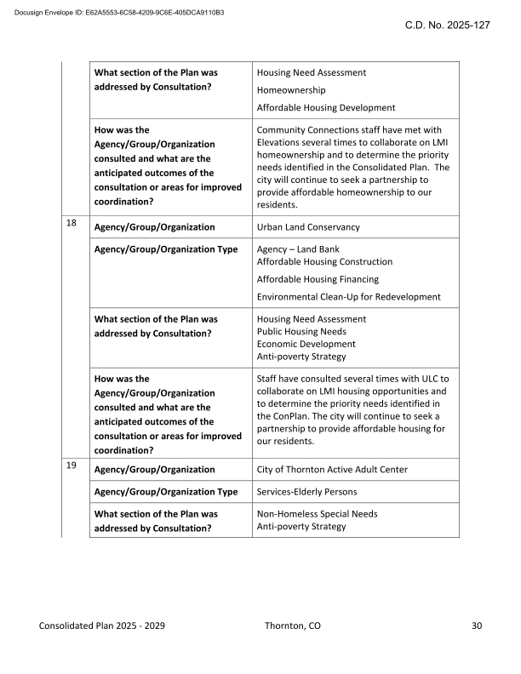
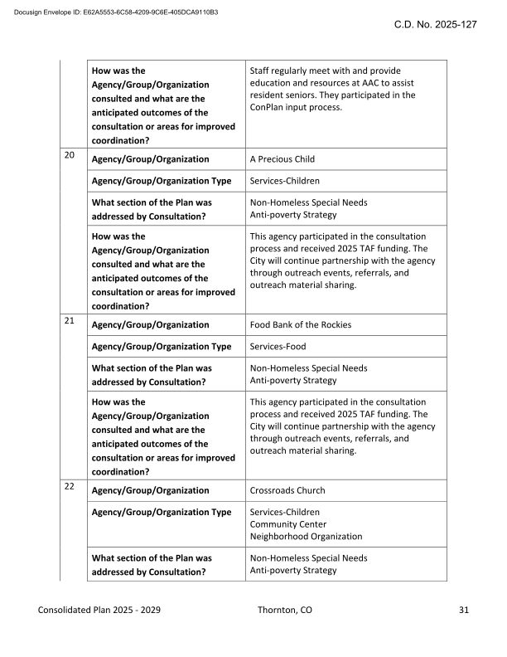
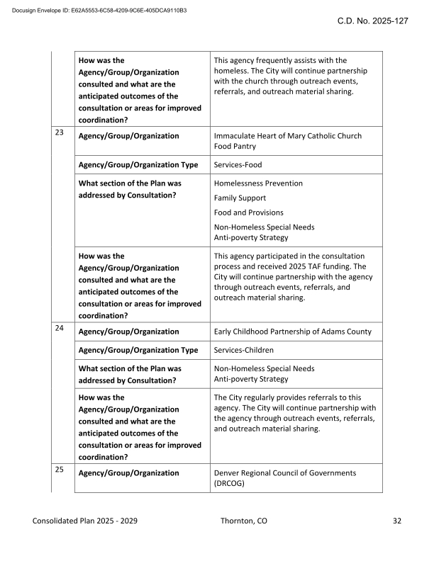
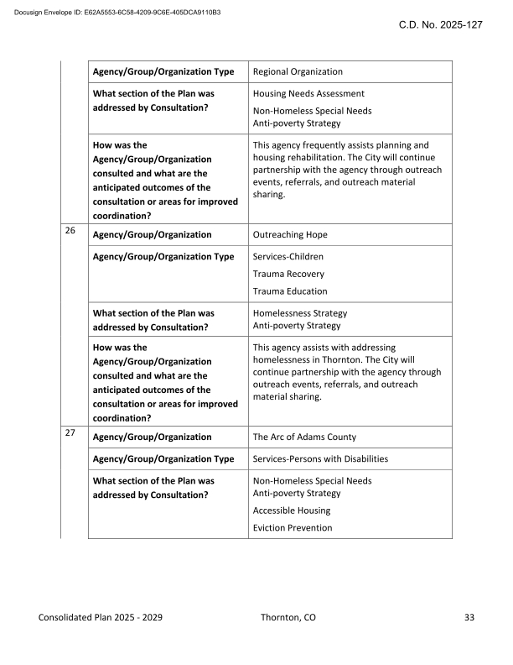
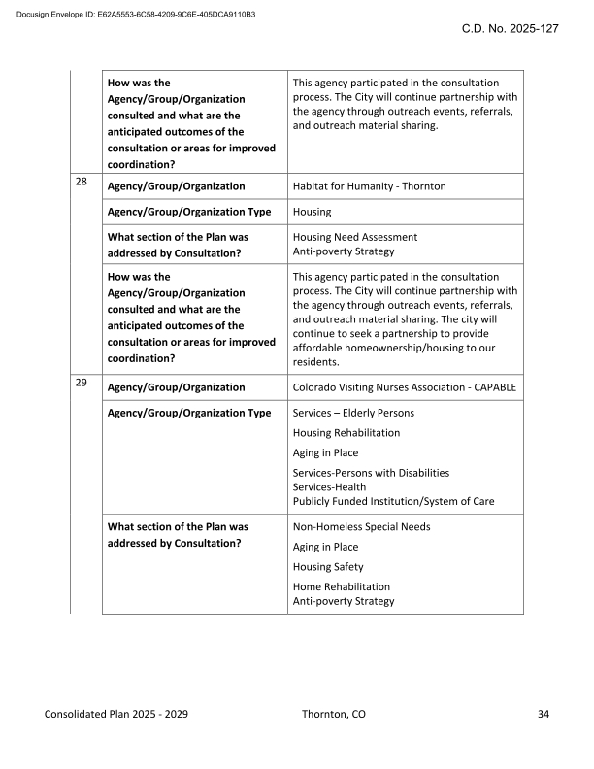
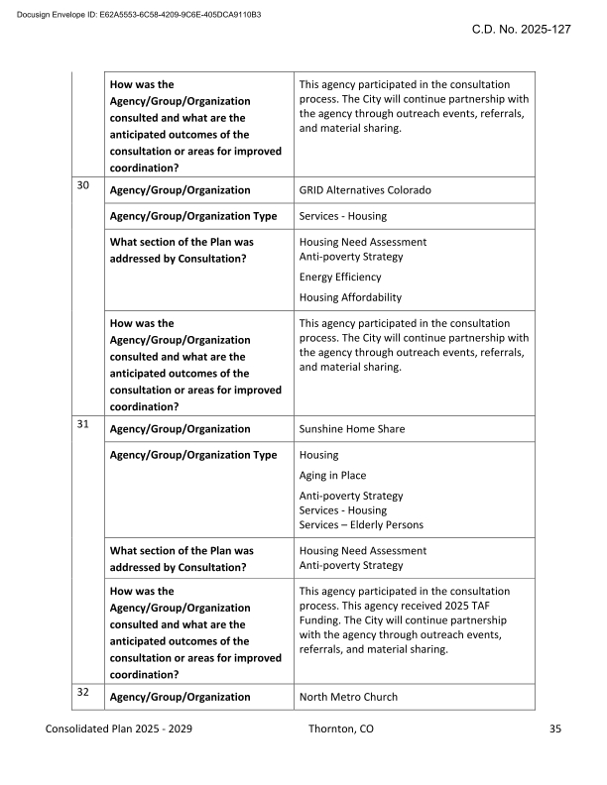
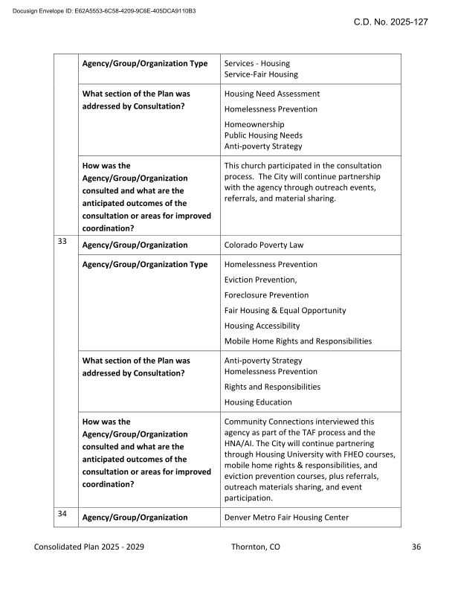
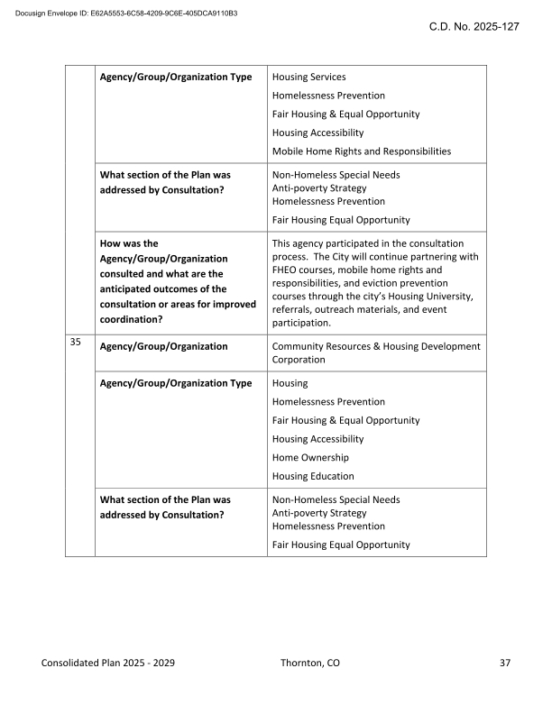
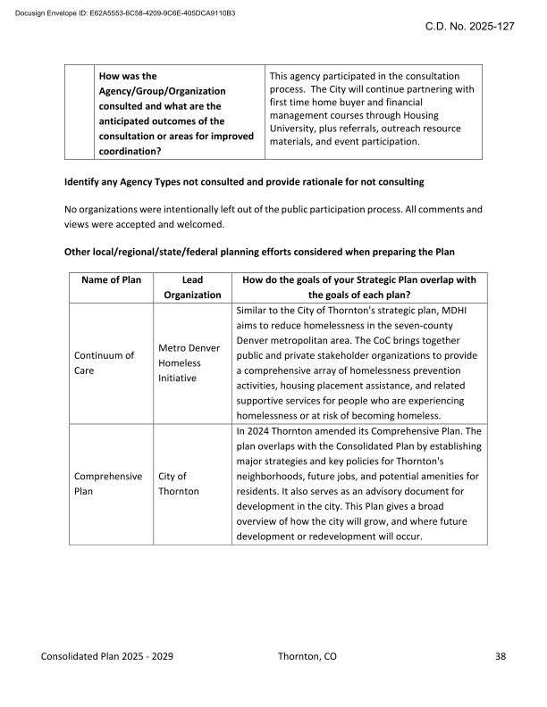
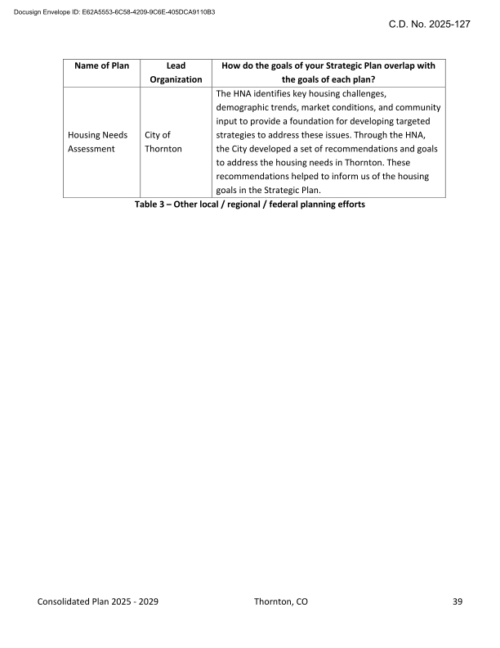
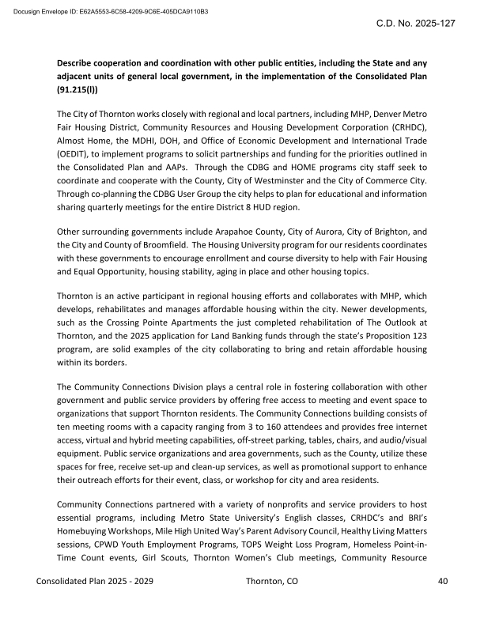
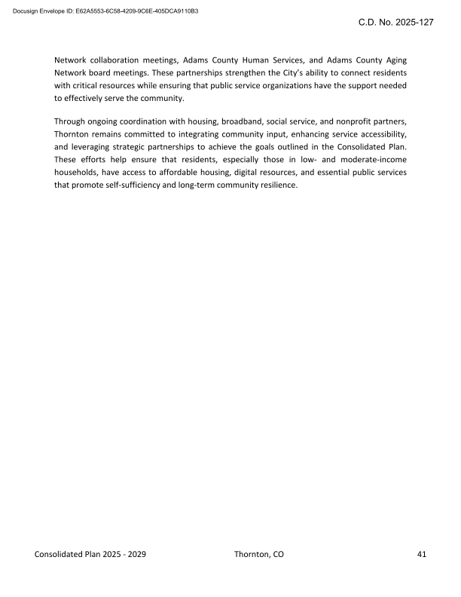




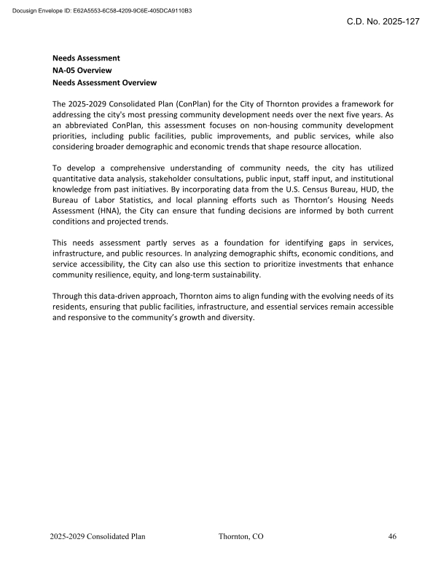
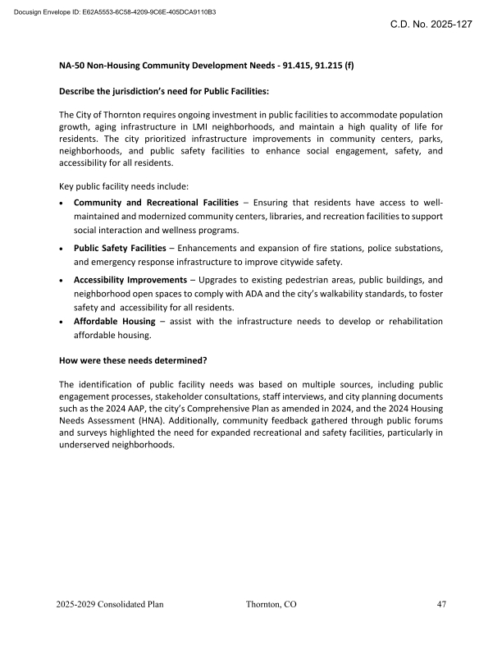
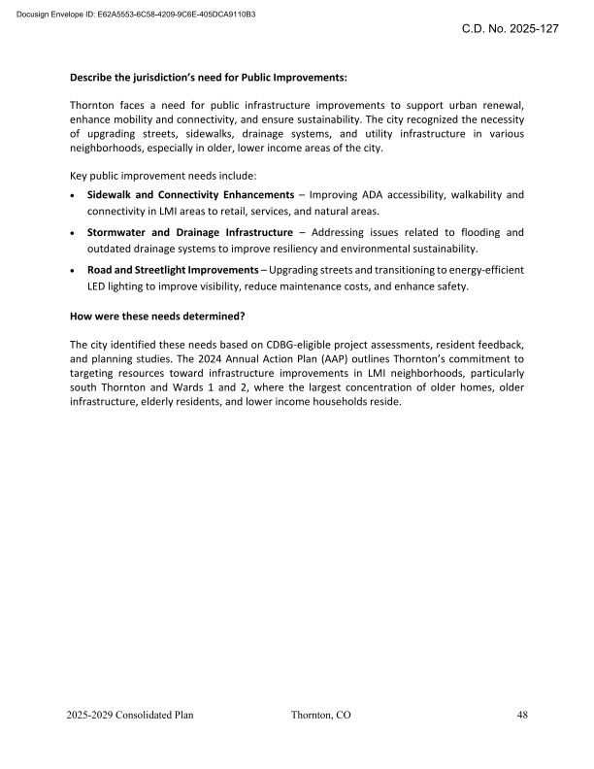
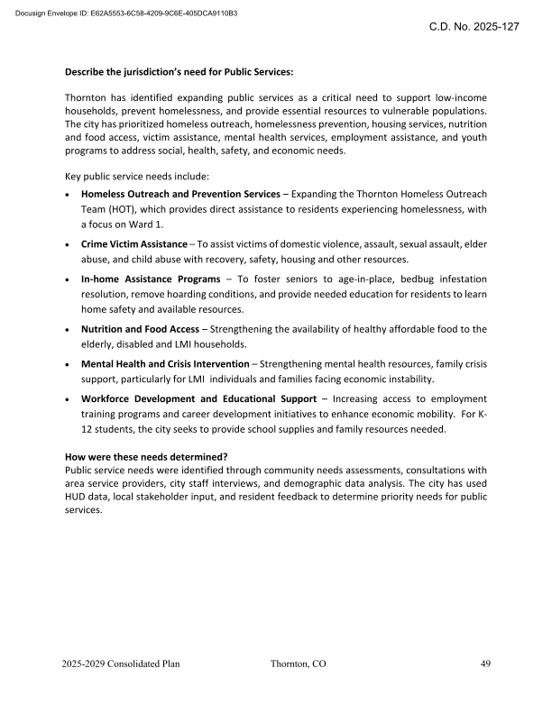
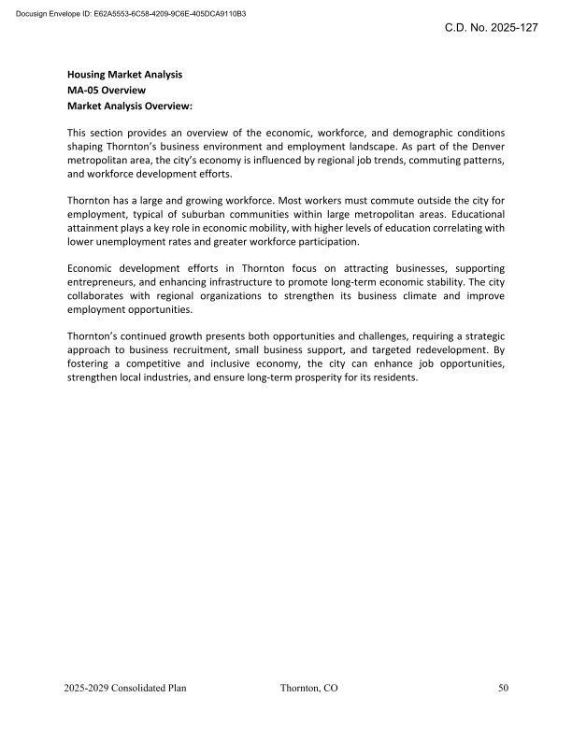
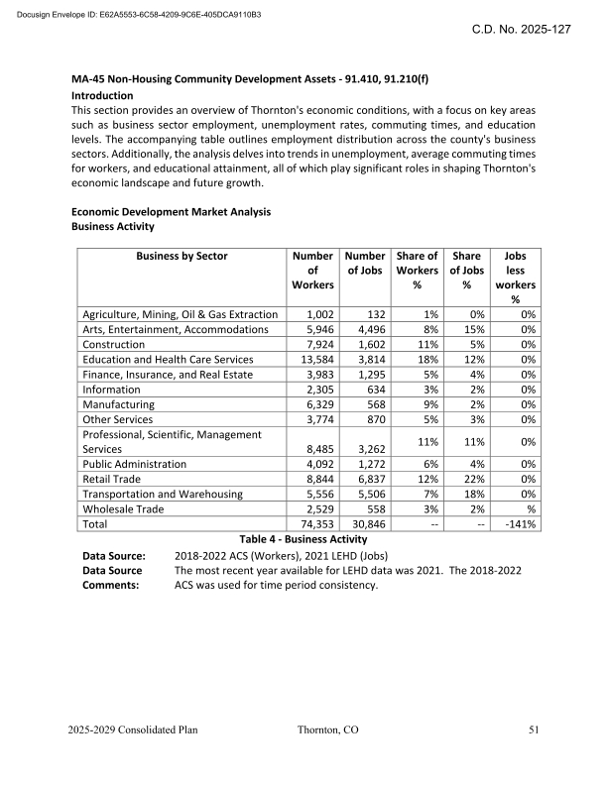
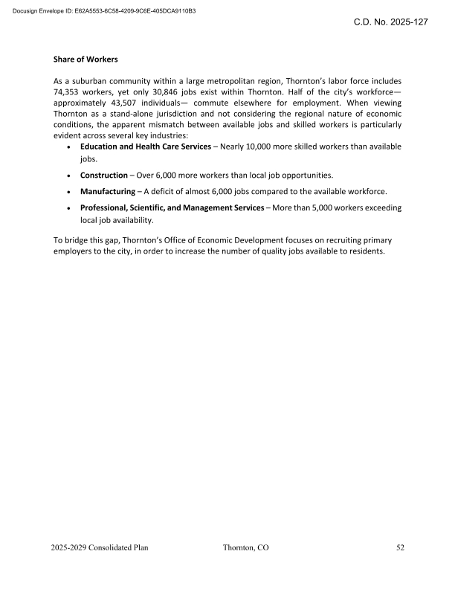
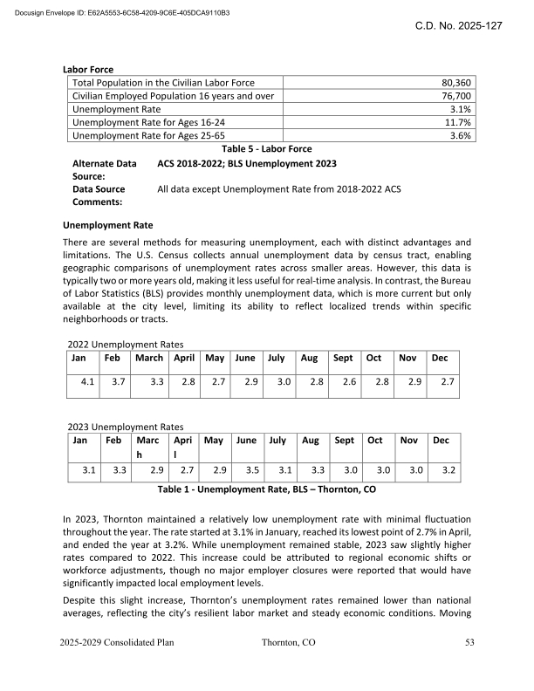

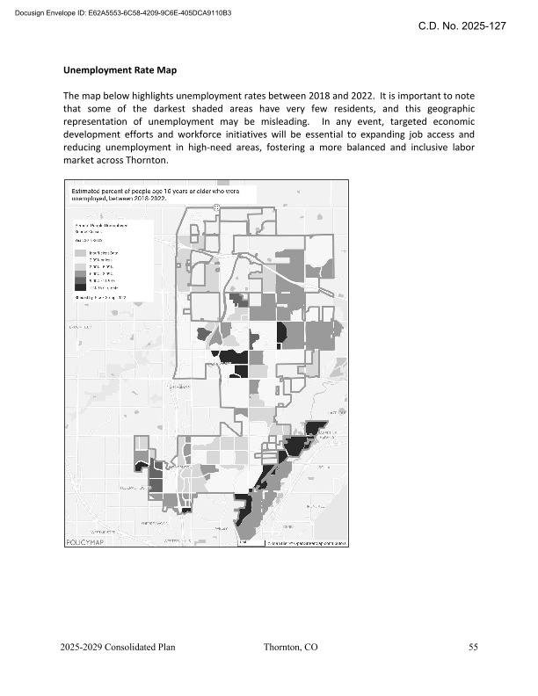
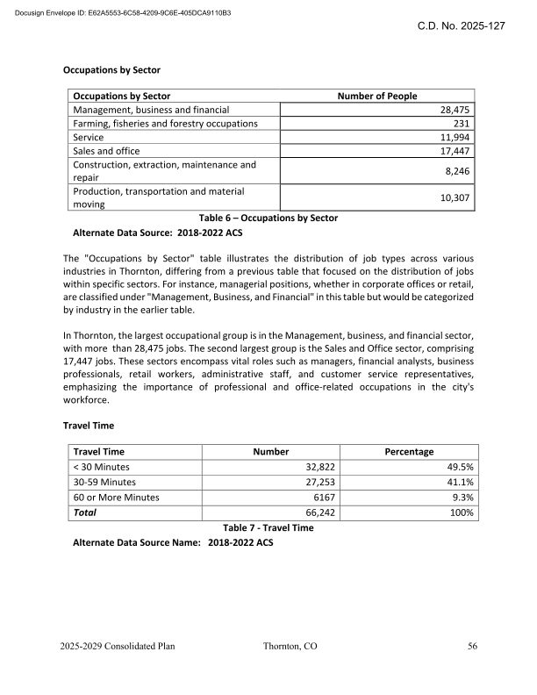
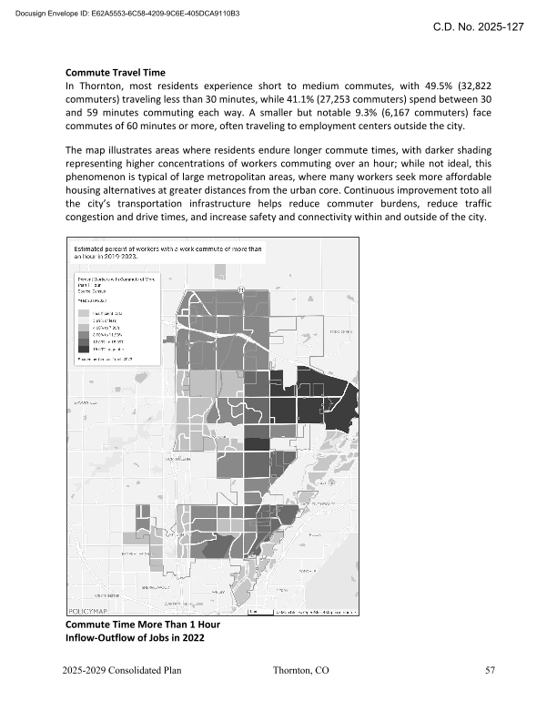
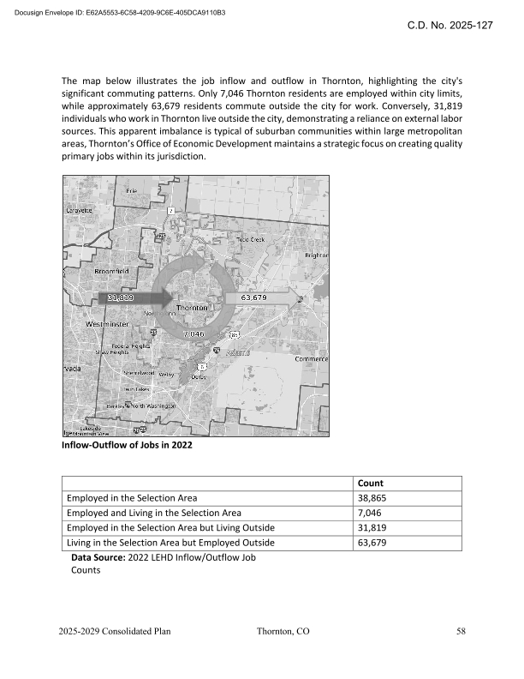
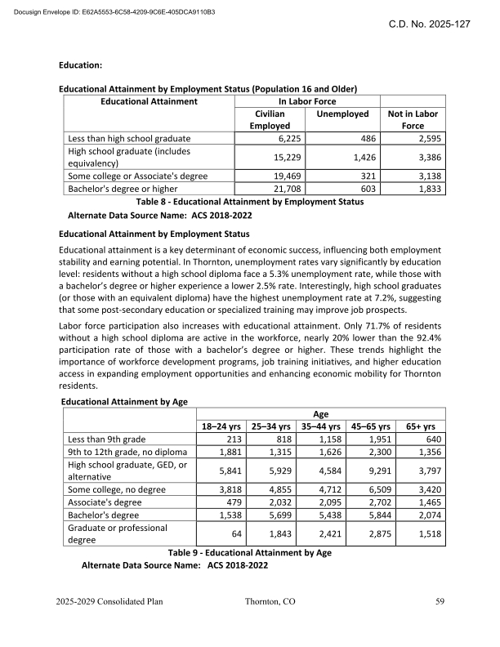
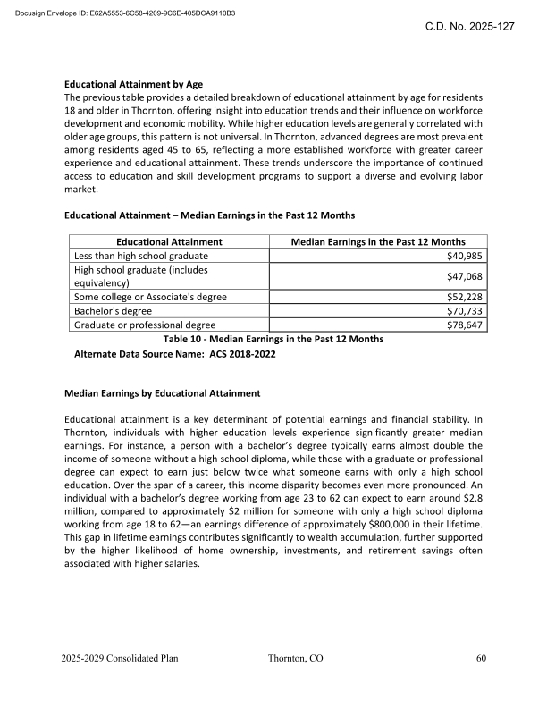
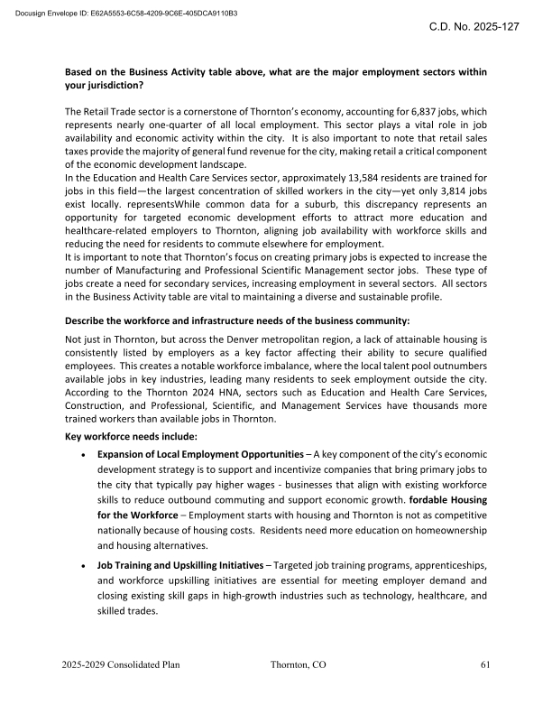
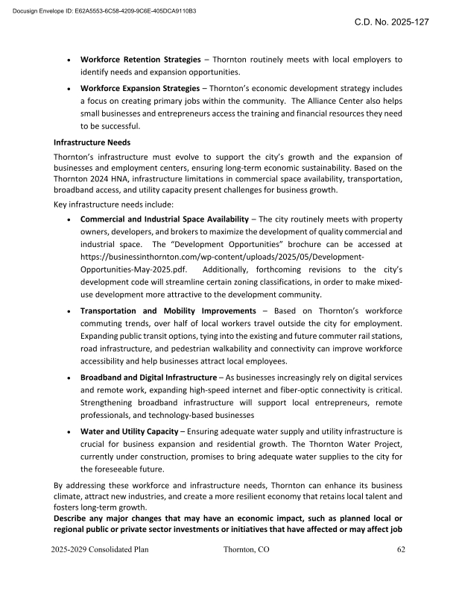
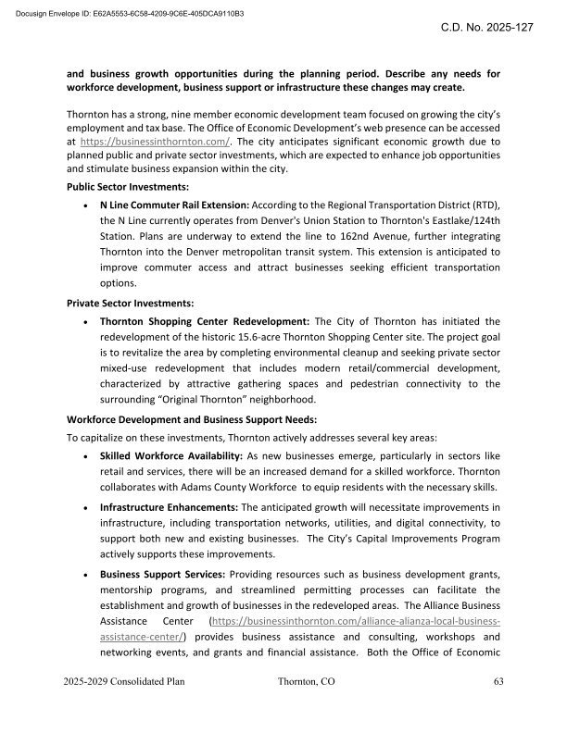
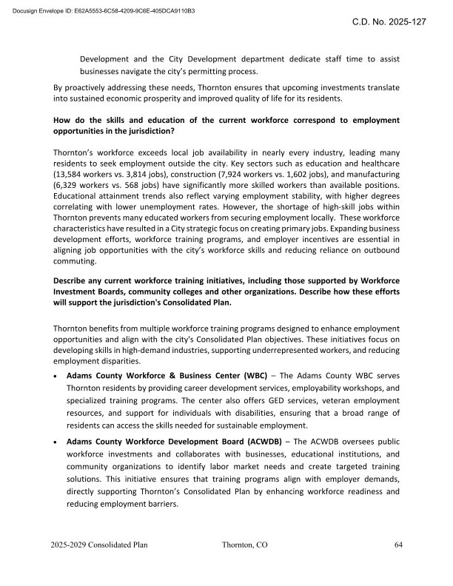
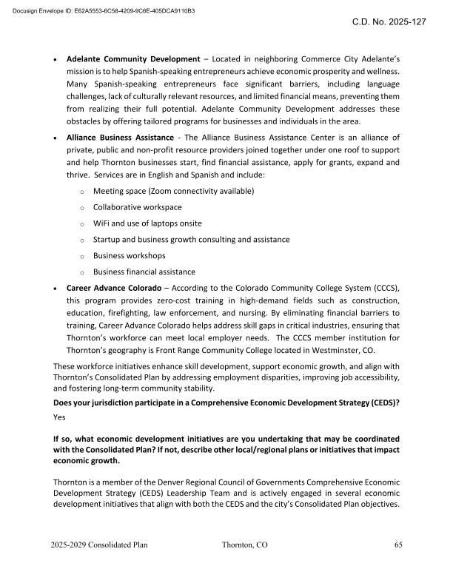
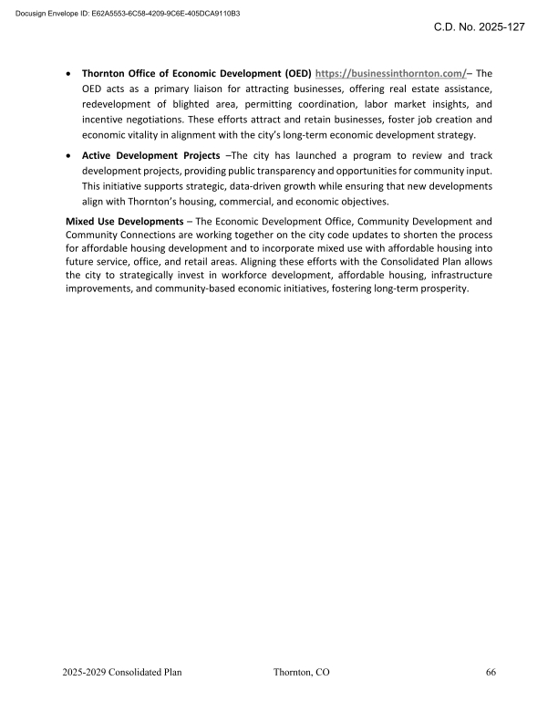
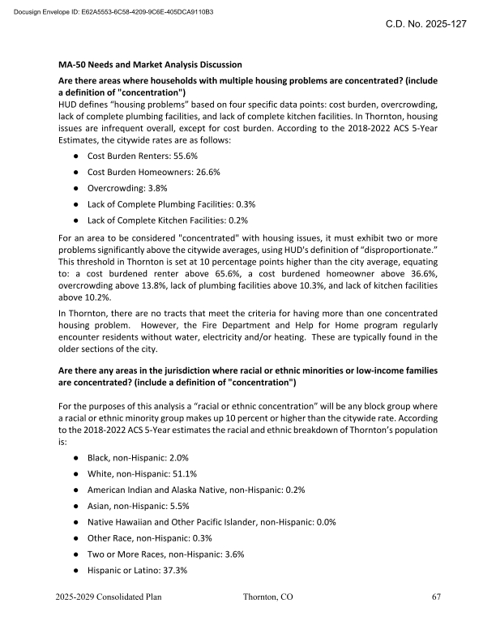
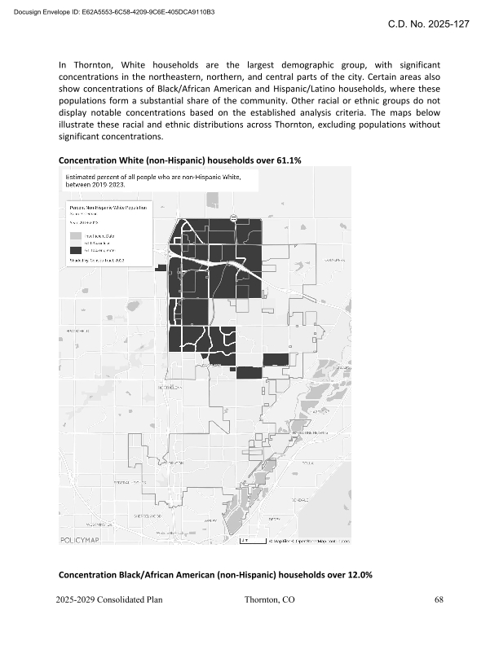
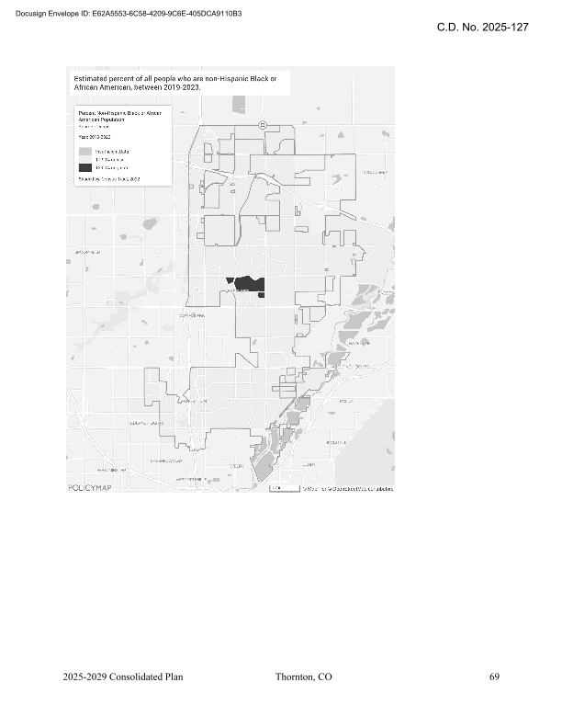
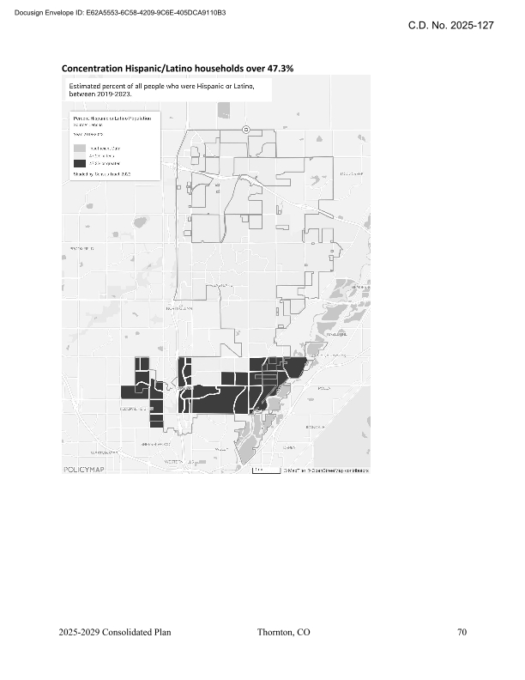
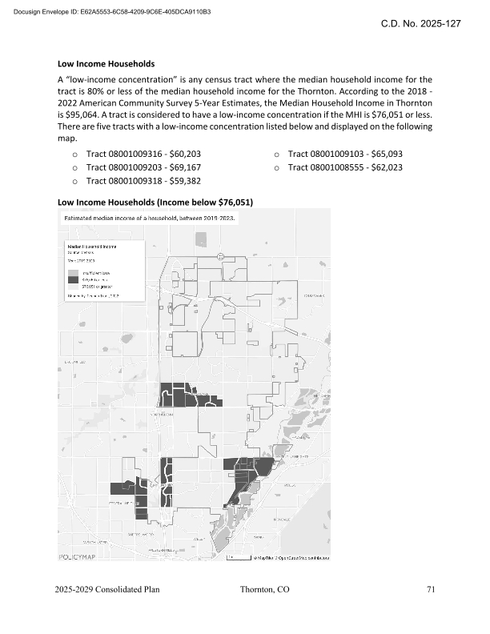
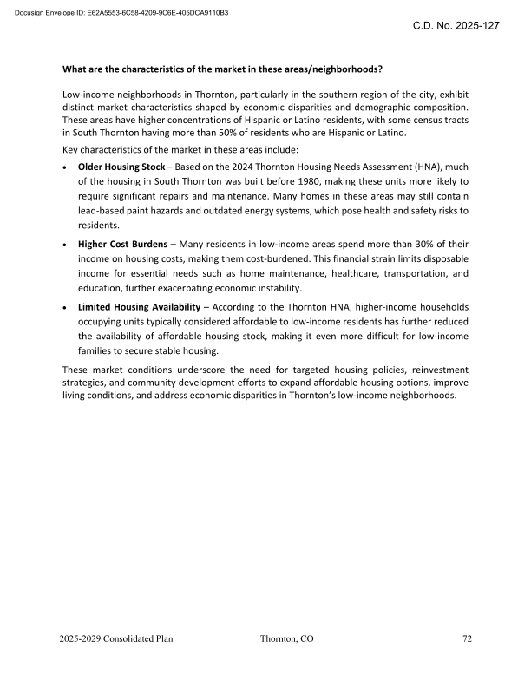
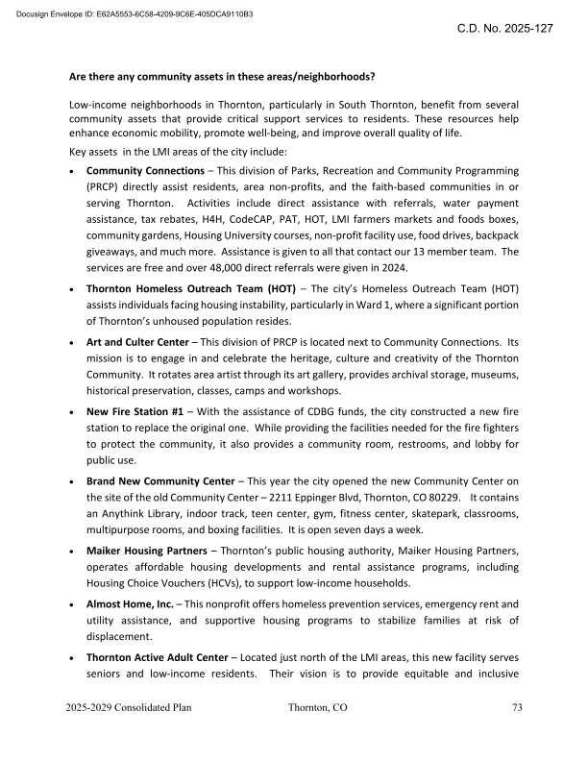
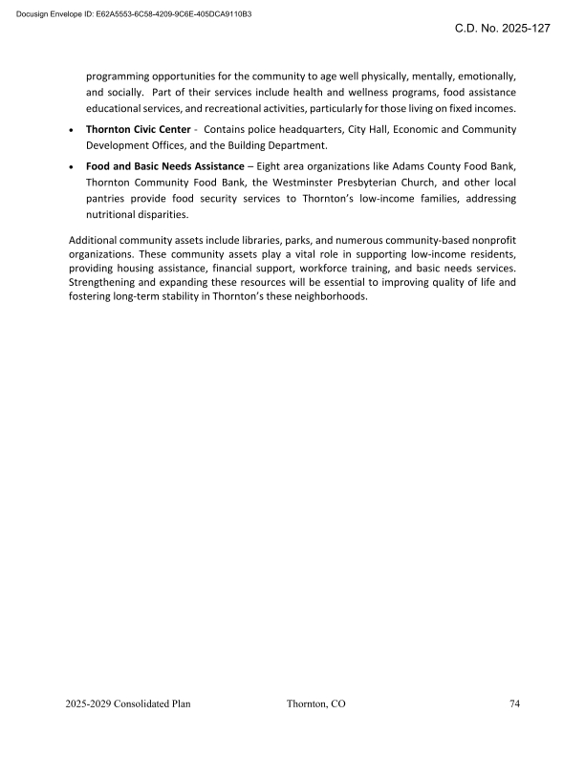
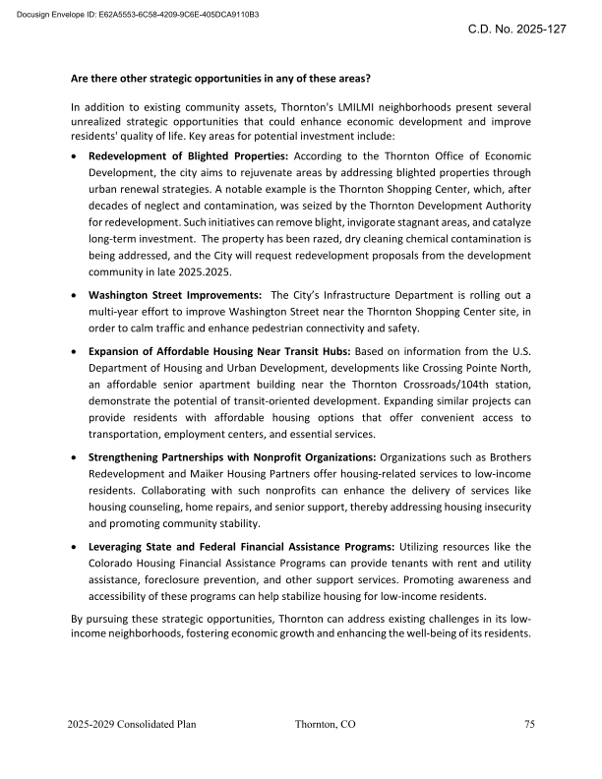
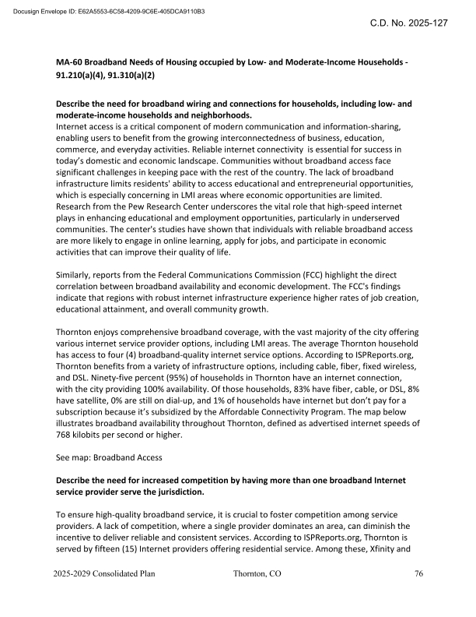
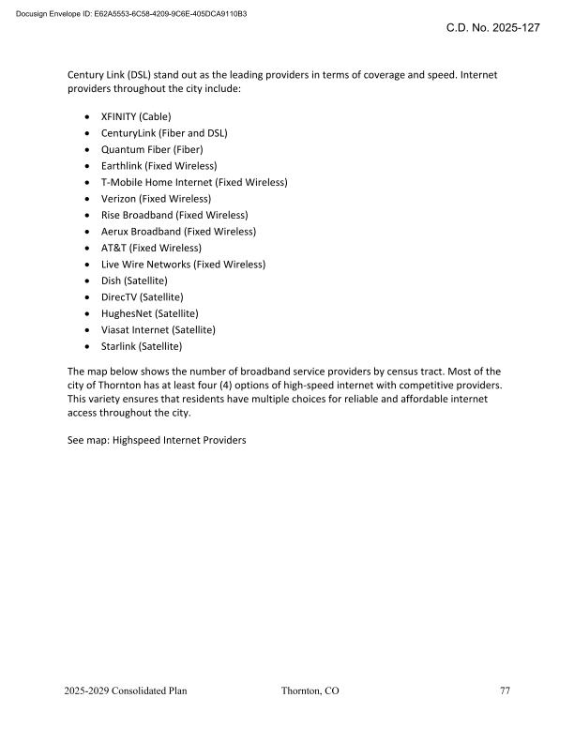
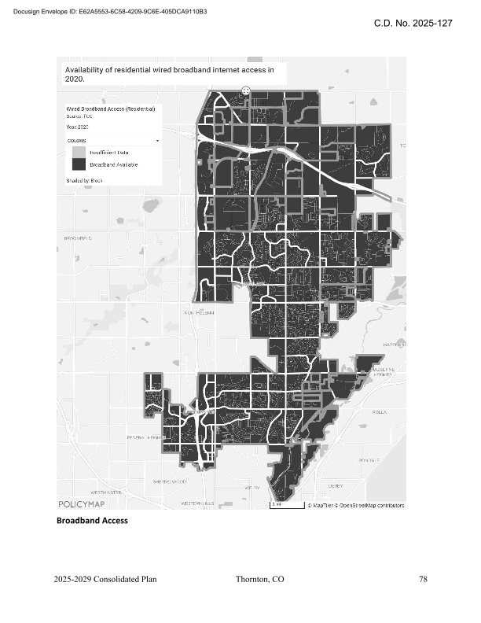
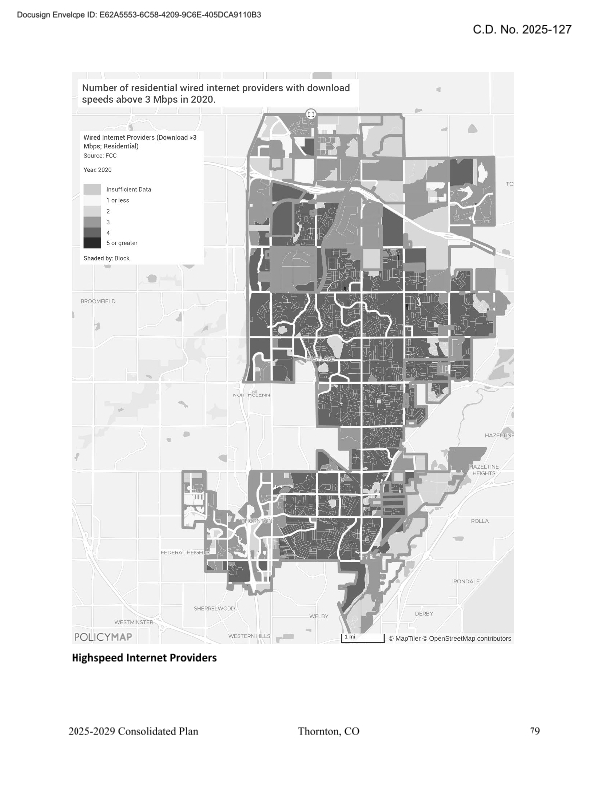
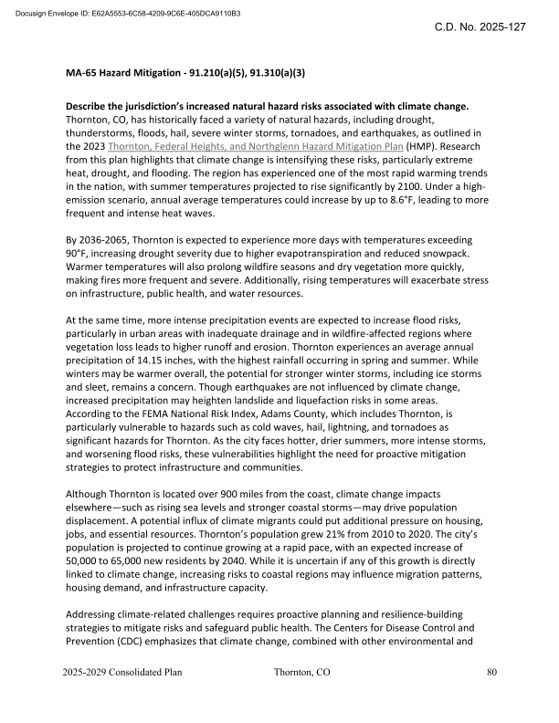
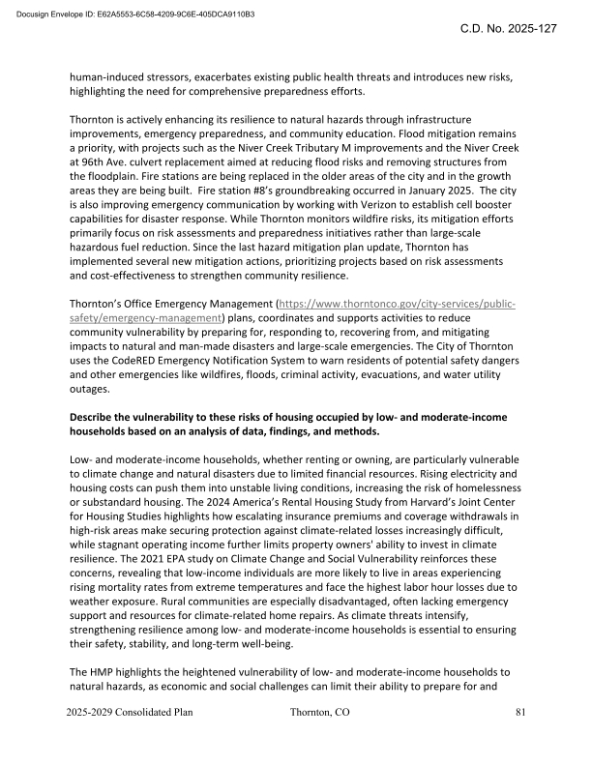
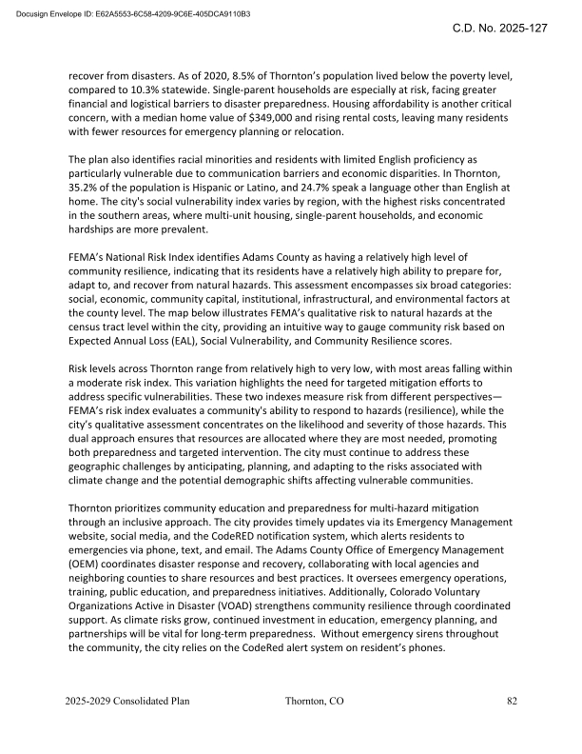
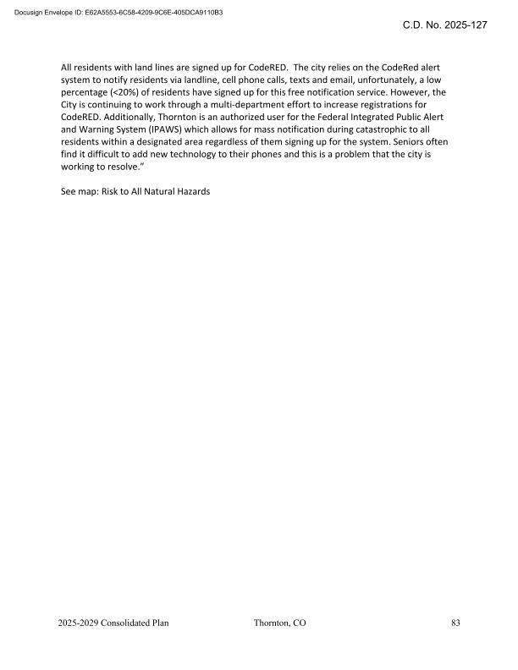
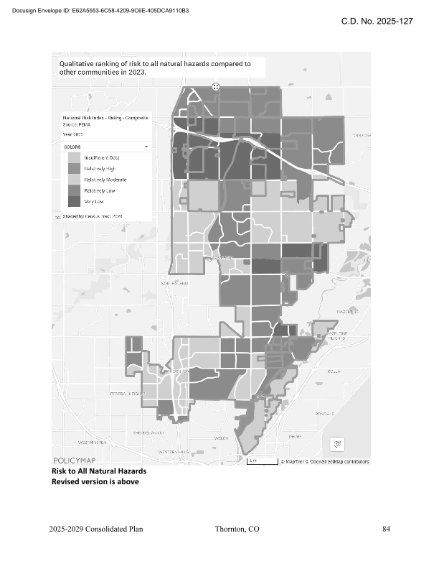
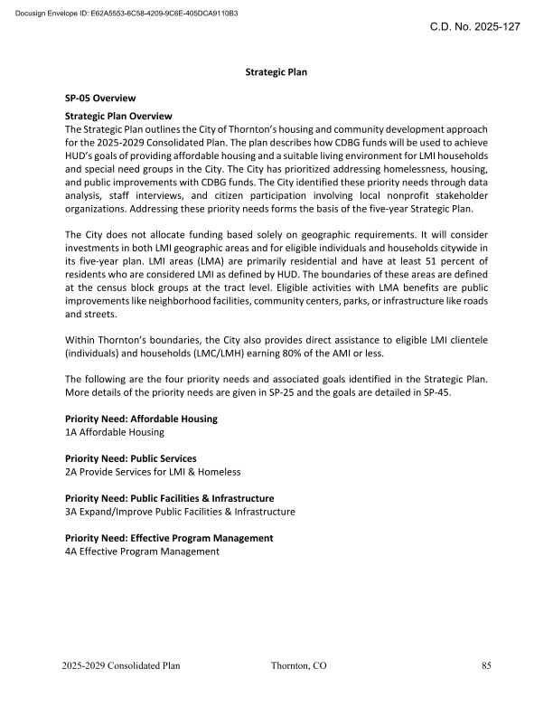
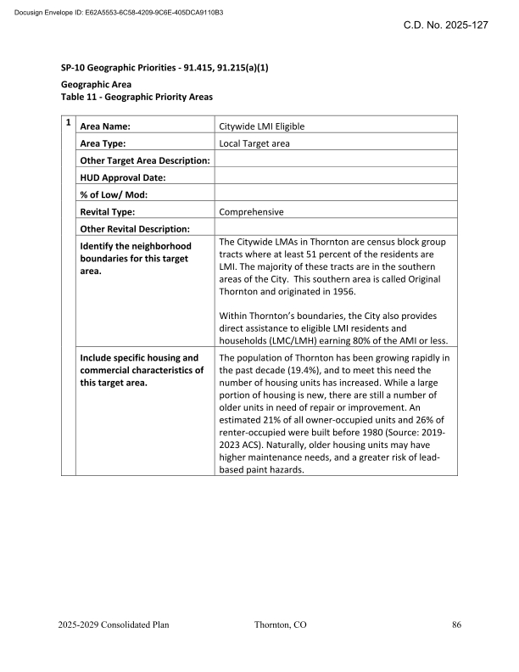
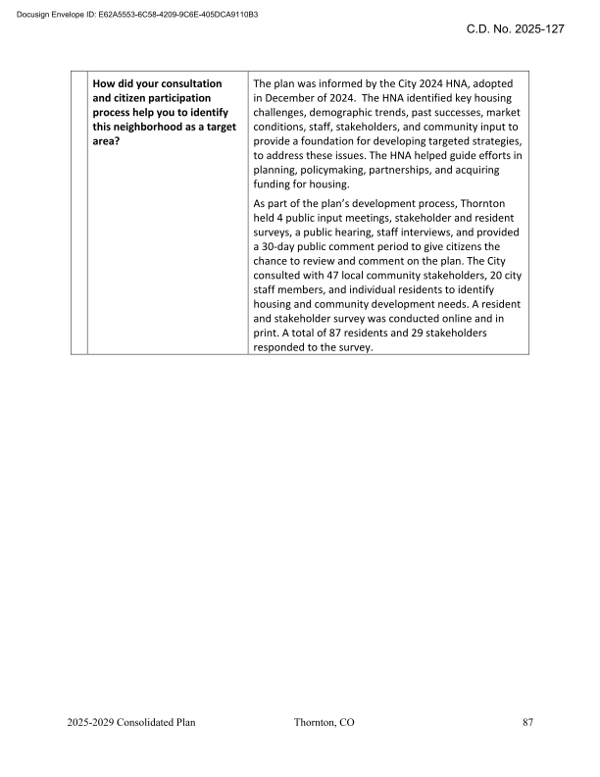
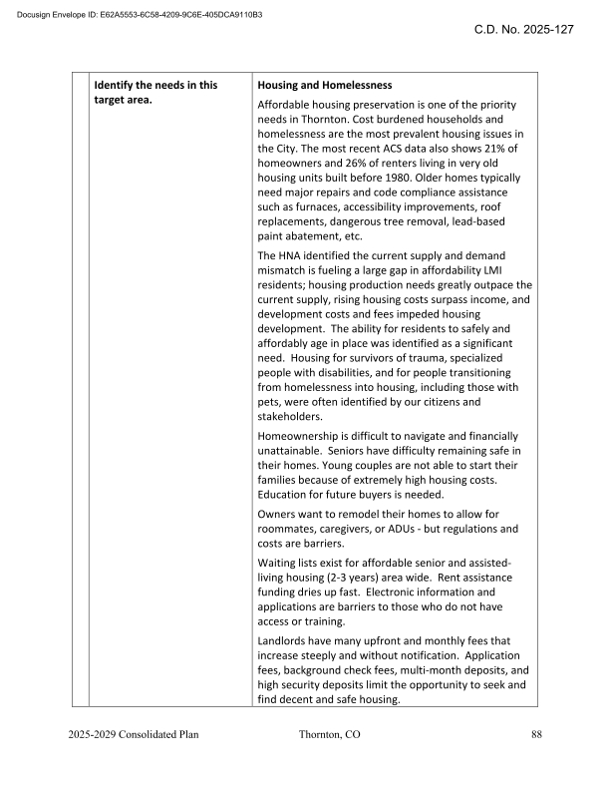
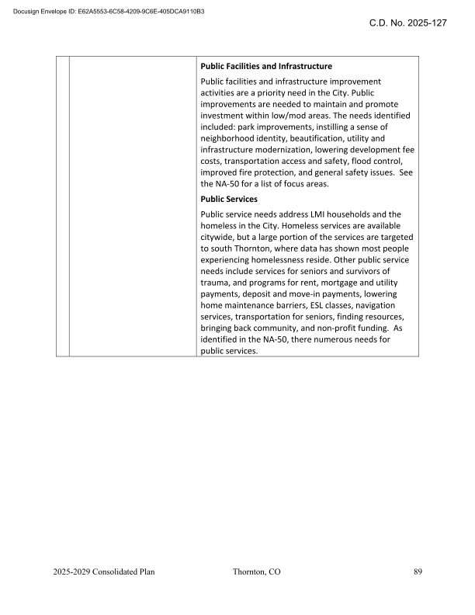
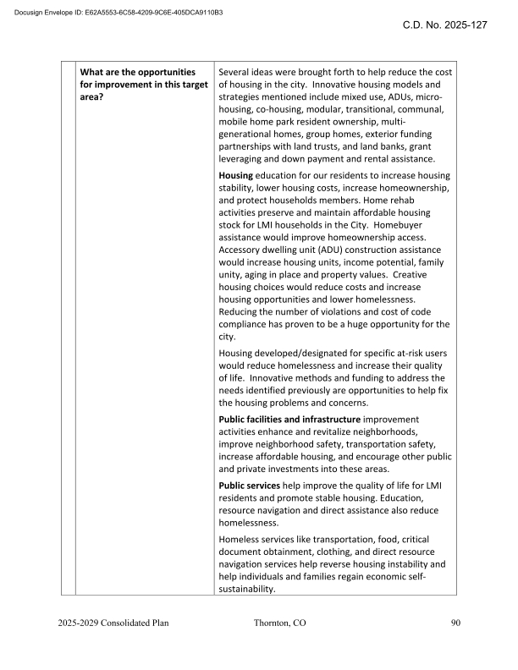
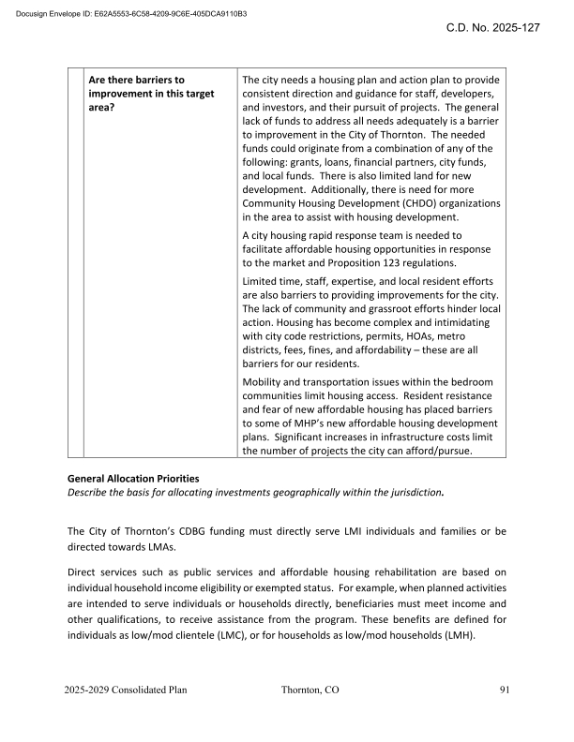
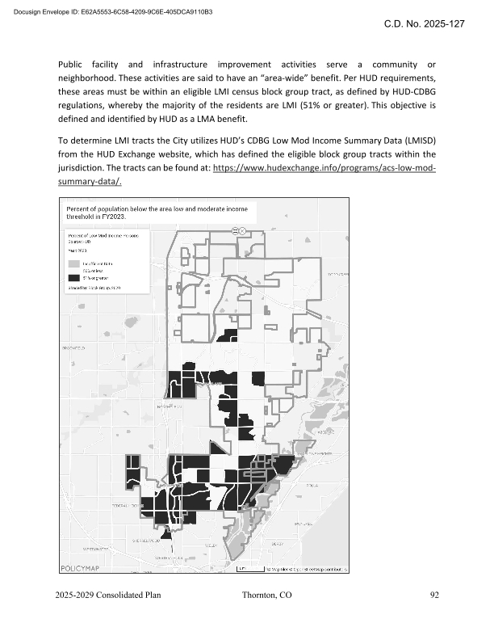

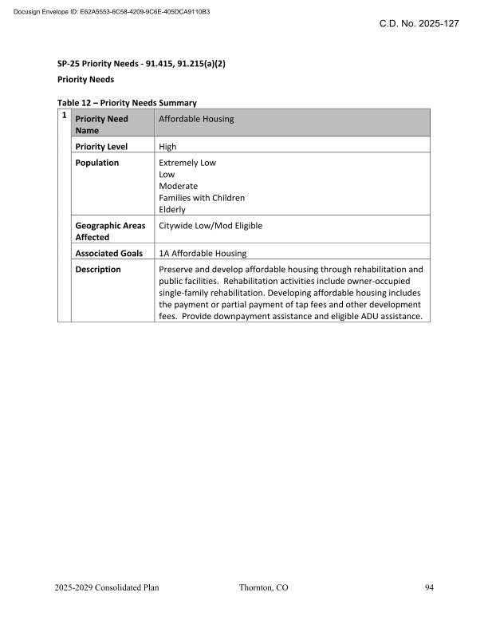
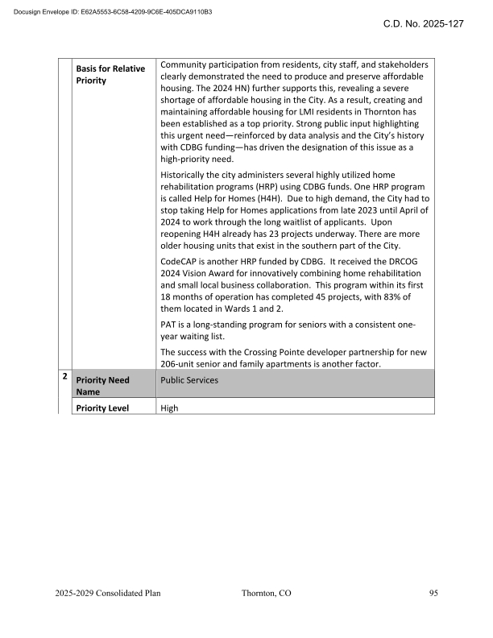
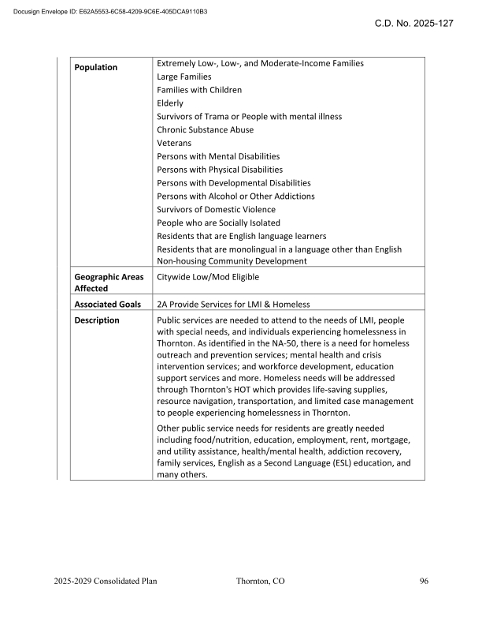
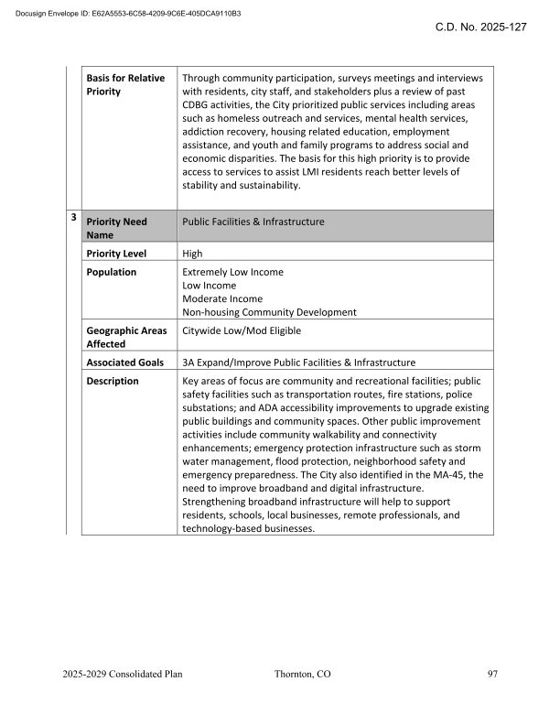
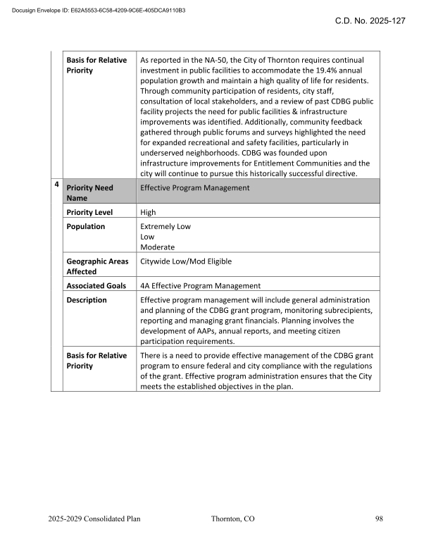
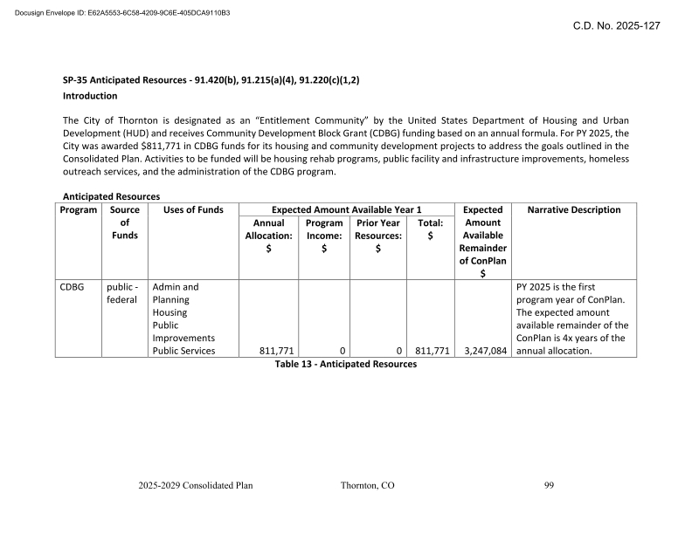
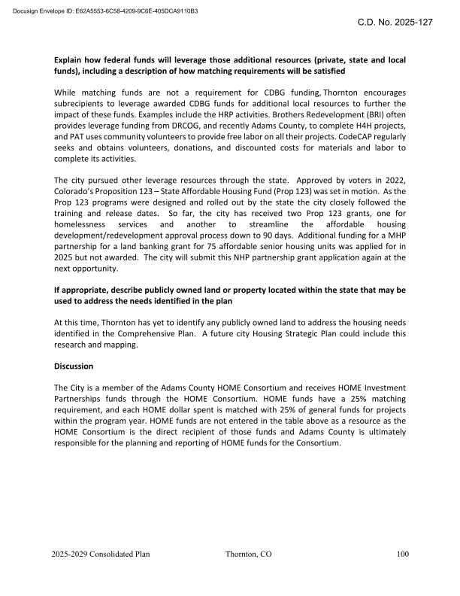
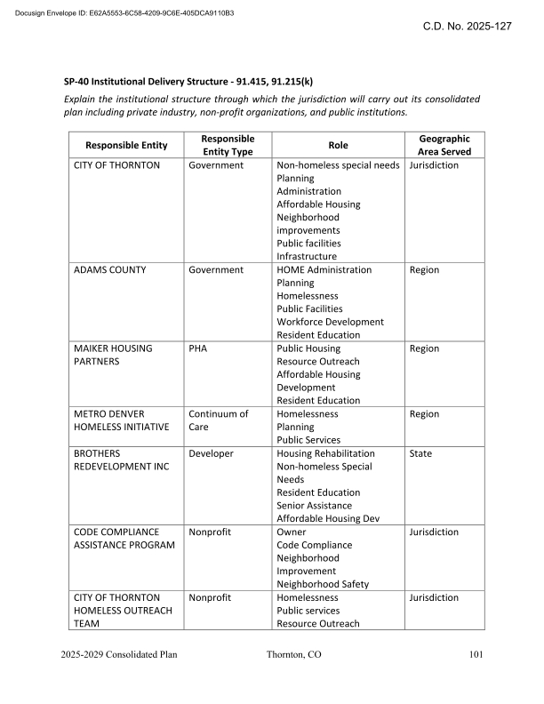
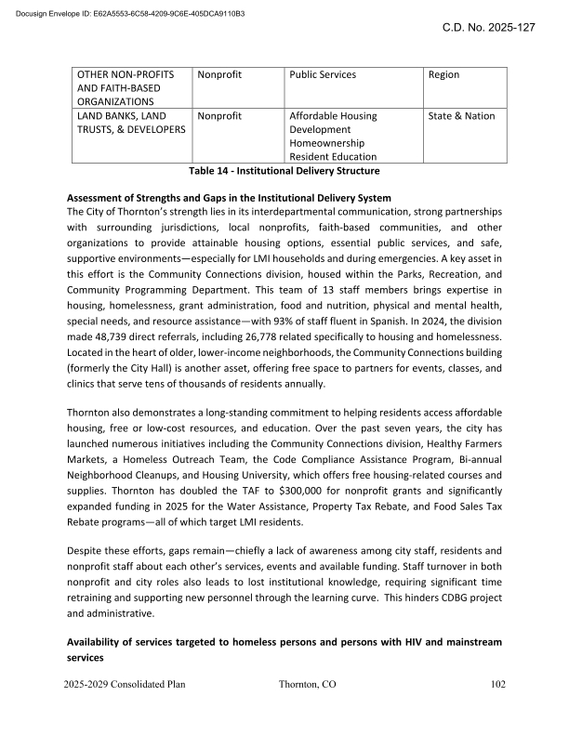
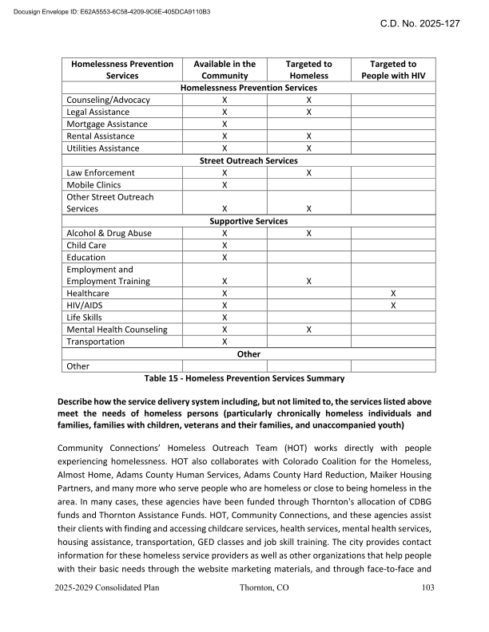
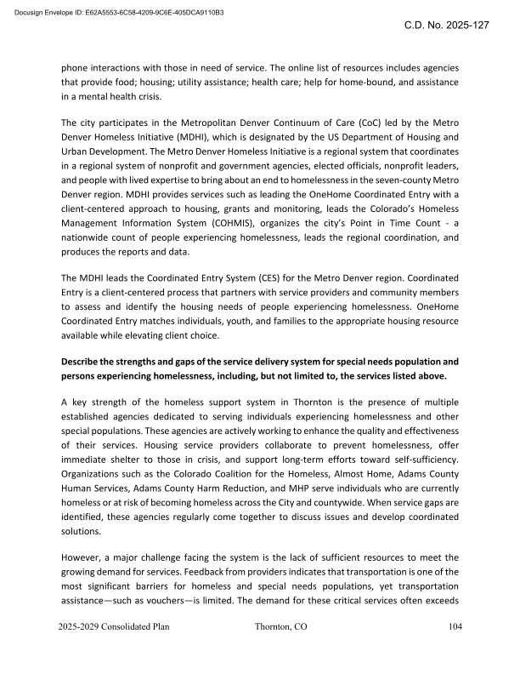
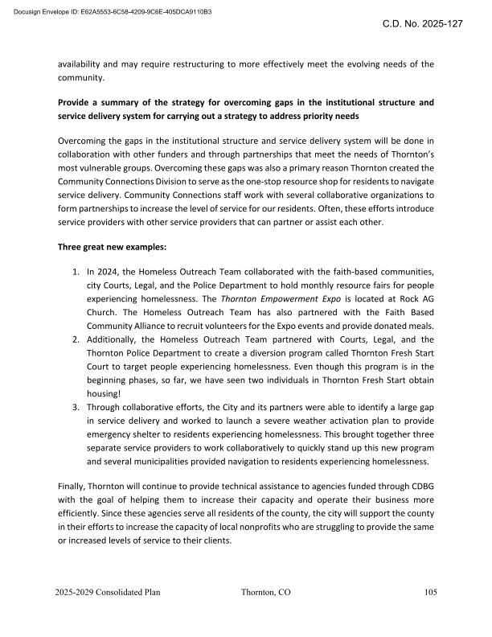
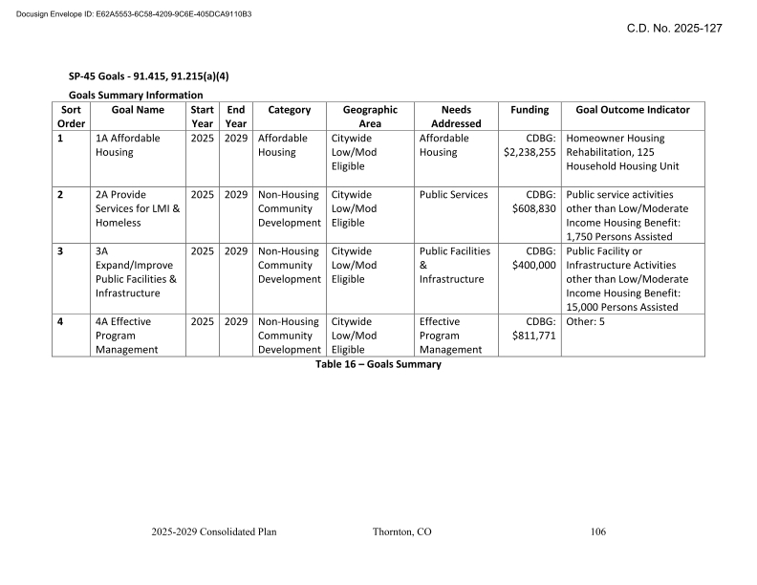
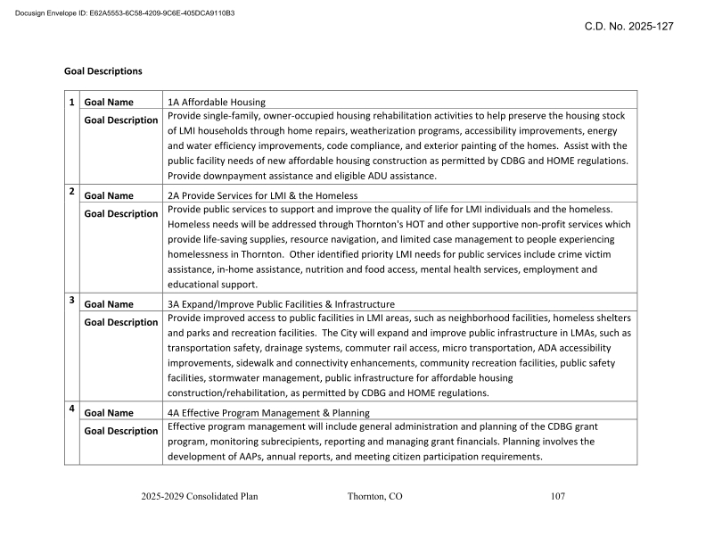

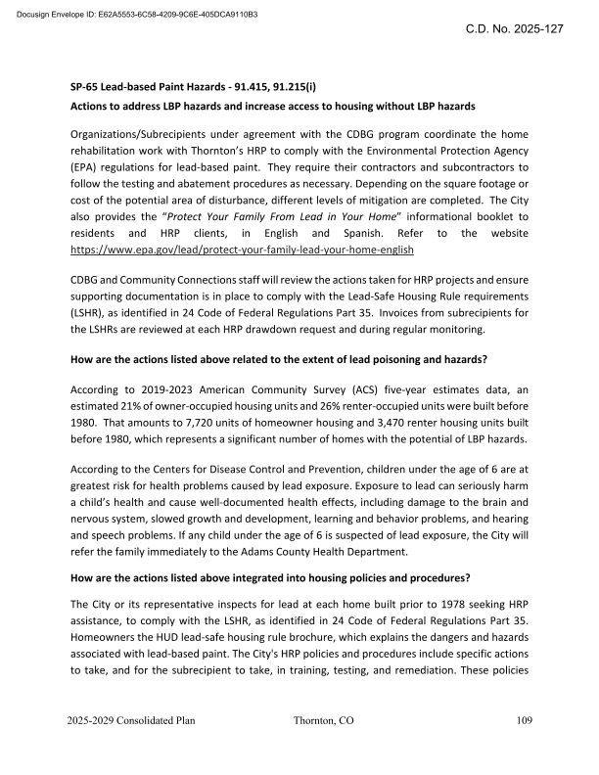

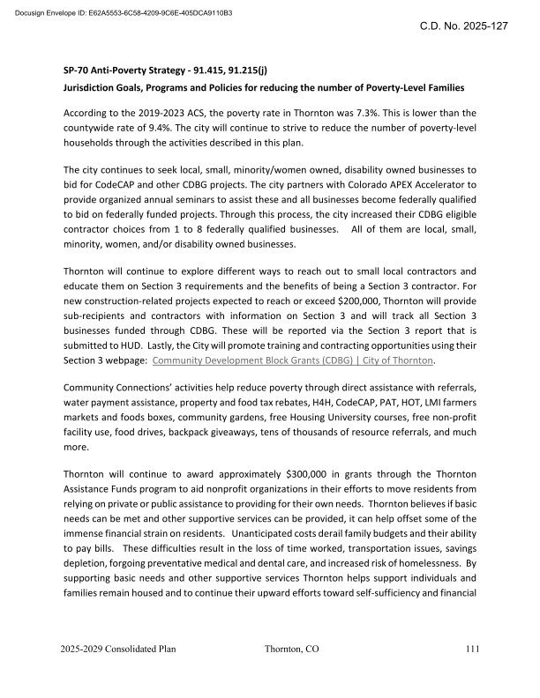
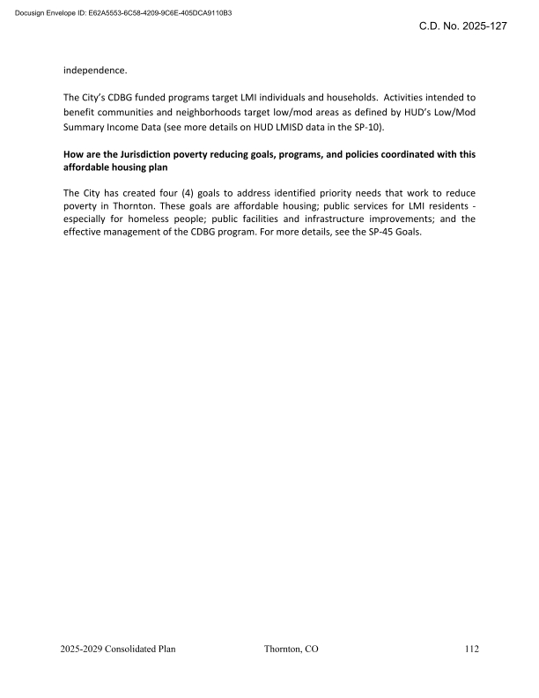
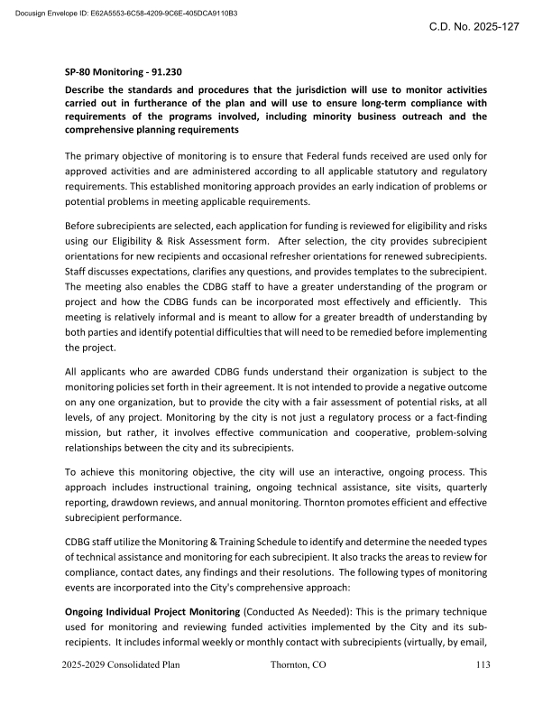
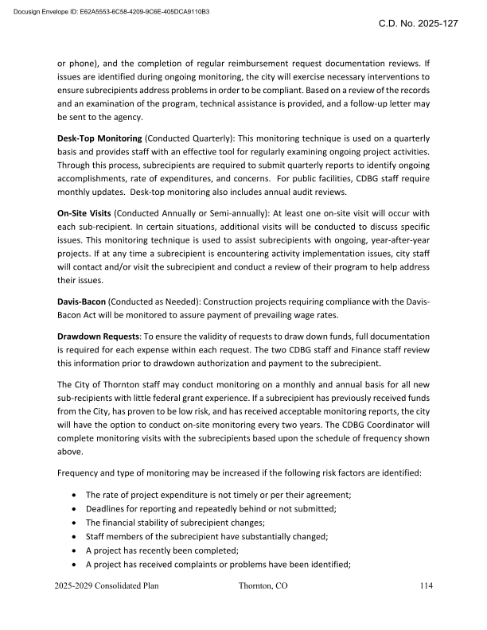

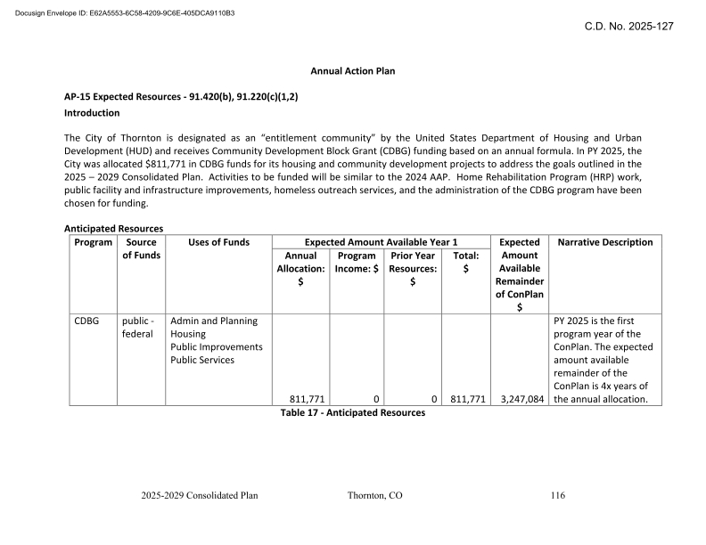
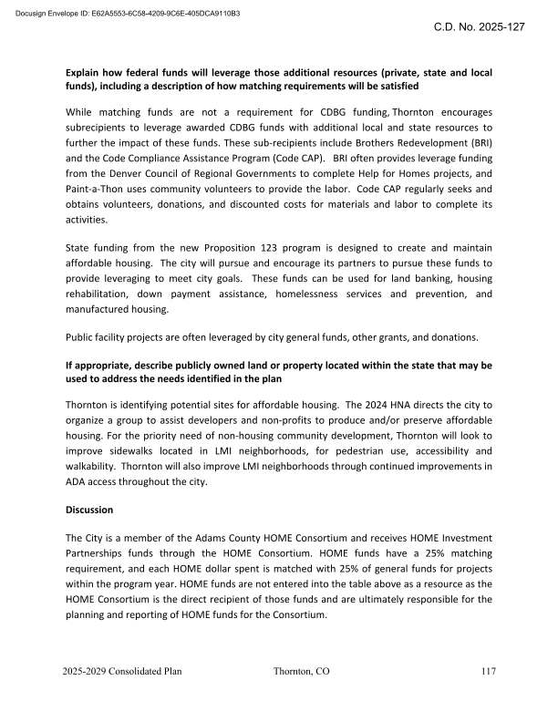
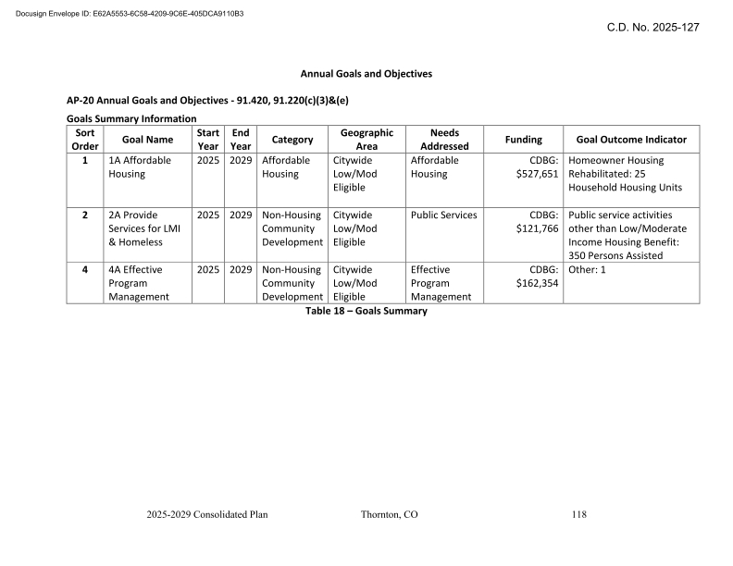
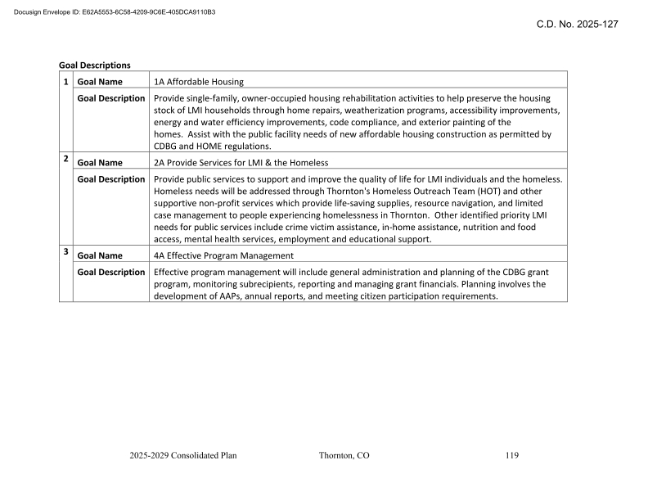
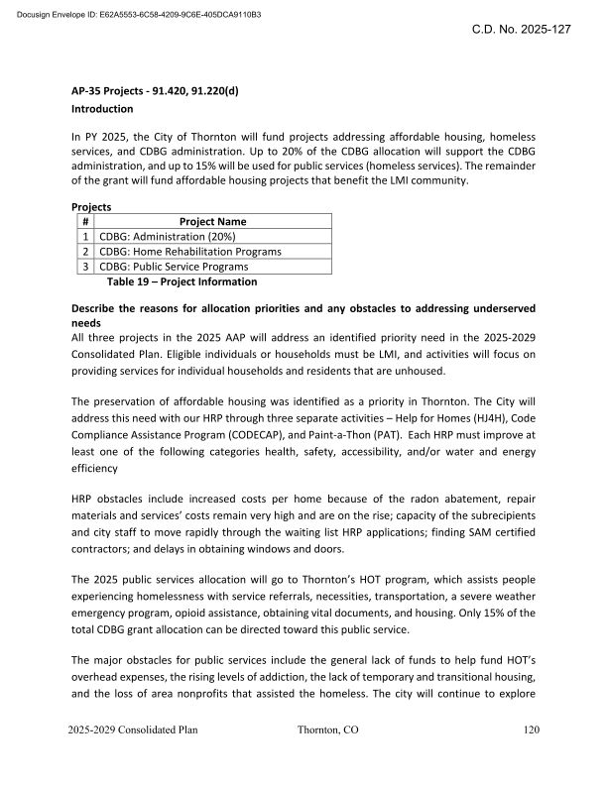

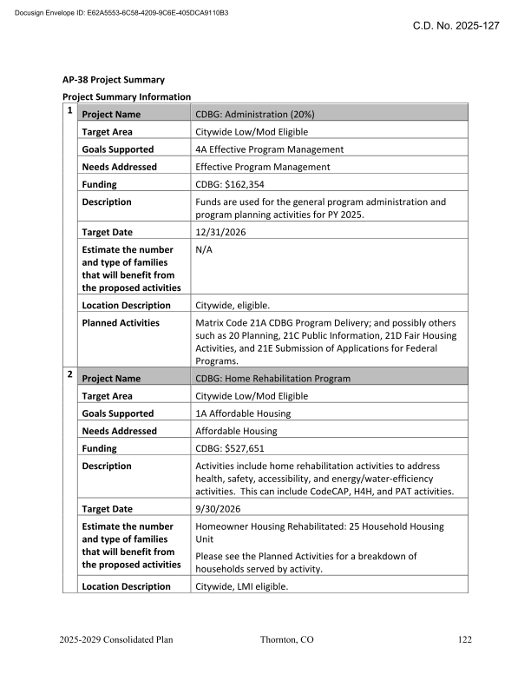
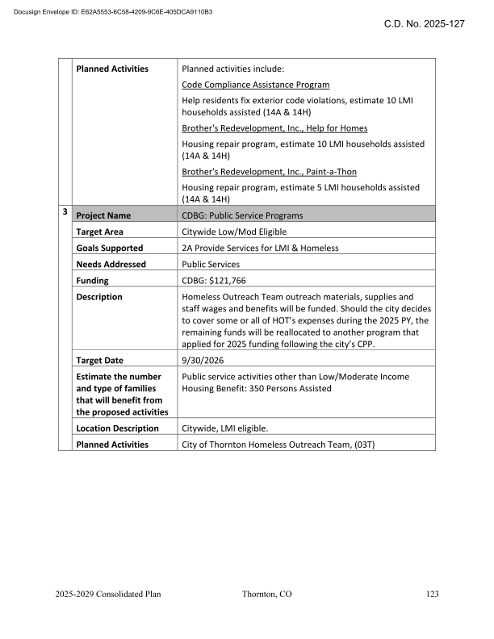
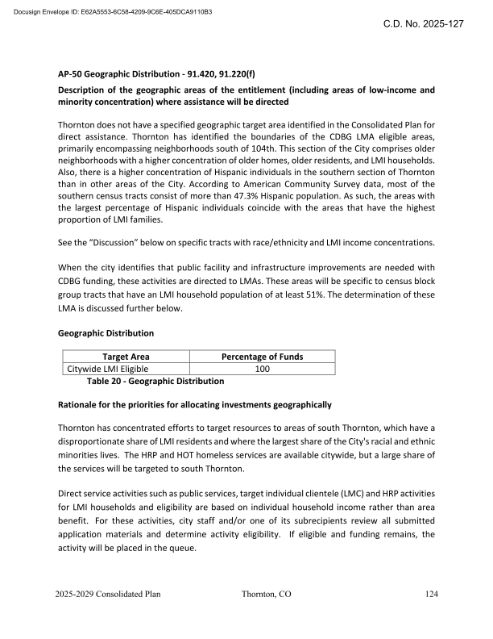
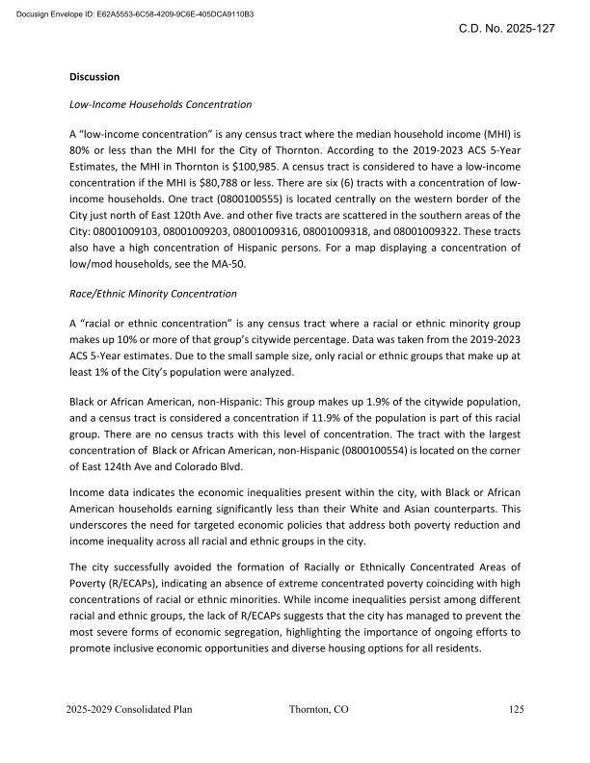
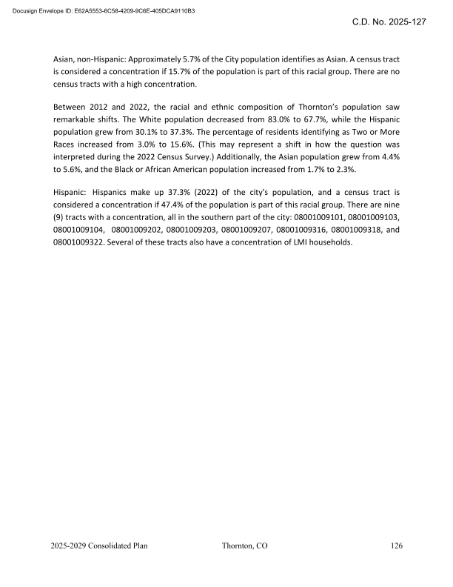
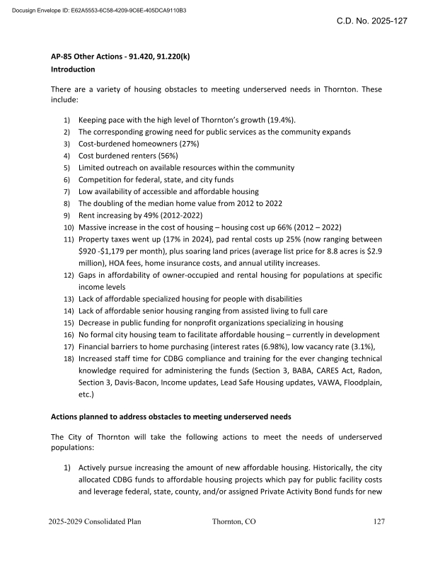
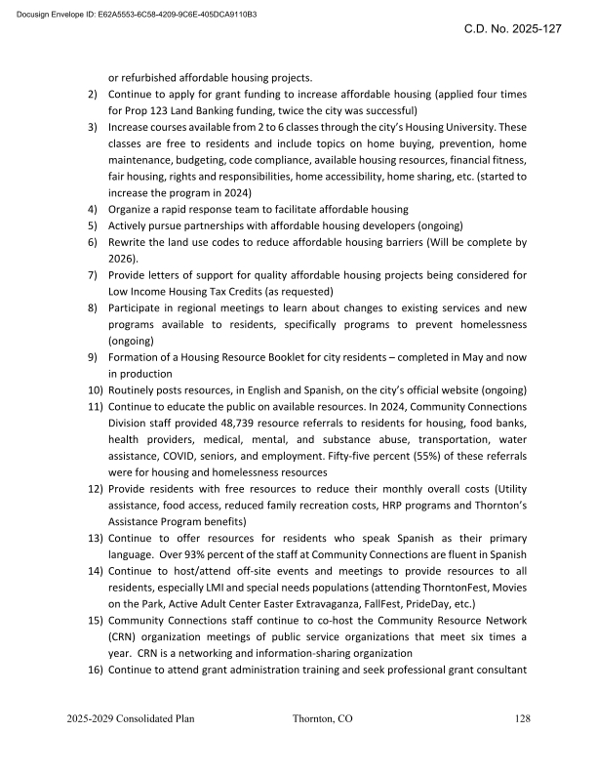
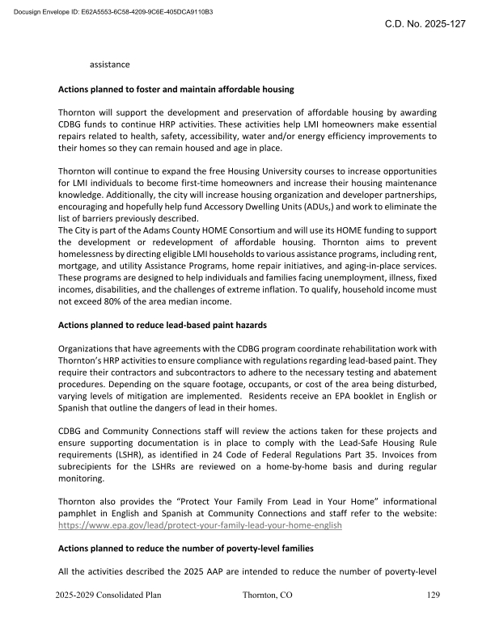
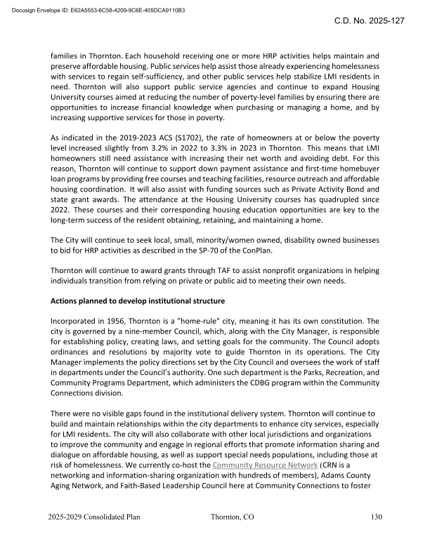
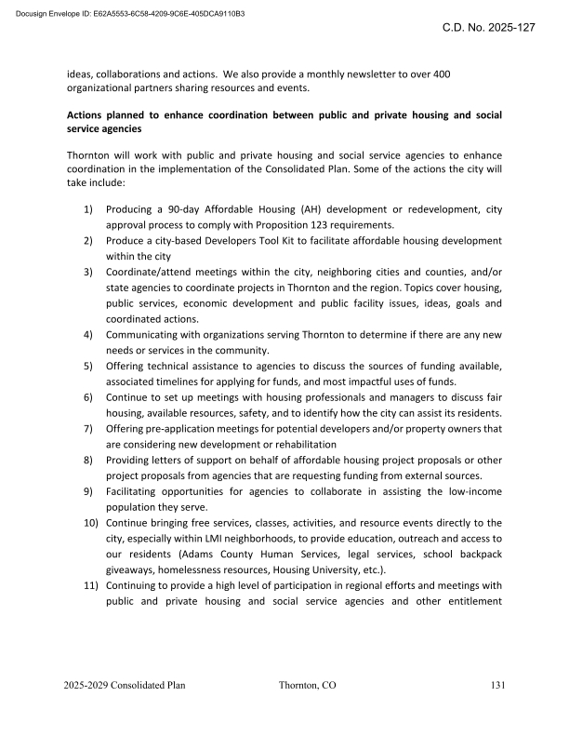
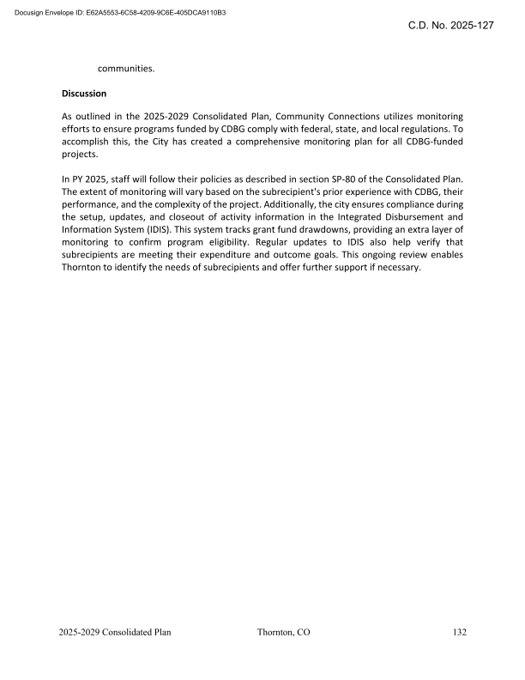
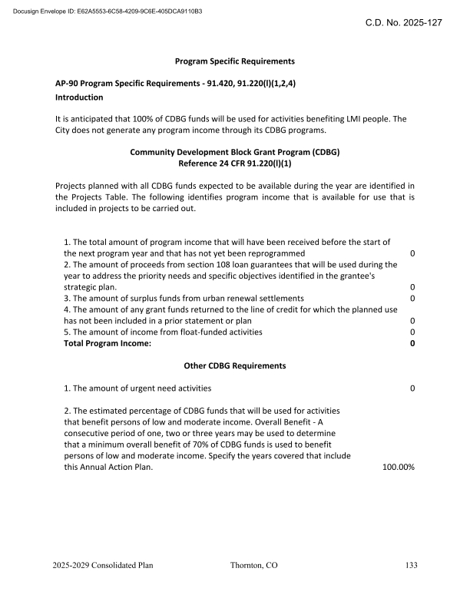
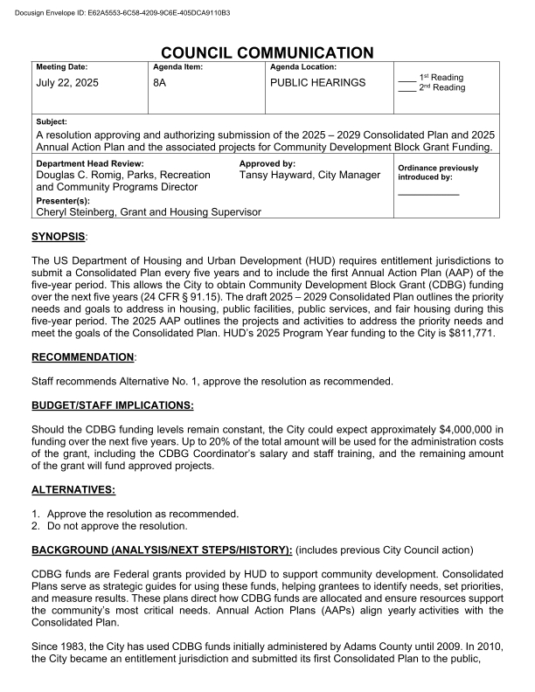
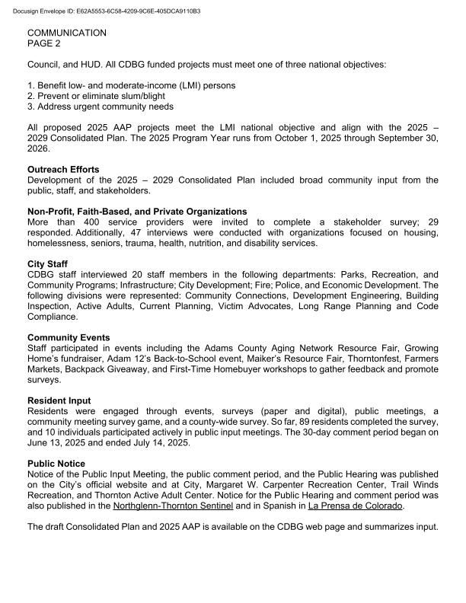
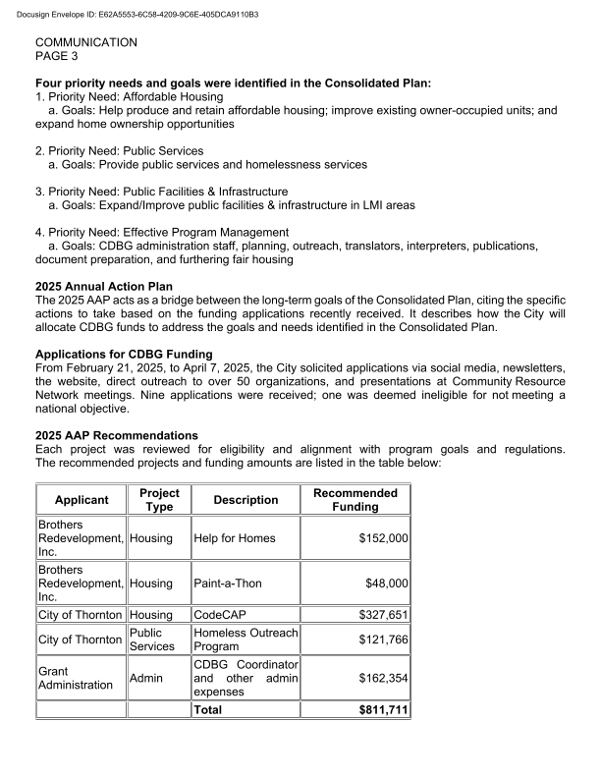
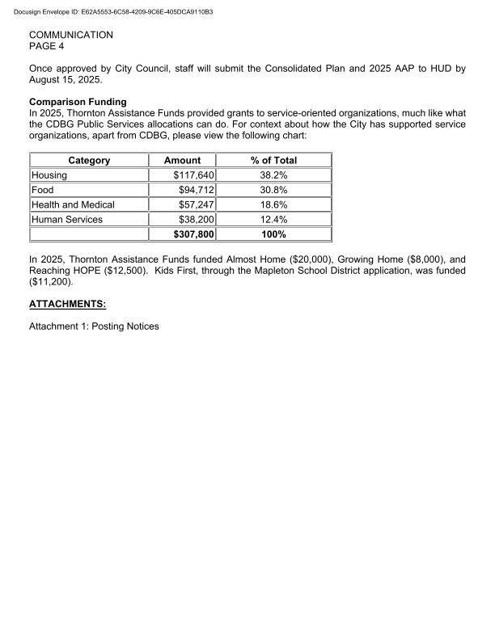





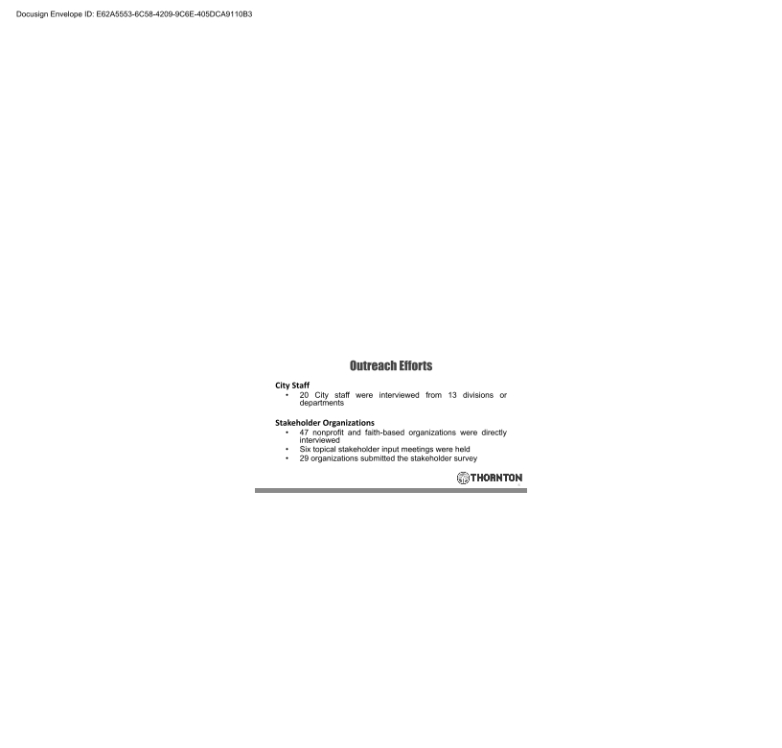

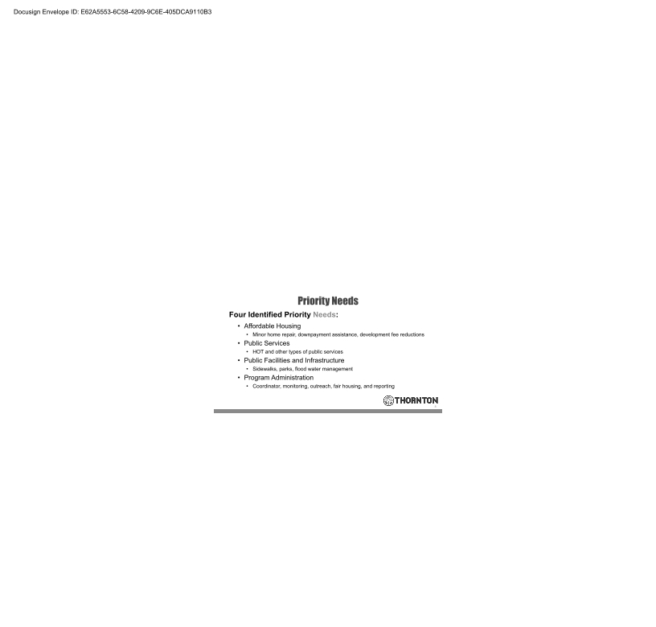


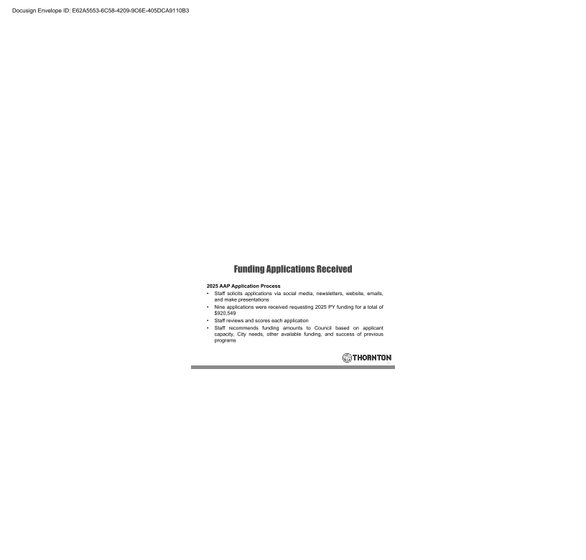
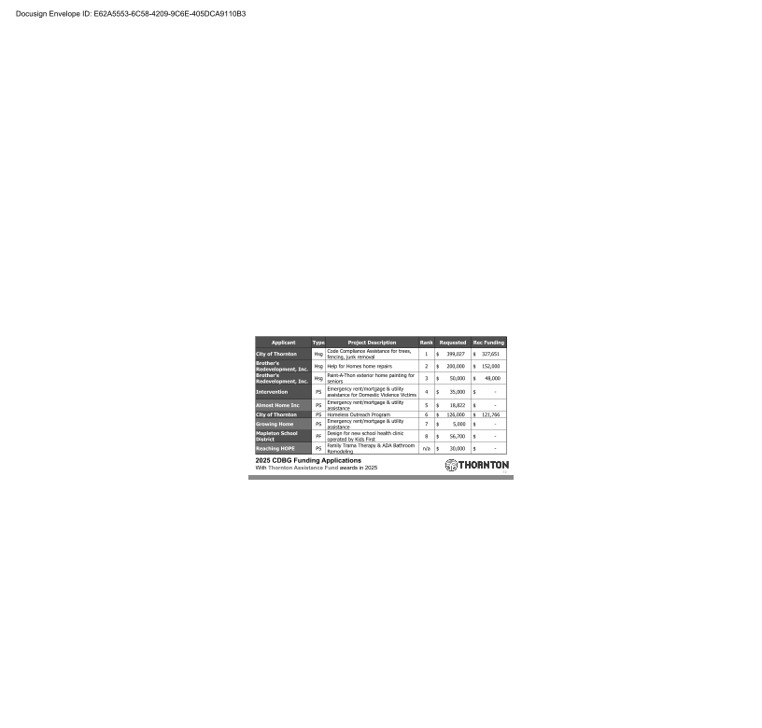
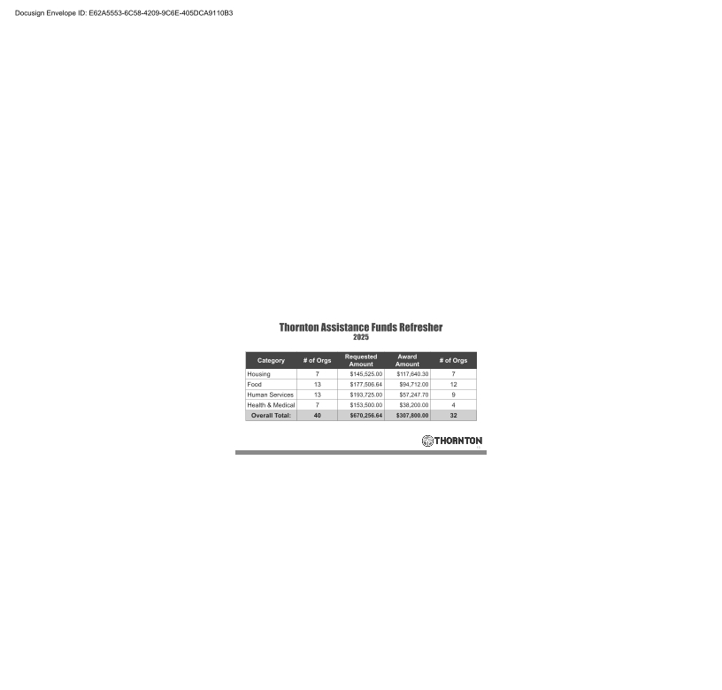
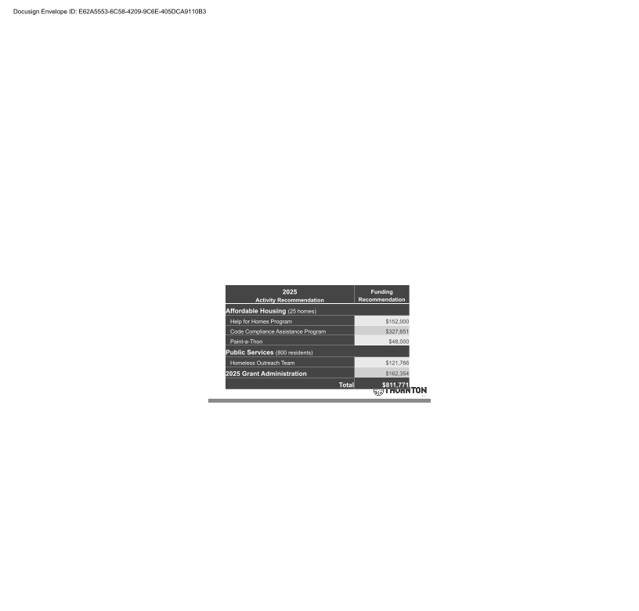
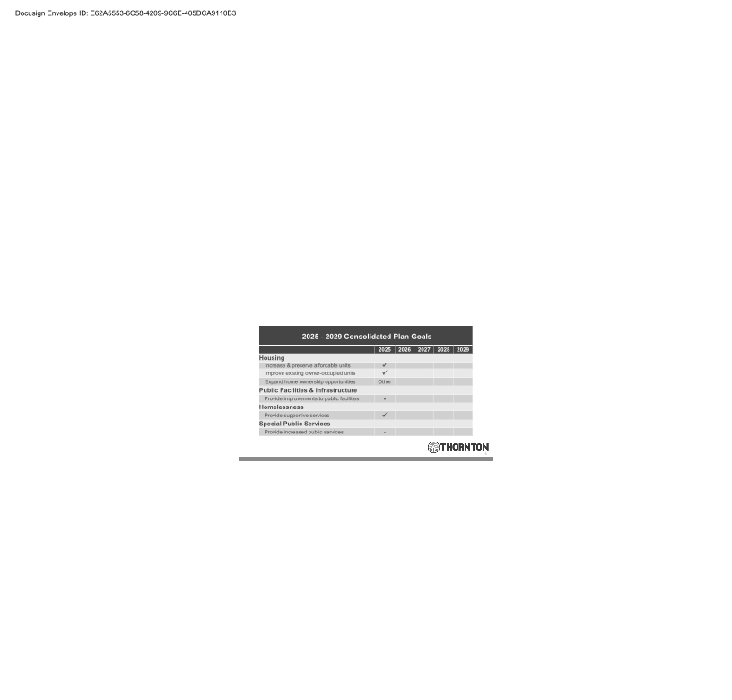


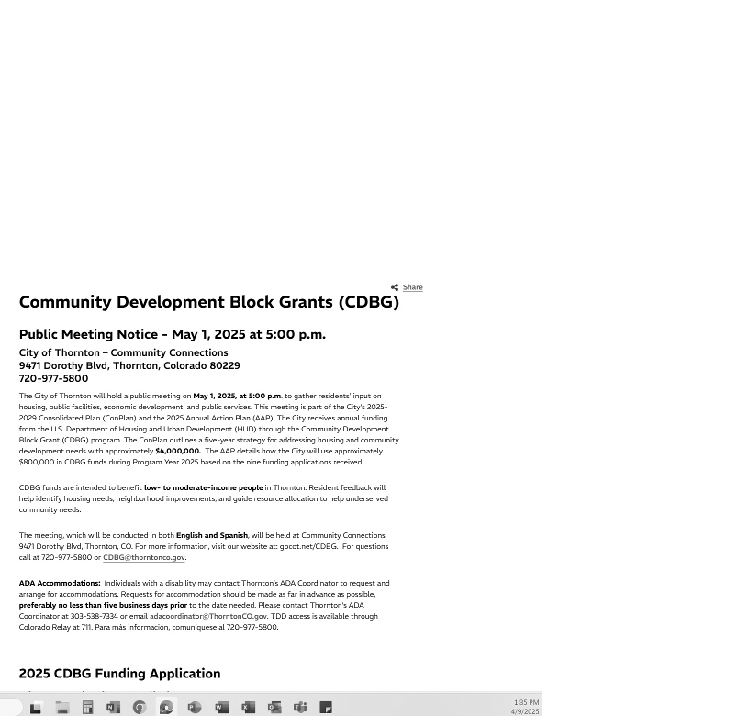
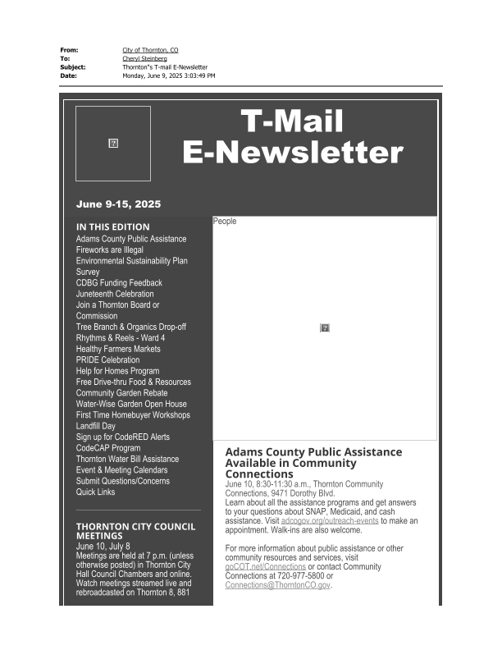
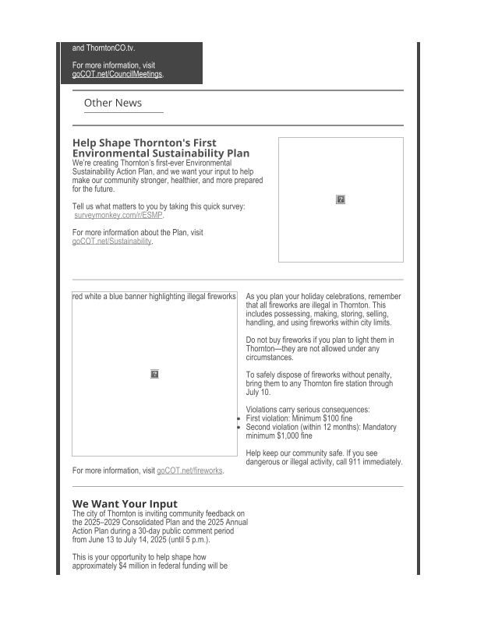
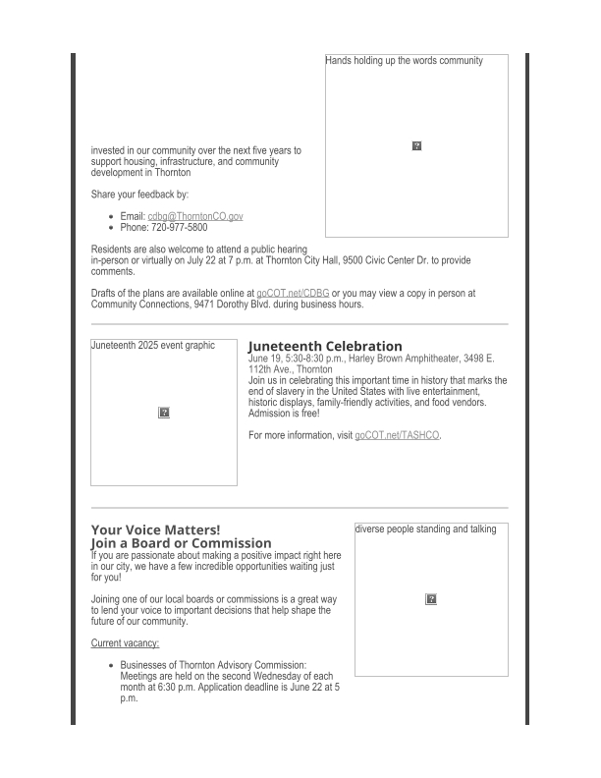
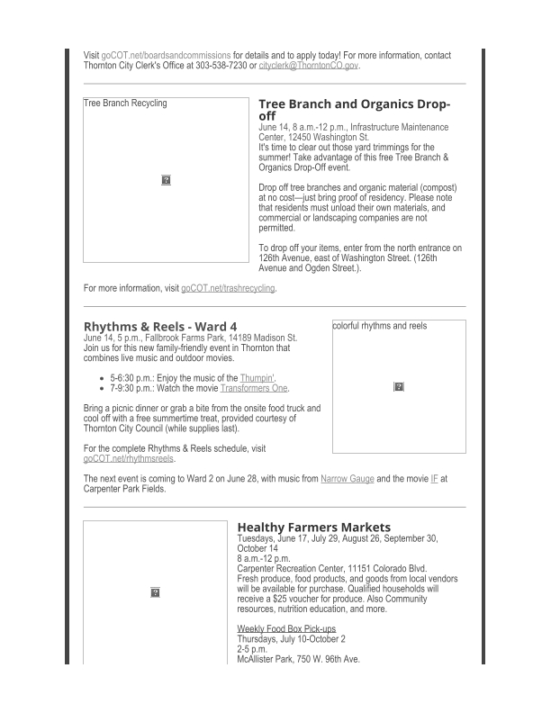
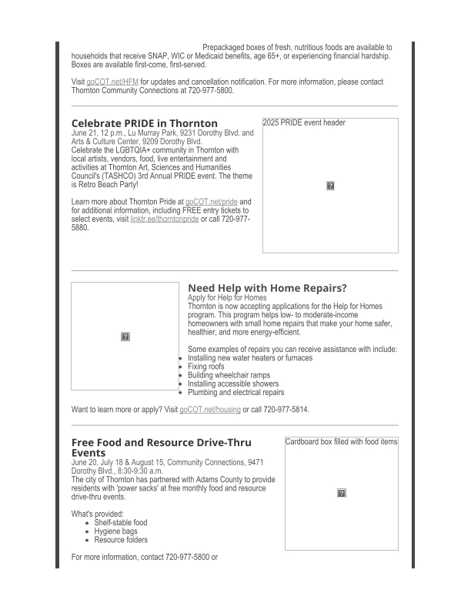

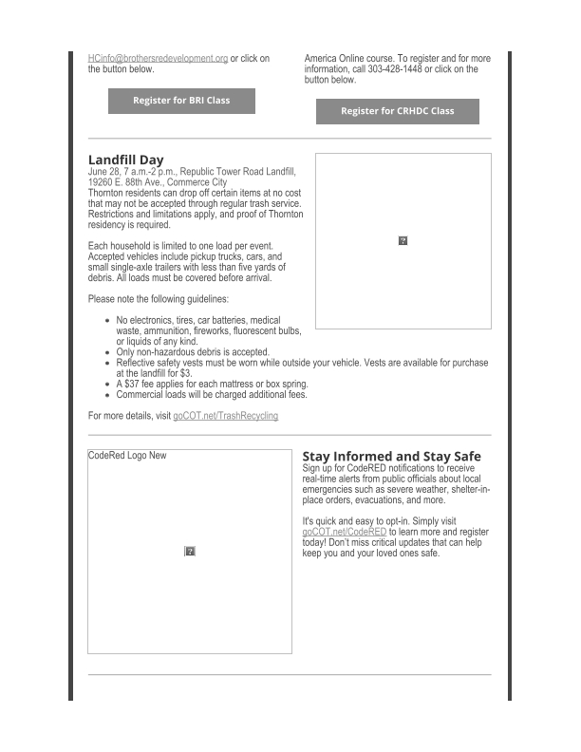
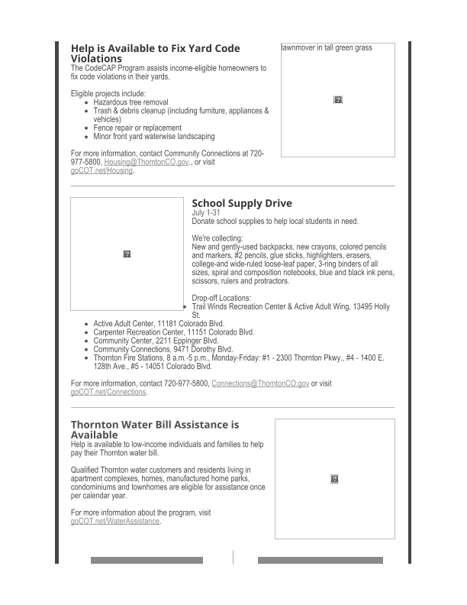
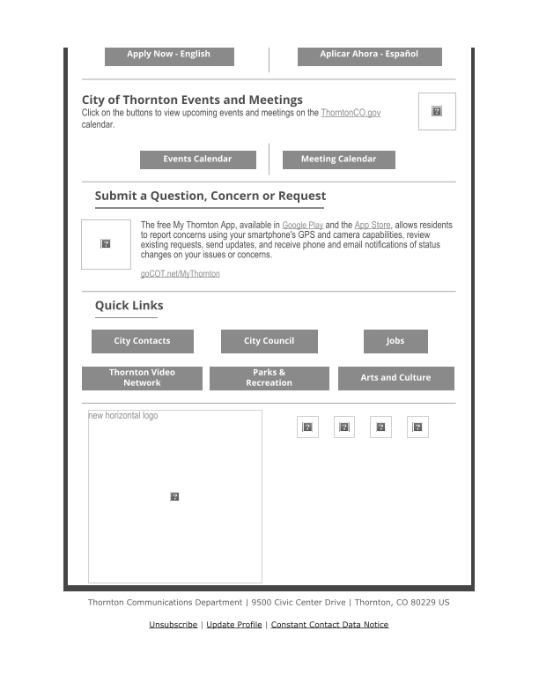

Grantee Unique Appendices
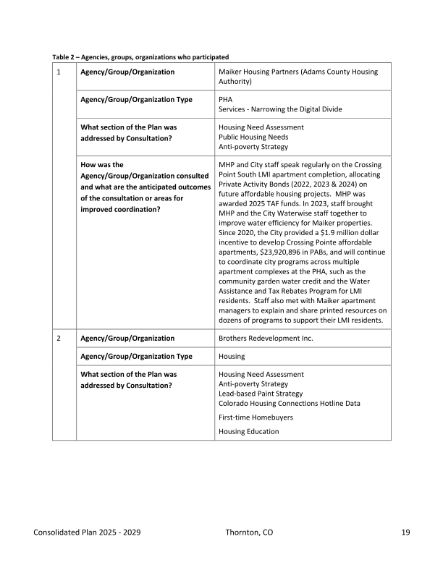
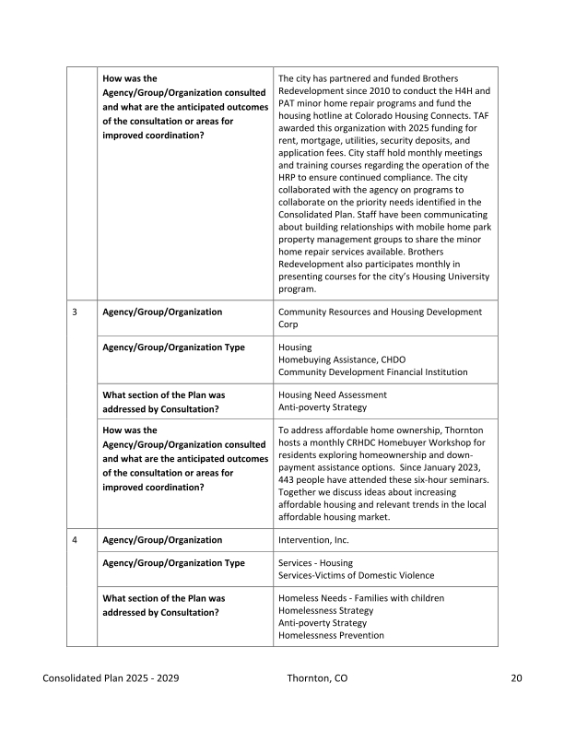
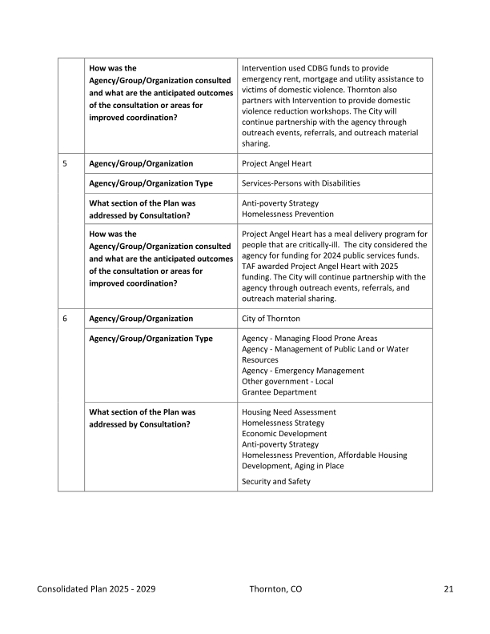
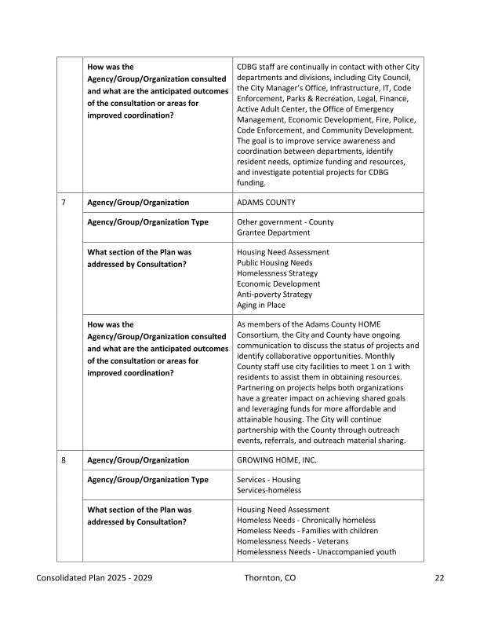
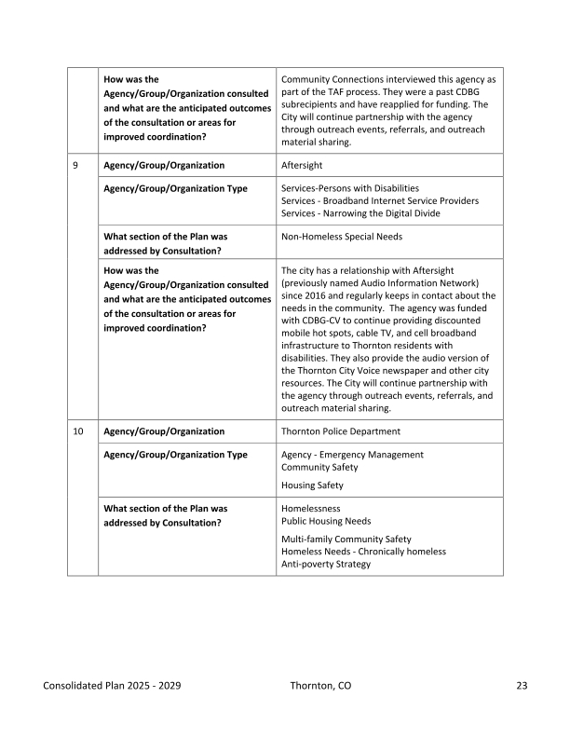
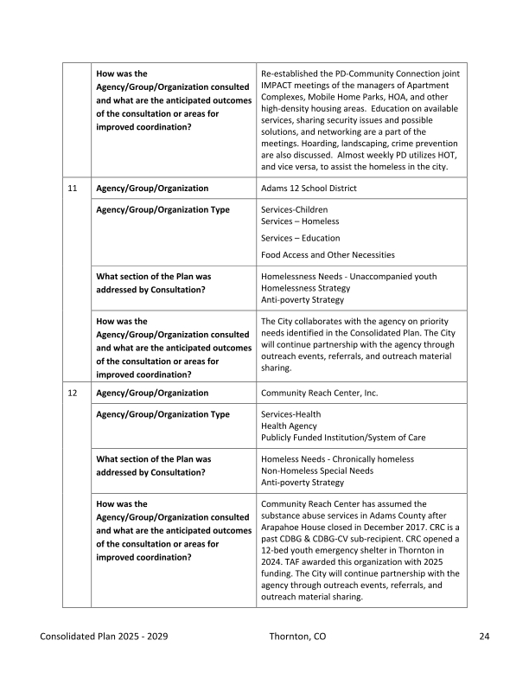
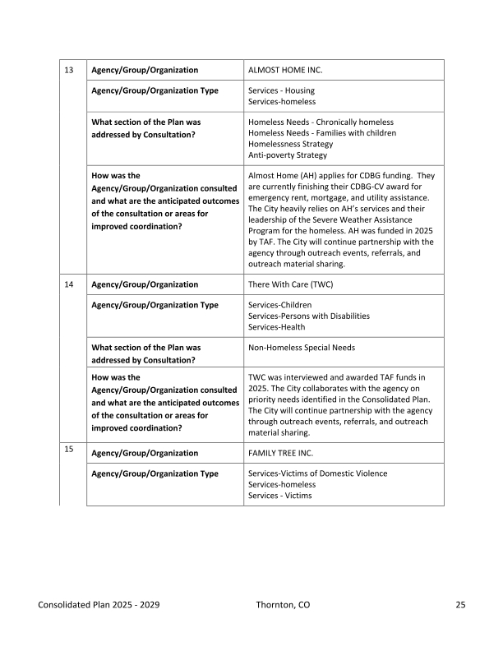
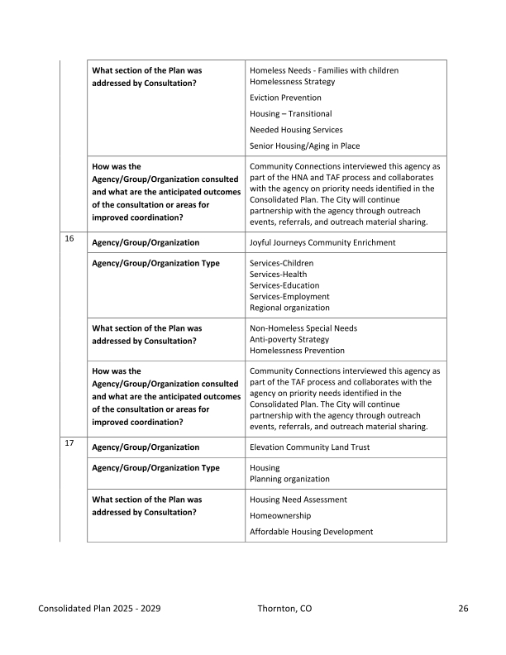
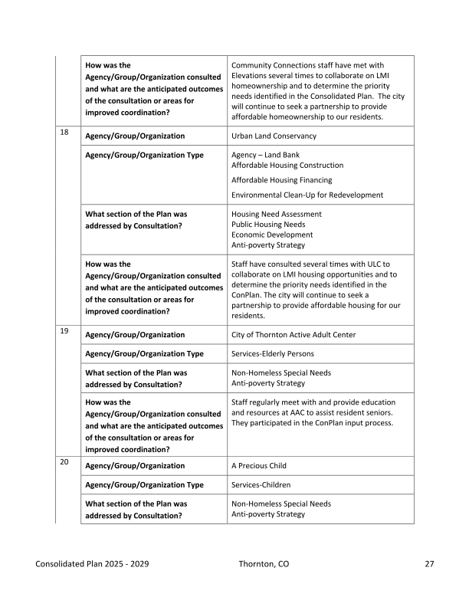
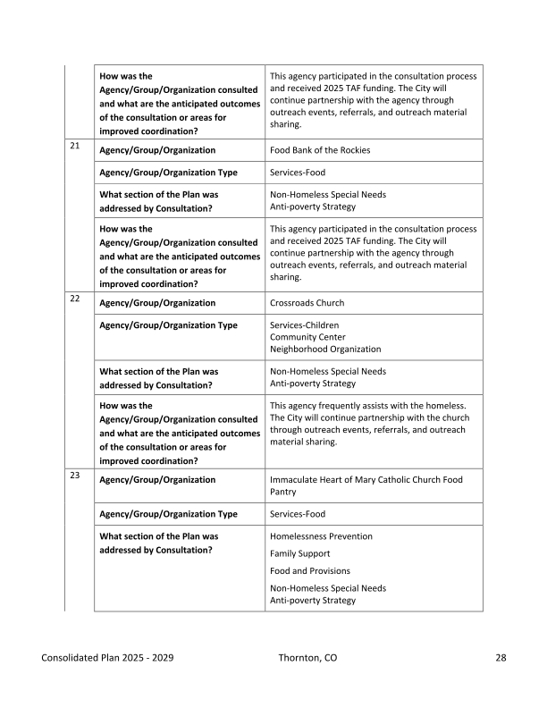
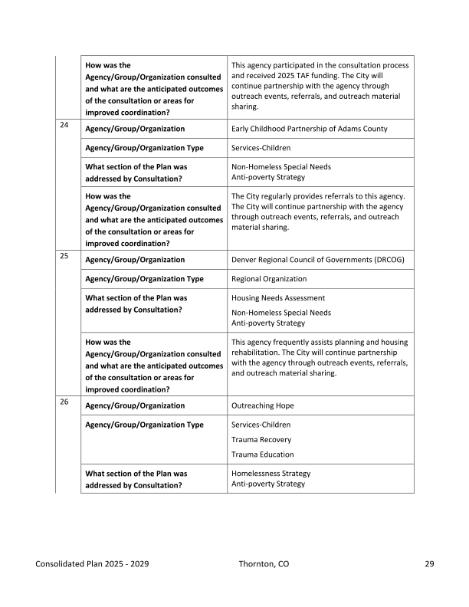
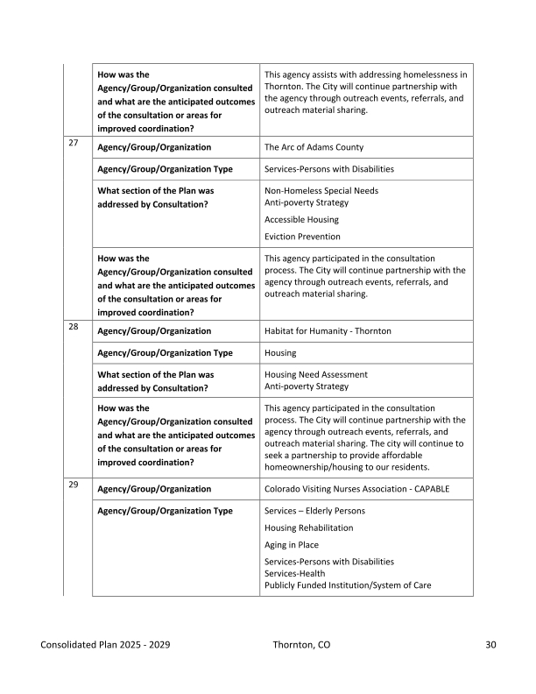
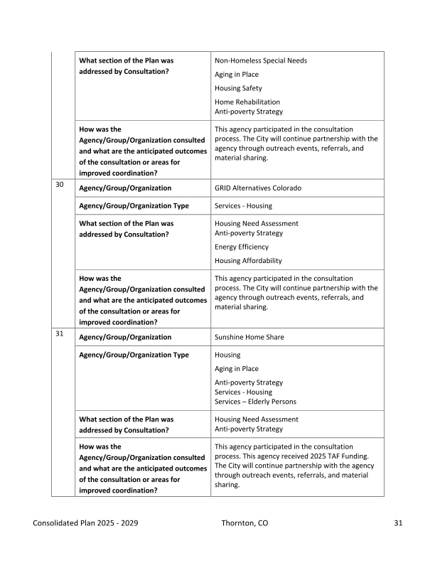
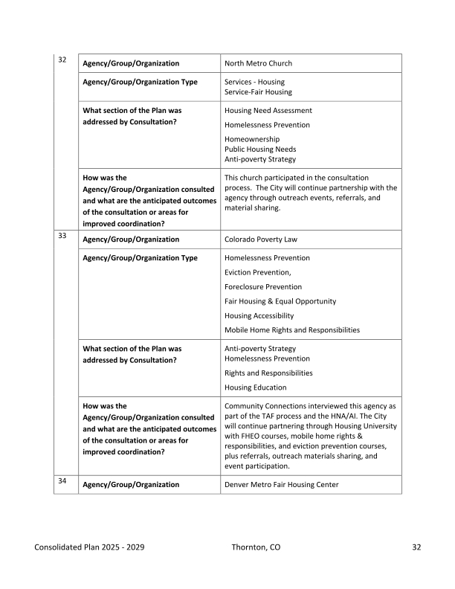
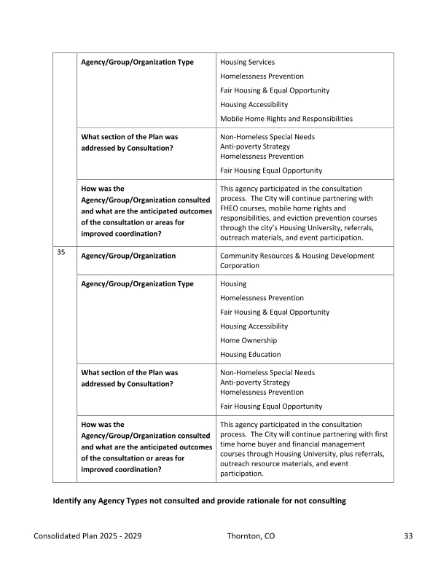
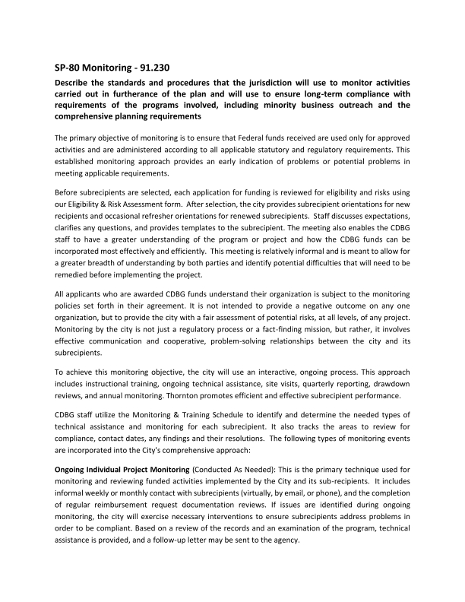
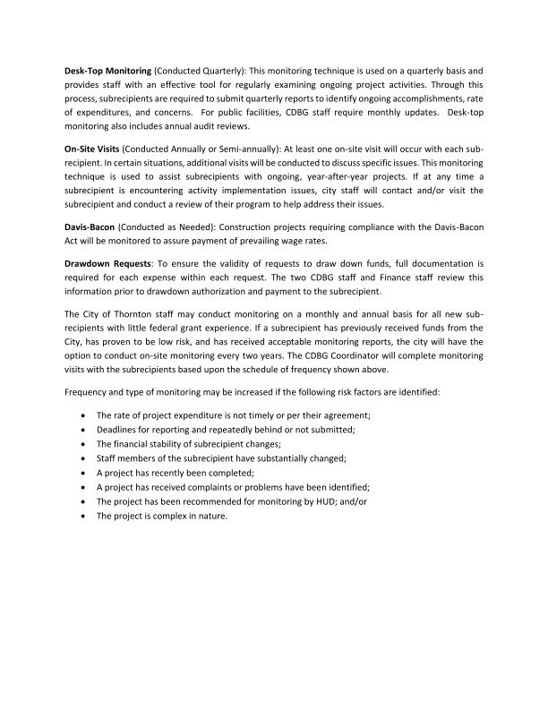

Grantee SF-424's and Certification(s)
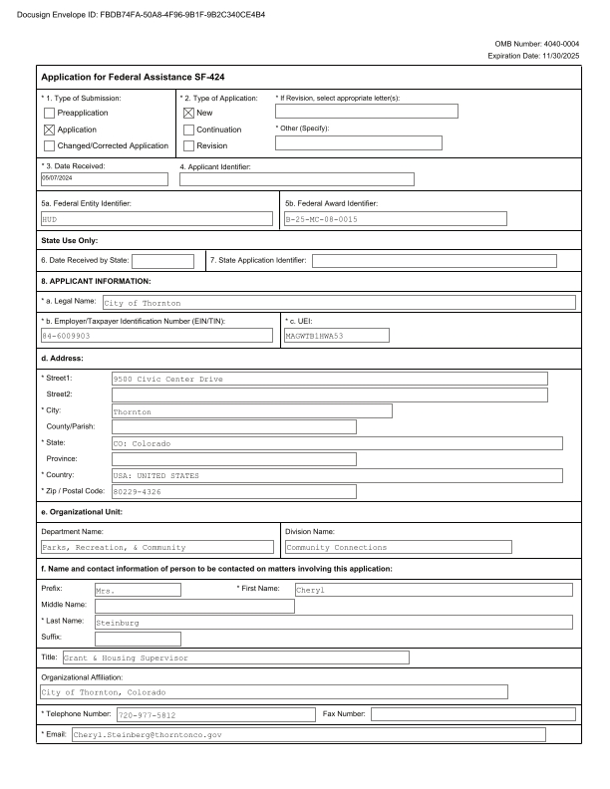
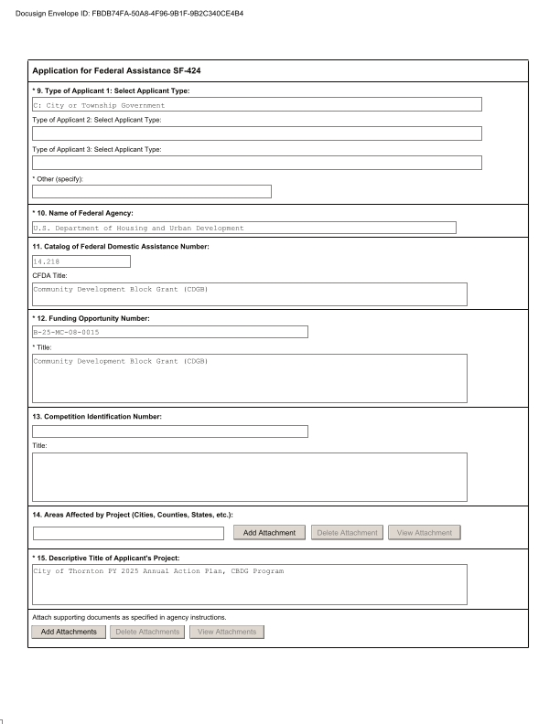
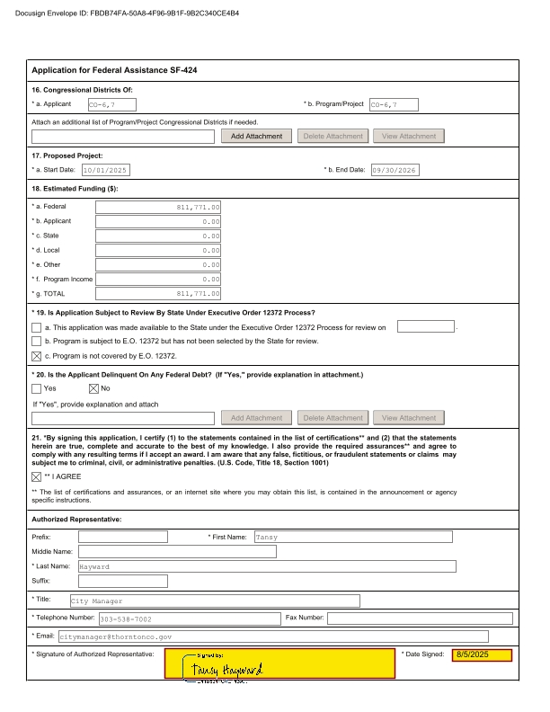
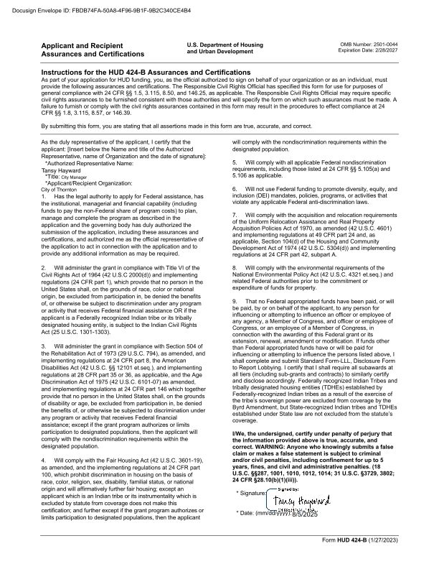
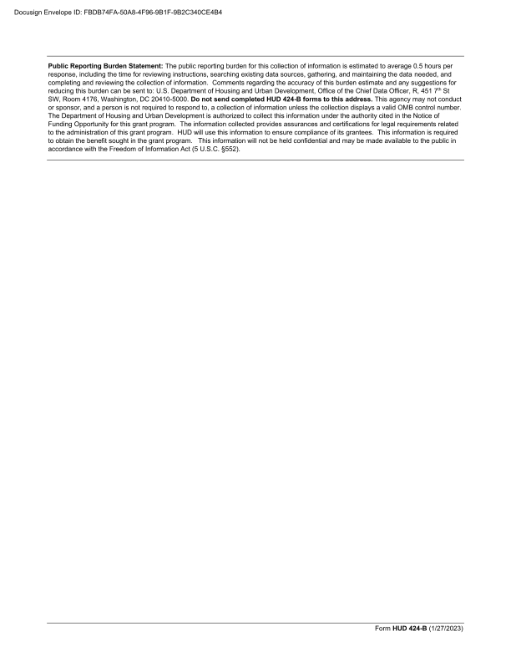
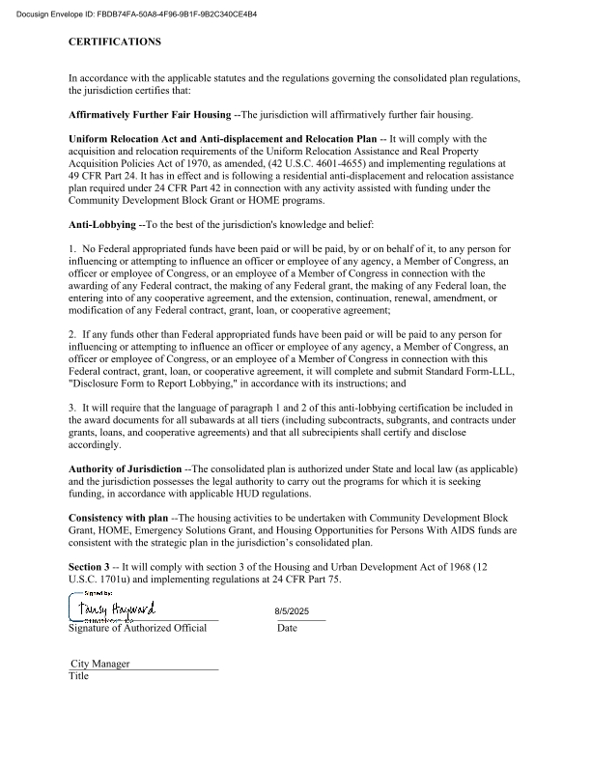
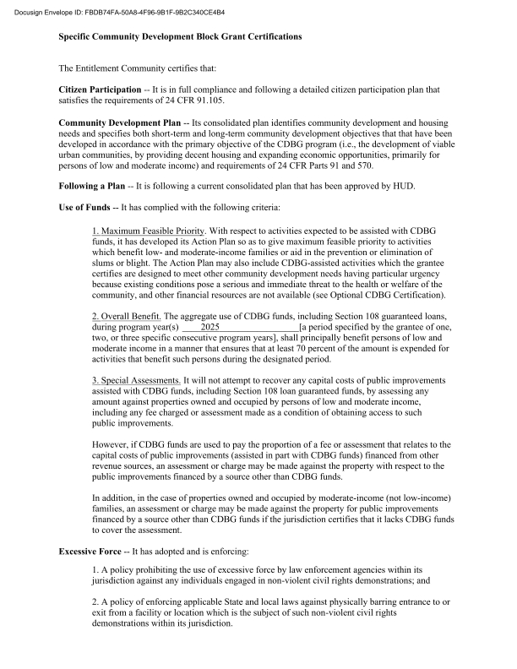
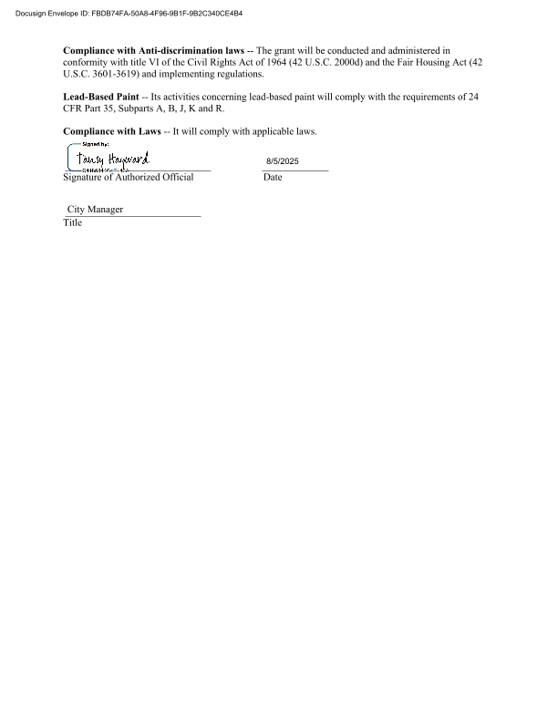


Appendix - Alternate/Local Data Sources

1 | Data Source Name  2018-2022 ACS (Workers), 2022 LEHD (Jobs)
1 | List the name of the organization or individual who originated the data set.  ACS and Longitudinal Employee-Household Dynamics: United States Census Bureau
1 | Provide a brief summary of the data set.  The American Community Survey (ACS)is an ongoing survey that provides data every year -- giving communities the current information they need to plan investments and services. Information from the survey generates data that help determine how more than $400 billion in federal and state funds are distributed each year. The ACS is accessed through the Census website, which provides data about the United States, Puerto Rico and the Island Areas.  The Longitudinal Employer-Household Dynamics (LEHD)program is part of the Center for Economic Studies at the U.S. Census Bureau. The LEHD program produces new, cost effective, public-use information combining federal, state and Census Bureau data on employers and employees under the Local Employment Dynamics (LED) Partnership.
1 | What was the purpose for developing this data set?  ACS: Information from the ACS help determine how more than $400 billion in federal and state funds are distributed each year to help communities, state governments, and federal programs.  LEHD: Information from the LEHD help state and local authorities who increasingly need detailed local information about their economies to make informed decisions. The LEHD Partnership works to fill critical data gaps and provide indicators needed by state and local authorities. LEHD’s mission is to provide new dynamic information on workers, employers, and jobs with state-of-the-art confidentiality protections and no additional data collection burden.
1 | How comprehensive is the coverage of this administrative data? Is data collection concentrated in one geographic area or among a certain population?  City of Thornton, CO
1 | What time period (provide the year, and optionally month, or month and day) is covered by this data set?  2018-2022 ACS (Workers), 2022 LEHD (Jobs)
1 | What is the status of the data set (complete, in progress, or planned)?  Complete
2 | Data Source Name  2019-2023 ACS
2 | List the name of the organization or individual who originated the data set.  US Census Bureau
2 | Provide a brief summary of the data set.  The American Community Survey (ACS) is an ongoing survey that provides data every year -- giving communities the current information they need to plan investments and services. Information from the survey generates data that help determine how more than $400 billion in federal and state funds are distributed each year. The ACS is accessed through the Census website, which provides data about the United States, Puerto Rico and the Island Areas.
2 | What was the purpose for developing this data set?  Information from the ACS help determine how more than $400 billion in federal and state funds are distributed each year to help communities, state governments, and federal programs.
2 | How comprehensive is the coverage of this administrative data? Is data collection concentrated in one geographic area or among a certain population?  City of Thornton, CO
2 | What time period (provide the year, and optionally month, or month and day) is covered by this data set?  2019-2023 ACS
2 | What is the status of the data set (complete, in progress, or planned)?  Complete
3 | Data Source Name  Bureau of Labor Statistics (BLS)
3 | List the name of the organization or individual who originated the data set.  Bureau of Labor Statistics (BLS)
3 | Provide a brief summary of the data set.  BLS unemployment rates are from the BLS Local Area Unemployment Statistics (LAUS). This program produces monthly and annual employment, unemployment, and labor force data for Census regions and divisions, States, counties, metropolitan areas, and many cities, by place of residence.
3 | What was the purpose for developing this data set?  The purpose of the BLS data is to collect, analyze, and disseminate essential economic information to support public and private decision making.
3 | How comprehensive is the coverage of this administrative data? Is data collection concentrated in one geographic area or among a certain population?  City of Thornton, CP
3 | What time period (provide the year, and optionally month, or month and day) is covered by this data set?  2022-2023 BLS
3 | What is the status of the data set (complete, in progress, or planned)?  Complete

