
City of Thornton – City Development
9500 Civic Center Drive
Thornton, Colorado 80229
Office: 303-538-7295

Pre-application Meeting Scheduling Handout
There are a few things you will need to have to schedule a pre-application meeting.

Documentation & Information Required:
- Cover Letter (in a PDF format) The cover letter should explain any anticipated uses, identify the number of units, provide the square-footage of the building, identify the types of businesses, number of employees, hours of operation, number of acres, etc. Please provide the names, telephone numbers, and addresses of the property owner(s), applicant representatives, or potential developers. Note: this should not be combined with the other required documents.

- Vicinity Map (in a PDF format) An image or arial view showing where the property is located. Note: this should not be combined with the other required documents.

- Proposed Site Development Plan (in a PDF format) This graphic should be drawn to scale and include a north arrow, building footprints, parking and landscape areas, access points, streets, potential park and open space areas and Rights-of-Way. Also identify any existing buildings on the site, natural features of the property which we should be made aware of, and any easements affecting the property. Note: this should not be combined with the other required documents.

- Parcel Number or Address of proposed location (info below on how to locate in the system) Annexation request instructions are included.

- Email Addresses of those who you would like to have attend (optional)

How and when are pre-application meetings scheduled:
Pre-application meetings are scheduled on a first-come, first-served basis and can be requested through our online application portal. The City schedules up to two (2) pre-application meetings each week on Thursdays. The above documents must be submitted to the City by 5 p.m. on Monday in order to schedule a meeting for the following week. Once both pre-application meeting time slots are filled for the week, requests are scheduled for the next available date and time in the order in which they were submitted. Due to the high volume of pre-application meeting requests, at times we are scheduling out several weeks from the date of submittal.

General meeting information:
- Meetings are virtual unless otherwise requested (this request can be made through the online application).

- You are welcome to bring anyone you wish to the pre-application meeting to discuss site development issues.

- City representatives in attendance usually include a planner, development engineer, fire protection engineer and landscape architect. Building Inspection or Economic Development staff may attend as appropriate.

- City staff is committed to providing exceptional customer service and information to help you make decisions about your project.

- If you have any questions, please contact the Planner of the Day.

How to request a Pre-Application Meeting
To request a pre-application meeting, please go to the CityView Portal and create an account or log in using your existing account.
Once logged in, click on the “Apply for a Planning Permit” link under Planning Department and select the option for a pre-application meeting from the “Choose the Project Type Drop down”
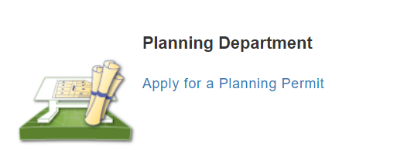
Once there, it will prompt you to provide some details for your project. Please use the information below as a guide to filling out the required information.

Filling out the online application:

Project Descriptive Name:
The Name should be the Legal Description of the property – this can be found by searching for the parcel/address information on the Adams County Property Search or the Adams County Interactive Map Application (examples on how to locate parcel information is attached to this handout). If the property is not subdivided or this is for a proposed Annexation you can provide a name and or use the Cross Streets instead and/or reference the parcel number in the comment section.
An Example of the Subdivision name would be: Rolling Hills Filing 1, Amendment 2, Block 3, Lot 4 or Rolling Hills F1 A2 B3 L4.
An Example of Cross Streets would be: NWC 104th Avenue and Colorado Boulevard

Comments:
The comments section should be a brief description of the proposed project.
Example: Pre-application meeting for the proposed development of a convenient store and a restaurant drive-through on the two vacant lots located at 1234 Thornton Way which would require a re-zone of both parcels to Community Retail (CR).

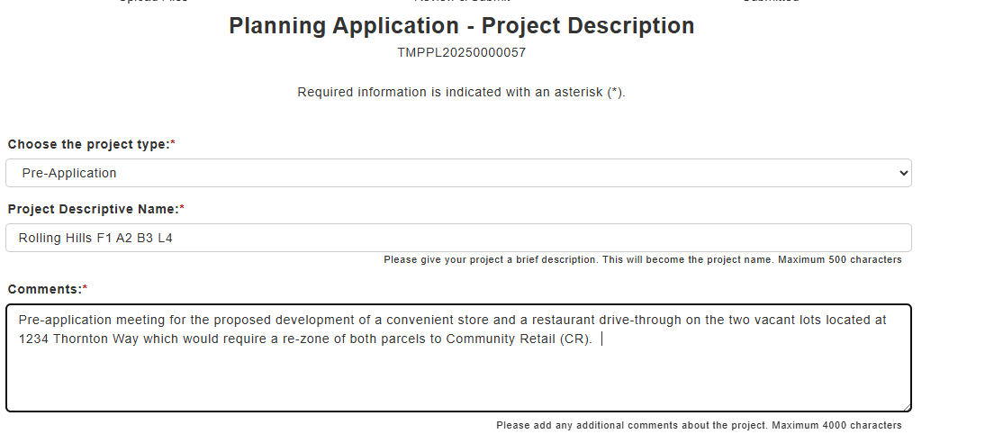

Scheduling:
Meetings are held on a first come first served basis. Pre-applications that are received prior to 5:00pm on Mondays will be scheduled for Thursday the following week if there are still appointments available. Applications received after 5pm or if times are filled will be scheduled for the next available Thursday.
When filling out your online application, please designate the preferred time of your meeting (either 8:30AM or 10:00AM) by checking the box next to your preferred meeting time.
If the time slot is not available at the time the application is received, we will schedule you for the next available time. For example, if 10 is available and you chose, 8:30 we would give the 10am meeting if the other was already booked.
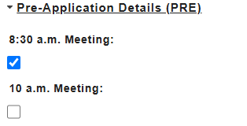
If you would like a specific Thursday date in the future beyond the default date, please indicate that in the future date field (you can fill this out or leave this blank if you want the first available Thursday)
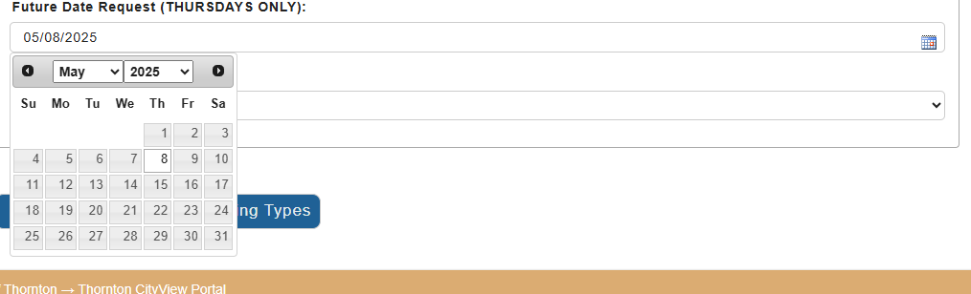
Meetings are held virtually using Teams unless otherwise requested. On the application, please indicate if your team plans to attend virtually only, in person only, or if your team prefers to attend both in person and online. The options are listed below
- Virtual Only
- In person only
- Virtual and In Person (Hybrid)
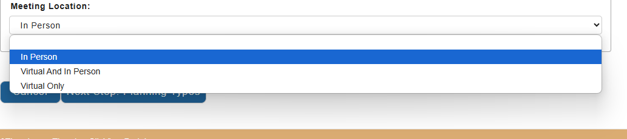
If you would like to include several people on the appointment invite, please use the email field to do so using the example format below.
Separate each email with Semicolons and a single space after (See example below).
Email_1@ThorntonCO.gov; Email_2@email.com; Email_Three@email.com
An email will be sent out those indicated in the email field by 5:00pm with the meeting information.
Continue on to the next page for information on entering the location of the project.

Location of Project:

How to look up a parcel or address:
There is an information guide on page 9 of this document if you want information on how to locate the address of your proposed site and how to create a quick vicinity map.
Please provide a Parcel Number or address. If you are unsure of the parcel number, please use the Adams County Map to locate the parcel number where your proposed project is.
How to enter a property address outside of the city for an annexation request
If the property is outside of the city, please search for “ANNEXATION PRE APP” which will populate PIN 9999999996326 and link those to your application but be sure to provide details and the parcel number in the comments section where the property is located and include the location on the Vicinity Map. Follow the same steps below, but for step 2, search for “ANNEXATION PRE APP”. Please make sure the location is indicated on your vicinity map.
If you can't find an address, but it is within the Thornton city Limits
If you are unable to find the address or the Parcel pin number and it is located within Thornton, you can search for "ADDRESS NOT FOUND" which will populate PIN 9999999996327 and link those to your application. Only use this option if you are unable to find the correct address and please make sure the location is indicated on your vicinity map.

Steps for entering an address for your online pre-application request:

Step 1: Either use the search bar to type in the address or parcel number OR you can choose “find a location near me” or “find a location in map”
Step 2: highlight the address you want to choose and once it shows in the 2nd box, you are set.
Note: Try to choose the option that does not have a .1 or .5 next to it. Unless there are no other options available.
Step 3: move on to Next steps unless you need to add multiple addresses.
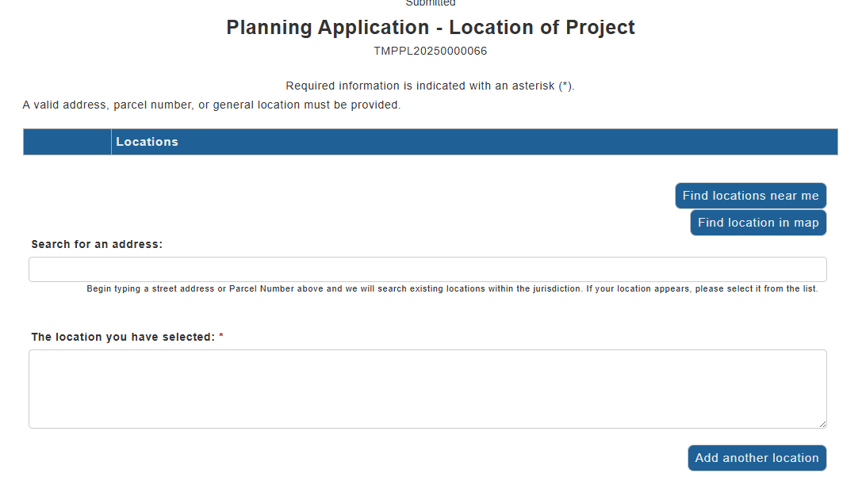
Optional last location step: you can add additional locations here and follow the same steps from above
Search for an address by typing in a parcel or address in the search bar.
You can choose “find a location near me” or “find a location in map” as well

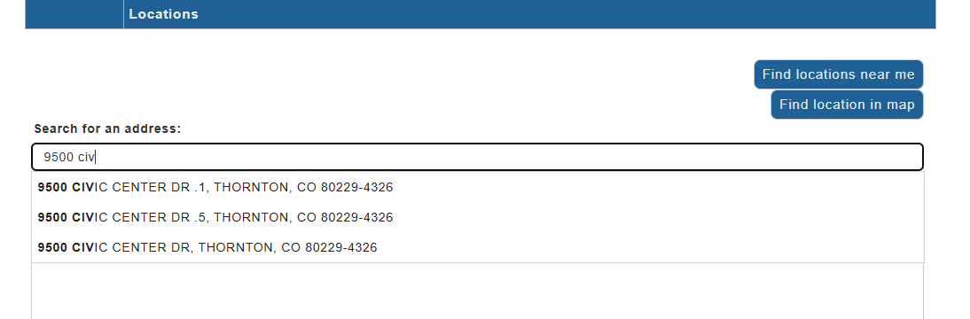
File Upload:
Please use the Naming Conventions indicated next to each file when submitting your documents without adding additional words or numbers.
- Cover Letter (in a PDF format)
- Vicinity Map (in a PDF format)
- Proposed Site Development Plan (in a PDF format)
If you have other items you would like to submit as part of your pre-application meeting, you can use the additional documents upload option and add them here. Please make sure they are in .PDF formatting and that the name clearly indicates what is being uploaded.
Optional items which help provide more detailed feedback:
- Building elevations and building materials.
- Occupancy classification.
- Subdivision lot arrangements.
Each item needs to be submitted separately (combined documents will not be accepted and can cause delays in scheduling)
Choose browse and locate the document you wish to upload.
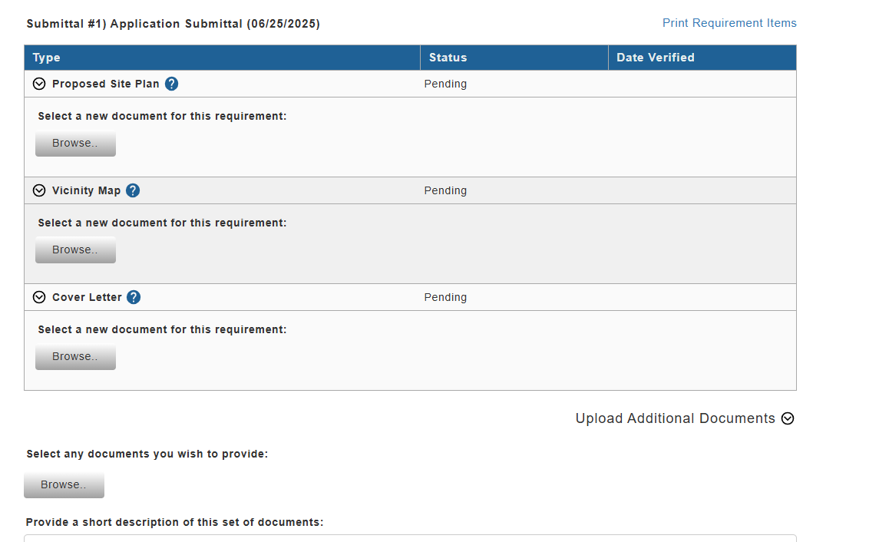
Once you have uploaded all 3 required documents, choose Next Step: Review and Submit.
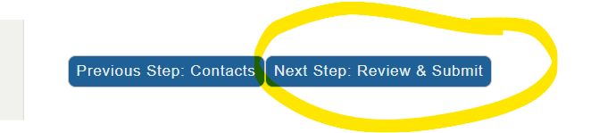

Final Review and Submission of your request.
Once you everything is ready to go, you can review your submission and then you would click “Submit Application”
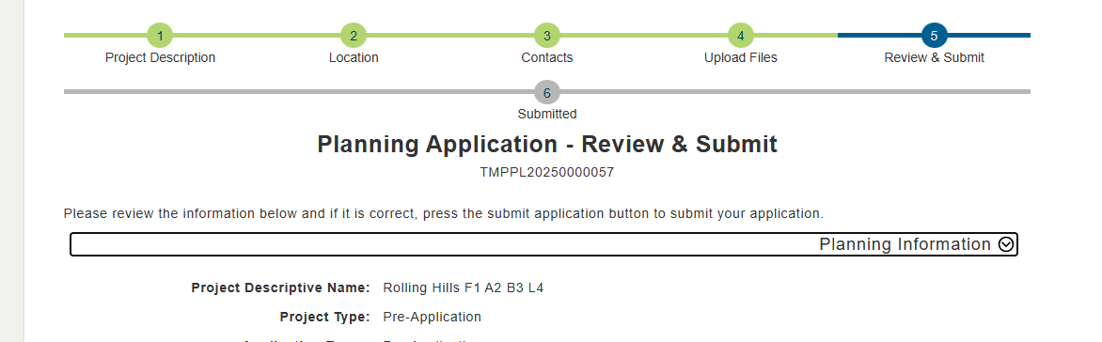

Submit Application
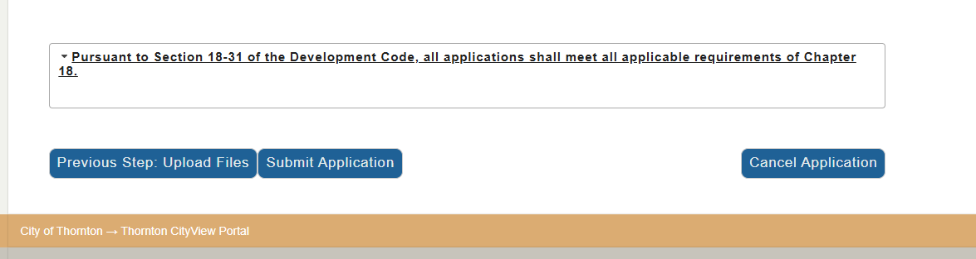
You will know your application has been submitted when you see that all steps are highlighted in green and the Planning Application shows Submitted (screenshot below).
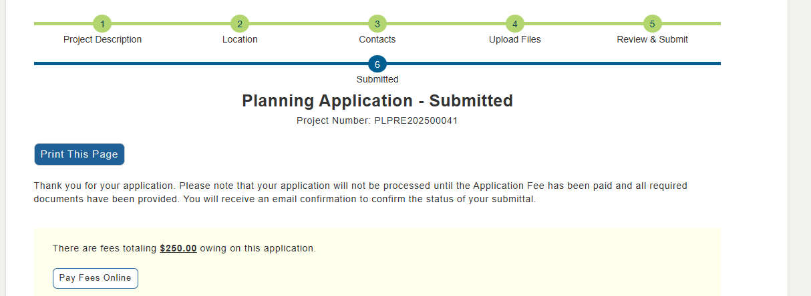

Payment information and how to make the payment
Once you submit, you will be given the option to make the payment right away.
Click on Pay Fees online
If you are logged out, you can log back into CityView Portal and go to your items, and under Planning Applications, you will be able to locate your pre-application submittal and pay the fees from there
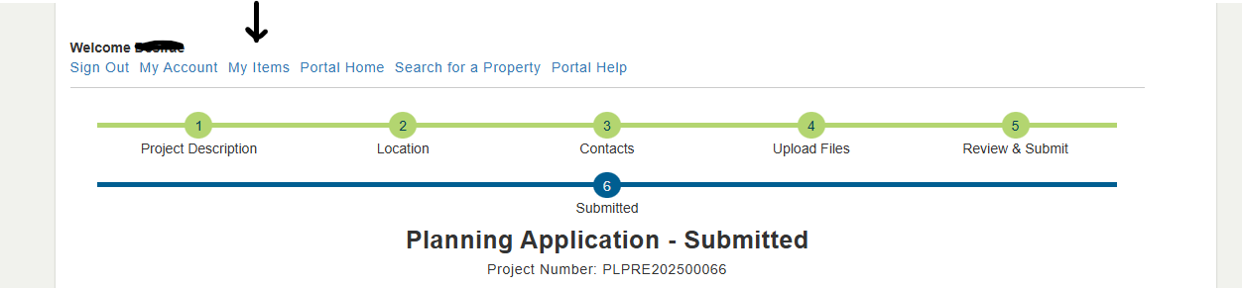
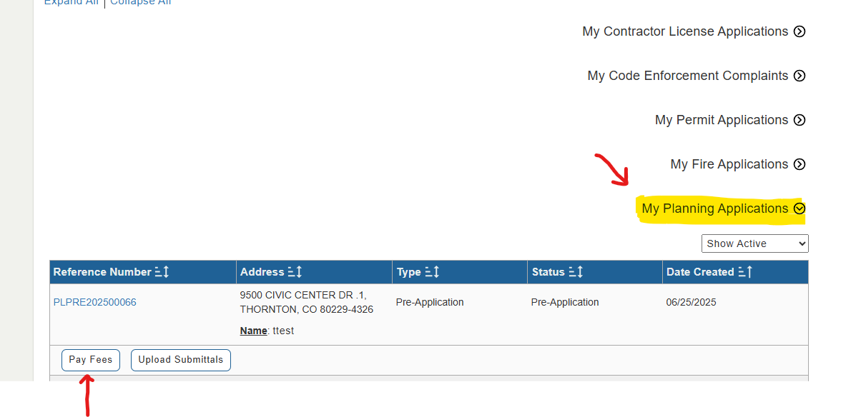
It will prompt you to make a payment using a Credit Card or an ACH.
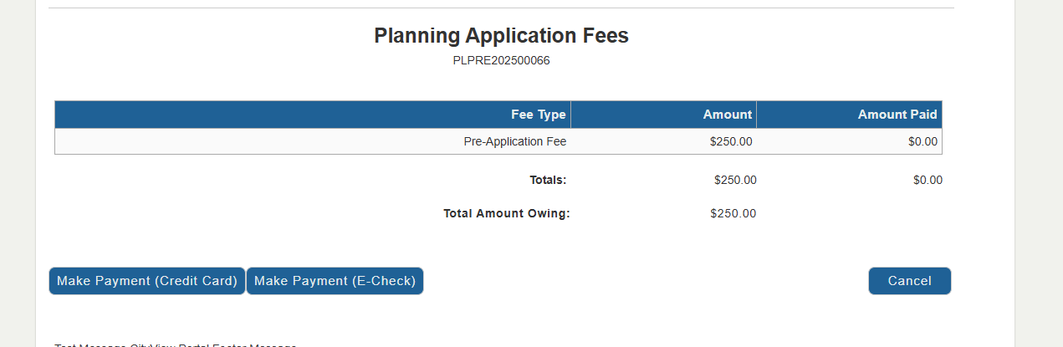
Pay with E-check (ACH)
Pay with Credit Card

Make Payment:
Credit Card
- 3.15 percent service fee to the card processor (not collected by city)
- needs to be completed correctly or it may create a return or be declined.

E-check
- No associated service fees
- needs to be completed correctly or it may create a return or be declined.
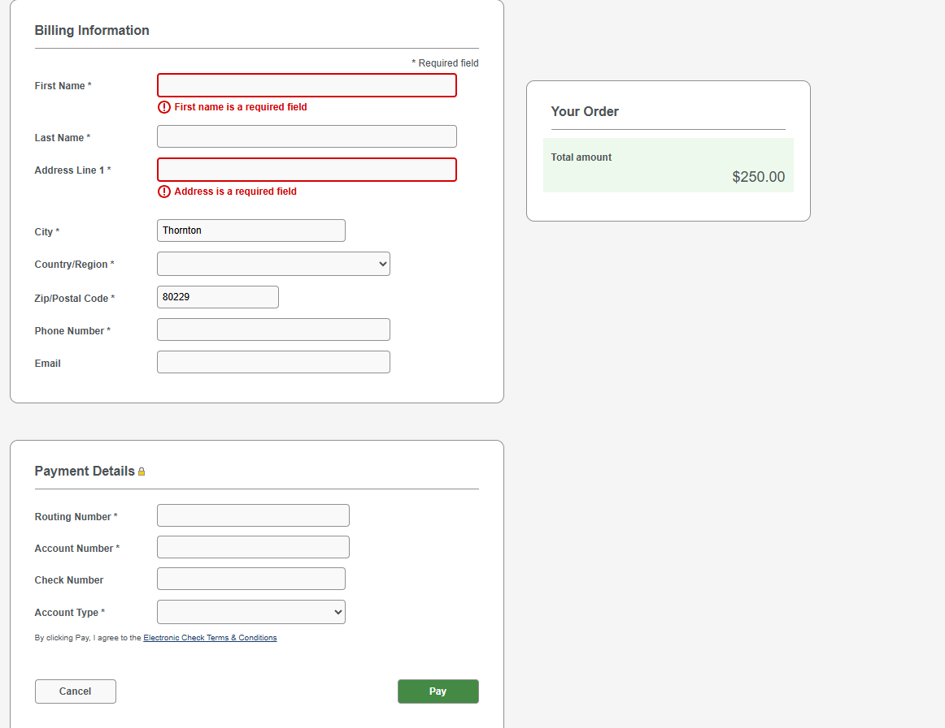
Bank information, make sure the Billing information matches the account payment details
Bank Address
Payee’s first and last name
If the account is under a business name (put the exact name under both first and last name as it appears on the account)
Pay with E-check (ACH)
Pay with E-check (ACH)

Guide: How to find the Parcel Number and the Legal Description for a property and create a Vicinity Map for a Pre-Application Meeting.

Finding a Parcel Number
Go to the Adams County Interactive Map and use the search feature in the top Right hand corner to search by the address. If you don’t know the address, you can zoom in and search for the property that way as well.
Once you locate the address, you can click on the Parcel information to the left and it will take you to property on the map and also provide the property report information.
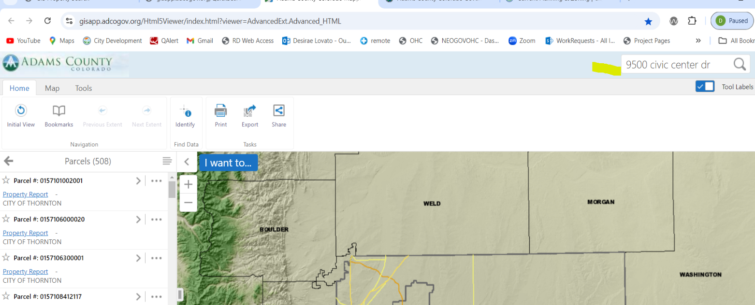
After you click on the property information it will zoom in closer the property and you can visually confirm that it is the correct location. Copy the Parcel number down that is listed on the webpage and use that for your application setup.
Finding the Legal Description: Choose the property report link
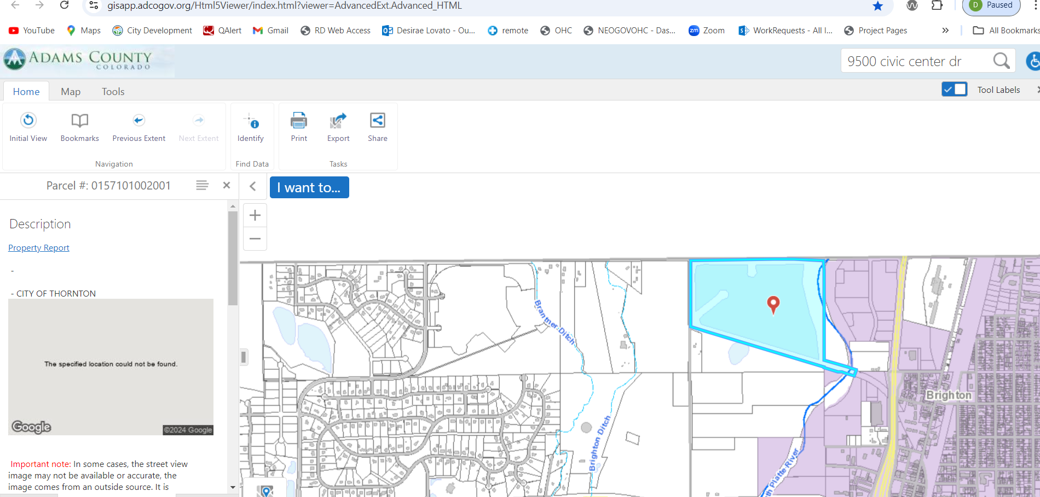

Once you click the property information link, it will give you the address, owner information and other property information.
Under Account Summary, you will find the legal description. Copy that information and use that for the NAME of your application.
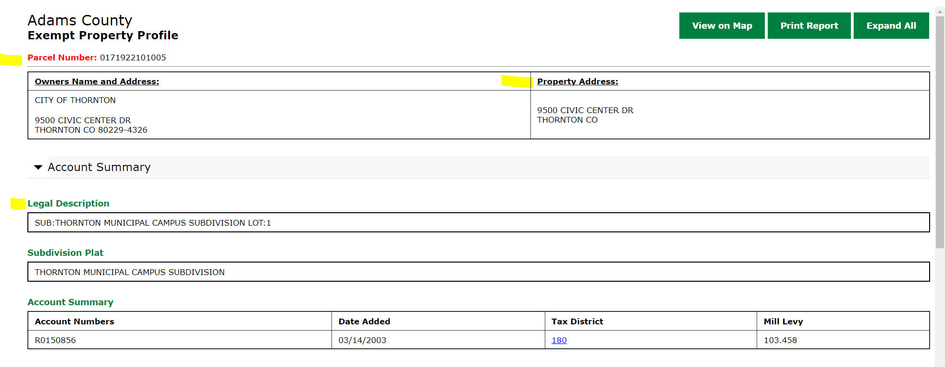
Create a Vicinity Map:
On the interactive map page you can highlight the property and do a screen shot, or you can choose the EXPORT button option and choose the image format as a .PDF. (Example below)
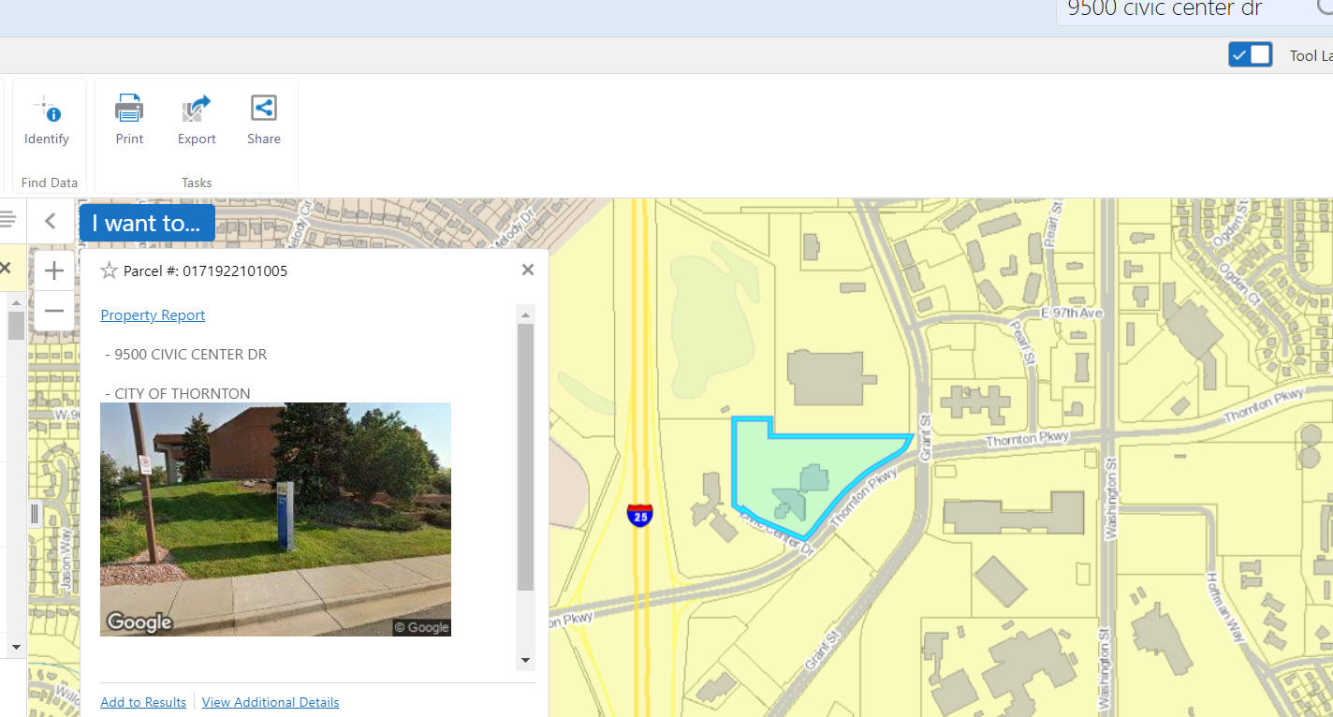

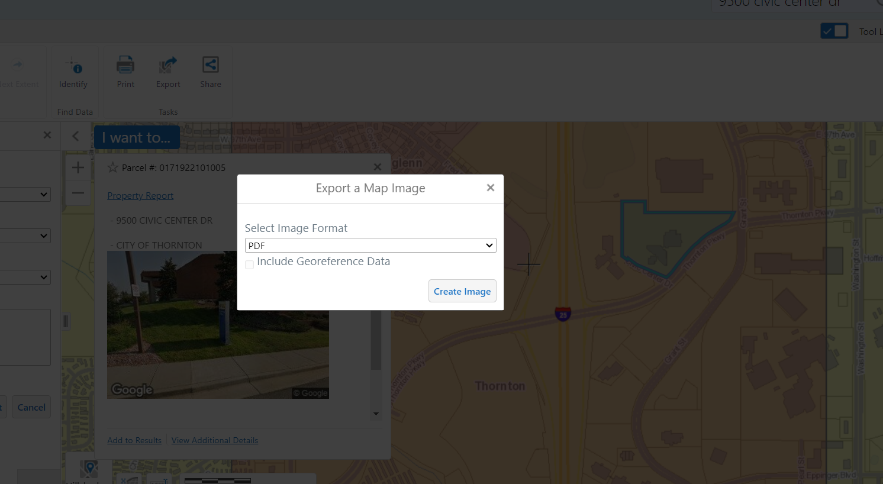
Below is what it will look like if you import it as a .PDF and you can save that as your Vicinity_Map file and you can also add text details to the image as well.
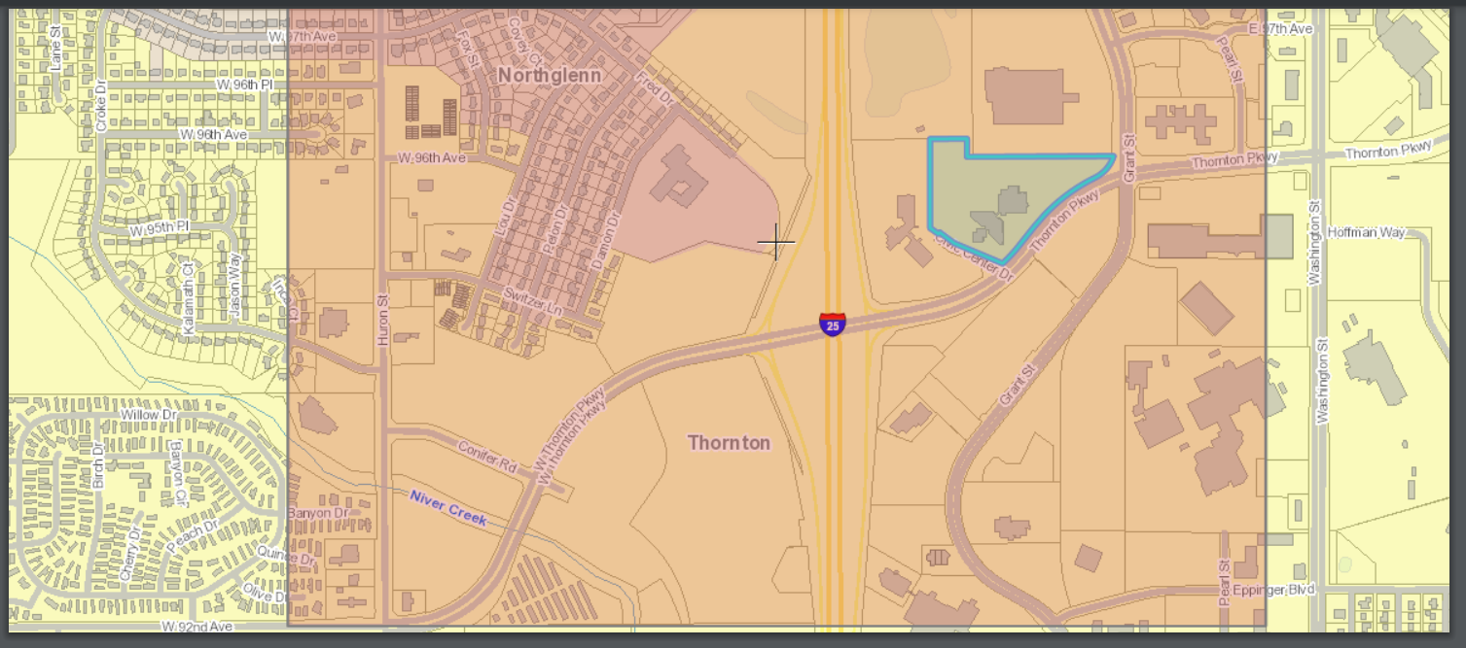

Additional Method:
You can also use the CityView Portal Property Search tool by searching for an address or parcel number if you already know the information. From there you can find the legal description, address and parcel number as well. This option would be best if you know the address or parcel number and it is not outside of the Thornton City limits.
